

Come join us for a free and fun evening, with snacks!
Saturday, October 7, @ 7p.m.
Safe Passage, 208 Dana Street
Come and watch
Stand and Deliver
The true story of Jaime Escalante, a high school teacher in East LA who successfully inspires his dropout students to learn. Calculus.

Saturday, September 30, @ 7 p.m.
Safe Passage, 208 Dana St. Street
Come and watch

McFarland USA
Based on true story of a coach who starts a cross-country
team in a town of agricultural workers in CA.

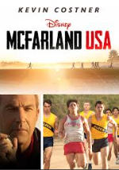
Movie Night!
Sponsored by
The Latino Coalition

NO children under 12 years of age unaccompanied


