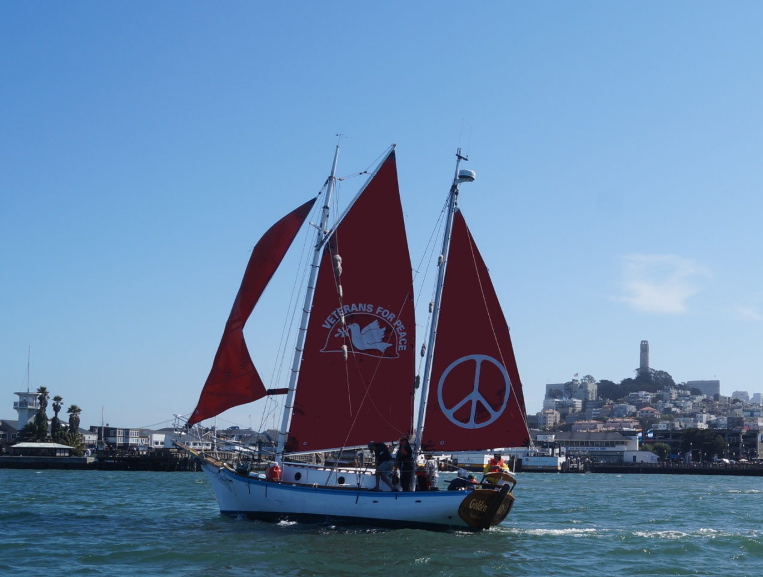
Sponsored by:
Occupy Mendocino
Ocean Protection Coalition

Meet and eat with the Crew of the
Historic Golden Rule Peace Boat!
Join us for a potluck and presentation:
Monday June 12, 2017, 6 pm
[Address]
The UN negotiations for a Treaty to Ban Nuclear Weapons are energizing the movement for nuclear disarmament, as is public concern about the very real possibility of nuclear war.
Join the crew for dinner and drinks. Learn about this amazing vessel’s voyages and how you can help stop the possibility of nuclear war and say NO to nuclear weapons “modernization”.
For more information, call Ann Rennicker 707-964-1420 or Helen Jaccard, 206-992-6364
Come out to Silver’s At The Wharf dock for a tour and get your picture taken on the Golden Rule. We might be able to take people sailing – call Helen Jaccard to get on the passenger list.
Boat tour (or sailing) schedule:
Monday June 12 12 pm – 4 pm
Tuesday June 13 10 am – 4 pm
Wednesday June 14 10 am – 12 pm
The Golden Rule is a National Project of Veterans For Peace, a 501(c)(3) non-profit organization.
www.VFPGoldenRuleProject.org
Facebook: Golden Rule Peace Boat
VFP Golden Rule Project, PO Box 87, Samoa, CA 95564

