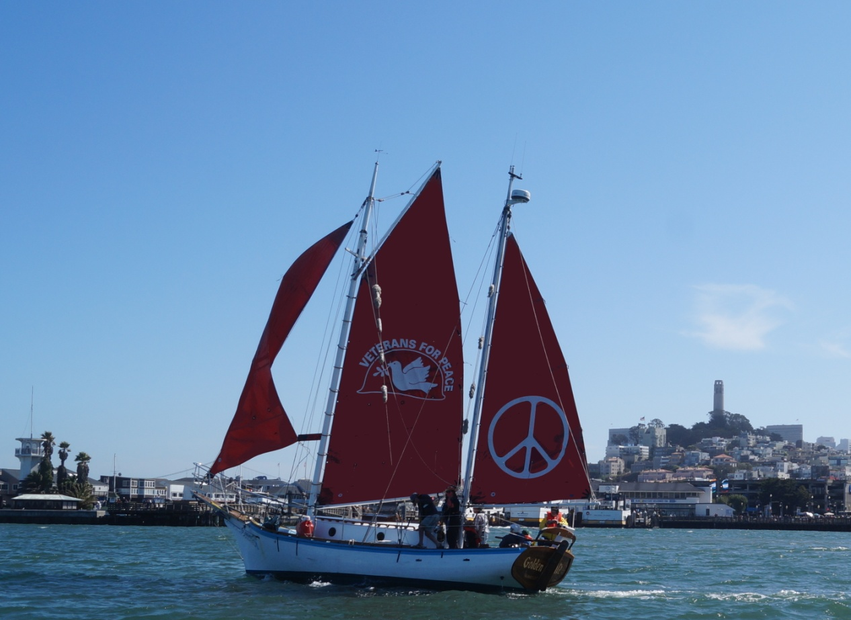
Wine, Dine and Learn with the Crew of the Historic Golden Rule Peace Boat!
Tuesday June 13, 2017
6 pm Dinner with the crew and shore support
7 pm Presentation and Discussion
Silver’s At The Wharf, overlooking the Golden Rule
32260 N Harbor Drive, Ft Bragg, 95437
In 1958 four Quaker peace activists sailed the Golden Rule toward the Marshall Islands to interfere with US nuclear bomb testing. This bold nonviolent direct action inspired a worldwide movement leading to the Partial Nuclear Test Ban Treaty of 1963.
This spring the UN negotiations for a Treaty to Ban Nuclear Weapons are energizing the movement for nuclear disarmament, as is public concern about the very real possibility of nuclear war.
Join the crew for dinner and drinks. Learn about this amazing vessel’s voyages and how you can help stop the possibility of nuclear war and say NO to nuclear weapons “modernization”
Walk to The Wharf dock for a tour and get your picture taken on the Golden Rule.
For more information, call Richard Karch 707-937-0334 or Helen Jaccard, 206-992-6364
The Golden Rule is a National Project of Veterans For Peace, a 501(c)(3) non-profit organization.
www.VFPGoldenRuleProject.org
Facebook: Golden Rule Peace Boat
Sponsored by:
Occupy Mendocino
Ocean Protection Coalition

