Charming Rustic Cottage for Rent in Meadow Setting!

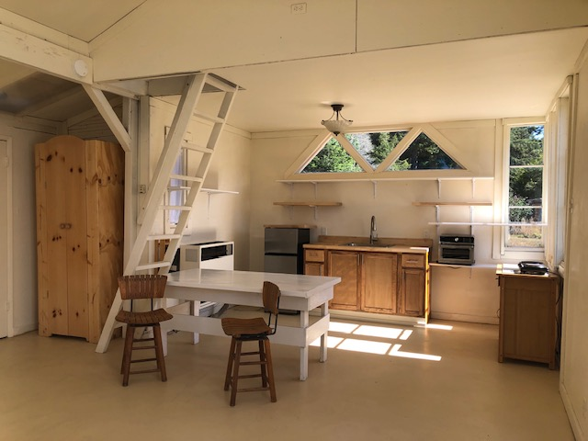

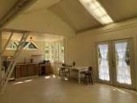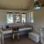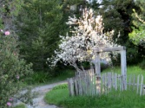

The Meadow Cottage!

Escape to tranquility in this beautiful sunlit 1,100 sq.ft. rustic cottage nestled in a serene meadow. This cozy cottage retreat features an upstairs loft area - a full bathroom with shower - large down stairs space with high cathedral ceilings - space for bedroom with handcrafted pine armoire and closet - a compact kitchen with oak shelving. Enjoy the peaceful surroundings through the French doors that open to a deck for relaxing. Stay warm and cozy with wood-burning stove and propane heating.

Perfect for a creative person and one who loves nature to inspire their dreams. Set on a hundred year old apple farm. 2 ½ miles inland from the ocean – In the Sunbelt - Short distance from Ft. Bragg and Mendocino.

Rental Price per month: $1,650.00 Plus Utilities, except for water.

For Inquires: Please respond with something about yourself, your occupation and employer, and any other pertinent information you care to provide.
We’re looking for someone who's a good fit for our property and retreat, with good credit and consistent, verifiable income, who wishes to stay a year or more.
All replies are strictly confidential.

Cottage Available March 8, 2026
1,100 sq.ft.
Handcrafted pine armoire and closet
Some furniture included
Utilities not included, except for water
Security Deposit/Cleaning: $1,650.00
Monthly Rent: $1,650.00
1-year lease
Move-in ready for qualified renter
No Smoking Please
No Dogs, One Cat Possible
Contact Cottage Manager to schedule a viewing or for more information!
goldharp@harpofgold.org
