My Life in Poetry
A series of six lectures on Zoom by Kathryn Hohlwein. Each session will include a one-hour talk on a topic in poetry, followed by a break, and 45 minutes of questions and discussion.
Tuesday afternoons: Oct. 10 to Dec. 19, from 1:00 pm to 3:00 pm PST. See schedule below for dates.
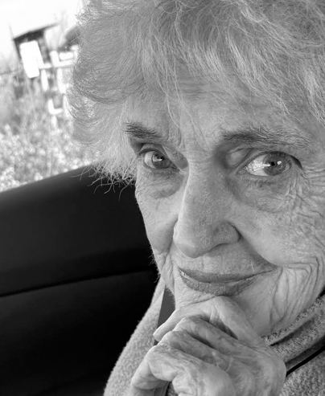
Solitude, my mother, Tell me my life again.
Join the irrepressible Kathryn Hohlwein as she speaks intimately on poetry every two weeks this fall! Each two-hour session will explore a different aspect of poetry. After Kathryn’s one-hour talk, there will be time for questions and discussion in our small Zoom group.
Cost of seminar is $250 per person for all six sessions. Please make checks payable to Kathryn Hohlwein, and mail checks to her at 411 34th Street, Sacramento, CA 95819
Please confirm your place in the class ASAP by emailing both Kathryn and Bob Stanley, and we will get you the zoom link for October 10 and the rest of the sessions.
khohlwein@gmail.com
stanleybob2010@gmail.com
Class Outline
Session 1 – October 10: Natural Piety. (Zoom hosted by Patrick Grizzell)
“God’s Grandeur” Gerard Manley Hopkins

The child is father to the man
And I could wish my days to be
Bound each to each by NATURAL PIETY.”
Wordsworth from “Ode on the Intimations of Immortality:”

Session 2 – October 24: Deep Time. (Zoom hosted by Bob Stanley)
“In Deep Time” poem by Kathryn Hohlwein

Session 3 – November 7: Senses: What the Body Knows. (host TBD)
Rhythms: our blood, our breathing, day and night sex, walking, dancing. Whistles, voice. Humming, whispering, purring.
“To Autumn” by John Keats
“My Papa’s Waltz” by Theodore Roethke
“After great pain, a formal feeling comes” by Emily Dickinson

Session 4 – November 21: The Resources of Language: Metaphor, Etymology, Figurative Language, Dictionary Meanings, Puns, etc.
Put a pun on low heat, add a little oil, saute words slowly, add seasoning to your taste.
Poem in October”. Dylan Thomas
“One Art” Elizabeth Bishop

Session 5 – December 5: Politics, Commitment, Community, Justice.

Session 6 – December 19: The Moral Imagination.
Letters of Keats, Dickinson
“Archaic Torso of Apollo” by Rilke

Kathryn Hohlwein graduated from the University of Utah and got her MA at Bread Loaf School of English, where she studied with Robert Frost, among others. She studied Philosophy in France, and moved to Lebanon, where she taught Literature at Beirut College for Women. Kathryn taught in colleges for 35 years, and settled at Sacramento State, where she taught The Homeric Imagination. In her retirement, she created The International Readers of Homer, which has put on Iliad and Odyssey readings all over the world for the last 25 years. Her free-flowing lectures continue to inspire and surprise writers and lovers of poetry and art all over the world.

