A ‘Rocking Ch

air Rebellion’: Seniors Call On Banks to Dump Big Oil
Older climate activists gathered in cities around the country for a day of action targeting banks that finance fossil fuel projects.

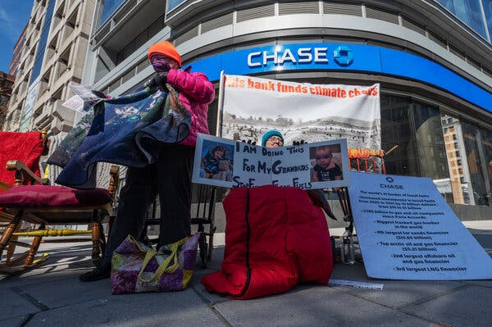
Two protesters outside a Chase Bank in Washington, part of a demonstration organized by Third Act, a group for older climate activists, on Tuesday.Credit...Craig Hudson for The New York Times


By Cara Buckley
March 21, 2023, 5:51 p.m. ET
Climate Forward There’s an ongoing crisis — and tons of news. Our newsletter keeps you up to date. Get it with a Times subscription
They were parents, grandparents, great-aunts and great-uncles, ranging in age from their 50s to their 80s and beyond, and together they braved frigid temperatures to protest all through the night, and to rock.
Bundled in long johns, puffer coats, layered knit hats and sleeping bags, and fortified by cookies sent by courier from a sympathetic supporter, dozens of graying protesters sat in rocking chairs outside of four banks in downtown Washington for 24 hours, in a nationwide protest billed as the largest climate action ever undertaken by older folks.
Calling themselves the Rocking Chair Rebellion, they were part of more than 100 climate actions staged across the country Tuesday by Third Act, a protest group for people aged 60 and older, co-founded by Bill McKibben, the author and climate campaigner.
Their targets were Chase, the subsidiary of JP Morgan Chase, Wells Fargo, Citibank and Bank of America, the biggest investors in fossil fuel projects, according to a 2022 report by the Rainforest Action Network and other environmental groups. Collectively, the four banks have poured more than $1 trillion between 2016 and 2021 into oil and gas.
“This is the world we helped create,” said Katie Ries, 66, who is retired from the National Oceanic and Atmospheric Administration, as she sat in a rocking chair outside the Chase branch in downtown Washington shortly after an unseasonably cold dawn on Tuesday. “When you put this temporary discomfort in perspective, against what we are out here for, what we are facing, it just pales, it disappears.”
Formed in 2021, Third Act has some 50,000 members on its mailing list, according to Mr. McKibben, including a few centenarians. While the group has staged protests before, sometimes bearing signs that read “fossils against fossil fuels,” they said that Tuesday’s actions were the biggest yet, with participants driven in part by the conviction that it was unfair to lay responsibility for fixing the climate crisis at the feet of younger generations who will bear its brunt.
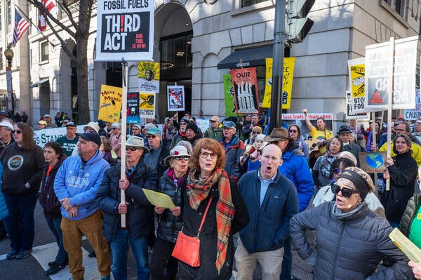
“I think anybody is complicit that is not trying to do anything,” one protester said.

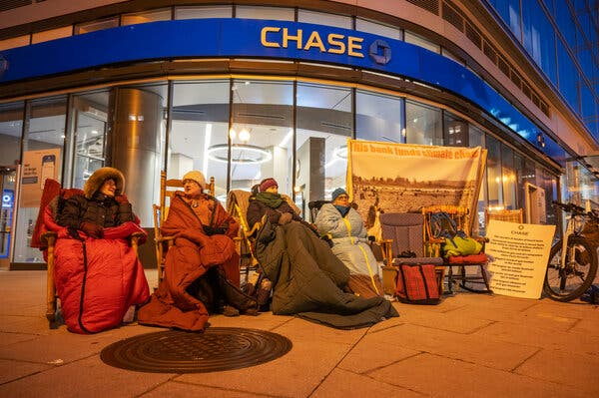
Activists sat in three-hour blocks throughout Monday night. Photo Credit...Craig Hudson for The New York Times

“For all their energy and intelligence and idealism, young people lack the structural power to make change on the scale we need in the time that we have,” said Mr. McKibben, who is 62, chatting early Tuesday before an anti-big bank climate rally in Washington’s Franklin Park. “We all vote, we ended up with most of the resources in our society. If we’re going to make Washington and Wall Street change, it’ll take a few people with hairlines like mine.”
The protests came on the heels of the latest dire report from the Intergovernmental Panel on Climate Change, which forecast that within the next decade, average global temperatures are likely to increase by 1.5 degrees Celsius, or 2.7 degrees Fahrenheit, compared to preindustrial levels and making catastrophic weather events harder for human and other life-forms to bear. To ward off the worst, nations must cut greenhouse gasses by half by 2030, the report said, and stop adding carbon dioxide to the atmosphere by the early 2050s.
Yet in 2022, carbon emissions hit record highs and the top oil producers reaped a record-breaking $220 billion in profits.
And though major oil-funding banks are also investing in renewable energy sources, several protesters dismissed such efforts as greenwashing. “They’re running ads on TV, a lot of the big oil companies, about how they’re doing all these environmentally friendly things, but they’re doing record oil exploration,” said Fred Solowey, 71. “And then these phony offsets that they use a lot, to pretend that they’re going to be carbon neutral. It’s hogwash.”
For the rockers, the goal was to urge people to pull their money out of the oil-funding banks, and to goose the consciences of bank executives.

“I think anybody is complicit that is not trying to do anything,” said Pam Murphy, 64, as she sat outside the Chase branch early Tuesday, in front of a sign that read “This bank funds climate chaos.” One rocking chair over sat Susan Flashman, 68, a retired electrician who lives in Mount Rainier, Md. “We’re the activists, we’re the boomers,” Ms. Flashman said. “People our age, we’re just incensed that no nobody’s doing anything. So here we are.”
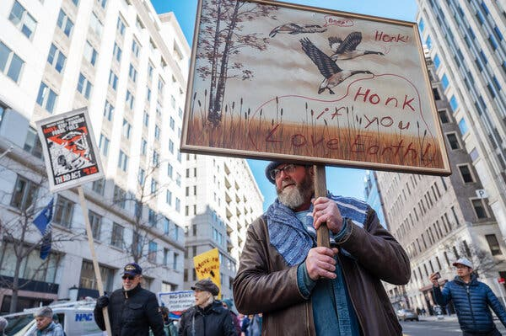
The protests came on the heels of the latest dire report from the Intergovernmental Panel on Climate Change.

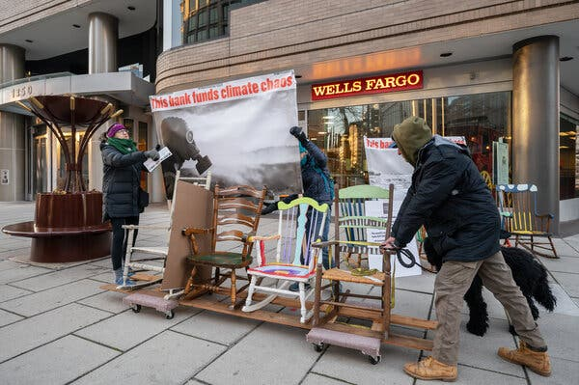
Most of the rocking chair activists were from the Washington metropolitan area, and sat in three-hour blocks throughout Monday night, though Ellen Barfield, 66, opted to sit multiple shifts from Monday evening until 5 a.m. Tuesday. She was a night owl anyhow, she said, and still up for the occasional all-nighter. “It’s better than a camp chair,” she said, of the seating arrangement, “And it’s poetic.”
“I mean, our climate is getting worse and worse,” Ms. Barfield continued. “We are far from doing what we need to do about it. And these banks are a big part of why, because they keep pouring money into this horrendous industry. And that has got to change, right?”
Most of the rocking chairs (there were about 50 in all) had been gathered by Lisa Finn, 57, and her husband, who live outside of Alexandria, Va., and hosted a rocking chair painting party before driving the chairs up in a U-Haul.
Along with the rally at Franklin Park (speakers included Ebony Twilley Martin, the co-executive director of Greenpeace USA; and Ben Jealous, executive director of the Sierra Club) there were marches featuring banners, outsize puppets and at least one shofar, and the blockading, with even more rocking chairs, of Wells Fargo and Chase. One protester was arrested after using paint on the street, organizers said.
Before addressing the rally, Mr. Jealous said pressure from older activists ought to make the banks take notice.
“For the banks, this is a very worrisome signal,” he said. “They can write off young people, they don’t see them as having a whole lot of money right now. They know these folks do.”
For his part, Mr. McKibben conceded that closing personal accounts in oil-funding banks was not likely to impose enough financial harm to force change, but said that merely underscored the urgent need to do more.
“We can put serious pressure on their reputations, their images, their brands, and their sense of themselves,” he said. “Right now, the most powerful people in the world are deeply complicit in the gravest crisis that the world has ever experienced. So part of today is an attempt to rouse these guys to some kind of sense of their place in history.”

Cara Buckley is a climate reporter who focuses on people working toward solutions and off-the-beaten-path tales about responses to the crisis. She joined The Times in 2006 and was part of a team that won a Pulitzer Prize in 2018 for reporting on workplace sexual harassment. @caraNYT • Facebook

