Our Forests Under Attack

Local Environmental Groups have joined a growing number of neighbors to express concern over a series of six or more Timber Harvest Plans (THPs) slated to begin in Spring of 2021 and cover at least 3,000 acres—over four and a half square miles. With the three recently completed THPs, this encompasses nearly the entire western side of Jackson Demonstration State Forest (JDSF). The neighborhoods impacted include the entire Mitchell Creek watershed, the Mendocino Woodlands, the North Fork Big River, Caspar, Jughandle, Railroad Gulch, and Thomson/Berry Gulches.

How JDSF operates reminds me of the famous Braxton Bragg story (true or not) included in Ulysses S. Grant's memoirs, about Bragg as a company commander at a frontier post where he also served as quartermaster. He submitted a requisition for supplies for his company, then as quartermaster declined to fill it. As company commander, he resubmitted the requisition, giving additional reasons for his requirements, but as the quartermaster, he again denied the request. Realizing that he was at a personal impasse, he referred the matter to the post commandant, who exclaimed, "My God, Mr. Bragg, you have quarreled with every officer in the army, and now you are quarreling with yourself!"

Why am I reminded of that story? CalFire creates the THPs, then CalFire approves the THPs it has created. We should wish one branch or the other would occasionally face Bragg’s dilemma.

JDSF has been very secretive about these THPs, only notifying residents within 300 ft. of a cut and allowing a small window of time for public comment. However, if you live on the east side of highway One, you will be impacted. If you live on the west side of highway One or in the town of Fort Bragg and enjoy horseback riding, hiking, biking, mushrooming, birding, or just ‘forest bathing’ (Shinrin Japanese for taking in the forest through our senses of sight, hearing, taste, smell and touch) these THPs affect you and your family, tourism, not to mention the displaced wildlife.

There is the risk of increased siltation of our rivers and creeks, possible herbicide contamination of the ground water and our wells, and an increased fire danger. Perhaps, by changing their name from California Department of Forestry to CalFire, they would like us to believe that thinning of the forest would reduce the risk of fire. These planned THPs may actually increase the risk. Logging dries the forest. A walk in any of the zones logged in Caspar and Hare Creek as long ago as ten to thirty years, reveals choked stands of small trees, volatile Scotch broom, a generally unhealthy forest and combustible understory.

A team of scientists just surveyed the August Fire. Most of the old growth trees survived. What burned were the young, smaller trees without dense, protective bark. A large percentage of the (valuable) old trees in each of the harvest are marked for removal, leaving the young trees, and the resulting slash to dry out and become fuel for the next fire season. These THPs put us all at risk, especially those of us living in the neighborhoods adjacent to the cuts. Those of us with only one way out in the event of a fire.

It gets worse. The 1st sentence under the CWE (Cumulative Watershed Effects) GHG (Greenhouse Gas) effects for the Mitchell THP states: Global climate change is subject to intensive debate. A factually incorrect statement like this begs the question how factually incorrect is everything else they're putting forward? The 2nd sentence begins with, "For now, the climate is warming...and goes on to say, paraphrased: "the atmosphere is warming, although exactly how and to what extent human activity plays a role in global climate change appears to be unknown."

Really? Kind of makes one wonder in what decade, or even century this was written in.

The next few pages are meant to provide insight into the impact these cuts will have on our lives.
The first scheduled cut is Mitchell Creek starting August 2021.
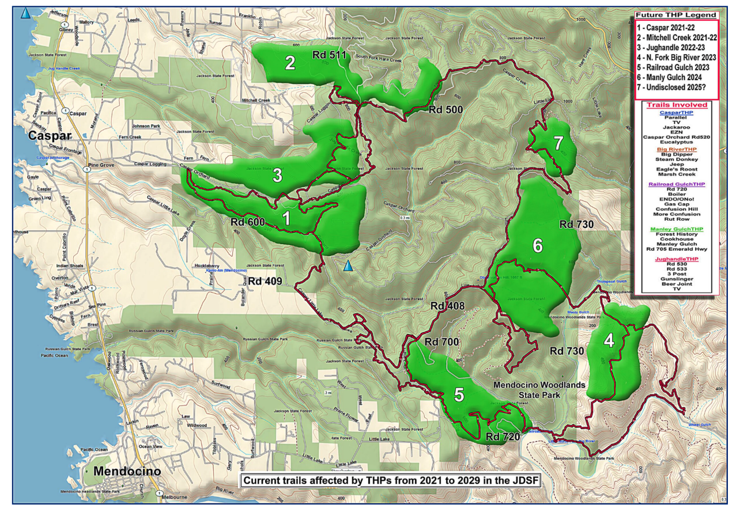

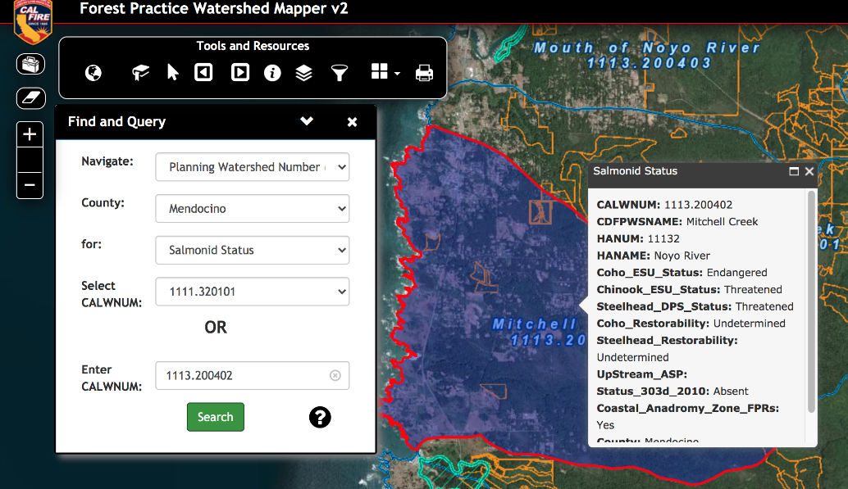
Mitchell Creek Salmon status
Mitchell Creek THP issues:

1
In CalFire’s own data base, they have the status of the three major salmonoids present in Mitchell Creek listed as endangered, threatened, and threatened.

According to the JDSF Master Plan: "Goal #3 - WATERSHED AND ECOLOGICAL PROCESSES: Promote and maintain the health, sustainability, ecological processes, and biological diversity of the forest and watersheds during the conduct of all land management activities. [...] Provide protection to listed species, to species of concern, and to their occupied habitats." [pgs 19-20]
How can you justify logging so close, and across both main branches of Mitchell Creek, when logging and road building/use by logging equipment, especially in riparian environments is well-known to be one of the largest drivers of erosion and sediment related pollution to streams? This THP seems in direct conflict with Goal#3 of the JDSFMP

The North Coast of California has some of the highest sediment yields in the world due to the high uplift rates, high rainfall, and particularly weak geologic units (Andrews and Antweiler 2013). The generally fine-textured geologic materials found in this region means that these high sediment yields also cause high turbidity levels. This is a major concern because of the potential adverse effects on the anadromous salmonid populations, many of which have been declared threatened or endangered by state and federal agencies. Most of the large watersheds in the northern part of the California Coast Ranges have been listed as sediment impaired under Section 303(d) of the Clean Water Act.
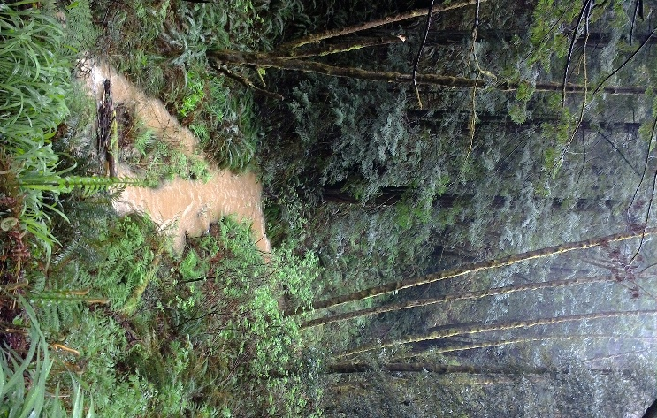
Mitchell Creek after a heavy rain.
2
The Mitchell THP has only one 10-acre research component attached: an experimental attempt to revert ‘degraded’ soil pine forest back to redwood. What constitutes ‘degraded’ is open to interpretation. Botanically, these soils are just as they should be: rare and unique types supporting threatened ecosystems.

3
Logs are only supposed to exit down Mitchell Creek Road for two weeks, entering from the presently decommissioned State Parks road just to the S of the failing Mitchell Creek culvert. Cal-Fire is asking the county to investigate the integrity of the culvert and repair it if necessary.

4
“CEQA forbids ‘piecemeal’ review of the significant environmental impacts of a project. Agencies cannot allow environmental considerations to become submerged by chopping a large project into many little ones, each with a minimal potential impact on the environment, which cumulatively will have disastrous consequences. This is exactly what is occurring here with these THPs. The extent of the logging proposed will have enormous consequences on the environment, and greatly impact the surrounding community for years to come; these impacts are not being considered cumulatively.” Chet Jamgochian

The cumulative impacts must be added to the THPs that have been done in the last 5 years. The THP’s are adjacent to each other so need to be looked at in that way. The cumulative impacts of up to 10 individual THPs over the space of ten years cannot and should not be ignored.

5
Increased fire danger for residents of these harvest plans, most of whom have only one way out of their neighborhoods. A study last week by scientists surveying the August Fire, found that the large trees survived a fire that consumed the smaller trees. These harvest plans are motived by the value of large trees and will likely leave the more susceptible smaller trees and the logging debris to dry out in time for the next fire season.

Natural small-scale wildfires by definition remove small trees and understory brush, not large, established mature trees. However, when they log by selection, or otherwise, they remove the large, established mature trees since they have all the market value. Hence their management practice does not replicate or replace the effects of small-scale fire. Even in higher intensity fires, it's the large trees that survive due to higher canopies and thicker bark which protects the living tissue. So selective management not only does not mimic the effects of small-scale fire, it removes the large fire hardy trees that make the forest more resilient to fire as a whole. In the study below 87% fire killed trees were confined to DBH classes of less than 20 cm. And even with the most severe level of cambium kill, nearly 100% of trees with DBH greater than 45 cm survived.

6
Use of herbicides INVASIVE PLANTS French (Genista monspessulana) and Scotch Broom (Cytisus scoparius) and Jubuta Grass (Cortaderia Jubata) are invasive exotic plants that are present in the plan area, most often along roads and seasonal or temporary roads and landings. Integrating JDSF’s Invasive Weed Plan, the following measures may be taken to identify immediate control needs to slow the spread of invasive weeds: Pull small immature plants if feasible. Consider the amount of soil disturbance associated with manual pulling of weeds. Soil disturbance can promote seed germination. * Ideally treat plants when small <12” tall with selective herbicides (target broom species) or with focused spot treatments with broad spectrum herbicides to maintain native and compatible species.

The EPA under Trump says the use of the most popular and widely used herbicide, Roundup, is safe. All the other information out there says it is not safe, and unless you’re living under a rock, or don’t own a TV, you’ve seen the adds by a law firm to join the class action suit against Bayer OKA Monsanto.
https://www.snopes.com/ap/2019/03/19/jury-roundup-weed-killer-major-factor-in-mans-cancer/

Are you on a well? How do you feel about cancer causing agent reaching your ground water? Or the fingerling steelhead in Mitchell Creek. Do you feel comfortable with the use of herbicides, especially with no oversight?

“People who breathed in spray mist from products containing glyphosate felt irritation in their nose and throat. Swallowing products with glyphosate can cause increased saliva, burns in the mouth and throat, nausea, vomiting, and diarrhea."

7
Rare plants “If rare plants are found next year before harvest, we will consult with CDFW for protection measures as needed.” Julie Rhoades

THPs are approved before the botanical surveys are done. Approval before evaluation is backwards. And the “protective measures” provide a 50’ buffer. No consideration is given to that plant’s requirements, for example, a shade-loving, moist-loving species.

“Botanical surveys are only proposed after the timber harvest plans are approved, which prevents the disclosure of potential sensitive botanical areas and the development of meaningful avoidance and mitigation measures during the formal review process.” Renee Pasquinelli, Conservation Co-Chair (North) CNPS

8
Wildlife The entire headwaters of Mitchell Creek will be encompassed by this THP, likely exacerbating the already existing erosion/siltation problem in a watercourse that has had salmonid species and is home to many amphibian species such as the Pacific Giant Salamander.

9
Impact on the economy
This large of a swath of logging activity will turn the Western end of JDSF into an industrial zone for years to come. The greater area of Mitchell Creek, Hare Creek, Jughandle Creek, Caspar Creek, and Big River watersheds is used by tens of thousands of people every year and is a large draw for recreational tourism--bringing millions of dollars into the county economy every year.

10
The undertaking of so many timber harvest plans at once brings up the question of whether these harvests are actually for research and demonstration—the prime stated mandate in the 2016 management plan—or whether they are just for generating revenue at the expense of another stated objective: the development of maturing second growth late (seral) succession forests.

“The purpose of stand thinning as a restoration tool is to speed forest development in order to produce certain old-growth characteristics more quickly. However, the development of a forest with a dominant species, such as Sequoia sempervirens, that commonly persists for 1500 to 2000 years is a lengthy process. And though the temptation to manipulate a regenerating forest so that management goals can be reached in a human time scale is compelling, the ecological costs of continued disturbance, particularly when using the same tools that caused the original damage, must be considered. The reason why some associated understory species reached old-growth equivalence, and others did not, is not clear. However, the answer likely relates to soil conditions and the relationships between plant roots and communities of soil microorganisms. Therefore, the protection of the soil from further human disturbance is essential so that natural soil development processes can occur. In addition, allowing natural processes to restore a system allows for stochastic factors to create stand complexity, while eliminating the simplifying influence of subjective human management.” Dr. Will Russell

11
Carbon sequestration is the process of capturing and storing atmospheric carbon dioxide. It is one method of reducing the amount of carbon dioxide in the atmosphere with the goal of reducing global climate change. Redwood trees and the soil-based ecosystems they support have been shown to be the premier carbon-sequestering teams in the world.
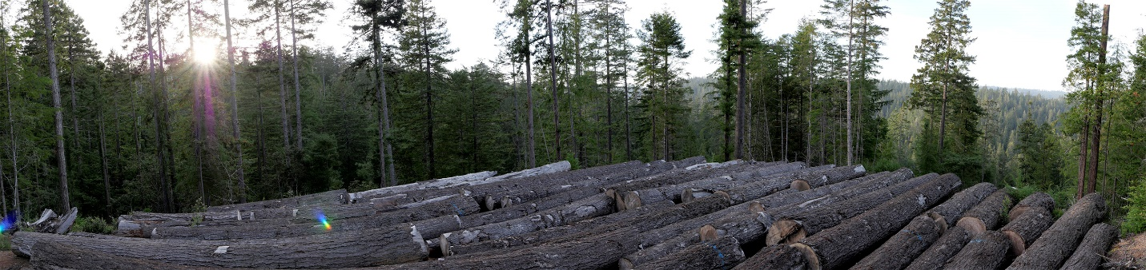
Art Mielke 2018 THP just west of 408. They’ve been there for 2 years.
For more information and pictures of recent harvests:
www.mendocinotrailstewards.org

Just FYI, nearly the entire length on the northside between THP 1 and 5 was logged last year.
After visiting the THP that occurred in the Caspar Creek (2018/19) water shed, along the north slope of road 409 on Monday (part of what has been called mushroom corners) it is quite evident …the amount of disturbance and slash left on the ground will preclude survival of herbaceous species for quite some time. We visited a wetland area within the THP that a tremendous amount of slash was left on top of the extant (existing/surviving) plants.

For more information: www.mendocinotrailstewards.org
Unfortunately, logging pays for fighting fires. There needs to be State funding. What too often remains after a CalFire THP looks like recreational bulldozer use.

Additional

Steps to establishing a preserve:
- Identify significant features
- Must be acquired by someone else, like MLT
- MOU management agreement

The Woodland THP hasn’t been cut since 1929, and will be the most tragic. No roads exist in the area. To do the harvest, 4 plus miles of roads on a steep slope will need to be cut. This will require a “full bench cut”.
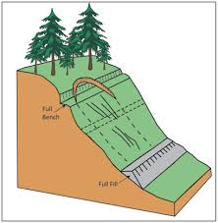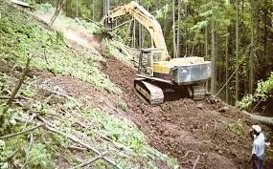

- Our goal is to try to make them do it well and obey the law that is already there.
- Logging has a drying effect.
- They take our comments, write a justification, check all the boxes (literally) then someone at an adjacent desk approves it.

