
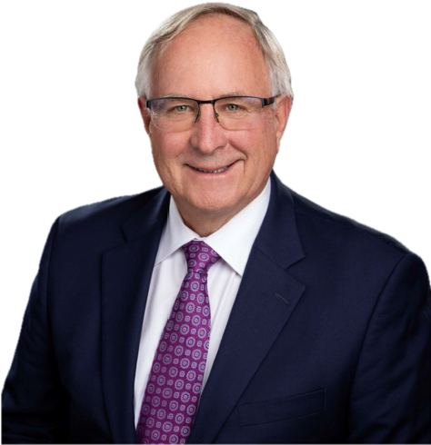
Monthly Newsletter
August 2026
District Governor Jeff Kolin
District Governor’s Message
Membership Is How We Keep Rotary Growing
August is Rotary’s Membership and New Club Development Month, a time to focus on one of the

most important questions we can ask: Who is not yet in the room?
Membership is more than a number. It is the way we bring new energy, new ideas, new skills, and

new friendships into Rotary. Every new member expands our ability to serve.
Every engaged member strengthens a club. Every new club creates another doorway into Rotary

for people who are ready to make a difference but may need a different meeting style, focus,

culture, or community connection.
Across District 5130, we are already seeing that spirit in action. Congratulations to the Rotary Club

of Napa on the creation of a new Interact Club at Vintage High School and for exploring the

possibility of a Ukrainian Rotary club in Napa. That is exactly the kind of imagination and welcome

that helps Rotary grow.
We also celebrate the continuing work of the Lakeport Rotary Club to finalize an Interact Club at its

local high school, the Saint Helena Rotary Club’s work toward forming a Rotaract Club at Pacific

Union College, and the collaboration among Santa Rosa Sunrise and many community leaders to

form a new Rotary club in Roseland.
These efforts remind us that membership growth does not happen by accident. It happens when

clubs look outward, listen carefully, and ask how Rotary can meet people where they are.
This month, I encourage every club to do three simple things: invite someone to experience Rotary, thank the members who make your club strong, and ask whether there is a new Rotary, Rotaract, Interact, satellite, cause-based, or community-focused club waiting to be formed in your area.
We are fortunate to have Renee McKenna serving as our District Membership Committee Chair this year. Renee is looking for additional Rotarians to join the committee and help support clubs across District 5130. She is also preparing training sessions for club membership chairs, planning a social media-based membership campaign for January, and exploring innovative ways to help clubs attract new members. If membership is one of your passions, or if your club has a creative idea to share, this is a wonderful time to get involved.
Rotary grows when people see a place for themselves in our service, our friendships, and our shared commitment to doing good. Let’s keep opening those doors.
Jeff Kolin
District Governor, Rotary District 5130
“Drafted with AI assistance and reviewed by District Governor Jeff Kolin.”

District Leader Showcase - Renee McKenna

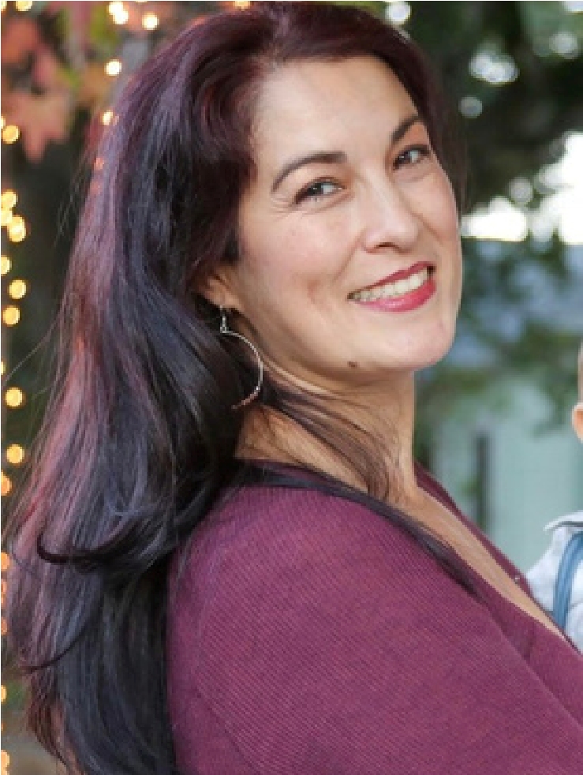
Renee McKenna, District Membership Chair
Renee McKenna is the Immediate Past President of the Rotary Club of Petaluma Valley. She has served our community through her profession as a Clinical Dietitian at Santa Rosa Memorial Hospital for 20 years. She also teaches nutrition as an adjunct instructor at the SRJC. Renee enjoys line dancing, teaching belly dance, and spending time with her family and friends. She recently celebrated 22 years of marriage with her husband, Scott, and together they're busy cheering on their 9-year-old son at his many youth sports. Renee believes the best communities are built through genuine connections, service, and having a lot of fun along the way. Go Giants!

Membership Month: Creating Lasting Impact
As I begin serving as District 5130's Membership Chair, I am honored to work alongside our clubs to support one of Rotary's greatest strengths—our members. To help guide and support our clubs, I am joined by a dedicated membership committee, including: Maggie Padovani, Paul O'Rear, and Derek Stefan.
Our committee is here to serve as a resource for you as we celebrate the unique spirit of every club and share ideas that inspire growth.
Membership is the heartbeat of Rotary. Every new member, every longtime Rotarian, and every person we inspire to serve strengthens our ability to make a difference throughout District 5130 and beyond. This Membership Month, I encourage every club to embrace Rotary International's theme, Create Lasting Impact, by investing in what matters most—our people.
To achieve this, our preliminary plans will rely on the Rotary Action Plan as our guiding tool for building membership. Additionally, the Board has approved the new "You Belong Here" campaign, a social media membership lead program. This program will roll out in January 2027 and moving forward we will be sharing the program and next steps with clubs and membership chairs.
Membership isn't simply about increasing numbers; it's about building vibrant clubs that reflect the communities they serve. Invite a guest to a meeting, reconnect with a former member, mentor someone new, or explore innovative club models that make Rotary accessible to more people.
Together, let's Create Lasting Impact—one member, one club, and one community at a time. Story submitted by Renee McKenna, District Membership Chair

Upcoming Zoom Meetings
End Polio Now Torch Relay Planning Meeting
Details: Tuesday, August 4th at 6pm
To participate, contact Renee McKenna at reneetmckenna@gmail.com for the Zoom link.
District Designated Funds Policy Changes for 2026-2027
Details: Thursday, August 6th at 5pm
To participate, contact David Mark-Raymond at dmarkray@gmail.com for the Zoom link.

DACdb IGNITE Roll-out - Wulff REinhold, PDG
District 5130 and Governor Jeff Kolin are thrilled to introduce IGNITE, a powerful mobile platform through DACdb, designed to increase member engagement, strengthen communication, and help clubs maximize their impact.
As part of this exciting district initiative, every club (yes, even the ClubRunner clubs) will also receive the Engagement Module, giving club leaders and members an easy way to track attendance, record service hours, and measure the incredible impact being made throughout our communities.
If you have any questions along the way, I will be serving as the district's IGNITE liaison and trainer. This is a powerful tool for communication, collaboration and for all members to easily get RI information without having to navigate the RI maze.
This is an exciting new path to help us all Create Lasting Impact.
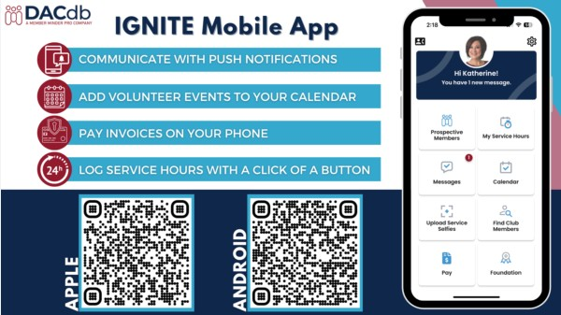

Rotary Club of Eureka Awards $1,700 to Play Street for New MultiSensory Play & Education Center
The Rotary Club of Eureka has awarded a $1,700 grant to Play Street to help fund equipment for a Multi-Sensory Play and Education Center opening in Eureka this July. The center will offer therapeutic spaces for children with disabilities, autism, and sensory disorders, aiming to create an inclusive, empowering environment for families. The Rotary Club’s Small Grants Program supports local groups working in youth development, senior support, community health, literacy, and homelessness.
Organizations interested in applying for future grants can visit www.rotary1.org.
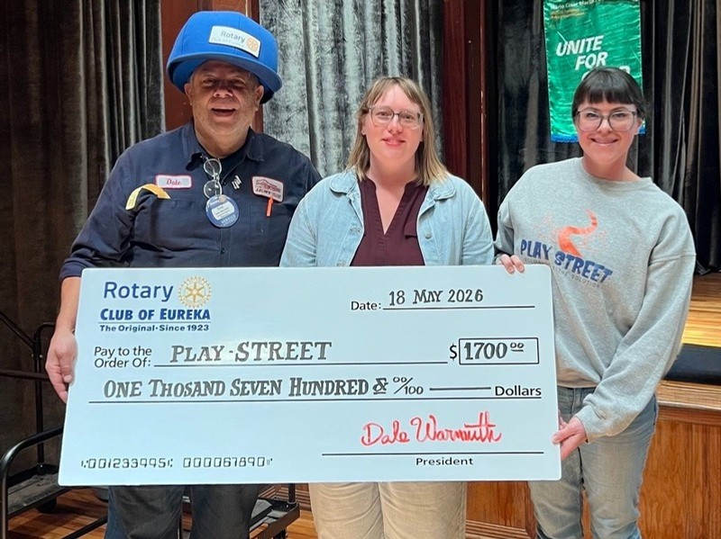

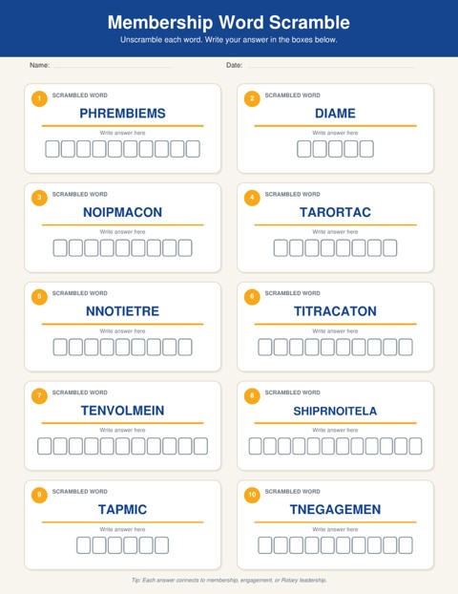

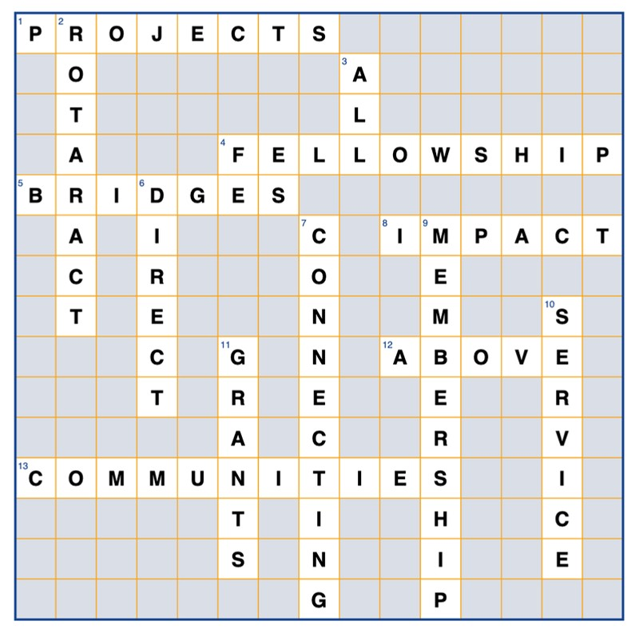
July Newsletter Crossword Puzzle Answers
Meet Your District 5130 Public Image Chair
I am honored to serve as Rotary District 5130 Public Image Chair for the 2026–2027 Rotary year.
Public Image is about more than promoting Rotary. It is how we share who we are, what we do, and

why our work matters. Every project, partnership, youth program, and Foundation initiative is an

opportunity to strengthen awareness and inspire involvement.
This year, the District Public Image Team will focus on:
Helping clubs tell compelling stories about their members, projects, and community impact
Providing practical tools, templates, resources, and guidance
Strengthening consistent Rotary branding, media outreach, social media, and collaboration among clubs
We are recruiting Public Image Area Team Representatives to partner with their Area Governors and support clubs with guidance, resources, and ideas. Representatives will also help identify local stories deserving broader recognition.
You do not need to be a marketing professional. We welcome Rotarians interested in storytelling, social media, photography, writing, or community outreach.
If you are interested—or would like to recommend someone from your club—please contact me at mpadpr@gmail.com or (408) 799-0455.
We are also pleased to welcome several new District Public Image Team members, whom we will introduce in the September newsletter.
Together, we can strengthen Rotary’s voice, expand our reach, and show how District 5130 is “Building Bridges, Connecting Communities.”
Story submitted by Marguerite “Maggie” Padovani

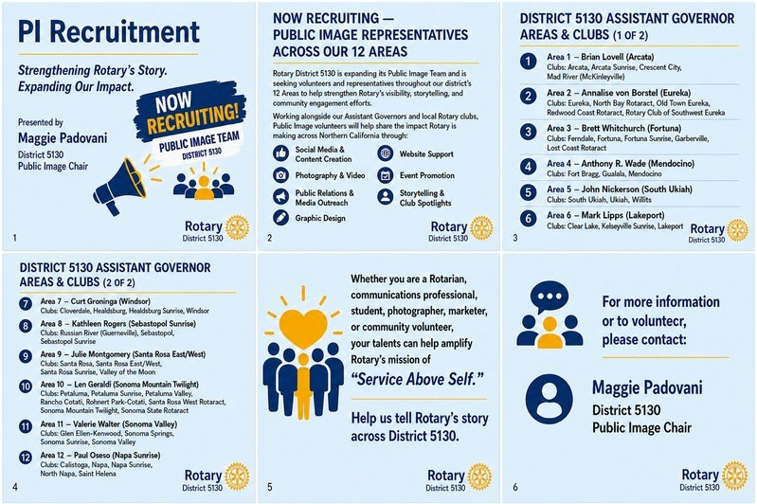
Upcoming Events at a Glance
Sonoma County Children’s Museum Visit: Friday, August 12, 2026 at 4pm at the museum in Santa Rosa
End Polio Now Torch Relay: October 2-24, 2026 spanning the district
RYE Golf Tournament: Saturday, October 17, 2026 at 1:30pm at Foxtail North Golf Club in Rohnert Park
Petaluma Gap Wind and Wine Festival: Saturday, October 17, 2026 at 1pm at Gambonini Family Ranch in Petaluma
Foundation Luncheon South: Sunday, November 15, 2026 at the Healdsburg Golf Course
Foundation Luncheon North: Sunday, November 22, 2026 at the Elks Lodge in Eureka
District Training Assembly: Saturday, April 3, 2027 at the Ukiah Valley Conference Center
District Conference: May 7-9, 2027 at Konocti Harbor Resort in Kelseyville
District Training Assembly 2027 - Save the Date!
Saturday, April 3, 2027 at the Ukiah Valley Conference Center.
There are planned to be 36 separate sessions and 34 expert presenters from all around the district.
Sessions will include:
Communication: Your Superpower
Motivating Volunteers
Feeding Your Heart in Rotary
Traveling to Serve
Conflict Resolution
Running an Effective Board
Launching Satellites
Leading Amazing Meetings
Selling the Rotary Story
“Fun-raising” and Event Planning What’s the Big Idea?
Rotary Outside the Box
Case Studies: Irresistible Clubs
Fun and Fearless Public Speaking
The Club Foundation
Creating a Vibrant Club
Plus more sessions on:
The Rotary Foundation
Membership Growth / Retention
Environmental Stewardship Rotaract and Interact
It will be fresh, deep and dynamic!
Story submitted by District Governor-Elect Jack Strange

Newsletter Submissions Welcome
Do you have interesting activities or events happening in your club or District committee? Is there something you’d like to see included in future newsletters? Send your ideas to Julie
Montgomery at julielovesrotary@gmail.com. They will be reviewed by District Governor Jeff
Kolin. Stories are limited to 100 words, and accompanying photos are encouraged. Write your story in a Word document with the photos attached to the email separately (don’t put the photos in the Word document). Content is due the last Monday of the month for inclusion in the following month. Thank you!

