Donna Schuler Address 31500 Johnson Lane, PO Box 1627 Ft. Bragg CA 95437 707 964-0487 818-1656 schuler.donna@gmail.com
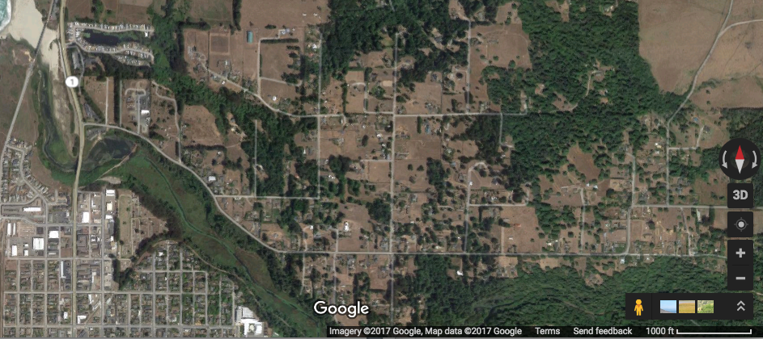
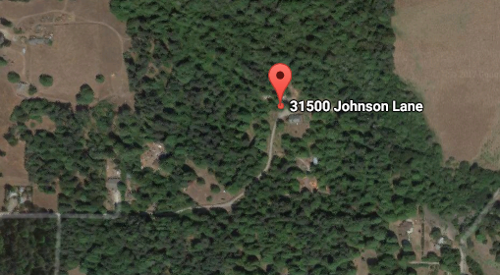

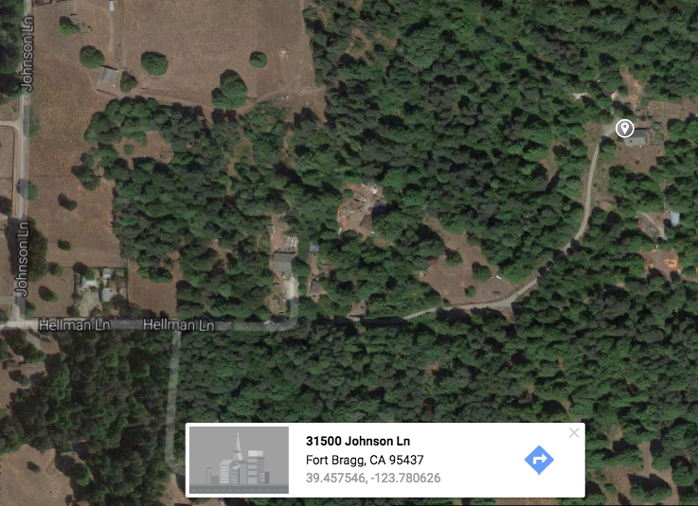
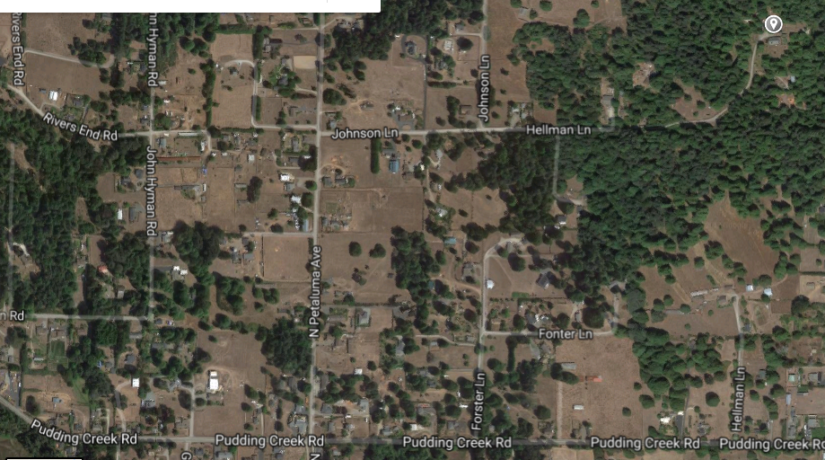
Dear Scholarship Committee, We are meeting Monday May 1 at 5:00pm at my house.
Our address is 31500 Johnson Lane, Fort Bragg. We are 2 miles from Jenny's Giant Burger, FYI.
Directions: From highway 1 northbound: Take a right turn onto Pudding Creek Road. Continue on Pudding Creek Road approximately 1 mile until you see Petaluma Ave, turn left onto Petaluma Ave. Continue about .5 mile until you see Johnson Lane, turn right onto Johnson Lane. Continue on Johnson Lane making no turns- road turns from pavement to gravel, (please slow down to 10 mph at this point), then to a potholed dirt road. Continue on this road, it becomes our driveway, you will pass a sign on the right that says Thomas (family name), you are on our land now. Road/driveway curves to left passing a fenced horse corral and leads to large redwood bungalow. Plenty of parking around the circular drive. I'll have something to snack on and a few beverages like coffee, tea and wine.
I'll see those of you who can make it Monday. Thanks, Donna

Donna Schuler Strategic Management Consulting President Elect, Mendocino Rotary

