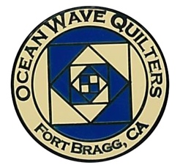
OCEAN WAVE QUILTERS
Fort Bragg, California – www.oceanwavequilters.com
JUNE 2026 NEWSLETTER
JUNE 2026    MEMBERSHIP DUES  ARE DUE!  $25  FBQS Reminders  * Sign up to volunteer for the show at the June 14th general meeting  *Register quilts for show by JUNE 6TH  *Turn in quilts for show at Sew n Sew on June 16th  COUNTRY STORE  *Turn in items at Sew n Sew on June 9th  ALL FORMS FOR FBQS CAN BE FOUND ON OUR WEBSITE | It’s Finally Here!  Yes, the month of the “Gardens by the Sea” Fort Bragg Quilt Show. Did you realize that this is our 30th Show? 30th! That’s pretty good. I want to thank all the quilters who have been involved in these 30 Quilt Shows. That’s a ton of quilts, a lot of volunteer hours, and hundreds of people who have been blessed and inspired by the art of quilting.  I have only been involved in setting up the FB Quilt Show for the last few years. It has been a great opportunity to get to know other members better, feel like I was part of the team, and get a pre-view of the awesome quilts to be seen.  I have been privileged to learn about some quilts by hanging out at the quilt retreats, accepting quilts for the show, and in quilting for many of you. Quilting has so many aspects to it and many of us have challenges with one or more parts. One quilter I know has great skill in applique and picking out colors but is challenged when it comes to laying out the blocks in the correct order. She picked fabric to make a beautiful quilt, but the blocks and seams didn’t seem to turn out like the pattern indicated they should. She, nevertheless, entered her quilt in the show. I was so excited to see it there because it was a triumph of persistence and a great accomplishment to finish what she started despite the great challenges she had in trying something new. If one looked at the quilt from a “Perfect Quilt” for a show perspective, they would miss the great story of struggle and persistence in the making of that quilt.  Other quilts I know were entered by quilters who were losing their sight, and their finger agility but nevertheless, entered their finished quilts, some with hand quilting. What a story of perseverance through pain and failing sight. I heard someone making negative comments about such a quilt, but they had no idea of the energy and love which went into the quilt.  Don’t get me wrong, I love to see well balanced, perfectly sewn, colorful, artistic quilts, but there is so much more room than that. We have had some very beautiful and perfect quilts for people to see. But we also have the growing quilts, the exploratory quilts, the quilts just for the love of it. They are beautiful too. There are no set rules which make up a “Perfect Quilt.” One comment I found on Facebook about the rules of quilting were “buy, cut, sew.”  I’m so glad that our “Gardens by the Sea” Quilt Show has enough room for quilts and quilters in all stages of growth.  Nadine Schultz, OWQ President

COMMUNICATIONS

- Check out the FBQS calendar under the show section and remember all the important dates!
- Ammended bylaws can be found at the end of the newsletter and will be voted on at the June general meeting.
- Don’t forget to mail in your checks or pay cash to Sharon L. at the next general meeting to continue your OWQ MEMBERSHIP - $25 by July 1st, Dues increase to $35 on August 1st!

Shari Lyons, Communications Chair

***We now have a Facebook Group page for the OWQ – Check it out! Kate added some wonderful photos of the past Quilt Shows! Go to Facebook and search for Ocean Wave Quilters – in the coming year we will be redoing the older Facebook account, but for now get current information and photos on the group page!

Proposed Amendments to the OWQ Bylaws – Sharon Lau

At the April Board meeting, we discussed some amendments that are needed to our bylaws to bring them into alignment with activities we are already doing. Please see the proposed amended bylaws, with the changes noted in red, at the end of the newsletter.
These changes note that we can use email and Zoom for discussions, meetings, and approval of things like expense invoices – given that some of our members live so remotely, this only makes sense.
The other change relates to wording about when the new board members come on board. We had already approved an amendment (last year) that extends chair terms to 2 years, but we hadn’t changed the wording of when the new and old board meeting. It’s a technicality, but we should try to be accurate.
We will be asking you to vote on these amendments – that were approved by the Board as of April 18, 2026 – at our June General Meeting. Please come prepared to vote.
If you have questions, let me know. – Sharon Lau
TREASURER’S REPORT

MEMBERSHIP DUES ARE DUE!!

Your 2026-2027 Ocean Wave Quilters dues are due now! The deadline is July 1st.
Dues increase to $35 if you don’t pay by August 1st! So, beat the crowd – get your dues in early! They are a bargain at just $25 for the year!
Send a check payable to Ocean Wave Quilters (PO Box 2687, Fort Bragg CA 95437) OR bring a check or cash (exact change really appreciated!) to the June 14th General Meeting to give to Sharon L., Treasurer. When you pay, you will get a membership card that some quilt shops will honor for a discount (Sew n Sew has their own discount program).

Thank you!

TREASURER’S REPORT

Ocean Wave Quilters |  |  | Fort Bragg Quilt Show
2026 May Treasurer’s Report |  |  | 2026 May Treasurer’s Report
Starting balance 4/1/2026 | $3,142.89 |  | Starting balance 4/1/2026 | $14,271.12
Batting for community quilts | $323.61 |  | Ticket stock for printing | $29.07
Albion Field Station for Retreat | $400.00 |  | Insurance for show | $25.00
Department of Justice for RR-1 filing | $25.00
OWQ Appreciation Luncheon Food | $756.35
Phenicie class/lecture fee/expenses | $1,115.85
Postage – Hospitality/Administration | $62.40
Sew n Sew for QGNQ gift supplies | $34.84
TOTAL EXPENSE | $2,718.05 |  | TOTAL EXPENSE | $54.07
Dues | $50.00 |  | Sponsorships | $530.00
Class fee - Phenicie | $35.00 |  | Quilt Show entries | $140.00
Class fee - Belden | $35.00 |  | Vendor fees | $200.00
Brown bag sales | $5.00
TOTAL INCOME | $125.00 |  | TOTAL INCOME | $870.00
Ending balance 5/20/2026 | $549.84 |  | Ending balance 5/20/2026 | $15,141.12
Submitted by Sharon Lau, Treasurer |  |  | Submitted by Sharon Lau, Treasurer
Approved at the 5-20-2026 Board Meeting |  |  | Approved at the 6-3-2026 FBQS Meeting

SERVICE COMMITTEE

Hello Quilters,
The donations given out for last month are as follows:

14 Pet Beds
6 Warm Welcome baby quilts
3 Community Quilts
6 Pillowcases

I am putting out the call that we are in need of Infusion (throw-sized) quilts (for adults or children/teens), baby quilts, and twin-sized quilts (55" or wider by 70" or longer) The donation cupboard is bare!! Twin quilts can be hand tied or quilted. There is a limited amount of backing material located in the back storage area of Sew n Sew, for a limited time for these donation quilts. Please ask for assistance. Also, once again Nadine and I are each offering to quilt one twin-sized quilt per month (at no charge) so we can meet our goal of getting the Hospitality House's (237 N. McPherson St. Ft. Bragg) 24 beds covered. A special "shout-out" goes to those of you who showed up at the May 24th Sew Sunday and generously donated your time to make Touch Quilts. A special "shout- out" to the kind souls who put the Touch Quilt kits together for the rest of us! These will be donated to the Sherwood Oaks Health Center. Cindi Jo sets out donated fabric kits for all donation projects at each monthly guild meeting. Please take a look to see if you find something you'd like to turn into a donation item. Thank you kindly for all you do! For questions, please call 707-937-3667

Kathy Demetri, Service Committee Chair

EDUCATION & SPECIAL EVENTS

BLOCK OF THE MONTH
JUNE INSTRUCTOR: Paula Perelstein
Instructions for blocks from July 2025 until June 2026 BLOCK OF THE MONTH can be found on the OWQ website or get a copy at Sew n Sew in the BOM binder on the OWQ shelf. June’s BOM pattern will be available after the June 14th general meeting. This completes our BOM for this fiscal year!!!
We will have a BOM reveal at the SEPTEMBER general meeting.

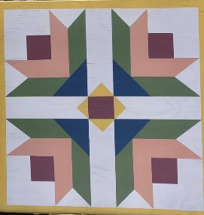
UPCOMING CLASSES
QUILT BARN ART– Instructor: Anelie Belden – Monday, July 13, 2026 – Join us in painting a 24”x24” wooded barn quilt to take home. We will have the option of 4 different patterns to choose from. Sign-up for this fun-painted creation will be available at the June & July general meetings. $35 for OWQ members plus $38 fee for kit that includes all supplies. If the class is not full by June 13th, we will open it up to non-OWQ members for a fee of $75. 10 students max.

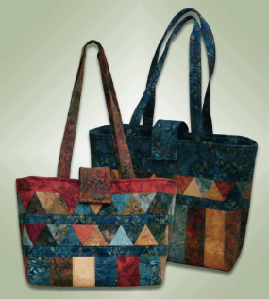
“THE CAROLINA BAG” Tote Bag Class - Instructor: Paula Perelstein – Sunday, August 23, 2026 – Sign-up now to create this fun and functional tote bag!
Paula Perelstein will be teaching this class at Sew n Sew. $ 25 for OWQ members. The class will open up to non-OWQ members for a fee of $75 starting June 1st.


PLEASE REMEMBER THAT CLASS REGISTRATION IS NOT COMPLETE UNTIL YOU HAVE PAID. Also, you can now find an updated class policy on our website.

FALL QUILT RETREAT

The Fall Quilt Retreat will take place from WEDNESDAY, OCTOBER 8TH to SATURDAY, OCTOBER 11TH It will again be located at the wonderful Albion Field Station location.

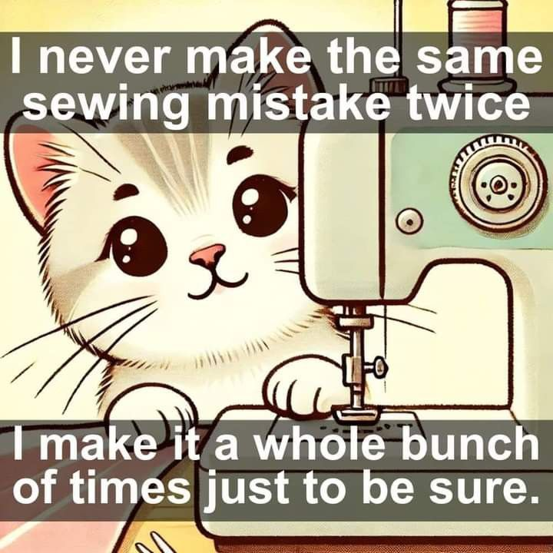
UPCOMING EVENTS
OWQ ANNUAL BBQ (Date TBD)
SPECIAL PROJECT FOR 2026-2027

Elizabeth Foster, Education & Special Events Committee Chair
Committee members: Steffany Baroni, Kathy Demetri and Lisa Carter

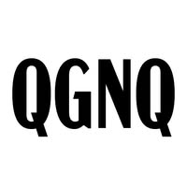
QUILT GUILDS of the NORTH QUARTER
Quilt Guilds of the North Quarter - QGNQ - is an organization that is made up of the smaller, more rural quilt guild in Northern California and gives us an opportunity to network, share ideas and classes, etc.
OWQ will be hosting the QGNQ meeting on Saturday, July 25th – Please let us know if you would be willing to volunteer for organizing, set-up, and take-down of this meeting! WE NEED HELPERS!

PLEASE DROP OFF YOUR COMPLETED KEYCHAIN WRISTLETS AT SEW N SEW. Remember that we have requested that you use sea-themed fabric. Thank you for your time and effort!

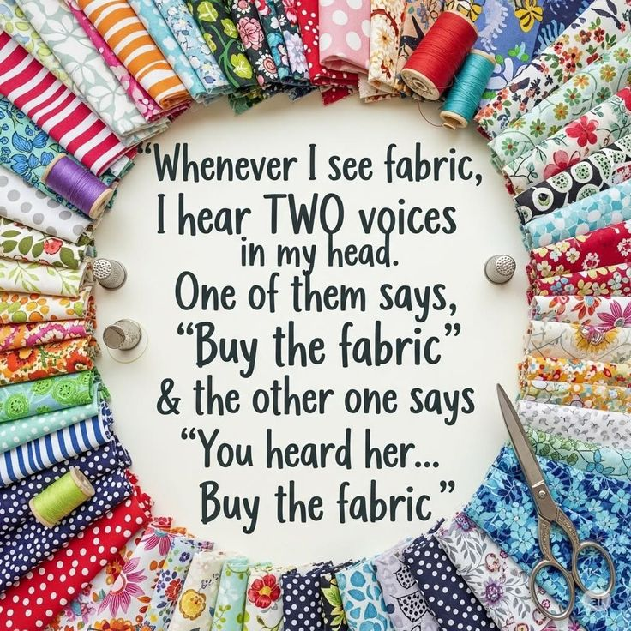

HOSPITALITY

Hospitality:
Connie, Dee, and Linda W. will be taking over for the general meeting
for June and they get to sell quarterly raffle bag tickets and give away
the goodies. (Picture attached) Instead of choosing a name raffle prize,
there is a smaller bag with quilty goodness in it as well (winner gets
the whole bag).
Sew Sunday was fun making the touch quilts, hopefully we'll set another
day to work on other charity quilts for our guild.

Cindi Jo Willey, Hospitality Committee Chair

JUNE BIRTHDAYS

June 6 Gretchen Moore

June 19 Kathy McCormick

June 24 Sharon Gieras

June 24 Linda Walzer

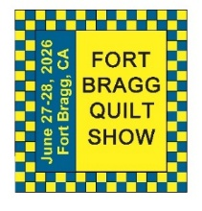
FORT BRAGG QUILT SHOW
Next Quilt Show Meeting
Wednesday – JUNE 3, 2026 - 10:30 am at SEW N SEW – final meeting before the show!

Well, it is almost here, the Ocean Wave Quilt Show!!!!! Have you entered your quilts? Have you gotten your things together for the Country Store? Have you signed up to help at the show? Remember this is our show and we need everyone to help.

We did not have anyone volunteer to advertise the show this year. So, when Elizabeth was able to get our show advertised in the local newspaper, it was great.
Check it out when it comes out in the local paper (June 18th & 25th) and online. Thank you Elizabeth!

I would like to remind everyone that the items for the Country store must be new, they must be something you made, and they need to be labeled with the cost of each item attached (if they are items you are selling). If they are donations, you must tell us that at drop off. You are responsible for picking up your unsold items at the designated time unless they are donations.

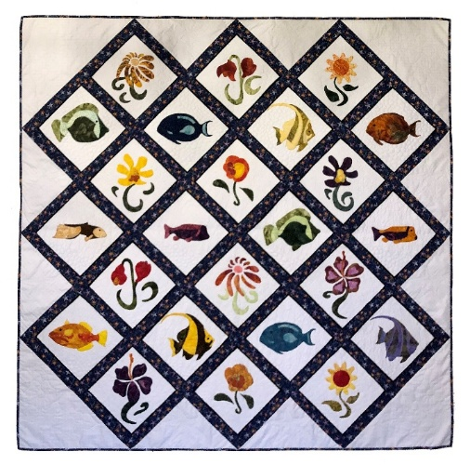
I would also like to thank everyone who sent quilts in for the Quilt Walk and who helped with getting all these quilts out to our local merchants. There are a lot of merchants who look forward to hanging your quilts in their store each year.

I'll see you at the show!!!
Carole Poma
2026 Quilt Show Chair
707-813-3001

Carole Poma, 2026 Fort Bragg Quilt Show Committee Chair

Don’t forget to get your Raffle Quilt tickets $5 for 1 ticket or $10 for 3!

Important Reminders!

- Final dates regarding the upcoming show:
- The last day to register your quilts for the Quilt Show is SATURDAY, June 6, 2026; forms are available online at our website.
- Items for the Country Store must be turned in at Sew n Sew on Tuesday, June 9, 2026, before 4:00pm.
- Quilts for the Quilt show must be turned in at Sew n Sew on Tuesday June 16, before 4:00pm.
- Set up for the Quilt Show to begin Thursday June 25, 2026 - more information to follow.
- Quilt Show opens Saturday June 27, 2026, and runs through Sunday June 28, 2026.
- Please sign up to volunteer to work at the show at one of our Sunday Monthly meetings.
- Pickup of all quilts and unsold Country Store items will begin at 5:00 pm on Sunday June 28, 2026.

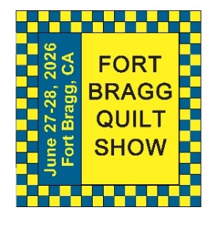 | June 2026  FBQS PLANNING
Sun. | Mon. | Tue. | Wed. | Thu. | Fri. | Sat.
 | 1 | 2 | 3 | 4 | 5 | 6
 |  |  |  |  |  | FINAL DAY TO REGISTER SHOW QUILTS ON WEBSITE
7 | 8 | 9 | 10 | 11 | 12 | 13
 |  | DROP OFF COUNTRY STORE ITEMS AT SEW N SEW
14 | 15 | 16 | 17 | 18 | 19 | 20
 |  | DROP OFF QUILT SHOW QUILTS AT SEW N SEW
21 | 22 | 23 | 24 | 25 | 26 | 27
 |  |  |  | BEGIN QUILT SHOW SET-UP |  | FORT BRAGG QUILT SHOW  10 – 5 PM
28 | 29 | 30
FORT BRAGG QUILT SHOW
10 – 4 PM
5 PM PU QUILTS

Notes | THE QUILT WALK WILL TAKE PLACE FROM MAY 23RD UNTIL JULY 6TH. PICK UP QUILT WALK QUILTS AT SEW N SEW ON JULY 7TH. PICK UP SHOW QUILTS AND UNSOLD COUNTRY STORE ITEMS 5PM ON JUNE 28^{TH.} IF YOU CAN NOT DROP OFF OR PU ANY OF YOUR ITEMS ON THE ASSIGNED DATES, PLEASE ARRANGE WITH ANOTHER TO DROP OFF OR PICK UP FOR YOU.

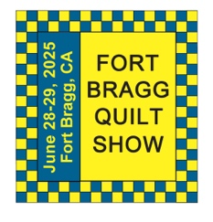
The 29th Annual
Fort Bragg Quilt Show
“Quilts for All Seasons”

A HUGE “Thank You”
to this year’s sponsors:

Diamond
Rossi Building Materials
Mendocino Railway

Platinum
Community First Credit Union

Gold
Sew-n-Sew Laurel Deli and Desserts
Mendo Litho REMax/First Equity Realty
D’Aurelio’s Noyo Fish Company
Norvell’s Noyo Pacific, Inc.

Silver
Pacific Pearl Upcycle Mercantile Mendocino Cookie Co.
Windsong Used Books & Records Chernoff’s Jewelers
Frankie’s Pizza & Ice Cream Noyo Fishing Center

Bronze
Beautiful Earth Splendiferous
Big Foot Ice Cream Essentially Hair
Tsunami’s Glass Shop Zapateria La Mexicana
Shirts and More Oh, Baby!
Egghead’s, Inc.

And THANKS to our Raffle contributors:
Purity, Imaginations, Reynolds, Cucina Verona Mercato, Sew-n-Sew, Fabled (Frame Mill), Pippi’s Socks, The Bookstore & Vinyl Cafe, Hot Pepper Jelly, Roundman’s Smoke House, Lunar Tide, Safeway, Harvest Market, Hare Creek Nursery, Highway 20 Feed, Simply Succulents, Zho Cellars, Larkin Cottage, Harbor Lite Lodge, FBQS Vendors, and OWQ members

MEMBER BIO – EVELYN HARRIS
FBQS 2026 FEATURED ARTIST

My mother taught me to sew when I was about 12 years old and I sewed most of my clothes through high school. After my mother-in-law retired from sewing, she gave me her Singer machine, a workhorse she bought in the early 1940s. It was and remains a beautifully built machine and I used it for years. It only sewed straight stitches, but it did that really well! I later bought a Janome Magnolia machine that has served me well for many years and many quilts.
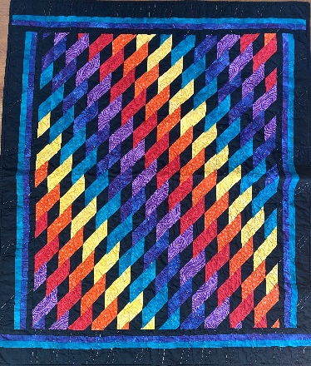
After working for some years at Sonoma State University and UC Davis, I took night classes and earned my K-12 teaching credentials. At around this same time my only child was born. Sewing at that time took a back seat to parenting and my teaching career, which started with teaching high school English. I later developed a reading program for those high school students who were still unable to read and was able to help many at-risk kids learn to read competently. It’s scary to think of the number of people who really cannot read.
My neighbor and friend at the time, Carole Stedronsky, made amazing art quilts and she got me started with
quilting. I quickly discovered that making art quilts was not my style but found myself making quilts using different ways of piecing. Some of my earliest quilts were made using a strip-piecing method developed by Rita Hutchins.

Retirement brought me to Mendocino after spending 40 years coming here every chance I got for vacations. I quickly became involved with the Mendocino Music Festival as well as the Ocean Wave Quilters guild.
Over time, I became very interested in making quilts that had 3-D effects, many of which created wonderful optical illusions. During the Covid lockdown I discovered a book by Ruth Ann Berry that used 60º triangles to create incredible 3-D effects and I was hooked. I cut out 1,080 triangles and sewed them together in long chains to create my Linkages Squared quilt. My whole family thought I had lost my mind, but the result is stunning (and I am still quite sane, more or less!). Berry produced another book on making Bargello quilts with a twisted look and I was hooked again!

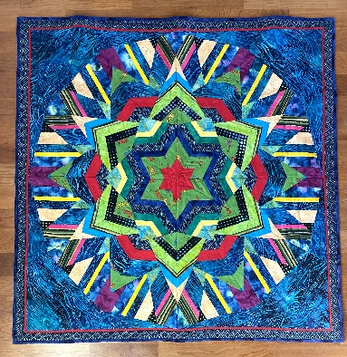
I also found patterns online developed by Karen Combs that I used to make wonderful 3-D quilts. I love the convergence quilts that Ricky Tims developed and was thrilled when I found his Kool Kaleidoscopes book. Kaleidoscope quilts are fun and fairly easy to make, though they look very complicated.
I also recently discovered ice-dyeing, a method of dyeing fabric that produces a beautiful, mottled effect. I made some shirts for myself using fabric I ice-dyed and love wearing them. I haven’t had a chance to incorporate the fabrics into many quilts, but the technique has endless possibilities!
Making quilts has been my passion for many years and I plan to continue finding ideas for making quilts to enjoy, to sell and to give away as gifts.

MARK YOUR CALENDARS FOR UPCOMING IMPORTANT DATES

JUNE 2026 | DAY | TIME | ACTIVITY | LOCATION
June 3rd | Wed | 10:30 am | FBQS Meeting | Sew n Sew
June 14th | Sun | 1:30 – 3:30 pm | General Meeting | Senior Center
June 17th | Wed | 10:30 am | Board Meeting | Sew n Sew
June 27th & 28th | Sat & Sun | 10:00 am – 5:00 pm  10:00 am – 4:00 pm | 30TH ANNUAL  QUILT SHOW | Dana Gray Elementary School
Please see the FBQS section and FBQS calendar for dates
JULY | DAY | TIME | ACTIVITY | LOCATION
July 1st | Wed | Midnight | Newsletter due date | JJefoster@yahoo.com
July 12th | Sun | 1:30 – 3:30 pm | General Meeting | Senior Center
July 13th | Mon | 10:00 – 3:00 pm | Quilt Barn Art Class | Sew n Sew
July 15th | Wed | 10:30 am | Board Meeting | Sew n Sew
July 25th | Sat | 11:00 am - | QGNQ Meeting | Veteran’s Hall
July 26th | Sun | 10:30 – 3:00 pm | Sew Sunday | Senior Center
July 29th | Wed | Midnight | Newsletter due date | JJefoster@yahoo.com
AUGUST | DAY | TIME | ACTIVITY | LOCATION
August 9th | Sun | 1:30 – 3:30 pm | General Meeting | Senior Center
August 19th | Wed | 10:30 am | Board Meeting | Sew n Sew
August 23rd | Sun | 10:30 – 3:00 pm | Sew Sunday | Senior Center
August 23rd | Sun | 10:00 – 3:00 pm | Tote Bag Class | Sew n Sew
August 26th | Wed | Midnight | Newsletter due date | JJefoster@yahoo.com

Hand quilting: Every Tuesday/Senior Center – 1:00-3:00 pm
Sew Sunday: 4th Sunday of the Month – 10:30 am – 3:00 pm
***Hand Sewing: Every Wednesday/ZOOM – 1:00 – 4:00 pm – Join Zoom Meeting
https://us06web.zoom.us/j/81292075496?pwd=bldtVHFrRGhpTTVxUGEraEFFc2hvQT09
Meeting ID: 812 9207 5496 Passcode: HandSew

2025-2026 Board Members and Committee Chairs

President | Nadine Schultz | 707-684-9627 | Quilterqueenbee@yahoo.com
Vice-President | Carole Poma | 707-813-3001 | carolepoma@comcast.net
Secretary | Paula Perelstein | 707-962-9006 | Paula@sew-n-sew.com
Treasurer | Sharon Lau | 707-937-3049H  707-357-7447C | quiltkats@yahoo.com  sharon@oceanwavequilters.com
Communications | Shari Lyons | 707-684-0831 | lybra@mcn.org
Newsletter | Elizabeth Foster | 510-292-7833 | JJefoster@yahoo.com
Service | Kathy Demetri | 707-937-3667 | kathydemetri@gmail.com
Education & Special Events | Elizabeth Foster | 510-292-7833 | JJefoster@yahoo.com
Hospitality | Cindi Jo Wiley | 707-357-4774 | queenbee@mcn.org
FBQS Chair | Carole Poma | 707-813-3001 | carolepoma@comcast.net

NEWSLETTER – Next newsletter articles/items are due July 1, 2026. The Newsletter will be sent out by July 5, 2026. Thank you, Elizabeth Foster, OWQ Newsletter Editor

By-laws of the Ocean Wave Quilters, Inc. – February 2007
Amended September 7, 2010
Amended August 10, 2014
Amended April 10, 2016
Amended June 13, 2016
Amended September 12, 2021
Amended June 8, 2025
Suggested Amendments April 15, 2026

ARTICLE 1: NAME
The name of the organization shall be Ocean Wave Quilters, Inc.

ARTICLE 2: PURPOSE
The purpose of this organization shall be to promote the knowledge of quilting, quilting skills, and techniques; to provide an atmosphere of friendship and growth through quilting; to share our enjoyment of quilting through charitable contributions of quilts and through quilt shows.

ARTICLE 3: MEMBERSHIP
Section 1: Membership is open to all individuals.
Section 2: Each paid-up member is entitled to one vote, encouraged to hold office and participate on committees. Section 3: Ocean Wave Quilters, Inc. welcomes visitors to two meetings after which they are expected to join the club or pay $5 to attend each subsequent meeting.

ARTICLE 4: ANNUAL MEMBERSHIP DUES
Section 1: Dues are to be paid each year on or before the July meeting.
Section 2: Dues received after August 1 shall be assessed a late fee; amount to be determined by the Board. Section 3: First-Time members joining after December 31 will pay ½ of yearly dues for the remainder of that year.

ARTICLE 5: BUSINESS YEAR AND MEETINGS
Section 1: The general meetings shall be held the second Sunday of every month. Section 2: The fiscal year shall run from July 1 to June 30.
Section 3: All meetings shall be run in a constructive and courteous manner. Section 4: A board meeting that is open to all members shall be held monthly.
Section 5: Guild business (such as approval of invoices, etc.) may be transacted via email. Documentation of such business must be provided to the appropriate Board officer for preservation with guild records.
Section 6: Meetings of the board or general membership (either in whole or for some participants) may be conducted through the use of internet meeting services. Accommodation for an internet meeting must be requested of the Communications Chair at least 5 days in advance of the meeting and announced to all affected participants at least 2 days in advance of the meeting date.

ARTICLE 6: VOTING
Section 1: Robert’s Rules of Order will be used as a guide when needed.
Section 2: The quorum for a general meeting shall be a minimum of 15 members. Simple majority of 51% (minimum of 8) required for a vote to pass.
Section 3: Any money decision being made outside of the approved budget that will cost the club more than $50, unless the decision is time sensitive, shall proceed within one month as follows:
- The item will be presented at a general meeting.
- The item will be published in the following newsletter, where members will be notified of an upcoming vote on the item at the following general meeting.
- The item will be voted on at the following general meeting.
- Decisions on time-sensitive expenditures shall be made by the Treasurer and President (or, in the President’s absence, the Vice-President).

ARTICLE 7: BOARD
Section 1: The Board shall consist of a minimum of five members and a maximum of nine.
Section 2: The Board shall include: President, Vice-President, Treasurer, Secretary, and chairs of standing committees. Section 3: Duties to be determined by the Board.
Section 4: Board Members shall serve the term of two years, with each outgoing officer committing to assisting their incoming counterpart with the duties of the role for a period of at least three months.. (Used to be Section 7)
Every two years (at change of term year):

Section 5: Board selection will proceed as follows:
- At the May general meeting, and in the May Newsletter, it shall be announced that all members interested in joining the Board shall attend the June Board meeting, or submit a notice of interest to any existing board member. Members shall also be reminded that voting for any office sought after by more than one member, if necessary, will take place at the June General Meeting.
- Immediately following the regular June Board Meeting Agenda, the new Board will be created by and from those present. Those interested shall be generously willing to take over any needed tasks. If more than one person wants to hold a certain office, a vote for that office will be held at the June general meeting. The Vice-President can assume the Office of President after the V-P year if they want.
- At the June general meeting, the new Board of Officers shall be presented, questions and/or concerns will be discussed, and any voting will take place, if necessary.
Section 6: The Outgoing Board members and Incoming Board members will all attend the July board meeting. There the Outgoing Board and Committee Chairs shall turn over all books, files and data of the Ocean Wave Quilters, Inc. to their successors. The Outgoing Board shall present any Bylaw amendments for discussion, and the Incoming Board shall take them to the July General Meeting for membership approval.
Section 7: The new Board will begin their duties at the July Board meeting and at the July General meeting. At the July Board meeting a Calendar for the new year will be set. In the August Newsletter, the new Calendar and updated Membership Roster will be published.
Section 8: All Board Members shall be active on a club committee.

ARTICLE 8: OFFICERS AND THEIR DUTIES
PRESIDENT: Shall preside at all meetings, lead the appointment of committee chairpersons, and help treasurer plan a proposed budget within first month of office. Provide agenda for every meeting. Set Calendar of Activities at July Board Meeting. Perform all other incidental duties of the office as required.
VICE-PRESIDENT: Shall assist the President and exercise all functions of the President in her absence. Perform all other incidental duties of the office as required.
TREASURER: Shall have charge of all funds, receive dues, and disburse monies upon authorization of the executive committees and report all transactions upon the ledger. Treasurer and one board member signature shall be required on all checks. With help from President and approval by the board, plan a proposed budget which shall be published in the May newsletter and voted on at the May General Meeting. Quarterly Monthly fiscal reports and annual budget shall be published in the newsletter. and posted at general meetings as follows: July-September Report in October, October-December Report in January, January-March Report in April, April-June Report in July.
SECRETARY: Shall keep records of all general and board meetings. Shall keep a file on votes and amendments to the Bylaws. Perform all incidental duties of the office as required.

ARTICLE 9: ONGOING COMMITTEES
Committees will be designated as needed by the sitting Board at the start of each year.

ARTICLE 10: AMENDMENTS TO BYLAWS
Section 1: Outside the yearly review by Outgoing Board, Bylaw Amendments may be proposed by any member. Section 2: Amendments shall be voted on as follows:
- The item will be presented at a general meeting.
- The item will be published in the following newsletter, where members will be notified of an upcoming vote on the item at the following general meeting.
- The item will be voted on at the following meeting.

ARTICLE 11: DISSOLUTION
Section 1: In the event of the dissolution of the organization known as the Ocean Wave Quilters, Inc., all assets will be turned over to a non-profit, charitable or educational organization to be selected by a majority of the Club Members at the time of such dissolution.

