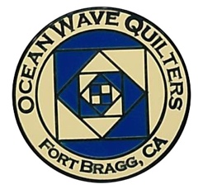
OCEAN WAVE QUILTERS
Fort Bragg, California – www.oceanwavequilters.com
MAY 2026 NEWSLETTER
Welcome May!    FBQS Reminders  * Quilt Walk quilts due at Sew n Sew by May 11th  * Sign up to volunteer at the show at May general meeting  *Register quilts for show by May 26th  *Turn in quilts for show at Sew n Sew on June 16th  COUNTRY STORE  *Turn in items at Sew n Sew on June 9th  SILENT AUCTION Brand new Kangaroo sewing cabinet and Antique White sewing machine and oak cabinet – put in your bid at the show! | Happy Spring, Quilters!  May is a wonderful time of year! On the Northern California Coast, it’s a perfect time with the sunshine, flowers, whales, baby animals, and quilting. I have been thinking of the beauty of nature and how it relates to quilting. I thought about summarizing the history of nature designs in quilting, but that just seemed a bit overwhelming and maybe a bit too much research for now.  My next thoughts are about the Ombre Bargello Class that was offered April 27th. The class was something that caught my attention when it was first introduced. Bargello quilts have such a cool look to them, and there are so many variations. The Ombre Bargello looked like an easy way to avoid rows and rows of sewing. I couldn’t sign up because of work conflicts, but before long that conflict was resolved and I was able to attend, and I’m so glad I did. I was educated in a two-room elementary school where part of learning survival was to be good at reading and following instructions on your own. So, for me a class has less to do with learning how to make something and more about the social aspects and picking up tips that are not actually written down anywhere from the teacher and others. I really enjoyed seeing the fabric combinations which were chosen for the class. Focus fabrics of flowers, leaves, swirls and dragons were some of those picked. It’s fascinating how many different styles of Ombre fabric there are and the different effects they can have. The teacher simplified the written instructions and added several helpful tips. Now a whole new world of options and possibilities has opened up for me because I chose to take a class.  I know there are some of you who are adventurous and take classes for the joy or challenge of learning something new. OWQ offers classes at such a good rate to the members that I want to encourage you to take advantage of these opportunities, if you can. For some of you, the task of loading all your quilting supplies and bringing them to a class is more than you want to take on, but maybe you can stop by and say Hello to everyone. This summer, we’re going to have a class on Barn Quilts. You won’t need a sewing machine for this one. But whether it’s in a class or at home, I want to challenge you to try something new.  While spring is still new and the fog is still out, take time to try a new quilting pattern.  ‘Till next month,  Nadine Schultz, OWQ President
TREASURER’S REPORT

Ocean Wave Quilters |  |  | Fort Bragg Quilt Show
2026 April Treasurer’s Report |  |  | 2026 April Treasurer’s Report
Starting balance 3/17/2026 | $4,238.89 |  | Starting balance 3/17/2026 | $14,047.94
WordPress annual fee | $96.00 |  | Dept of Justice (2026 raffle permit} | $30.00
Annual rental fee - storage-Sew n Sew | $1,000.00 |  | VIP ribbons | $71.06
TOTAL EXPENSE | $1,096.00 |  | Featured Artist plaque | $50.76
 |  |  | TOTAL EXPENSE | $151.82
 |  |  | Raffle Quilt | $375.00
TOTAL INCOME | $0.00 |  | TOTAL INCOME | $375.00
Ending balance 4/1/2026 | $3,142.89 |  | Ending balance 4/1/2026 | $14,271.12
Submitted by Sharon Lau, Treasurer |  |  | Submitted by Sharon Lau, Treasurer
Approved at the 4-15-2026 Board Meeting |  |  | Approved at the 4-8-2026 FBQS Committee Meeting
Sharon Lau, OWQ Treasurer
Proposed 2026-2027 Budget - Sharon Lau

According to our bylaws, each year the proposed budget is printed in the May newsletter and voted on at the May General Meeting. Please take the time to review the budget that is attached. (Please see budget at the end of the newsletter.)

A couple of comments:

Yes, we show that we will have greater expenses than income.

- One of the reasons for that is that we did not budget donations (because cash donations are not a sure thing!) However, past experience tells us that we can expect to receive donations in the coming year; last year we received more than $1100 and in prior years, we have received as much as $5000.
- Another reason we are not concerned about this discrepancy is that we are actively seeking grant support for some of our charitable activities. We have received a grant in the past from the Community Foundation, and we continue to look for other opportunities.
- Finally, we do have a significant balance in the FBQS account that we can draw from; hopefully we'll be adding a good amount to that balance after this year's show. (You can help by volunteering to sell raffle tickets for this year’s quilt and by spreading postcards advertising the show everywhere you go!)

In conclusion, our Committee Chairs, each of whom now has a year of experience in their role, continue to be acutely aware that they need to be judicious in their spending.

COMMUNICATIONS

Check out the FBQS calendar under the show section and remember all the important dates!
Also, don’t forget to be prepared to vote on next fiscal year’s budget at the May meeting. Amended bylaws will be available in the June newsletter and will be voted on at the June general meeting.

Shari Lyons, Communications Chair
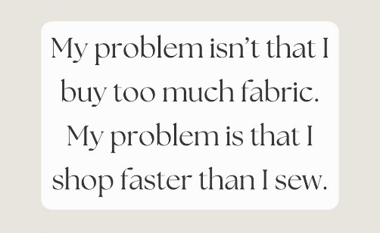
Contributed by Nadine Schultz

SERVICE COMMITTEE

Hi Quilters,

The donation numbers for April are as follows:

4 Community Quilts
6 Warm Welcome Quilts
0 Pet Beds
0 Dress A Girl dresses
22 Port Pillows
0 Pillowcases

Don't forget to join us at May 24th Sew Sunday for a group effort to get some touch quilts made! These are small 12" x 24" lap sized and fun to put together. Material will be provided. Please bring your sewing machine. Look forward to seeing you there!

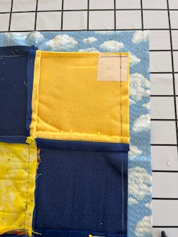
Kathy Demetri, Service Committee Chair

When finishing texture quilts, we put the back fabric and the top right sides together, then stitch all around the edge leaving an opening to turn them right side out. TIP: Reinforce the corners with a small piece of light interfacing (see photo) This prevents distortion in the corners.
(Contributed by Dee Goodrich)

EDUCATION & SPECIAL EVENTS

BLOCK OF THE MONTH
MAY INSTRUCTOR: Evelyn Harris
Instructions for blocks from July 2025 until April 2026 BLOCK OF THE MONTH can be found on the OWQ website or get a copy at Sew n Sew in the BOM binder on the OWQ shelf. May’s BOM pattern will be available after the May 10th general meeting.

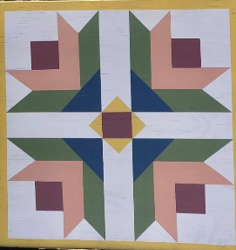
UPCOMING CLASSES
QUILT BARN ART– Instructor: Anelie Belden – Monday, July 13, 2026 – Join us in painting a 24”x24” wooded barn quilt to take home. We will have the option of 4 different patterns to choose from. Sign-ups for this fun painted creation will be available at the May & June General meeting: $35 for OWQ members plus $38 fee for kit that includes all supplies. If the class is not full by June 13th, we will open it up to non-OWQ members. 10 students max.

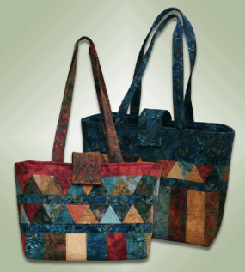
“The Carolina Bag” Tote Bag Class - Instructor: Paula Perelstein – Sunday, August 23, 2026 – Sign-ups and more information coming in May. Paula will be teaching us how to make this lovely and very useful bag.

ROUND ROBIN Round Robin Quilts will be displayed at the 2026 FBQS!

The Round Robin(RR) is now complete. If you plan to have your RR quilt displayed at the quilt show, you will need to register it (no fee) by May 26th and have it completed by the quilt show quilts due date of June 16th.

UPCOMING EVENTS
The committee will be working on dates for upcoming events like the Annual BBQ, next year’s BOM, Fall Quilt Retreat (we have dates for that: OCTOBER 7-11, 2026, at the Albion Field Station) and fun ideas like School House, etc. for our general meetings.

Elizabeth Foster, Education & Special Events Committee Chair
Committee members: Steffany Baroni, Kathy Demetri, and Lisa Carter
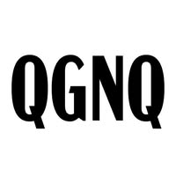
QUILT GUILDS of the NORTH QUARTER
Quilt Guilds of the North Quarter - QGNQ - is an organization that is made up of the smaller, more rural quilt guilds in Northern California and gives us an opportunity to network, share ideas, and classes, etc.
OWQ will be hosting the QGNQ meeting on Saturday, July 25th – Please let us know if you would be willing to volunteer for organizing, set-up, and take-down of this meeting! WE NEED HELPERS, please! E-mail Elizabeth Foster – JJefoster@yahoo.com or call/text 510-292-7833.

The Appreciation Luncheon and Ombre Bargello class taught by Yvonne Phenicie were both great fun! Please enjoy the photos
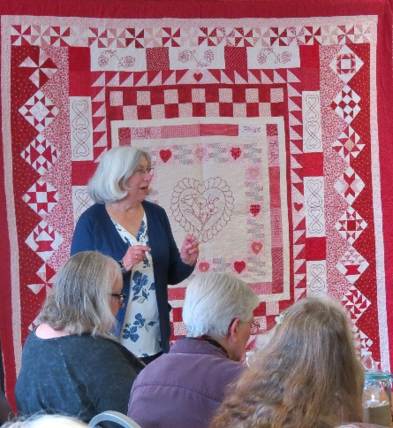
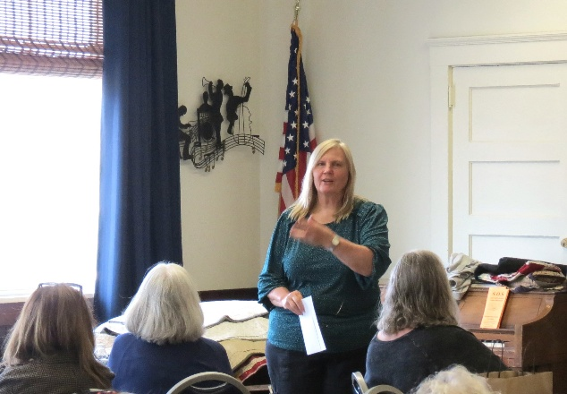
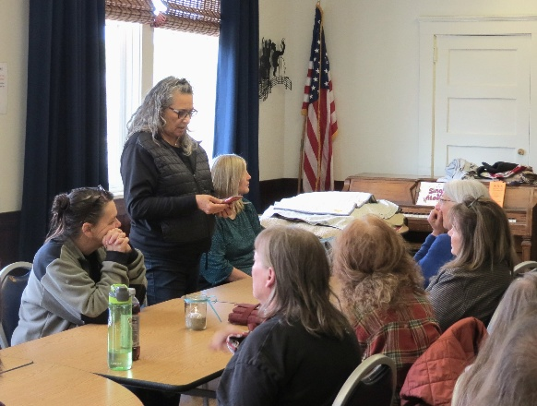
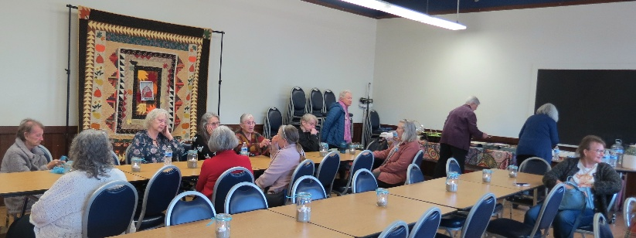
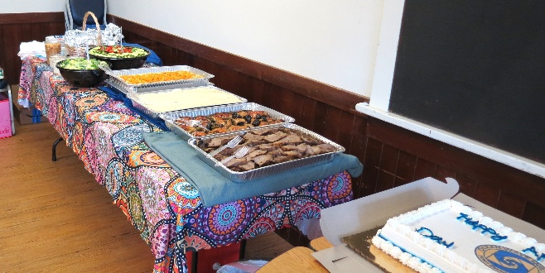
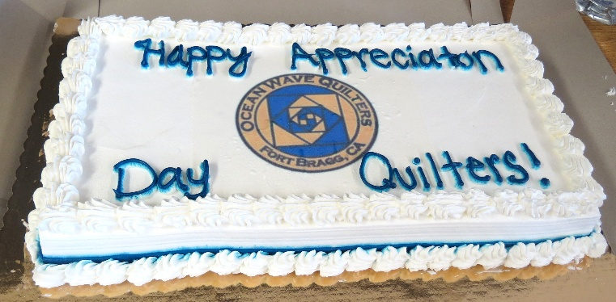
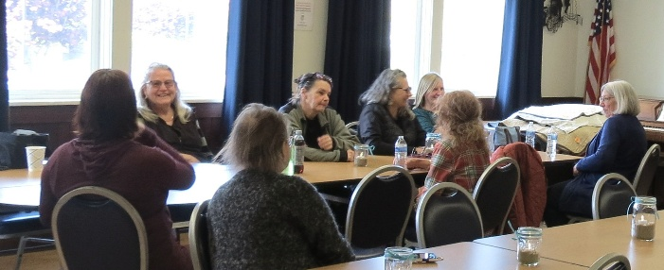
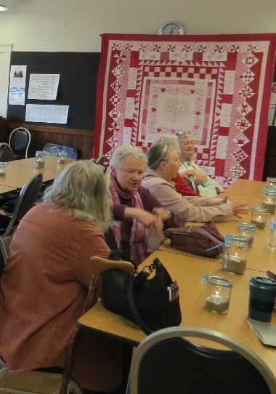
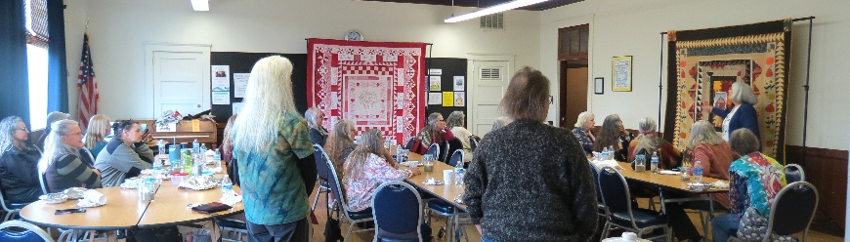

Thank you, for
all you
do!

OMBRE BARGELLO!

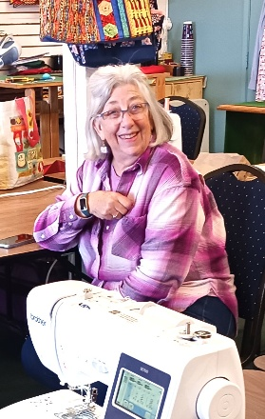
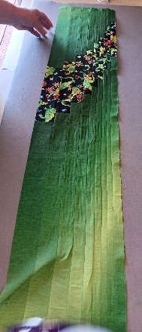
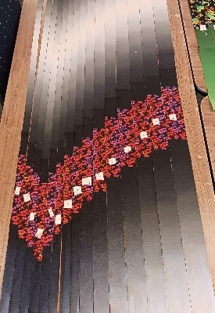
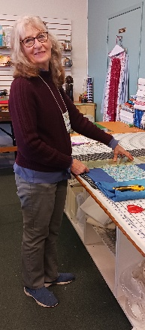
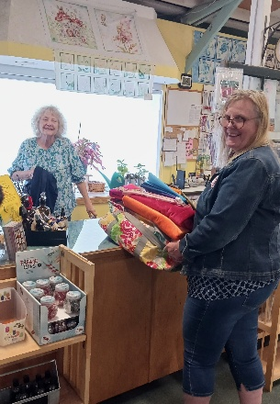
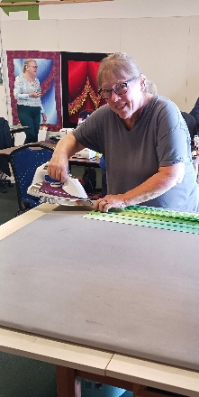
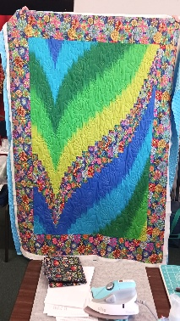

HOSPITALITY

Some new ideas will be tried this year for the monthly name tag drawing and the quarterly raffle prizes. Some of the "nicer" (worth more $) donated items will be included for the name tag drawing prizes, and one
or two larger items will be up for the quarterly raffle prizes. The next quarterly raffle is in June when the last bag full of goodies will be up for the prize. September will begin with fewer but more desirable items
to win. I hope that makes sense. The boxes of kits available for service projects are moving to the back
of the room on a round table next to the closet door, so don't forget to look there for those items to take home and make. On Sunday, May 24th, our regular Sew Sunday will be open from 10:30 until approximately 3:00. On that day, members will be there making texture quilts. If you would like to help with that, please bring your sewing machine. Otherwise, bring whatever you need for your own personal project. We hope to see you there! - Cindi Jo

Cindi Jo Willey, Hospitality Committee Chair

MAY BIRTHDAYS

Shirlee Paoli May 1


Paula Perelstein May 2

Charlene Younker May 4

Priscilla Adams May 6

Suzanne Salter May 9

Sharon Lau May 17

Steffany Baroni May 21

Becky Bright May 21

Ginny Cooper May 23

Christine Hartesveldt May 25

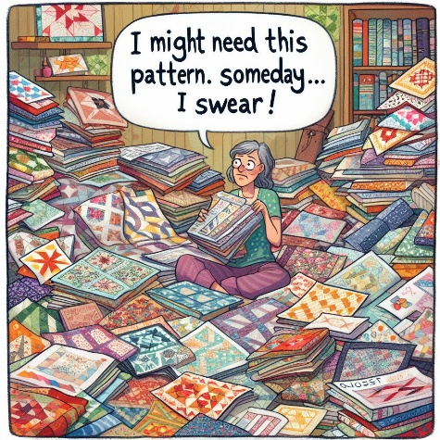

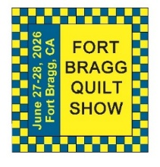
FORT BRAGG QUILT SHOW
Next Quilt Show meeting will be
Wednesday – May 6, 2026 - 10:30 am at SEW N SEW

Our Quilt Show is coming up fast. Your committee members are working hard to make this a wonderful show.
Be sure to enter your quilts for the Quilt Walk, the Country Store and the Quilt Show by the required dates. May 26, 2026 is the last day to register your quilts for the Quilt show. May 11, 2026 is the last day to drop off your quilts for the Quilt Walk at Sew & Sew.
Susan C. is still in need of a few individuals to help deliver the quilts to the merchants downtown (delivery date is May 19th), please consider helping.

Please remember we still need volunteers to help: intake quilts, deliver racks and quilts, set up the show, work at the show, return quilts, take down, and clean up. The sign-up sheet will be at the May meeting.
We hope all of you are as excited about this year’s show as we are.
If you have any questions, please feel free to give me a call.

Carole
Carole Poma, 2026 Fort Bragg Quilt Show Committee Chair

Important Reminders

- Here are some important informational highlights and dates regarding the upcoming show:
- We will have 10 to 15 VIP judges this year.
- We will not have a paid judge.
- There will be no Challenge quilts sponsored by Sew n Sew.
- New this year will be the Country Store. Items for sale will be made by our members.
- Silent auction of Kangaroo sewing cabinet and White Family Rotary antique sewing machine with solid oak sewing cabinet.
- Susan Collins is our Quilt Walk Chairman for 2026, so please contact her if you have any questions regarding the quilt walk.
- All quilts for the Quilt Walk are due by Monday, May 11, 2026 (at Sew n Sew).
- Quilts will go out to Merchants starting Tuesday, May 19, 2026.
- Merchants are to have all quilts hung by Saturday, May 23, 2026.
- Last day to register your quilts for the Quilt Show is Tuesday, May 26, 2026; forms are available online at our website.
- Items for the Country Store must be turned in at Sew n Sew on Tuesday, June 9, 2026, before 4:00pm.
- Quilts for the Quilt show need to be turned in at Sew n Sew on Tuesday June 16, before 4:00pm.
- Set up for the Quilt Show to begin Thursday June 25, 2026 - more information to follow.
- Quilt Show opens Saturday June 27, 2026 and runs through Sunday June 28, 2026.
- Please sign up to volunteer to work at the show at one of our Sunday Monthly meetings.
- Pickup of all quilts will begin at 5:00pm on Sunday June 28, 2026.

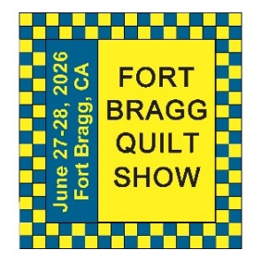 | May 2026  FBQS PLANNING
Sun. | Mon. | Tue. | Wed. | Thu. | Fri. | Sat.
 |  |  |  |  | 1 | 2
3 | 4 | 5 | 6 | 7 | 8 | 9
10 | 11 | 12 | 13 | 14 | 15 | 16
 | QUILT WALK QUILTS DUE AT SEW N SEW
17 | 18 | 19 | 20 | 21 | 22 | 23
 |  | QUILT WALK QUILTS GO OUT TO MERCHANTS |  |  |  | FINAL DAY FOR MERCHANTS TO HANG QUILT WALK QUILTS
24 | 25 | 26 | 27 | 28 | 29 | 30
 |  | FINAL DAY TO REGISTER QUILT SHOW QUILTS
31
Notes | THE QUILT WALK WILL TAKE PLACE FROM MAY 23RD UNTIL JULY 6TH. PICK UP QUILT WALK QUILTS AT SEW N SEW ON JULY 7TH. PICK UP SHOW QUILTS 5PM ON JUNE 28^{TH.} IF YOU CAN NOT DROP OFF OR PICK UP ANY OF YOUR ITEMS ON THE ASSIGNED DATES, PLEASE ARRANGE WITH ANOTHER TO DROP OFF OR PICK UP FOR YOU.

June 2026
FBQS PLANNING
Sun. | Mon. | Tue. | Wed. | Thu. | Fri. | Sat.
 | 1 | 2 | 3 | 4 | 5 | 6
7 | 8 | 9 | 10 | 11 | 12 | 13
 |  | DROP OFF COUNTRY STORE ITEMS AT SEW N SEW
14 | 15 | 16 | 17 | 18 | 19 | 20
 |  | DROP OFF QUILT SHOW QUILTS AT SEW N SEW
21 | 22 | 23 | 24 | 25 | 26 | 27
 |  |  |  | BEGIN QUILT SHOW SET-UP |  | FORT BRAGG QUILT SHOW  10 – 5 PM
28 | 29 | 30
FORT BRAGG QUILT SHOW
10 – 4 PM
5 PM PU QUILTS

Notes | THE QUILT WALK WILL TAKE PLACE FROM MAY 23RD UNTIL JULY 6TH. PICK UP QUILT WALK QUILTS AT SEW N SEW ON JULY 7TH. PICK UP SHOW QUILTS 5PM ON JUNE 28^{TH.} IF YOU CAN NOT DROP OFF OR PU ANY OF YOUR ITEMS ON THE ASSIGNED DATES, PLEASE ARRANGE WITH ANOTHER TO DROP OFF OR PICK UP FOR YOU.

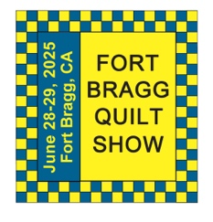
The 29th Annual
Fort Bragg Quilt Show
“Quilts for All Seasons”

A HUGE “Thank You”
to this year’s sponsors:

Diamond
Rossi Building Materials
Mendocino Railway

Platinum
Community First Credit Union

Gold
Sew-n-Sew Laurel Deli and Desserts
Mendo Litho REMax/First Equity Realty
D’Aurelio’s Noyo Fish Company
Norvell’s Noyo Pacific, Inc.

Silver
Pacific Pearl Upcycle Mercantile Mendocino Cookie Co.
Windsong Used Books & Records Chernoff’s Jewelers
Frankie’s Pizza & Ice Cream Noyo Fishing Center

Bronze
Beautiful Earth Splendiferous
Big Foot Ice Cream Essentially Hair
Tsunami’s Glass Shop Zapateria La Mexicana
Shirts and More Oh, Baby!
Egghead’s, Inc.

And THANKS to our Raffle contributors:
Purity, Imaginations, Reynolds, Cucina Verona Mercato, Sew-n-Sew, Fabled (Frame Mill), Pippi’s Socks, The Bookstore & Vinyl Cafe, Hot Pepper Jelly, Roundman’s Smoke House, Lunar Tide, Safeway, Harvest Market, Hare Creek Nursery, Highway 20 Feed, Simply Succulents, Zho Cellars, Larkin Cottage, Harbor Lite Lodge, FBQS Vendors, and OWQ members

Member Bio - Lony Marlene Fiduccia
I grew up in Southern California. My parents bought a house in Anaheim, down the street from Disneyland, in 1957. My mother was from Berlin, Germany, and grew up during WWII. She came to California in 1954 and got a job as an operator for Pacific Bell, where she met my father. My father grew up in Glendale, California, and was raised in a very traditional American family. After my parents married and settled down in Anaheim, most of my mother’s family also migrated from Germany to Southern California. With German war survivors on one side and good old apple pie, football, and hot rod cars on the other, my childhood provided a very diverse view of the world. Coupled with Disneyland as my playground, I was never bored. As a kid, I spent a lot of time with my dad in the garage, helping him work on his cars. I also spent an unusual amount of time at Disneyland, so much so that the rides were no longer interesting to me. What became more interesting was trying to figure out how they worked. I asked lots of questions: Why didn’t people fall out of the Matterhorn ride? How did the teacups spin? The place became a wonder of engineering to me.
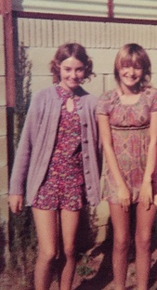
In seventh grade, I met my best friend, Donna. Donna’s mom was a master seamstress. She had a sewing room with three sewing machines set up and ready to use. Most days after school, Donna and I would spend our time with her mom sewing. Donna’s mom, Anne, first taught us to make clothes from a pattern; then she taught us to make alterations to patterns, and from there we began to design and make our own clothes. This after-school sewing with my friend and her mom continued through the end of high school. Learning to sew provided a great outlet for my need to figure out how things worked, to create, do math and measure, and design. This was all just another form of engineering. I loved it. I didn’t know at the time that I was heading for a career in engineering, and I don’t think anyone else would have guessed it either.
After high school, sewing fell to the wayside. At 17, I got a job at an electronics firm in the stockroom. This was my first introduction to engineering. I saw how a factory worked and thought that I could do that; it felt familiar, like hanging out in the garage with my dad working on cars. I enrolled in the local junior college and got an AA degree in electronics technology. I was the only female in all my classes. A representative from McDonnell Douglas was told that a female had just graduated with a degree in Electronics Tech. They interviewed me and offered me a job as a technician at the space division, working in the engineering lab with design engineers. I was 19 years old at the time, and I was the first female technician to ever work in the engineering lab.
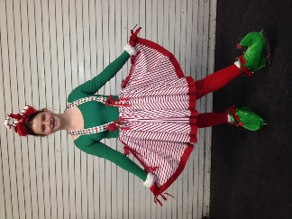
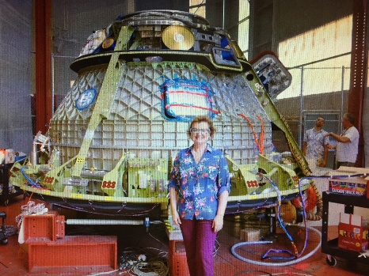
I went on to obtain a bachelor’s degree in Engineering Technologies from Long Beach State University. McDonnell Douglas promoted me into the Quality Engineering department, and from there I went on to have a 40-year career in engineering and program management for space products like satellites, Delta rockets, the Space Station, and space crew vehicles. I also met my husband while working on the Delta IV launch vehicle program. After I got married is when I began sewing again. This time, sewing was for making ice skating costumes for our youngest daughter, and I also found it to be a wonderful escape from the pressures of work schedules, business trips, and endless meetings.
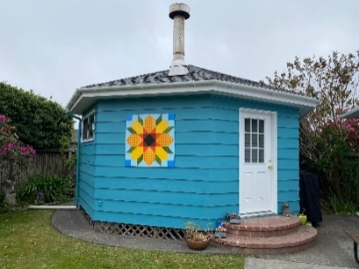
The first time I ever saw a quilt was as a young teenager, when my mom and my Aunt Lony took me on a shopping trip to a small town a few hours away from home. The main street of this town was lined with quilt shops. I was amazed at all the quilts on display. My Aunt Lony bought me one of those quilts, and I still have it with me today. I made a few quilts back when I was still working, but I never really had the time to focus on the craft. When Mark and I retired, we bought a home here in Fort Bragg because we loved it here, and our middle daughter lives here with her family. One of my requirements for my retirement years was to have my own space to sew and create. The home we bought here has a separate studio from the main house. It was a woodworking shop for the original owner of the home. We donated all the woodworking tools and have made this space into my dream sewing space. We call my studio the “Yurt” because of its unique octagon shape.
I feel very grateful for the life experiences, and the people in my life who have helped me be successful on this path to a happy retirement. I plan to spend many years ahead creating and learning more about the craft of quilting.

MARK YOUR CALENDARS FOR UPCOMING IMPORTANT DATES

MAY 2026 | DAY | TIME | ACTIVITY | LOCATION
May 6th | Wed | 10:30 am | FBQS Meeting | Sew n Sew
May 10th | Sun | 1:30 – 3: 30 pm | General Meeting | Senior Center
May 20th | Wed | 10:30 am | Board Meeting | Sew n Sew
May 24th | Sun | 10:30 am – 3:00 pm | Sew Sunday | Senior Center
May 27th | Weds | Midnight | Newsletter due date | JJefoster@yahoo.com
JUNE | DAY | TIME | ACTIVITY | LOCATION
June 3rd | Wed | 10:30 am | FBQS Meeting | Sew n Sew
June 14th | Sun | 1:30 – 3:30 pm | General Meeting | Senior Center
June 17th | Wed | 10:30 am | Board Meeting | Sew n Sew
June 27th & 28th | Sat & Sun | 10:00 am – 5:00 pm  10:00 am – 4:00 pm | 30TH ANNUAL  QUILT SHOW | Dana Gray Elementary School
Please see the FBQS section and FBQS calendar for dates
JULY | DAY | TIME | ACTIVITY | LOCATION
July 1st | Wed | Midnight | Newsletter due date | JJefoster@yahoo.com
July 12th | Sun | 1:30 – 3:30 pm | General Meeting | Senior Center
July 13th | Mon | 10:00 – 3:00 pm | Quilt Barn Art Class | Sew n Sew
July 15th | Wed | 10:30 am | Board Meeting | Sew n Sew
July 25th | Sat | 11:00 am - | QGNQ Meeting | Veteran’s Hall
July 26th | Sun | 10:30 – 3:00 pm | Sew Sunday | Senior Center
July 29th | Wed | Midnight | Newsletter due date | JJefoster@yahoo.com
Monthly Activities:
Hand quilting: Every Tuesday/Senior Center – 1:00-3:00 pm
Sew Sunday: 4th Sunday of the Month – 10:30 am – 3:00 pm
***Hand Sewing: Every Wednesday/ZOOM – 1:00 – 4:00 pm – Join Zoom Meeting
https://us06web.zoom.us/j/81292075496?pwd=bldtVHFrRGhpTTVxUGEraEFFc2hvQT09
Meeting ID: 812 9207 5496 Passcode: HandSew

2025-2026 Board Members and Committee Chairs

President | Nadine Schultz | 707-684-9627 | Quilterqueenbee@yahoo.com
Vice-President | Carole Poma | 707-813-3001 | carolepoma@comcast.net
Secretary | Paula Perelstein | 707-962-9006 | Paula@sew-n-sew.com
Treasurer | Sharon Lau | 707-937-3049H  707-357-7447C | quiltkats@yahoo.com  sharon@oceanwavequilters.com
Communications | Shari Lyons | 707-684-0831 | lybra@mcn.org
Newsletter | Elizabeth Foster | 510-292-7833 | JJefoster@yahoo.com
Service | Kathy Demetri | 707-937-3667 | kathydemetri@gmail.com
Education & Special Events | Elizabeth Foster | 510-292-7833 | JJefoster@yahoo.com
Hospitality | Cindi Jo Willey | 707-357-4774 | queenbee@mcn.org
FBQS Chair | Carole Poma | 707-813-3001 | carolepoma@comcast.net

NEWSLETTER – Next newsletter articles/items are due May 27, 2026. The Newsletter will be sent out by May 31, 2026. Thank you, Elizabeth Foster, OWQ Newsletter Editor

Ocean Wave Quilters
Proposed 2026-2027 Budget - INCOME
INCOME |  | Budgeted 2025-2026 | Proposed 2026-2027 budget
Hospitality | Raffles | 650.00 | 650.00
Education/  Special Events | Classes | 600.00 | 700.00
 | Brown Bag | 200.00 | 80.00
 | Sew n Sew Challenge | 120.00 | 120.00
Administrative | Donations | 500.00 | -
 | Dues | 1,600.00 | 1,600.00
 | Quilt Show | 5,000.00 | 5,000.00
TOTALS |  | 8,670.00 | 8,150.00

Ocean Wave Quilters
Proposed 2026-2027 Budget - EXPENSE
EXPENSE |  | Budgeted 2025-2026 | Proposed 2026-2027 budget
Hospitality | Food Table Supplies | 100.00 | -
 | Name Tag Drawing | 120.00 | -
 | Greeting cards/flowers | 150.00 | 20.00
 | Raffles | 100.00 | 200.00
Education and Special Events | Classes, speakers, BOM | 2,000.00 | 3,000.00
 | Block of the Month | 75.00 | -
 | Retreats | 900.00 | 840.00
 | BBQ/Luncheon | 700.00 | 250.00
 | Appreciation Luncheon | (in above) | 700.00
 | Brown Bag | 200.00 | 80.00
 | Sew n Sew Challenge | 120.00 | -
 | Holiday party | 100.00 | 150.00
Continued on page 2

Ocean Wave Quilters
Proposed 2026-2027 Budget - EXPENSE
Continued from page 1
EXPENSE |  | Budgeted 2025-2026 | Proposed 2026-2027 budget
Service | Batting | 1,150.00 | 1,150.00
 | Supplies | 30.00 | 200.00
 | Dress-a-Girl | 45.00 | 45.00
 | Fabric | 200.00 | -
Communications | Supplies | 100.00 | -
 | Website | 120.00 | 120.00
 | Domaine registry | 20.00 | 20.00
 | Zoom | 159.00 | 160.00
 | Newsletter | 25.00 | 50.00
Administrative | PO Box | 250.00 | 250.00
 | Postage | 50.00 | 50.00
 | Senior Center donation | 750.00 | 750.00
 | Supplies | 50.00 | 50.00
 | OWQ Guild Pins | 200.00 | -
 | QGNQ Dues and Travel | 450.00 | 200.00
 | QGNQ Hosting Meeting | - | 50.00
 | Other Expense | 100.00 | 100.00
 | Annual CA Corp. filing fee | 100.00 | 100.00
 | President's quilt | 250.00 | 250.00
 | President's petty cash | 100.00 | 100.00
 | SCCQG Dues | 50.00 | 50.00
 | Liability Insurance | 400.00 | 500.00
 | Yearly Sew n Sew Storage | 1,000.00 | 1,000.00
 | Storage Facility | - | -
 | NCQC dues | - | -
TOTALS |  | 10,164.00 | 10,435.00

Submitted by Sharon Lau, Treasurer
Approved by the OWQ Board 4/18/2026

