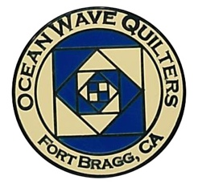
OCEAN WAVE QUILTERS
Fort Bragg, California – www.oceanwavequilters.com
APRIL 2026 NEWSLETTER
Happy Easter!  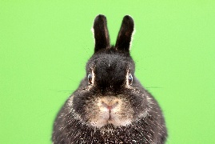  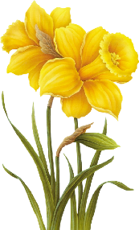  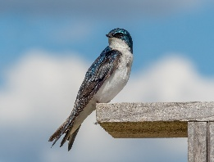  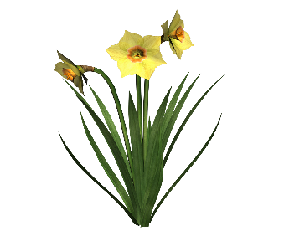  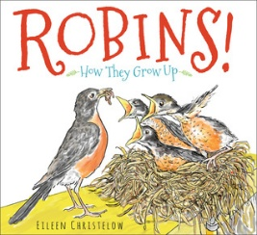 | Wow! It’s April. Happy April to all!  April brings sunshine to my house. It’s a very cheery month at my place. The rhododendrons and azaleas are beginning to bud, and the daffodils are still blooming. About four years ago, 30 daffodil bulbs of various varieties were planted in the garden by the lab building. It took time for them to grow and produce bulblets which then grew to become independent bulbs and produce flowers, but now the garden is full of a wide variety of beautiful daffodils.  The Ocean Wave Quilters are like the garden of daffodils. It produces a wide variety of beautiful quilts which seem to multiply and grow. Some are young bulblets, others are mature bulbs, but together we make a bouquet of quilts to share with the community during the year and with the Quilt Show in June.  Albion has more than just flowers; the grass is green and the Canada Geese are back. They roam the lawns by the river eating and looking for the best nesting spots. The Green Tree Swallows have also returned and are swooping around like little jets. The Robins have again taken up residence and hop around looking for delicious meals.  Speaking of Robins, they bring to mind the joy I had today being involved in the giving of a Round Robin back to its originator. She was so pleased with how her project turned out. What a special gift we give when we become part of someone else’s quilt project. As I reflect on the other Round Robin quilts that I’ve seen, I am delighted at the creativity which gets put into them. I also have enjoyed the various discussions during the past few months when several people were trying to decide what to do on their next “round”. I have benefited greatly from others’ input and the joy that comes from that discussion and the ideas which it creates. I know that, sometimes, it can be a challenge to know what to do, and ideas and plans don’t always work out, but in the end, there are some very beautiful quilts. I know that it will be a great delight to see all the quilts at the quilt show in June.  The industry of spring has hit more than the flowers and birds; today was the first day of our Spring Retreat. We had 9 ladies come by. Six of us sewed/worked and 3 were touch and go. I’m so happy for those who could come by for the first time, attend for the first time, or return. Tomorrow, more will come. There’s something special about the community of women sewing –creating, sharing, giving, receiving, and reaching out to others. When hands are busy, hearts open and relationships grow.  I hope you had a chance to come by the Retreat and enjoyed the beautiful flowers, birds and quilts.  Happy Quilting!  Nadine Schultz, OWQ President
TREASURER’S REPORT

Ocean Wave Quilters Fort Bragg Quilt Show
2026 March Treasurer’s Report 2026 March Treasurer's Report
Starting Balance 02/19/2026 $3,958.89 Starting Balance 0 2/19/2026 $13,807.94

QGNQ Dues | $20.00
Total Expense | $20.00 | Total Expense | $0.00
Raffle Basket Proceeds | $ 90.00 | Raffle Quilt | $240.00
Yvonne Phenicie Class Fees | $ 210.00
Total Income | $300.00 | Total Income | $240.00

Ending Balance 03/17/2026 $4,238.89 Ending Balance 03/17/2026 $14,047.94
Submitted by Sharon Lau, OWQ Treasurer Approved at the 03/18/2026 Board Meeting
Sharon Lau, OWQ Treasurer
COMMUNICATIONS

- The "OWQ Zoomies" are having a retreat at the Veteran's Hall in Fort Bragg, April 24-26. All are welcome to attend! Please direct questions to Cindi Jo W.
- The 2027 RAFFLE QUILT is progressing! Thanks to everyone who took the time and energy to make blocks! It takes a village.
- Still need volunteers to cover some of the shops for the quilt walk. Please contact Susan C. If you can, volunteer some time to make this event a success!

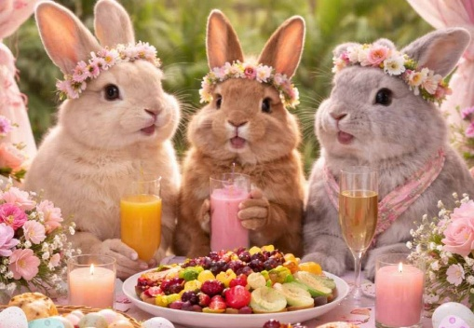
Keep on quilting!

Shari Lyons, Communications Committee Chair

UPCOMING LOCAL QUILT SHOWS

Quilter’s Sew-Ciety of Redding Presents Quilt Show 2026
“Quilt America: 250 Years of Creativity”
Shasta District Fairgrounds and Event Center, 1890 Briggs St, Anderson, CA 96007
Friday, May 1, 2026, 10am-5pm & Saturday, May 2, 2026, 10am-4pm

You will enjoy hundreds of handmade quilts, original designed “Stars and Stripes Forever” quilt challenge submissions, our boutique of member-created, handmade items, dozens of vendors, multiple bed turning demonstrations showcasing quilt styles over the decades, raffle opportunities – baskets & opportunity quilts, Quilt of Valor presentation, CA Heritage Quilt Project, door prizes hourly, and much more! $10 admission covers both days, children under 12 free! We look forward to seeing you!!!

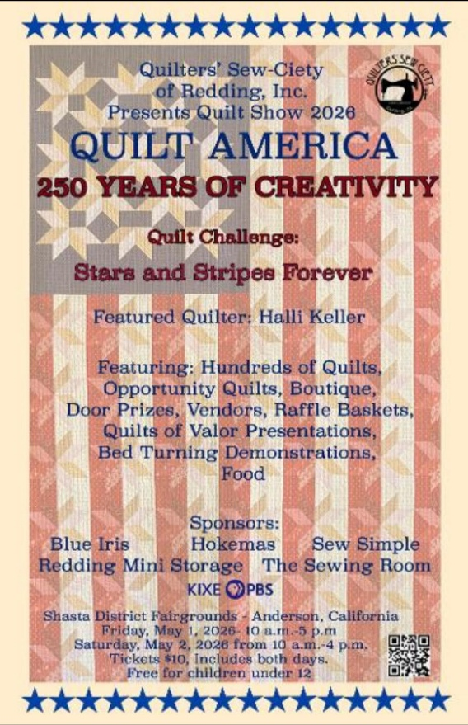
Also, check out the Grapevine Quilters of Mendocino County!
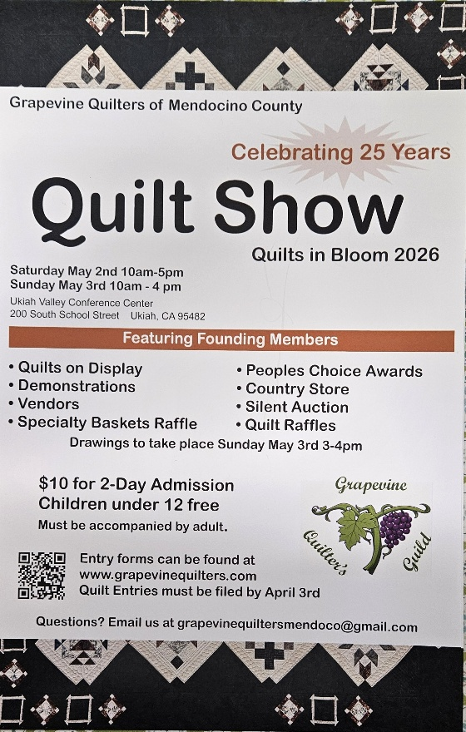

SERVICE COMMITTEE
Hello Quilters...Happy Spring!!

The donation numbers for March are as follows:
3 Community Quilts
6 Warm Welcome Quilts
6 Pet Beds
18 Dress-A-Girl

Please keep those baby quilts coming. Judy Whitlock always has a need for more, and we are very low on Infusion Quilts and Port Pillows for the hospital. I am still trying to collect enough twin size or large lap size quilts to make one big donation to the Hospitality House. Also, it is time for me to donate to Child Protective Services again, so quilts for children would be greatly appreciated!
Sharon Lau does a wonderful job keeping our guild labels available on the shelf in the back room at Sew n Sew, so you can sew a label onto your quilt before handing them in.

Thank you for all you do!! Kathy Kathy Demetri, Service Committee Chair

EDUCATION & SPECIAL EVENTS

SPRING APPRECIATION LUNCHEON
Please join us on SUNDAY April 26, 2026, 12:00pm at the Senior Center to celebrate all of us!

Happy Appreciation Day
OCEAN WAVE QUILTERS!

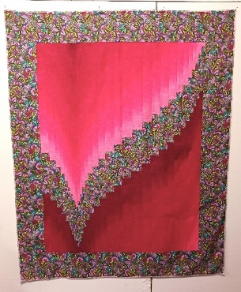
Yvonne Phenicie – “I Love a Challenge” will present at the Appreciation Luncheon. Check out Yvonne’s BIO that can be found at the end of the newsletter!

MONDAY, APRIL 27, 2026 – YVONNE PHENICIE
OMBRE BARGELLO 1 DAY WORKSHOP – Class is now full. See Steffany if you are interested in being on the wait list if any participants cancel.

BLOCK OF THE MONTH
APRIL INSTRUCTOR: Elizabeth Foster
***Instructions for blocks from July 2025 until March 2026 BLOCK OF THE MONTH can be found on the OWQ website or get a copy at Sew n Sew in the BOM binder on the OWQ shelf. April’s BOM pattern will be available after the April 12th general meeting.

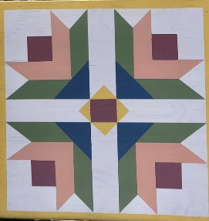
UPCOMING CLASSES
QUILT BARN ART– Instructor: Anelie Belden – Monday, July 13, 2026 – Sign-up and more information for this fun painted creation will be available at the April General meeting.

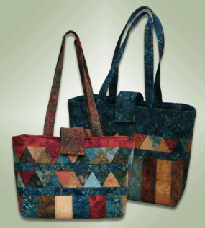
“The Carolina Bag” Tote Bag Class - Instructor: Paula Perelstein – Sunday, August 23, 2026 – Sign-up and more information coming in May.

ROUND ROBIN Round Robin Quilts will be displayed at the 2026 FBQS!
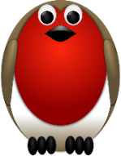
The Round Robin(RR) is now complete. If you plan to have your RR quilt displayed at the quilt show, you will need to register it (no fee) by May 26th and have it completed by the quilt show quilts due date of June 16th.

Elizabeth Foster, Education & Special Events Committee Chair
Committee members: Steffany Baroni, Kathy Demetri, and Lisa Carter

QUILT GUILDS of the NORTH QUARTER
Quilt Guilds of the North Quarter - QGNQ - is an organization to which we belong. It is made up of the smaller, more rural quilt guild in Northern California and gives us an opportunity to network, share ideas and classes, etc.
Any member of Ocean Wave Quilters is welcome to participate in QGNQ, including attending their quarterly meetings. (provided by Sharon Lau)

Next quarterly meeting will take place in Ukiah on Saturday, April 25th Meet the Teachers.
OWQ will be hosting the QGNQ meeting on Saturday, July 25th – Please let us know if you would be willing to volunteer for organizing, set-up, and take-down of this meeting!

We all had a great time at the OWQ SPRING QUILT RETREAT! Check out the photos! First one shows the amazing progress on the 2027 Raffle Quilt!
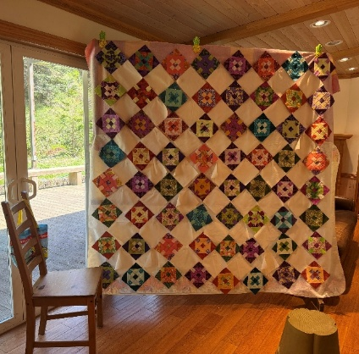

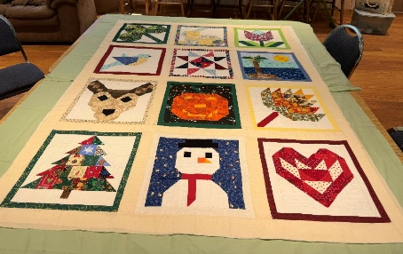
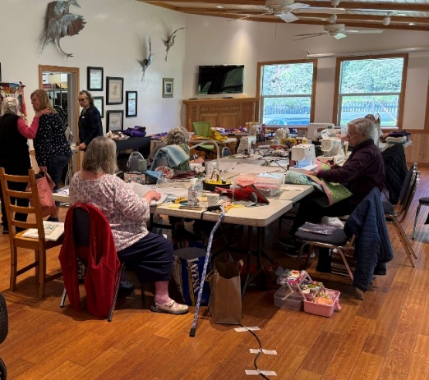
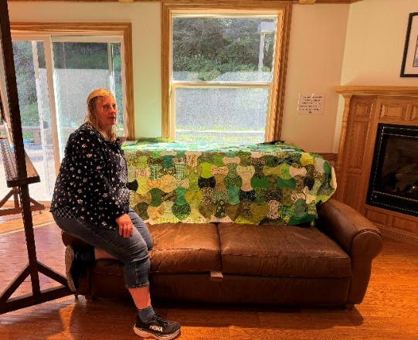
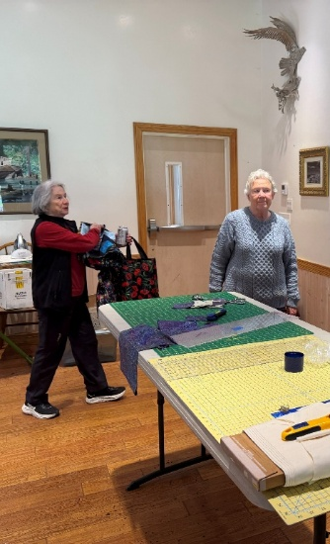
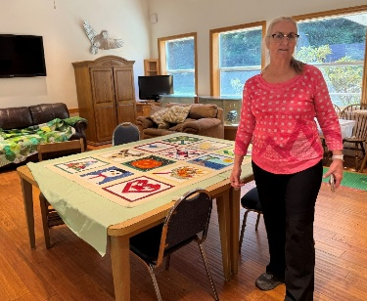
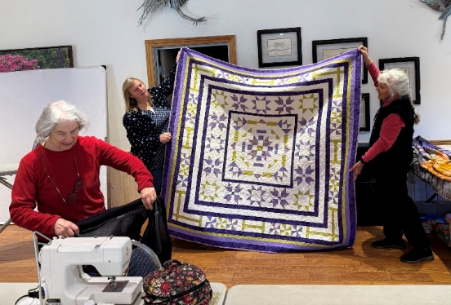
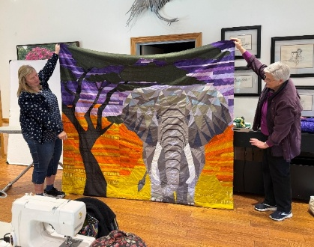

HOSPITALITY

Hospitality – Thank you all again for helping to clean up the room after our general meetings. I also appreciate those who help set the chairs out before the meeting. The tables and all else are okay, but those chairs make my shoulders ache. We’ve had a few donations for the upcoming quarterly raffle baskets. If you would like to donate quilting items, please call, text, or email me or drop items off at Sew n Sew in the labeled box.

For Newer members –-We have weekly Wednesday meetings through Zoom from 1:00 until about 4:00. This allows more visiting than we have at our regular meetings and we share tips and quilting knowledge when needed. It also allows members that don’t live on the coast to join us and get to know each other. Today we even had one member traveling with her husband in Arizona (he was driving!). Although we have a core group that have been meeting on Zoom for years, all guild members are welcome to join. We welcome new faces even if just for a quick visit. We have also reserved the Veteran’s hall in Fort Bragg (on Laurel between Whipple and Harrison streets) for a little retreat from Friday, April 24th until Sunday, April 26th. We will be attending the luncheon on Sunday, then maybe return to retreat some more. We’re flexible like that. We hope to see you!
Thank you! -CINDI JO :) -Cindi Jo Willey, Hospitality Committee Chair

APRIL BIRTHDAYS


Martin Weber April 4

Joanie Packard April 11

Pamela McCurdy April 23

Barbara Johnson April 24

Daisy Woodhams April 24

QUILTING FUNNIES
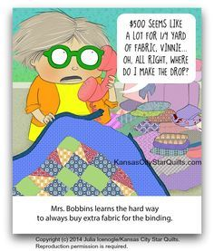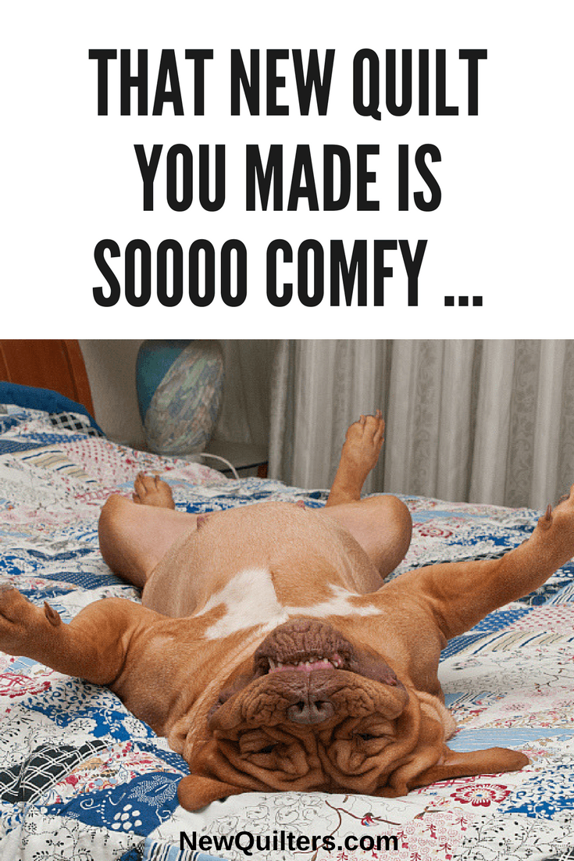

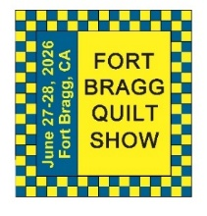
FORT BRAGG QUILT SHOW
Next Quilt Show meeting will be
Wednesday – April 1, 2026 - 10:30 am at SEW N SEW

The quilt show is quickly approaching, and things are happening quickly now!

- Here are some important informational highlights and dates regarding the upcoming show:
- We will have 10 to 15 VIP judges this year.
- We will not have a paid judge.
- There will be no Challenge quilts sponsored by Sew n Sew.
- New this year will be the Country Store. Items for sale will be made by our members.
- Silent auction of Kangaroo sewing cabinet and White Family Rotary antique sewing machine with solid oak sewing cabinet.
- Susan Collins is our Quilt Walk Chairman for 2026, so please contact her if you have any questions regarding the quilt walk.
- All quilts for the Quilt Walk are due by Monday, May 11, 2026 (at Sew n Sew).
- Quilts will go out to Merchants starting Tuesday, May 19, 2026.
- Merchants are to have all quilts hung by Saturday, May 23, 2026.
- Last day to register your quilts for the Quilt Show is Tuesday, May26, 2026; forms are available online at our website.
- Quilts for the Quilt show need to be turned in at Sew n Sew on Tuesday June 16, before 4:00pm.
- Last day to register your items for the Country Store is Tuesday, May 26, 2026.
- Items for the Country Store must be turned in at Sew n Sew on Tuesday, June 9, 2026, before 4:00pm.
- Set up for the Quilt Show to begin Thursday June 25, 2026 - more information to follow.
- Quilt Show opens Saturday June 27, 2026 and runs through Sunday June 28, 2026
- Please sign up to volunteer to work at the show at one of our Sunday Monthly meetings.
- Pickup of all quilts will begin at 5:00pm on Sunday June 28, 2026.
If you have any questions, please feel free to give me a call.

Carole

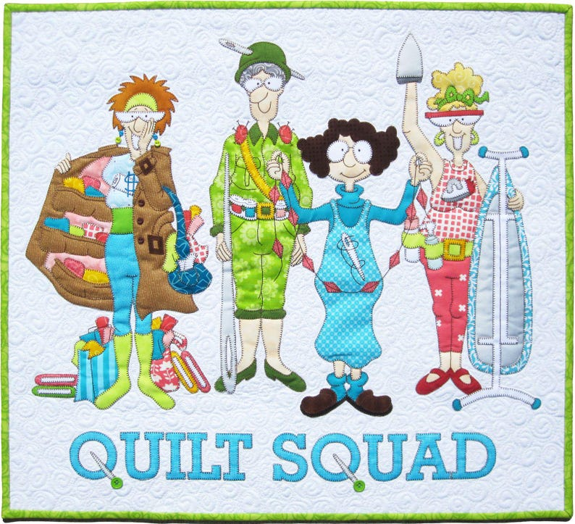
Carole Poma, 2026 Fort Bragg Quilt Show Committee Chair

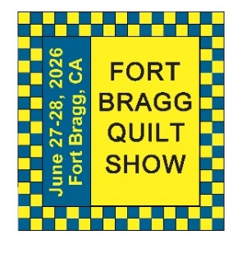 | May 2026  FBQS PLANNING
Sun. | Mon. | Tue. | Wed. | Thu. | Fri. | Sat.
 |  |  |  |  | 1 | 2
3 | 4 | 5 | 6 | 7 | 8 | 9
10 | 11 | 12 | 13 | 14 | 15 | 16
 | QUILT WALK QUILTS DUE AT SEW N SEW
17 | 18 | 19 | 20 | 21 | 22 | 23
 |  | QUILT WALK QUILTS GO OUT TO MERCHANTS |  |  |  | FINAL DAY FOR MERCHANTS TO HANG QUILT WALK QUILTS
24 | 25 | 26 | 27 | 28 | 29 | 30
 |  | FINAL DAY TO REGISTER QUILT SHOW QUILTS & COUNTRY STORE
31
Notes | THE QUILT WALK WILL TAKE PLACE FROM MAY 23RD UNTIL JULY 6TH. PICK UP QUILT WALK QUILTS AT SEW N SEW ON JULY 7TH. PICK UP SHOW QUILTS 5PM ON JUNE 28^{TH.} IF YOU CAN NOT DROP OFF OR PU ANY OF YOUR ITEMS ON THE ASSIGNED DATES, PLEASE ARRANGE WITH ANOTHER TO DROP OFF OR PICK UP FOR YOU.

June 2026
FBQS PLANNING
Sun. | Mon. | Tue. | Wed. | Thu. | Fri. | Sat.
 | 1 | 2 | 3 | 4 | 5 | 6
7 | 8 | 9 | 10 | 11 | 12 | 13
 |  | DROP OFF COUNTRY STORE ITEMS AT SEW N SEW
14 | 15 | 16 | 17 | 18 | 19 | 20
 |  | DROP OFF QUILT SHOW QUILTS AT SEW N SEW
21 | 22 | 23 | 24 | 25 | 26 | 27
 |  |  |  | BEGIN QUILT SHOW SET-UP |  | FORT BRAGG QUILT SHOW  10 – 5 PM
28 | 29 | 30
FORT BRAGG QUILT SHOW
10 – 4 PM
5 PM PU QUILTS

Notes | THE QUILT WALK WILL TAKE PLACE FROM MAY 23RD UNTIL JULY 6TH. PICK UP QUILT WALK QUILTS AT SEW N SEW ON JULY 7TH. PICK UP SHOW QUILTS 5PM ON JUNE 28^{TH.} IF YOU CAN NOT DROP OFF OR PU ANY OF YOUR ITEMS ON THE ASSIGNED DATES, PLEASE ARRANGE WITH ANOTHER TO DROP OFF OR PICK UP FOR YOU.

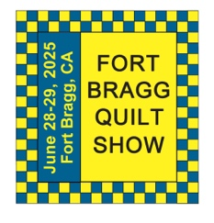
The 29th Annual
Fort Bragg Quilt Show
“Quilts for All Seasons”

A HUGE “Thank You”
to this year’s sponsors:

Diamond
Rossi Building Materials
Mendocino Railway

Platinum
Community First Credit Union

Gold
Sew-n-Sew Laurel Deli and Desserts
Mendo Litho REMax/First Equity Realty
D’Aurelio’s Noyo Fish Company
Norvell’s Noyo Pacific, Inc.

Silver
Pacific Pearl Upcycle Mercantile Mendocino Cookie Co.
Windsong Used Books & Records Chernoff’s Jewelers
Frankie’s Pizza & Ice Cream Noyo Fishing Center

Bronze
Beautiful Earth Splendiferous
Big Foot Ice Cream Essentially Hair
Tsunami’s Glass Shop Zapateria La Mexicana
Shirts and More Oh, Baby!
Egghead’s, Inc.

And THANKS to our Raffle contributors:
Purity, Imaginations, Reynolds, Cucina Verona Mercato, Sew-n-Sew, Fabled (Frame Mill), Pippi’s Socks, The Bookstore & Vinyl Cafe, Hot Pepper Jelly, Roundman’s Smoke House, Lunar Tide, Safeway, Harvest Market, Hare Creek Nursery, Highway 20 Feed, Simply Succulents, Zho Cellars, Larkin Cottage, Harbor Lite Lodge, FBQS Vendors, and OWQ members

Member BIO – SHARON LAU
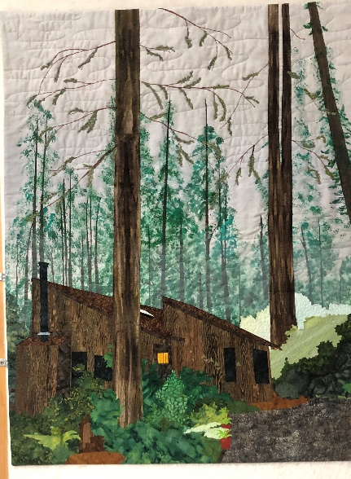
I was born in Northern Illinois in a very small town. My childhood was spent riding my bike all over town, swimming at the local park district every day in the summer and ice skating on the lake across the road from our house in the winter. The big change in my life came when I went off to college – to Los Angeles, of all places! After graduation, I taught elementary school for a few years, then moved to North Carolina where I worked at Duke in a job that opened my eyes to a whole new career path. Initially, I thought medical school was my future, but I became interested in the financial and administrative aspects of health care, so I got a Master’s in Health Care Administration and spent the next 20 years as an administrator in a pediatric hospital, then another 15 years as a quality consultant, traveling to 30 children’s hospitals across the U.S. and Canada. On retirement, my husband and I looked for a place to live that had cooler weather and more trees and green landscape than the big city. We landed by chance in Mendocino and have never regretted it!
My first attempt at quilting was in 2000. I was living half-time in Illinois near my dad, who needed a little extra TLC after the sudden death of my mom. I needed something to occupy my time while he watched his favorite TV shows in the evening, so I thought I’d give quilting a try. My first project was a king-size, New York Beauty quilt (I never do things half-way) that took a few years, but it did get finished.
After piecing a few more quilts, I decided that I’d try a raw-edge applique pattern by McKenna Ryan. It had trees, deer, an eagle and all kinds of fun woodland critters, and I was hooked! Raw-edge applique is my technique of choice whenever I decide to start a new project.
I usually begin with a photo. The Iconic Mendocino Buildings project is a good example. A group of us made 18 x 18” quilts, working from pictures of buildings in Mendocino. We were invited to display our quilts in a special exhibit at PIQF in Santa Clara, at the Willits Center for the Arts, and at the Grace Hudson Museum in Ukiah. And we were featured in an article in Quilting Arts magazine!
I don’t really enjoy piecing, though I do it from time to time to try to keep the scrap bins under control. I am intrigued by thread painting and want to do more of it. I love to quilt on the longarm quilts that other Guild members make for our community projects. I also am known for really despising having UFOs, so when I start a project, I generally don’t start anything else until the first project is complete.
Howard and I have two daughters, one an internal medicine/infectious diseases physician who works at the NIH, the other a plant pathologist who works in Kauai. We are blessed with three grandkids, one in medical school, another a nurse, and a 10-year-old who is a riot.
I’ve been a member of Ocean Wave Quilters since 2014. I chaired the 2015 Quilt Show and have held board positions almost every year, including being President a few times. My recent battle with cancer has left me without the stamina to participate as fully as I’d like, but I always look forward to sharing my knowledge of the guild and ideas about quilting with other members of our great group.
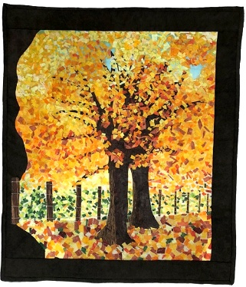
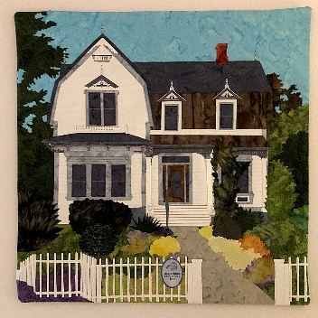

MARK YOUR CALENDARS FOR UPCOMING IMPORTANT DATES

APRIL 2026 | DAY | TIME | ACTIVITY | LOCATION
April 1st | Wed | 10:30 am | FBQS Meeting | Sew n Sew
April 12th | Sun | 1:30 – 3: 30 pm | General Meeting | Senior Center
April 15th | Wed | 10:30 am | Board Meeting | Sew n Sew
April 26th | Sun | 12:00 pm | APPRECIATION LUNCHEON | Senior Center
April 27th | Mon | 10:00 am – 4:00 pm | Yvonne Phenecie Class | Sew n Sew
MAY | DAY | TIME | ACTIVITY | LOCATION
May 6th | Wed | 10:30 am | FBQS Meeting | Sew n Sew
May 10th | Sun | 1:30 – 3: 30 pm | General Meeting | Senior Center
May 20th | Wed | 10:30 am | Board Meeting | Sew n Sew
May 24th | Sun | 10:30 am – 3:00 pm | Sew Sunday | Senior Center
JUNE | DAY | TIME | ACTIVITY | LOCATION
June 3rd | Wed | 10:30 am | FBQS Meeting | Sew n Sew
June 14th | Sun | 1:30 – 3:30 pm | General Meeting | Senior Center
June 17th | Wed | 10:30 am | Board Meeting | Sew n Sew
June 27th & 28th | Sat & Sun | 10:00 am – 5:00 pm  10:00 am – 4:00 pm | 30TH ANNUAL  QUILT SHOW | Dana Gray Elementary School
Please see the FBQS section and FBQS calendar for dates
Monthly Activities:
Hand quilting: Every Tuesday/Senior Center – 1:00-3:00 pm
Sew Sunday: 4th Sunday of the Month – 10:30 am – 3:00 pm
***Hand Sewing: Every Wednesday/ZOOM – 1:00 – 4:00 pm – Join Zoom Meeting
https://us06web.zoom.us/j/81292075496?pwd=bldtVHFrRGhpTTVxUGEraEFFc2hvQT09
Meeting ID: 812 9207 5496 Passcode: HandSew

2025-2026 Board Members and Committee Chairs

President | Nadine Schultz | 707-684-9627 | Quilterqueenbee@yahoo.com
Vice-President | Carole Poma | 707-813-3001 | carolepoma@comcast.net
Secretary | Paula Perelstein | 707-962-9006 | Paula@sew-n-sew.com
Treasurer | Sharon Lau | 707-937-3049H  707-357-7447C | quiltkats@yahoo.com  sharon@oceanwavequilters.com
Communications | Shari Lyons | 707-684-0831 | lybra@mcn.org
Newsletter | Elizabeth Foster | 510-292-7833 | JJefoster@yahoo.com
Service | Kathy Demetri | 707-937-3667 | kathydemetri@gmail.com
Education & Special Events | Elizabeth Foster | 510-292-7833 | JJefoster@yahoo.com
Hospitality | Cindi Jo Wiley | 707-357-4774 | queenbee@mcn.org
FBQS Chair | Carole Poma | 707-813-3001 | carolepoma@comcast.net

NEWSLETTER – Next newsletter articles/items are due April 22, 2026. The Newsletter will be sent out by April 26, 2026.

Thank you, Elizabeth Foster, OWQ Newsletter Editor

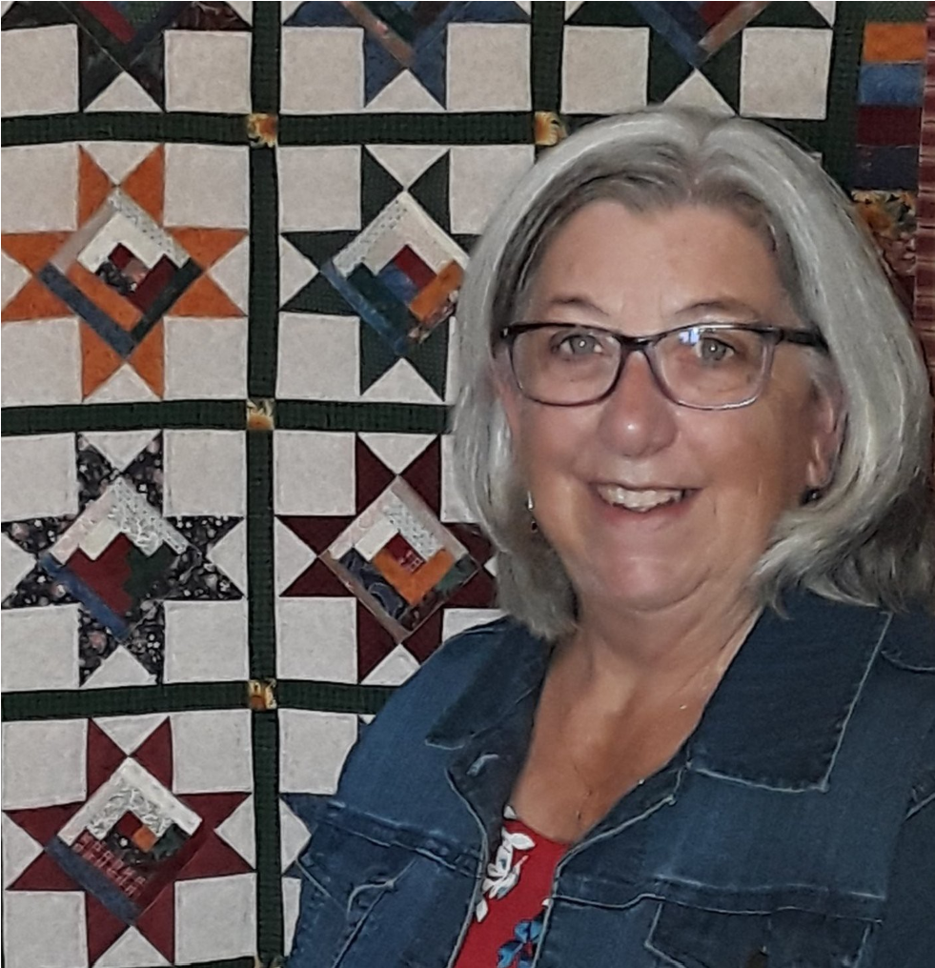

YVONNE PHENICIE
INSPIRE QUILTS
Yvonne Phenicie is a quilt maker, teacher, and designer. Not shy about using color, most of her quilts are bright and fun. She has been a quilt maker since 1990 when she started working at a local quilt shop where she taught quilting classes—from beginning kids to paper piecing and more. She has continued to teach quilting classes, both in Northern and Southern California, as well as locally. In 2017, she taught a paper piecing class at the Quilt Jamboree in Redding, California, and in 2019 she became a Sew Kind of Wonderful Certified Teacher.
Yvonne is a member of the Pacific Flyway Quilt Guild in Colusa and the Orland Quilt Guild in Orland, California. She has been president of the Pacific Flyway guild twice, has designed and made two of their opportunity quilts, and contributed to two other opportunity quilts.
Yvonne retired in 2016 from the County Office of Education as a Special Education Transportation Assistant and currently lives in Colusa with her husband Mike, a retired Jr High and High School Music teacher. When not quilting, they enjoy camping and traveling in their RV, and spending as much time as they can with their five grandchildren.

