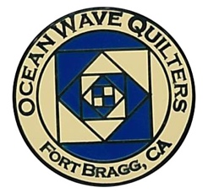
OCEAN WAVE QUILTERS
Fort Bragg, California – www.oceanwavequilters.com
MARCH 2026 NEWSLETTER
Hey March!          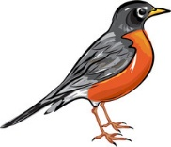 | Happy March to all you Quilters!  It’s still been cool and wet, but warmer weather is on the way! In either case, quilting is a good activity. Speaking of quilts...I think I was in the middle of comparing our guild to a quilt and parts of quilt making. We have more board members who I would like to mention.  “Show and Tell” in a very practical sense is handled by Kathy Demitri. Most of us show and tell in our meeting, but Kathy has the privilege of showing so much of our work to the community. Kathy also has a great team who support her in the distribution of all our community projects. In her beautiful quiet way, Kathy takes our creations of love and warmth and shares them with organizations who in turn give them to people. Thank you, Kathy for being the “hands and feet” of the “Show and Tell” for us. Kathy also works to inform us of needs, find new outlets for projects, and encourages her team to keep up the kits. Thank you, team. And thank you to all who put their time and resources into making the love quilts for our community.  “Show and Tell” also can take on another aspect in our Quilt Show. The Quilt Show is literally a “Show” and a way to “Tell” our community about our mission and activities. It is also our major source of income for the guild. Plans for the Quilt Show begin more than a year before the actual Show. This year Carole Poma has been in charge. She has taken the “pattern” which was created by previous Quilt Show Chairs and is turning it into a beautiful project. This is a complicated pattern and process, and involves lots of steps, detailed planning, and implementing. The hands needed are uncountable. Carole has a wonderful team each creating a piece of the whole. Each one of you is appreciated and will make a difference in the final project, whether it’s a small thing like printing postcards or more active like working on the quilt walk, advertising, soliciting donations, selling raffle tickets, etc. (I know I can’t list them all but know that each of you is appreciated). Every quilter can enter a quilt to show. We learn and share and grow by entering our quilts. We all are artists.  Carole is also my back-up and support – kind of like the batting and backing in one. Her encouragement and experience are vital to me and thus to you. You are much appreciated, Carole.  Binding all of us together is the Newsletter which comes out edited by Elizabeth Foster. Bright, cheery, informative, timely, and with humor – Thank you to all the team who have made this job easier for Elizabeth by submitting your information on time, and thank you to Elizabeth for all the background work you do to keep us all informed. This also involves Susan Blackmer who continues to review the newsletter and Sharon Lau, who speeds things to us via the internet and assists Elizabeth whenever she needs help.  You might have thought of what part you are in the quilt. Some of you feel a bit hesitant about being a seam ripper or ruler to make sure we’re following the pattern correctly, but even those things are important. Each of us is vital. Thank you for being part of our beautiful quilt guild, your uniqueness enriches the whole.  ‘Till next month…. Nadine – Nadine Schultz, OWQ President
TREASURER’S REPORT

Sharon Lau, OWQ Treasurer

COMMUNICATIONS

- I would like to thank everyone who participates in providing food/drinks/snacks for the guild meetings. Please take home any leftovers or arrange for someone to take them at the end of the meeting. It becomes a chore for those left to clean up the meeting if things are left behind.
- I would also like to thank those that have provided items on the "FREE" table. I found it very valuable as a new quilter in adding to my stash! But, once again, please either take home things that have not been claimed or arrange for someone to do it for you.
- The OWQ 2026 Quilt Show is STILL in need of an Advertising Chair. Please look into your hearts to take on this very important task. The Quilt Show team will help you do the job! We just need someone to be "in charge".
- Hospitality House is still in need of twin size "toppers" or quilts to cheer up their surroundings and support those that need a place to stay. Contact Kathy D. If you have any questions.
- RAFFLE QUILT 2027 ( next year’s!). Many of the packets have been returned and they are wonderful! For those of you that have yet to return your completed blocks, please do so by March 7 or at the next meeting on March 8. We are excited to begin piecing the full quilt top!

Shari Lyons, Communications Committee Chair


Quilter’s Sew-Ciety of Redding Presents Quilt Show 2026

“Quilt America 250 Years of Creativity”

Shasta District Fairgrounds and Event Center, 1890 Briggs St, Anderson, CA 96007
Friday, May 1, 2026, 10am-5pm & Saturday, May 2, 2026, 10am-4pm

You will enjoy hundreds of handmade quilts, original designed “Stars and Stripes Forever” quilt challenge submissions, our boutique of member-created, handmade items, dozens of vendors, multiple bed turning demonstrations showcasing quilt styles over the decades, raffle opportunities – baskets & opportunity quilts, Quilt of Valor presentation, CA Heritage Quilt Project, door prizes hourly, and much more!
$10 admission covers both days, children under 12 free! We look forward to seeing you!!!

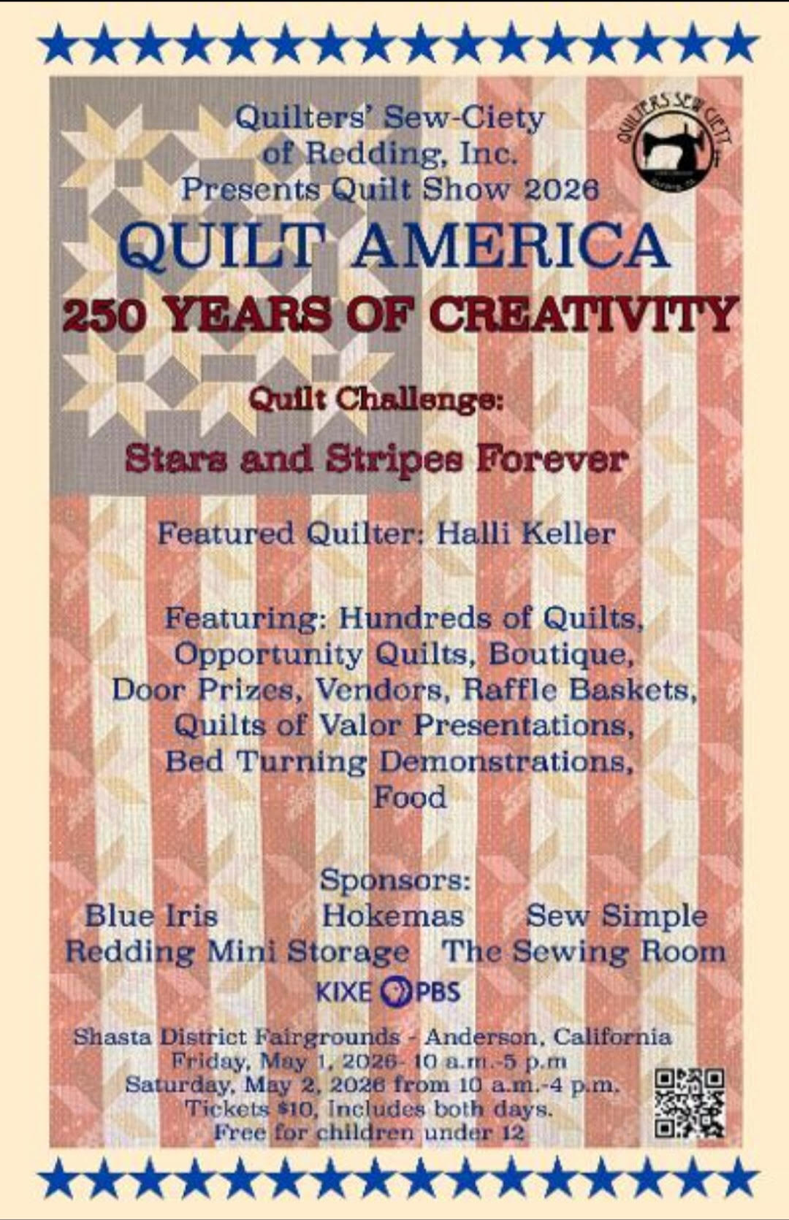

SERVICE COMMITTEE
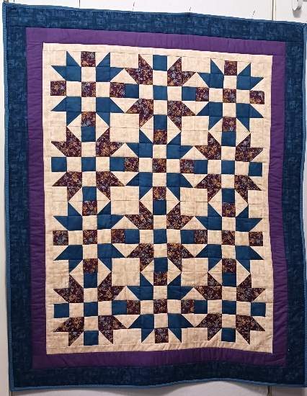
Dear Guild Members,
Our donation numbers for February 2026, are as follows:
2 community quilts
3 port pillows
7 pet beds

Thank you for all you do!
Kathy

Kathy Demetri, Service Committee Chair

EDUCATION & SPECIAL EVENTS

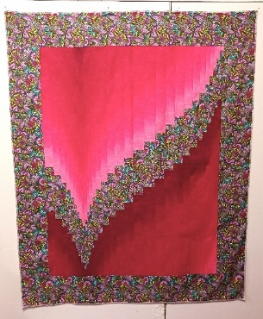
UPCOMING CLASS
MONDAY - APRIL 27, 2026 – YVONNE PHENICIE –
OMBRE BARGELLO 1 DAY WORKSHOP

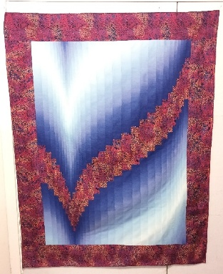
Sign-up sheet for Yvonne’s class will be available at the March & April 2026 General Meeting. It is first-come/first serve, and registration is not complete until payment is received. Please pay with exact cash or check (made out to Ocean Wave Quilters) to either Steffany B. or Sharon L. This will be a 1-day class using “Two Fabric Bargello” pattern by Susie Weaver. The cost will be $35 for OWQ Members plus $10 for the pattern (available from Yvonne at the class). Once you have signed up and paid, you will be provided with the class supply list. The sign-up will be available for OWQ members until the end of March; following that, if there are still vacant spots, we will open it to nonmembers at cost of $50. If you have questions or want to view the quilt samples in person (at Sew n Sew) please contact Steffany Baroni, Education and Special Events Committee Co-Chair.

BLOCK OF THE MONTH
MARCH INSTRUCTOR: Lisa Carter
***Instructions for blocks from July 2025 until February 2026 BLOCK OF THE MONTH can be found on the OWQ website or get a copy at Sew n Sew in the BOM binder on the OWQ shelf. March’s BOM pattern will be available after the March 8th general meeting.
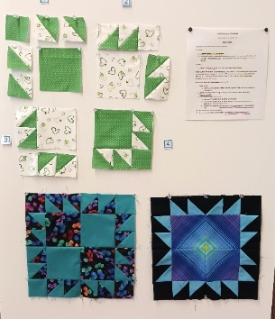

“Old Crow” February 2026 BOM taught by Lony Fiduccia


SPRING QUILT RETREAT is HERE!
The Spring Retreat will be from Wednesday, March 25 until Saturday, March 28, 2026.
It will be located at the Albion Field Station in Albion.
Doors will open at 9:00 am Wednesday morning.
DIRECTIONS TO ALBION FIELD STATION:
From Hwy 20 intersection -
- Turn left on to Highway 1 southbound toward Albion (15 miles)
- Turn left at Albion (0.1 miles)
- Turn left into the Albion market parking area and continue, following the signs to Albion Field Station (signs have the whale tail logo on them – 0.5 miles)
  - SEE LIST AT END OF THE NEWSLETTER FOR RECOMMENDED ITEMS TO BRING WITH YOU!
  - OWQ will supply ironing boards, irons, cutting tables, rulers, and mats. Plus, Keurig coffee and tea, cups, small plates and bowls, plastic utensils, and bottled water.
    - Bring some snacks to share!
ATTENTION! Please send Elizabeth an email if you plan to attend. WE NEED SOME ASSISTANCE WITH SET-UP AND CLEAN-UP while Elizabeth is recovering from surgery.
Thank you!
We hope you can join us for this fun event, which gives a chance to socialize and enjoy each other’s’ company!

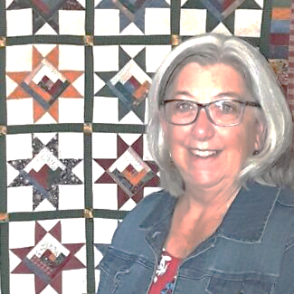
SPRING APPRECIATION LUNCHEON

Yvonne Phenicie – “I Love a Challenge” will present at the
April 26, 2026, Appreciation Luncheon. 12:00 Senoir Center
She will also be doing a one-day Ombre Bargello class on Monday, April 27, 2025 (see above)
Sign up for the April 27th class will available our March and April 2026 General Meeting and at Sew n Sew (see Steffany B).

ROUND ROBIN

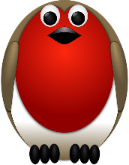
We are at the end our Round Robin – Last exchange will be at the March 8th General Meeting!

Round Robin Quilts will be displayed at the 2026 FBQS!

Elizabeth Foster, Education & Special Events Committee Chair
Committee members: Steffany Baroni, Kathy Demetri, and Lisa Carter

***QUILT GUILDS of the NORTH QUARTER***

Next quarterly meeting will take place in Ukiah on Saturday, April 25th “Meet the Teachers”
OWQ will be hosting the QGNQ meeting on Saturday, July 25th – Please let us know if you would be willing to volunteer for organizing, set-up and take-down of this meeting!

HOSPITALITY

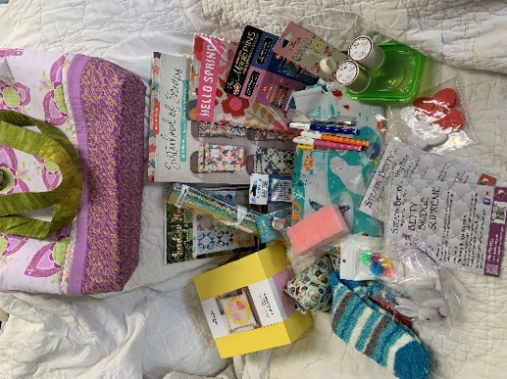
For the March general meeting we will have another raffle bag/basket available for a chance to win!
Bring your cash or checks to the meeting to purchase tickets to take home the bag full of quality treasures. Please remember that we can always use your generous (or simple) donations to fill our future prize bags to raise money for our service projects.

Cindi Jo Wiley, Hospitality Committee Chair

MARCH BIRTHDAYS

Grace Van Doren March 5


Lana Houger March 8

Lisa Carter March 10

Susan Collins March 10

Carley Miller March 13

Verna Oliver March 14

Sue Arnold March 23

Sharon Brayton March 26

Ronnie Kemper March 27

Sue Snowdy March 31

FORT BRAGG QUILT SHOW

Next Quilt Show meeting will be
Wednesday – March 4, 2026 - 10:30 am at SEW N SEW

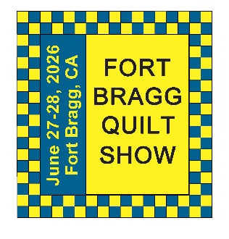
Happy Spring to everyone; planning for the quilt show is coming along. We still need help on some of the committees, so please consider helping. We will be providing information on where, when, and how to drop off your quilts for the quilt walk in the next newsletter. We are working out the details now.

Two (2) quilts were dropped off at Dana Gray School. These quilts were made as a "Thank You" to the staff and Children at the school for allowing us to use their school all these years.

Hope everyone is working on their quilts for the show. I look forward to seeing them.

Regards, Carole

Carole Poma, 2026 Fort Bragg Quilt Show Committee Chair

Quilts created by Carole Poma and Sharon Gieras – Donated to Dana Gray School
Check out the dozens of French knots to create the
lettering!
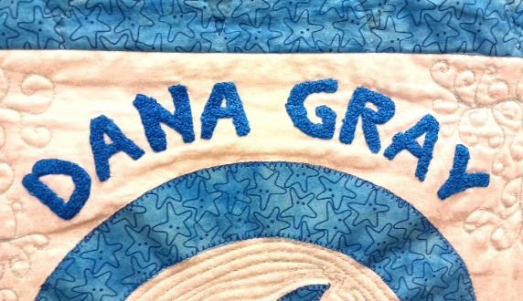
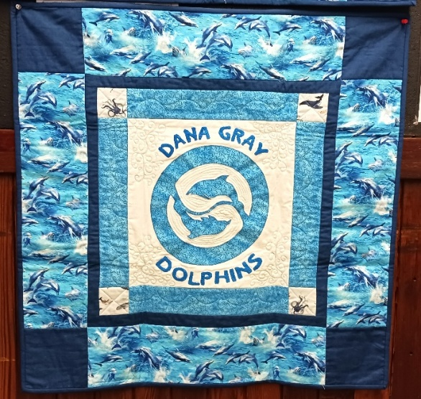
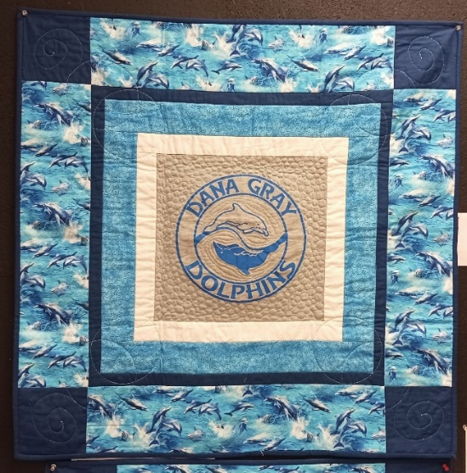

Stay tuned for the 2026 FBQS Planning Calendar to come next month!
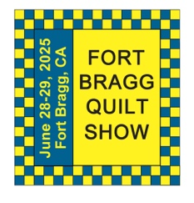
The 29th Annual
Fort Bragg Quilt Show
“Quilts for All Seasons”

A HUGE “Thank You”
to this year’s sponsors:

Diamond
Rossi Building Materials
Mendocino Railway

Platinum
Community First Credit Union

Gold
Sew-n-Sew Laurel Deli and Desserts
Mendo Litho REMax/First Equity Realty
D’Aurelio’s Noyo Fish Company
Norvell’s Noyo Pacific, Inc.

Silver
Pacific Pearl Upcycle Mercantile Mendocino Cookie Co.
Windsong Used Books & Records Chernoff’s Jewelers
Frankie’s Pizza & Ice Cream Noyo Fishing Center

Bronze
Beautiful Earth Splendiferous
Big Foot Ice Cream Essentially Hair
Tsunami’s Glass Shop Zapateria La Mexicana
Shirts and More Oh, Baby!
Egghead’s, Inc.

And THANKS to our Raffle contributors:
Purity, Imaginations, Reynolds, Cucina Verona Mercato, Sew-n-Sew, Fabled (Frame Mill), Pippi’s Socks, The Bookstore & Vinyl Cafe, Hot Pepper Jelly, Roundman’s Smoke House, Lunar Tide, Safeway, Harvest Market, Hare Creek Nursery, Highway 20 Feed, Simply Succulents, Zho Cellars, Larkin Cottage, Harbor Lite Lodge, FBQS Vendors, and OWQ members

Member BIO

This is an opportunity to share with others how we got into quilting and any other interesting things we would like to share.

Marcia Weeks

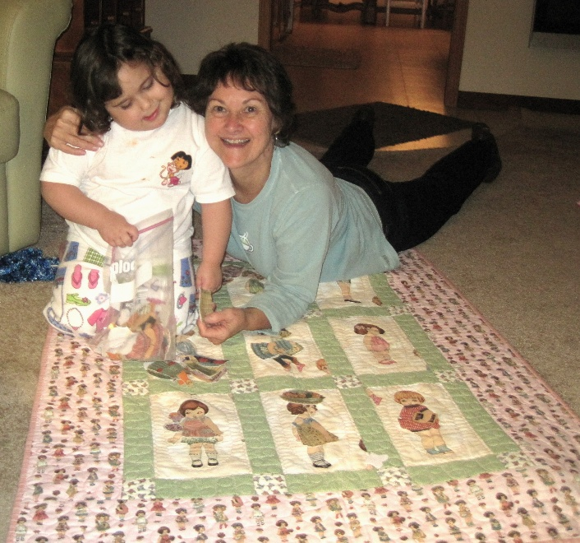
My mom was a farm girl, and my gramps was a singer sewing machine salesman. I grew up in Iowa with all hand sewn clothes, Mom as a sewing perfectionist. I wanted to be a nurse at the age of 4 wearing a uniform-NO SEWING!
As our child and later our grand twins came, I worked hard to love sewing. What about quilting? Well, loved it! and I didn't have to wear THAT! My mentor was Susan Bivins (now sadly in Montana), and I promised her I would join the quilt club when I retired. One of the best decisions I’ve made! I love the group and how readily they share. I was even able to enter some quilts in the show. My very favorite quilt is the one I did for the twins “Paper Dolls”.

A cancer diagnosis for me and Paul's stroke sort of took the wind out of our sails, but many of the quilt members were there for me: Sharon L. brought food, Sharon G. came for swing visits, Dee always there to help. The hand sewing group encouraged me!
My days now are filled with caregiving, a small amount of gardening, reading, quilting, and church activities.
Paul and I have had 59 yrs of marriage with strong family times, religious beliefs, and fun traveling experiences. BUT I STILL HAVE FABRIC AND IDEAS, SO AM NOT DONE YET!

At the February 8, 2026 OWQ General Meeting Marcia shared with us the quilt her husband, Paul Weeks, received. It is a QUILT OF VALOR – this is a great honor, and we were delighted to view it!

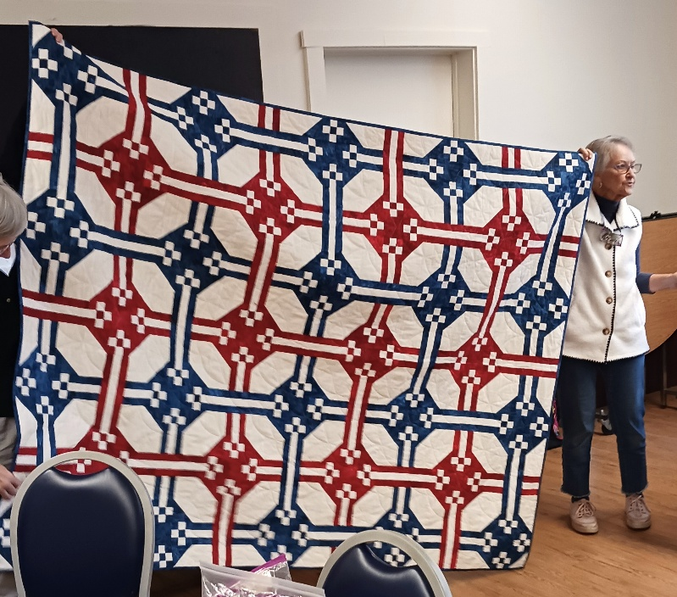

The QOVF Mission: To cover Service Members and Veterans touched by war with comforting and healing Quilts of Valor.
The Quilt of Valor® Foundation and volunteers appreciate the service and sacrifice of those who are serving or have served in the Armed Forces and protect our freedoms. Our Founder, Catherine Roberts, created the concepts in 2003 that underpin our mission statement.
Quilts of Valor Foundation |www.qovf.org

MARK YOUR CALENDARS FOR UPCOMING IMPORTANT DATES

MARCH 2026 | DAY | TIME | ACTIVITY | LOCATION
March 4th | Wed | 10:30 am | FBQS Meeting | Sew n Sew
March 8th | Sun | 1:30 – 3:30 pm | General Meeting | Senior Center
March 18th | Wed | 10:30 am | Board Meeting | Sew n Sew
March 22nd | Sun | 10:30 am – 3:00 pm | Sew Sunday | Senior Center
March 25 – 28 | Wed – Sat | 9:00 am – 4:00 pm | OWQ SPRING RETREAT | Albion Field Station
APRIL | DAY | TIME | ACTIVITY | LOCATION
April 1st | Wed | 10:30 am | FBQS Meeting | Sew n Sew
April 12th | Sun | 1:30 – 3: 30 pm | General Meeting | Senior Center
April 15th | Wed | 10:30 am | Board Meeting | Sew n Sew
April 26th | Sun | 12:00 pm | APPRECIATION LUNCHEON | Senior Center
April 27th | Mon | TBD | Yvonne Phenecie Class | Sew n Sew
MAY | DAY | TIME | ACTIVITY | LOCATION
May 6th | Wed | 10:30 am | FBQS Meeting | Sew n Sew
May 10th | Sun | 1:30 – 3:30 pm | General Meeting | Senior Center
May 20th | Wed | 10:30 am | Board Meeting | Sew n Sew
May 24th | Sun | 10:30 am – 3:00 pm | Sew Sunday | Senior Center
Monthly Activities:
Hand quilting: Every Tuesday/Senior Center – 1:00-3:00 pm
Sew Sunday: 4th Sunday of the Month – 10:30 am – 3:00 pm
***Hand Sewing: Every Wednesday/ZOOM – 1:00 – 4:00 pm – Join Zoom Meeting
https://us06web.zoom.us/j/81292075496?pwd=bldtVHFrRGhpTTVxUGEraEFFc2hvQT09
Meeting ID: 812 9207 5496 Passcode: HandSew

2025-2026 Board Members and Committee Chairs

President | Nadine Schultz | 707-684-9627 | Quilterqueenbee@yahoo.com
Vice-President | Carole Poma | 707-813-3001 | carolepoma@comcast.net
Secretary | Paula Perelstein | 707-962-9006 | Paula@sew-n-sew.com
Treasurer | Sharon Lau | 707-937-3049H  707-357-7447C | quiltkats@yahoo.com  sharon@oceanwavequilters.com
Communications | Shari Lyons | 707-684-0831 | lybra@mcn.org
Newsletter | Elizabeth Foster | 510-292-7833 | JJefoster@yahoo.com
Service | Kathy Demetri | 707-937-3667 | kathydemetri@gmail.com
Education & Special Events | Elizabeth Foster | 510-292-7833 | JJefoster@yahoo.com
Hospitality | Cindi Jo Wiley | 707-357-4774 | queenbee@mcn.org
FBQS Chair | Carole Poma | 707-813-3001 | carolepoma@comcast.net

NEWSLETTER – Next newsletter articles/items are due March 25, 2026. The Newsletter will be sent out by March 29, 2026.

Thank you, Elizabeth Foster, OWQ Newsletter Editor

