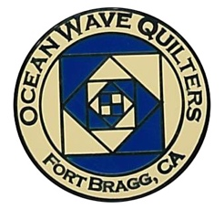
OCEAN WAVE QUILTERS
Fort Bragg, California – www.oceanwavequilters.com
FEBRUARY 2026 NEWSLETTER
 | Hello all you Lovely Quilters!  I hope that you are enjoying making lots of quilts. With the cooler and wetter weather, it’s such a good time to settle down in front of a sewing machine! As I was sitting in front of my sewing machine I thought about how when a quilt is done, we often notice the fabric or pattern but don’t always think about the thread, cutters, rulers, pins, clips and sewing machine or even seam rippers which are also involved.  With these thoughts in mind, I reflected on how our Ocean Wave Quilters Guild is like a quilt, and I would like to spend a few minutes thanking some of the faithful members who work for your pleasure. They may be a bright and cheery fabric, a background fabric, thread, binding, or even pins and clips. You can decide…  Having a cheery greeting as we enter the meeting at the Senior Center is so welcoming. I appreciate all Cindi Jo does to make us feel welcome and make sure we get or give the correct information before our meetings. She also does background work with the Sew Sunday and the storage room, cards and letters. Thank you.  Some of you have held guild offices and know about the planning and calling and coordinating of events. Elizabeth and her team have done so well with the events and education aspects of OWQ. We have a very diversified group who meet because of the love of quilting, all kinds of quilting – basic block quilts, HST quilts, traditional quilts, geometric quilts, art quilts, modern quilts, mystery quilts, group quilts, small quilts, large quilts. Beyond quilting, we enjoy making dresses, shirts, bags, pillowcases, port pillows and pet beds, etc. With such a variety in what we make, it’s easy to see there is a variety in the kinds of classes and events we enjoy. So, thank you very much Elizabeth and team for all your thought, work, action, and joy you bring to include all of us.  A measured guide is our treasurer, Sharon Lau. Sharon, we know your heart is for all of us in the guild. You go the extra mile to make sure we not only understand the finances, but also the history of the guild. Sharon also quilts many donation quilts and makes sure that the small items are done – labels available, documentation, insurance, website, etc. Your contribution to our smooth running is huge. Thank you.  A quiet but most important job is done by Paula, the secretary. Having an accurate record of proceedings is not only required, but super helpful when we must look back over previous meetings for comments, decisions or dates. Thank you to all of you who conscientiously read the minutes and help us keep a correct account of what we do.  Pictures, addresses and phone numbers have been tenaciously kept up to date by communications chair, Shari. She also sends emails, is involved in the website and seems to keep many edges from unraveling. Thank you, Shari, for all your involvement.  And now, I come to the end of the page without completing my thoughts nor covering all parts of our OWQ Quilt. But maybe this month, you can think about what part you are in a quilt, for all the parts, tools, ideas, and fabrics are important.  Happy Sewing, Nadine Schultz  (More to come next month)
TREASURER’S REPORT

Sharon Lau, OWQ Treasurer

COMMUNICATIONS
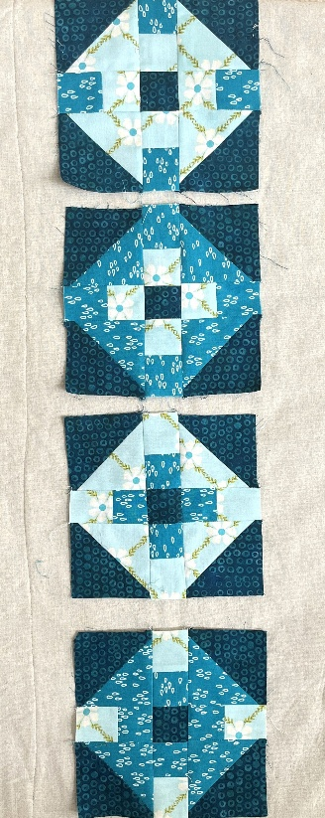
2027 RAFFLE QUILT - Dee and I put together 15 fabric packets and asked volunteer quilters to pick them up from Sew n Sew last week, and they did! If everyone makes at least 3 blocks and returns them by March guild meeting we may have enough to make the top. Unfortunately, not everyone got a packet who wanted one, and once I get back from my travels in mid February I plan to make more to share. I will send out an email once I get it together. Susan C is donating the background fabric and Linda W is donating the fabric for the back. Thanks to everyone working to make this raffle quilt happen!!! Please return the blocks to SewnSew and check off your name as returned. The more quilters that return their blocks early will help with determining if we need more!
I also want you to know the blocks should be 6 3/4 unfinished. The very early trial pattern stated 6 1/4—that is the finished size!
Check out a sample of our progress so far
Thanks for all you do!

One of our new members, Sue S., has already joined in the fun!

Shari Lyons, Communications Committee Chair

SERVICE COMMITTEE

Dear Guild Members,
Our donation numbers for January 2026, are as follows:
12 Pet Beds,
8 Warm Welcome Quilts
4 Community Quills

Looking forward to this new year! I humbly and with gratitude remind all of us that our guild is a non-profit based in part on the fact that we donate to our community, and it is required that we keep a running total of all donations made throughout the year. Our mission statement also reflects the stance that we are committed to reaching out to our community through education and donations. Having said that, we rely on the generosity of your quilt submissions for donations. Judy Whitlock has put out the call that more Warm Welcome baby quilts are needed. We are still in need of many twin-sized quilts between 55"-70" wide by 70"-85" long (or larger) and are always in need of smaller throw-size quilts for the Infusion patients, etc. Thank you for all you do!

Sincerely, Kathy - Kathy Demetri, Service Committee Chair

Please find a special message from Evelyn Harris below...

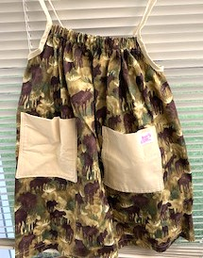
Dress a Girl - By Evelyn Harris

I would like for us to increase our output of dresses, if that is at all possible. I am very grateful to those of you who continue to give me dresses you have completed and am now trying to help make it a bit easier for more people to make a dress or two. First, I have put several packets together and they are available for you to pick up in the back room at Sew n Sew. In addition, I have included several Dress-a-Girl tags in an envelope with the kits, so if you want to make a dress using your own fabric, you can do so.

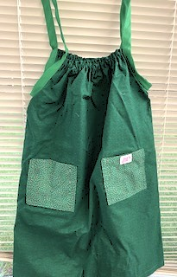
Instructions for making the dresses can be found on our website (www.oceanwavequilters.com). Look for Community Activities on the home page, then scroll down until you find Dress a Girl. Click on the Dress a Girl Guidelines button and it will bring up a pdf file with the instructions.
There is apparently more demand for the larger size dresses, so if you can make a large or extra-large dress that would be wonderful. You can use an extra piece of cloth to act as a bodice to provide more length, if you wish. Small and medium size dresses are excellent as well. I recommend against using rick-a-rack or other decorations because it doesn’t look good without ironing and the girls usually don’t have access to irons. Simple embroidery is fine, but no need to be fancy.
These dresses are very much appreciated and loved by the girls who wear them. Each dress you make is a deeply meaningful gift. Please get in touch with me if you have any questions or issues. I would be happy to sit with you and walk you through making a dress if that would help. You can call me at 707-962-0706 or text me at 530-635-2163 anytime during the day. Thanks for all that you do, Evelyn .

EDUCATION & SPECIAL EVENTS

UPCOMING CLASS
MONDAY - APRIL 27, 2026 – YVONNE PHENICIE – OMBRE BARGELLO 1 DAY CLASS
Sign up for Yvonne’s class will be available at the February and March 2026 General Meeting. Sign up is first-come/first serve, and registration is not complete until payment is received. Please pay with exact cash or check (made out to Ocean Wave Quilters) to either Steffany B. or Sharon L. This will be a one-day class using the “Two Fabric Bargello” pattern by Susie Weaver. The cost will be $35 for OWQ Members plus $10 for the pattern (available from Yvonne at the class). Once you have signed up and paid, you will be provided with the class supply list. The sign-up will be available for OWQ members until the end of March; following that, if there are still vacant spots, we will open to nonmembers at a cost of $75. If you have questions or want to view the quilt samples in person (at Sew n Sew) please contact Steffany Baroni, Education and Special Events Committee Co-Chair.

These are samples of the quilt possibilities
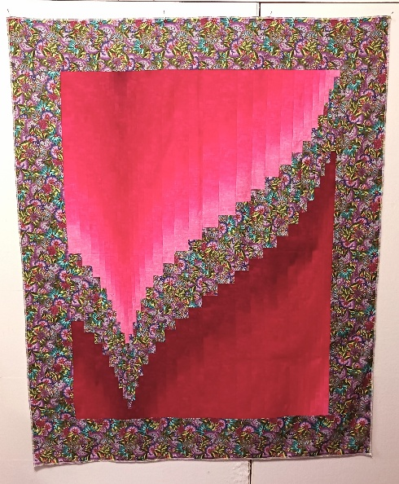
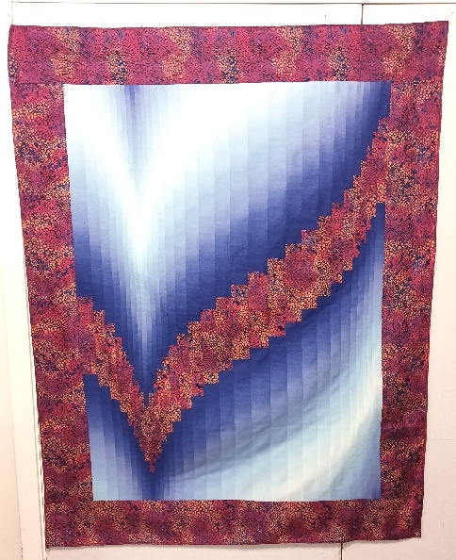
OMBRE BARGELLO (light -dark-light) OMBRE BARGELLO (light -dark)

BLOCK OF THE MONTH
FEBRUARY INSTRUCTOR: Lony Fiduccia

***Instructions for blocks from July 2025 until January 2026 BLOCK OF THE MONTH – Can be found on the OWQ website or get a copy at Sew n Sew in the BOM binder on the OWQ shelf. February’s BOM pattern will be available after the February 8th general meeting.

SPRING QUILT RETREAT
The Spring Retreat will be from Wednesday, March 25th until Saturday, March 28, 2026. It will be located at the Albion Fields Station in Albion. We hope you can join us for this fun event, which gives a chance to socialize and enjoy each other’s’ company!

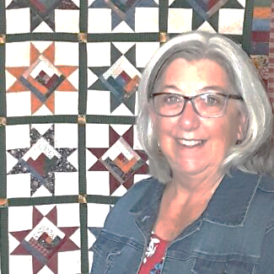
SPRING APPRECIATION LUNCHEON
Yvonne Phenicie – “I Love a Challenge” will present at the April 26, 2026, Appreciation Luncheon.
She will also be doing a one-day Ombre Bargello class on Monday, April 27, 2025 (see above). Sign up for the April 27th class at our February and March 2026 General Meeting and at Sew n Sew (see Steffany B).

ROUND ROBIN
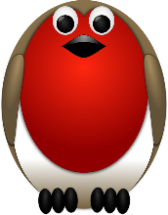
We are in the 4th Round of the “Round Robin”! One more to go! Target completion date is April 12, 2026.

The next switch will take place at the February 8, 2026, general meeting ♥️♥️ It’s neat to get all these cool quilts and enjoy being part of this amazing process!

Elizabeth Foster, Education & Special Events Committee Chair
Committee members: Steffany Baroni, Kathy Demetri, and Lisa Carter
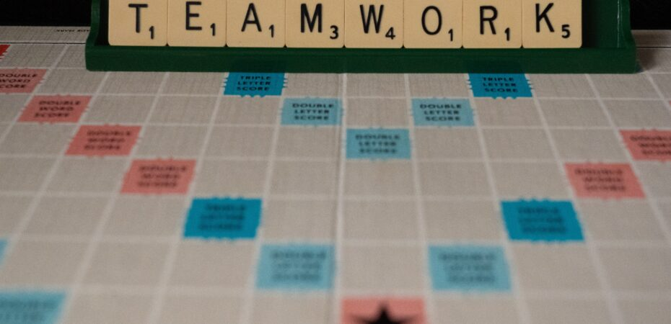

HOSPITALITY

Everyone bringing food items to share and free sewing items for the free table have been doing a great job sharing as well as taking the leftover items with them after the meeting. Taking our garbage away has also been working well by having a few people willing to take it home with them. Anything we can do to make sure we remain welcomed at the Senior Center is a good thing.
We still have the name tag raffle at each meeting, and a room one day per month for our own sewing that the hospitality committee is responsible for. If you have suggestions or someone in our group that needs a "get well" or "thinking of you" card, please let Cindi Jo know. Thanks!
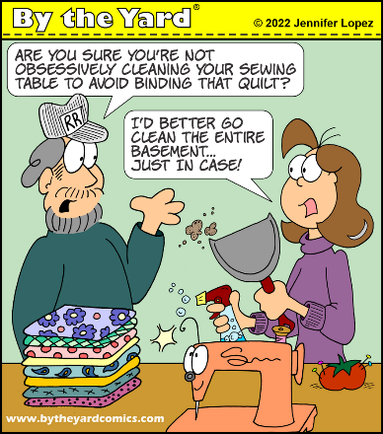
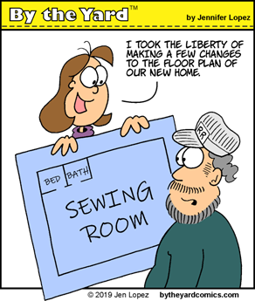
Cindi Jo Wiley, Hospitality Committee Chair


FEBRUARY BIRTHDAYS

Susan Hall February 6

Yola Sharpe February 8

Sandi Smith February 8

Dee Goodrich February 18

Nancy Kozak February 22

Evelyn Harris February 24

FORT BRAGG QUILT SHOW

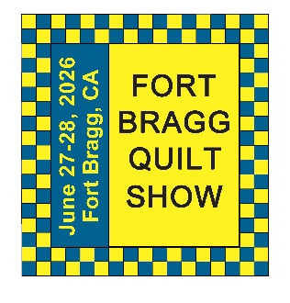
Next Quilt Show meeting will be
Wednesday – February 4, 2026 - 10:30 am at SEW N SEW

Your Quilt Show Committees are working away to prepare for the 2026 quilt show. The date is coming up soon; time flies when you are preparing for this show. The location has been set, pins have been ordered and received, post cards have been printed and are ready to be sent out.
Kits for the 2027 raffle quilt have been handed out, and individuals are working on putting blocks together. If you have not signed up to help with this quilt and would like to, please contact Shari Lyons.
The many committees are preparing for their special duties. If you are interested in helping with the quilt show, please let anyone on the committee know.

Our Featured Artist for 2026 is Evelyn Harris; the Featured Artist for 2027 will be Linda Walzer, and the Featured Artist for 2028 will be Nancy Lamphear. Giving our artists advanced notice gives them time to prepare for their show.

Respectfully submitted,

Carole Poma, 2026 Fort Bragg Quilt Show Committee Chair

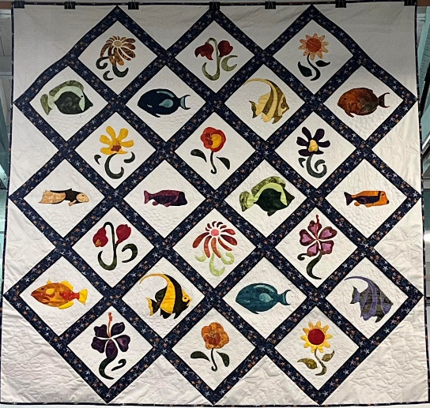Gardens by the Sea

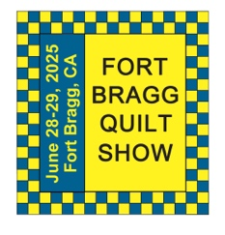
The 29th Annual
Fort Bragg Quilt Show
“Quilts for All Seasons”

A HUGE “Thank You”
to this year’s sponsors:

Diamond
Rossi Building Materials
Mendocino Railway

Platinum
Community First Credit Union

Gold
Sew-n-Sew Laurel Deli and Desserts
Mendo Litho REMax/First Equity Realty
D’Aurelio’s Noyo Fish Company
Norvell’s Noyo Pacific, Inc.

Silver
Pacific Pearl Upcycle Mercantile Mendocino Cookie Co.
Windsong Used Books & Records Chernoff’s Jewelers
Frankie’s Pizza & Ice Cream Noyo Fishing Center

Bronze
Beautiful Earth Splendiferous
Big Foot Ice Cream Essentially Hair
Tsunami’s Glass Shop Zapateria La Mexicana
Shirts and More Oh, Baby!
Egghead’s, Inc.

And THANKS to our Raffle contributors:
Purity, Imaginations, Reynolds, Cucina Verona Mercato, Sew-n-Sew, Fabled (Frame Mill), Pippi’s Socks, The Bookstore & Vinyl Cafe, Hot Pepper Jelly, Roundman’s Smoke House, Lunar Tide, Safeway, Harvest Market, Hare Creek Nursery, Highway 20 Feed, Simply Succulents, Zho Cellars, Larkin Cottage, Harbor Lite Lodge, FBQS Vendors, and OWQ members

NEW SECTION!
Member BIO

I thought I would try something new and introduce a biography section. This will be an opportunity to share with others how we got into quilting and any other interesting things we would like to share. I will start with myself:
Elizabeth Foster – Nurse by weekday, Quilter by weekend
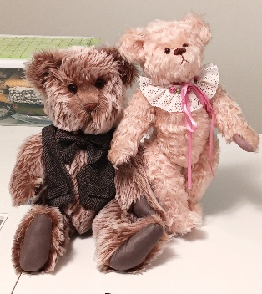
I may not be as prolific a quilter as many of you, including my mother, Suzanne, but I started sewing when I was about 14 years old. So, I wouldn’t consider myself a beginning sewer nor beginning quilter My Mom signed me up for a sewing class at what was at that time New York Fabrics in Pleasant Hill, CA. I used to have fun sewing things like overalls and hair scrunchies; items popular in the 80s and early 90s. In 1995, I took a teddy bear making class and really got into that for a while, buying mohair, glass eyes and fitting all the bears with moving joints. I even sold my bears at the Pleasant Hill Holiday craft fair in 1995.
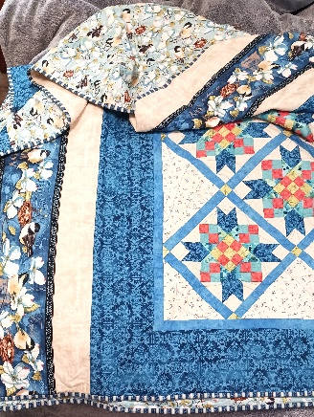
I started to become interested in quilting in the late 90s and signed up for a quilt class at our local quilt store. I ended up transferring the class over to my Mom, most likely due to a work schedule change or something. I put my desire to learn to quilt on the back burner until after my husband and I returned from living in the Netherlands (2002-2007). While living overseas I had my Viking sewing machine with me, but had very little time to sew between work, social life and traveling. I ended up selling it before we moved back to California. My Mom had bought a new machine, so she gave me her Bernina 1530 and that is what I used up until 2016, when I bought a machine with a larger throat in order to be able to machine quilt the king size quilt I made for my Mom for her 75th B-day (see quilt at the meeting). Ironically, I ended up quilting it on her long-arm and adding the borders after.
(section of Mom’s 75th B-day quilt “Feather Your Nest” 2016)

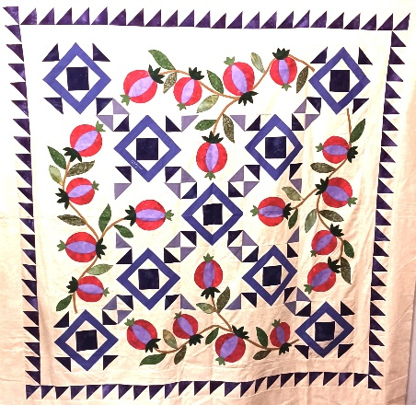
My first official quilt class was in 2008 with Laura Nownes; it was a beginner basic quilt class. I took several classes, many with Linda Ballard, and went on quilt retreats until about 2015, when I hurt my back at work. At this point things really slowed down for me. I have had back issues since 1995, but the last incident really set the tone for what is now my limited physical state. I am not able to sit or stand for extended periods of time without a lot of discomfort. To top it all off, I have a Sensory Processing Sensitivity personality trait that makes sewing in groups or at retreats challenging – I get very distracted and find it hard to focus. So, I don’t produce a lot—not compared to our extremely talented group—and I ask a lot of questions, it’s not necessarily because I don’t know something, but because I have learned to take advantage of being around others who have greater experience and I really like to learn new things. Being part of Ocean Wave Quilters in the highlight to “living my best life” here on the Mendocino Coast!

(“Pomegranates of Love” 2011 -quilt top made for my husband, Jon, for his B-day. Waiting in the que to be hand quitted by OWQ)

Stay tuned for next month’s Quilter “Member Bio”!
***If you are willing to share your quilting experience please let me know and I will put you in our biography section***

MARK YOUR CALENDARS FOR UPCOMING IMPORTANT DATES

FEBRUARY 2026 | DAY | TIME | ACTIVITY | LOCATION
February 4th | Wed | 10:30 am | FBQS Meeting | Sew n Sew
February 8th | Sun | 1:30 – 3:30 pm | General Meeting | Senior Center
February 18th | Wed | 10:30 am | Board Meeting | Sew n Sew
February 22nd | Sun | 10:30 am – 3:00 pm | Sew Sunday | Senior Center
MARCH | DAY | TIME | ACTIVITY | LOCATION
March 4th | Wed | 10:30 am | FBQS Meeting | Sew n Sew
March 8th | Sun | 1:30 – 3: 30 pm | General Meeting | Senior Center
March 18th | Wed | 10:30 am | Board Meeting | Sew n Sew
March 22nd | Sun | 10:30 am | Sew Sunday | Senior Center
APRIL | DAY | TIME | ACTIVITY | LOCATION
April 1st | Wed | 10:30 am | FBQS Meeting | Sew n Sew
April 12th | Sun | 1:30 – 3:30 pm | General Meeting | Senior Center
April 15th | Wed | 10:30 am | Board Meeting | Sew n Sew
April 26th | Sun | 12:00 pm | APPRECIATION LUNCHEON | Senior Center
April 27th | Mon | TBD | Yvonne Phenecie Class “Ombre Bargello” | Sew n Sew
Monthly Activities:
Hand quilting: Every Tuesday/Senior Center – 1:00-3:00 pm
Sew Sunday: 4th Sunday of the Month – 10:30 am – 3:00 pm
***Hand Sewing: Every Wednesday/ZOOM – 1:00 – 4:00 pm – Join Zoom Meeting
https://us06web.zoom.us/j/81292075496?pwd=bldtVHFrRGhpTTVxUGEraEFFc2hvQT09
Meeting ID: 812 9207 5496 Passcode: HandSew

2025-2026 Board Members and Committee Chairs

President | Nadine Schultz | 707-684-9627 | Quilterqueenbee@yahoo.com
Vice-President | Carole Poma | 707-813-3001 | carolepoma@comcast.net
Secretary | Paula Perelstein | 707-962-9006 | Paula@sew-n-sew.com
Treasurer | Sharon Lau | 707-937-3049H  707-357-7447C | quiltkats@yahoo.com  sharon@oceanwavequilters.com
Communications | Shari Lyons | 707-684-0831 | lybra@mcn.org
Newsletter | Elizabeth Foster | 510-292-7833 | JJefoster@yahoo.com
Service | Kathy Demetri | 707-937-3667 | kathydemetri@gmail.com
Education & Special Events | Elizabeth Foster | 510-292-7833 | JJefoster@yahoo.com
Hospitality | Cindi Jo Wiley | 707-357-4774 | queenbee@mcn.org
FBQS Chair | Carole Poma | 707-813-3001 | carolepoma@comcast.net

NEWSLETTER – Next newsletter articles/items are due February 25, 2026. The Newsletter will be sent out by March 1, 2026.

Thank you, Elizabeth Foster, OWQ Newsletter Editor

