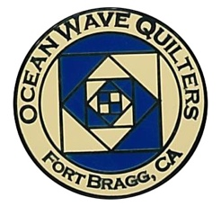
OCEAN WAVE QUILTERS
Fort Bragg, California – www.oceanwavequilters.com
JANUARY 2026 NEWSLETTER
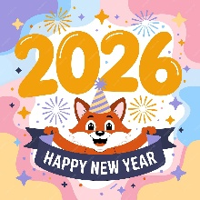  WELCOME TO THE NEW YEAR 2026!  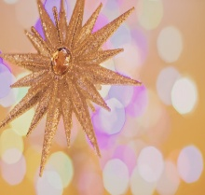  We had a great time at the  OWQ 2025  HOLIDAY PARTY!  ENJOY THE PHOTOS THAT CAN BE FOUND AT END OF THE NEWSLETTER! | Happy New Year!  And some thoughts on Quilts, Gifts, Memories and Stories…  In my house, I have a sturdy curtain rod on which to hang my quilts. At times, there is one large quilt hanging there, but at others, there may be one or two small quilts. Today, there are 7 (see next page). While decorating for the holidays, I pulled out a stack of smaller quilts and decided to hang them all up on the quilt rod. This was done, of course, for my own enjoyment. However, last night, when my son was commenting on them, I realized that each quilt is a story worth telling—no matter if it’s short or long, easy or complex. My stories all involve my mom. On the far right is Sunbonnet Sue. This was a gift from mom. It was probably made in her early days of making quilts. I remember having it in college or shortly thereafter, certainly before I had any appreciation for Sunbonnet Sue. I usually hung it from the top of a door with thread and a thumb tack. It’s puffy from the polyester batting, but I love the simplicity of it – certainly a favorite.  The pair of candy canes was a Christmas gift from mom about 15 years ago. I love candy canes. Maybe it’s the red and white contrast, maybe it’s just the red—I have always loved red. I never asked her about them; I just accepted them as a beautiful gift. I’d like to hear her story about them now…  The two quilts between the candy canes, the “Christmas Tree” and the “Christmas Manger”, were kit gifts from my mom during the 10 years in Indiana. The Christmas tree pattern she gave with tiny pieces of pre-cut fabric she had chosen. This was not a kit I would have purchased myself, but I found myself really enjoying the process of creating this tiny quilt. I added buttons and ribbons. There are gingerbread buttons on the tree representing the people in my family and buttons of toys beneath the tree. The train wheels are buttons, and buttons decorate the border. Lovely memories.  The “Christmas Manger” just came as a pattern with Nativity and shepherd buttons. I remember working on part of it while spending Christmas with my aunt (the one I made the African quilt for), my parents, and my family in Sarasota, FL. It was a very special Christmas. My aunt was a fantastic hostess—but that is another story. We went fabric shop-hopping looking for the right fabric for the star. Later, I found wise men and camel buttons, so there are lots of camels in the scene.  “Christmas Stockings” was a gift made by mom. Once again, I don’t know the story. It is cute, I love the brick fabric, but am unaware of her story. Now I wish…just one question could have opened up a whole world of information…  But I do know the story of the final quilt. When mom moved from Indiana to California, she had to downsize significantly. My sister-in-law really wanted the Christmas ornament quilt. I was feeling generous and let her take it, but I felt sad afterwards. I finally expressed my sadness to mom and she said, “I’ll make you another one!” And, she did. I like it even better. She even cut up one of her Christmas sweatshirts with a wreath on it to make an ornament. And it has more memories--it was one of the first quilts I used my new Bernina longarm to quilt. I was just learning, and now I laugh at how difficult it was to make that computer do the simple thing I wanted it to do.  Quilts, gifts, memories, stories…. Do you share your quilt story with those you gift a quilt to? Maybe they don’t ask. So, maybe you can ask, “Would you like to hear the story about this quilt?” It might not be complex; it could be as simple as, “I know you like candy canes and I thought of you when I saw this pattern and make it for you”. Happy Quilting during 2026!!  Nadine Schultz, OWQ President
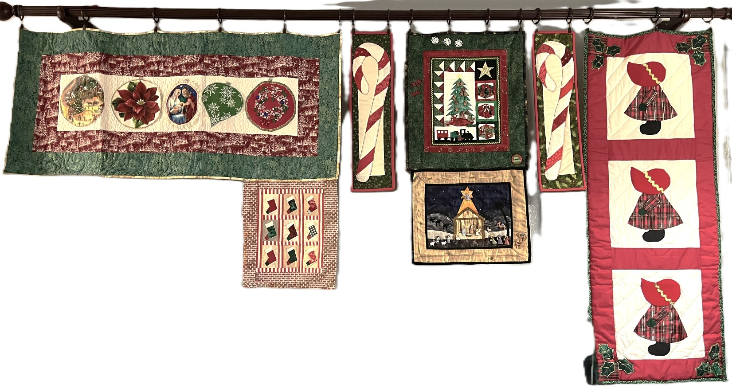

TREASURER’S REPORT

Ocean Wave Quilters
2025 December Treasurer’s Report
Starting balance 11/19/2025 | $4172.25
Insurance for Albion Retreat | $10.00
Insurance for meetings at Senior Center | $25.00
Insurance for meetings at Senior Center - resubmit | $25.00
Printer stock for labels for community quilts | $145.36
Brown bag prizes (from money paid) | $80.00
Holiday party door prizes | $100.00
TOTAL EXPENSE | $385.36
Donation - Stella Regalia memorial | $1,000.00
Quarterly raffle basket | $162.00
TOTAL INCOME | $1,162.00
Ending balance 12/16/2025 | $4,948.89

Fort Bragg Quilt Show
2025 December Treasurer’s Report

Starting balance 11/19/2025 | $13,764.99
2026 Quilt Show Pins | $297.00
2026 Quilt Show Postcards | $265.05
TOTAL EXPENSE | $562.05
Raffle Quilt Tickets | $470.00
TOTAL INCOME | $470.00
(was $490, but check was not accepted at CFCU)
Ending balance 12/16/2025 | $13,672.94

Submitted by Sharon Lau, Treasurer
Approved at the 12-17-2025 Board Meeting

Sharon Lau, OWQ Treasurer

COMMUNICATIONS

Susan C., Chair of the 2026 Quilt Walk, wants to remind the guild members to begin making small quilts and blocks to enter into the Quilt Walk. Time is flying by, and we need 100+ small blocks by May! She will be bringing a sign up sheet to the next meeting so you can create a block for a specific business, if you choose.

The next Quilt Show meeting has been rescheduled to Friday, January 9 at 10:30 at Sew-n-Sew. Please come and join the team!

Shari Lyons, Communications Committee Chair

SERVICE COMMITTEE
Hello Quilters!
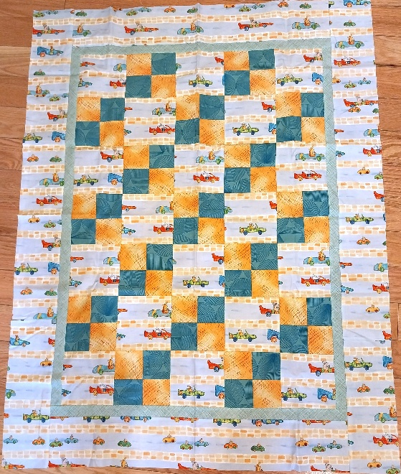
Hope you all enjoyed the holidays! The donation numbers for December 2025 were:

12 Warm Welcome quilts
16 Chemo Port Pillows
14 Pillowcases
3 Pet Beds

If anyone has any suggestions for creating new donation items, or can suggest a new organization to donate to, please let me know!

Happy New Years to all!
Kathy Demetri, Service Committee Chair Warm Welcome Quilt

EDUCATION & SPECIAL EVENTS

UPCOMING CLASS

MONDAY - APRIL 27, 2026 – YVONNE PHENICIE – OMBRE BARGELLO ONE DAY CLASS
Sign up for Yvonne’s class will be available at the January 2026 General Meeting on Jan 11th. This will be a one-day class using “Two Fabric Bargello” pattern by Susie Weaver. The cost will be $35 for OWQ Members plus $10 for the pattern (available from Yvonne at the class). Once you have signed up and paid, you will be provided with the class supply list. The sign-up will be available for OWQ members in January and February; following that, if there are still vacant spots, we will open up to outside of OWQ membership. If you have questions or want to view the quilt samples in person (at Sew n Sew) please contact Steffany Baroni, Education and Special Events.

Here are two samples of the quilt possibilities:
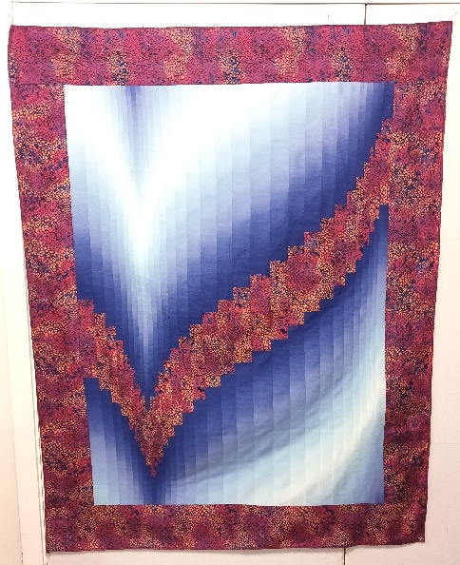
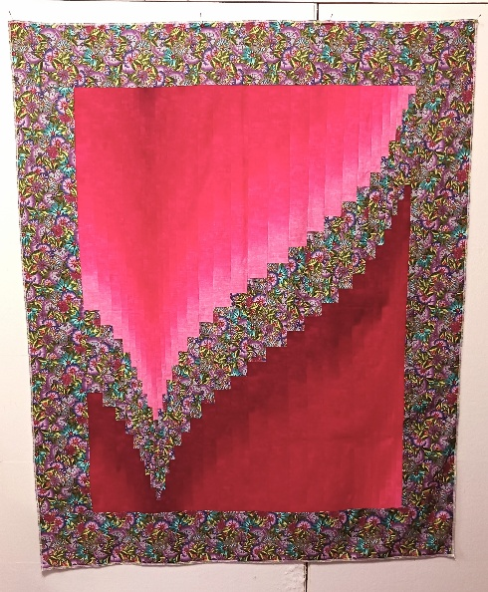
OMBRE BARGELLO (light -dark-light) OMBRE BARGELLO (light -dark)

BLOCK OF THE MONTH
JANUARY INSTRUCTOR: Martin Weber

Instructions for the DECEMBER 2025 BLOCK OF THE MONTH – Can be found on the OWQ website or get a copy at Sew n Sew in the BOM binder on the OWQ shelf. January’s BOM pattern will be available after the January 11th general meeting.

SPRING QUILT RETREAT
The Spring Retreat will be from Wednesday, March 25th until Saturday, March 28, 2026. It will be located at the Albion Field Station in Albion.

SPRING APPRECIATION LUNCHEON
Yvonne Phenicie will be our guest for the April 26, 2026 Appreciation Luncheon. She will also be doing a one-day Ombre Bargello class on Monday, April 27, 2025 (see above)
Sign-up for the April 27th class will available at our January 11, 2026 General Meeting.

ROUND ROBIN

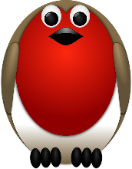
We are in the 3rd Round of the “Round Robin”! 2 more to go! Target completion date is April 12, 2026

The next switch will take place at the January 11, 2026 general meeting ♥️♥️

Elizabeth Foster, Education & Special Events Committee Chair
Committee members: Steffany Baroni, Kathy Demetri, and Lisa Carter

HOSPITALITY

The Quarterly Raffle at December's meeting was won by Susan MacDonald! I hope she is enjoying all the goodies that were packed in the bag.
Because of all the gifting at the December meeting, we skipped the nametag raffle for the month. Be prepared next meeting by wearing your nametag as we will return to drawing a name for a prize (or two).
Our next Sew Sunday at the Senior Center is on Sunday, January 25th from 10:30 until about 2:30.
If you know of a member that is under the weather or might need a pick-me-up, please contact me to send them a card.

Thank you,

Cindi Jo Wiley, Hospitality Committee Chair

JANUARY BIRTHDAYS

Janet Nylund January 2

Shari Lyons January 4

Linda Moore January 4

Teresia Zadroga-Haase January 16

Tracy Salkowitz January 18

Phoebe Graubard January 26

Daffy Hervilla January 30

QUOTE OF THE MONTH
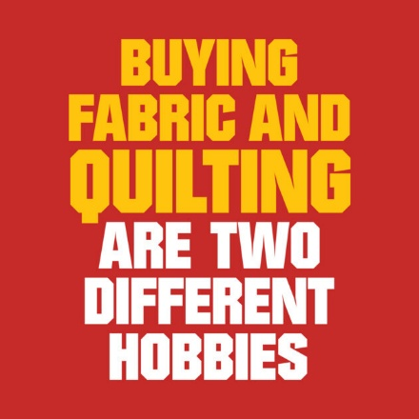
Submitted by Kate Rule-Gustafson

FORT BRAGG QUILT SHOW
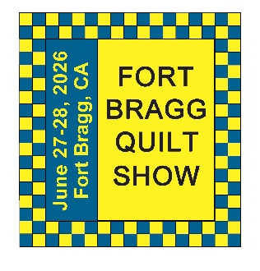
Next Quilt Show meeting will be
Friday, January 9, 2026* - 10:30 am at SEW N SEW
*PLEASE NOTE DATE CHANGE FOR JUST THIS MEETING

We will have more interesting items starting next month. The fun will begin with this new year!

Carole Poma, 2026 Fort Bragg Quilt Show Committee Chair
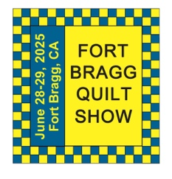
The 29th Annual
Fort Bragg Quilt Show
“Quilts for All Seasons”

A HUGE “Thank You”
to our sponsors:

Diamond
Rossi Building Materials
Mendocino Railway

Platinum
Community First Credit Union

Gold
Sew-n-Sew Laurel Deli and Desserts
Mendo Litho REMax/First Equity Realty
D’Aurelio’s Noyo Fish Company
Norvell’s Noyo Pacific, Inc.

Silver
Pacific Pearl Upcycle Mercantile Mendocino Cookie Co.
Windsong Used Books & Records Chernoff’s Jewelers
Frankie’s Pizza & Ice Cream Noyo Fishing Center

Bronze
Beautiful Earth Splendiferous
Big Foot Ice Cream Essentially Hair
Tsunami’s Glass Shop Zapateria La Mexicana
Shirts and More Oh, Baby!
Egghead’s, Inc.

And THANKS to our Raffle contributors:
Purity, Imaginations, Reynolds, Cucina Verona Mercato, Sew-n-Sew, Fabled (Frame Mill), Pippi’s Socks, The Bookstore & Vinyl Cafe, Hot Pepper Jelly, Roundman’s Smoke House, Lunar Tide, Safeway, Harvest Market, Hare Creek Nursery, Highway 20 Feed, Simply Succulents, Zho Cellars, Larkin Cottage, Harbor Lite Lodge, FBQS Vendors, and OWQ members

MARK YOUR CALENDARS FOR UPCOMING IMPORTANT DATES
JANUARY 2026 | DAY | TIME | ACTIVITY | LOCATION
January 9th * | Fri (one time change) | 10:30 am | FBQS Meeting | Sew n Sew
January 11th | Sun | 1:30 – 3: 30 pm | General Meeting | Senior Center
January 21st | Wed | 10:30 am | Board Meeting | Sew n Sew
January 25th | Sun | 10:30 am – 3:00 pm | Sew Sunday | Senior Center
FEBRUARY | DAY | TIME | ACTIVITY | LOCATION
February 4th | Wed | 10:30 am | FBQS Meeting | Sew n Sew
February 8th | Sun | 1:30 – 3:30 pm | General Meeting | Senior Center
February 18th | Wed | 10:30 am | Board Meeting | Sew n Sew
February 22nd | Sun | 10:30 am – 3:00 pm | Sew Sunday | Senior Center
MARCH | DAY | TIME | ACTIVITY | LOCATION
March 4th | Wed | 10:30 am | FBQS Meeting | Sew n Sew
March 8th | Sun | 1:30 – 3: 30 pm | General Meeting | Senior Center
March 18th | Wed | 10:30 am | Board Meeting | Sew n Sew
March 22nd | Sun | 10:30 am – 3:00 pm | Sew Sunday | Senior Center

Monthly Activities:
Hand quilting: Every Tuesday/Senior Center – 1:00-3:00 pm
Sew Sunday: 4th Sunday of the Month – 10:30 am – 3:00 pm
***Hand Sewing: Every Wednesday/ZOOM – 1:00 – 4:00 pm – Join Zoom Meeting
https://us06web.zoom.us/j/81292075496?pwd=bldtVHFrRGhpTTVxUGEraEFFc2hvQT09
Meeting ID: 812 9207 5496 Passcode: HandSew

2025-2026 Board Members and Committee Chairs

President | Nadine Schultz | 707-684-9627 | Quilterqueenbee@yahoo.com
Vice-President | Carole Poma | 707-813-3001 | carolepoma@comcast.net
Secretary | Paula Perelstein | 707-962-9006 | Paula@sew-n-sew.com
Treasurer | Sharon Lau | 707-937-3049H  707-357-7447C | quiltkats@yahoo.com  sharon@oceanwavequilters.com
Communications | Shari Lyons | 707-684-0831 | lybra@mcn.org
Newsletter | Elizabeth Foster | 510-292-7833 | JJefoster@yahoo.com
Service | Kathy Demetri | 707-937-3667 | kathydemetri@gmail.com
Education & Special Events | Elizabeth Foster | 510-292-7833 | JJefoster@yahoo.com
Hospitality | Cindi Jo Wiley | 707-357-4774 | queenbee@mcn.org
FBQS Chair | Carole Poma | 707-813-3001 | carolepoma@comcast.net

NEWSLETTER – Next newsletter articles/items are due January 28, 2026. The Newsletter will be sent out by February 1, 2026.

Thank you, Elizabeth Foster, OWQ Newsletter Editor

OWQ 2025 HOLIDAY PARTY

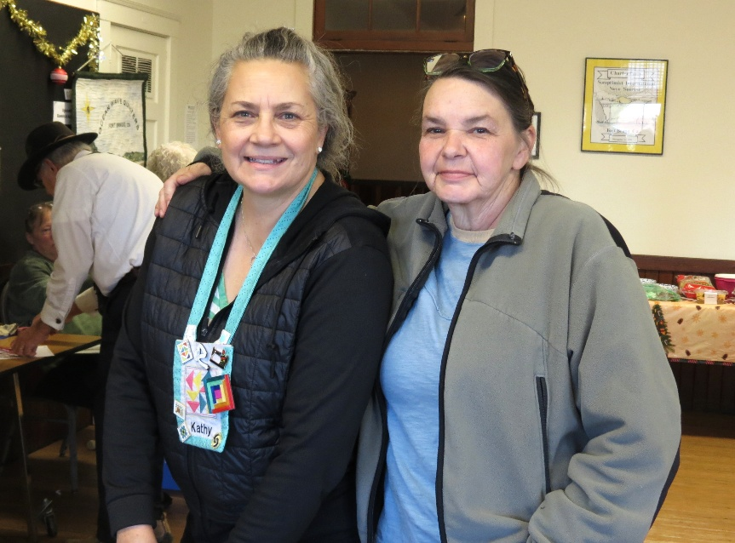

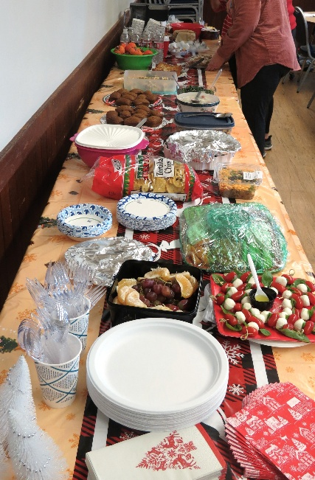
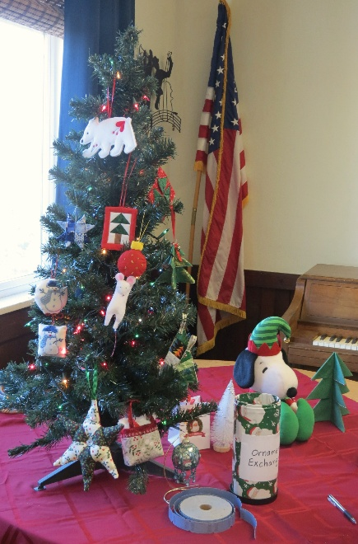
owq

