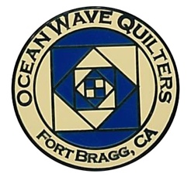

OCEAN WAVE QUILTERS
Fort Bragg, California – www.oceanwavequilters.com
DECEMBER 2025 NEWSLETTER
HOLIDAY PARTY  DECEMBER 14, 2025  12:00 – 3:30 pm  - Potluck style food  - Ornament Exchange  - “New” Welcome Raffle  - Quarterly Basket Raffle  - December BOM handout  - Brown Bag Challenge  - Round Robin Swap  - General Meeting  Will start at 1:00pm  Please join us! For more details – see Special Events section  *** NO free table and NO Show and Tell at this meeting!  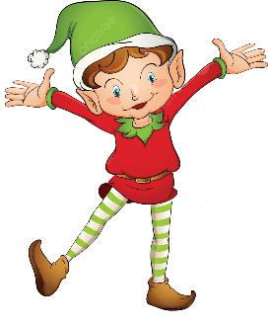 |   Happy December!  December strikes me as a family month. I do wish you all a busy and family filled month.  One of my favorite family members was my dad’s sister. My aunt was a powerful woman who was full of energy, wisdom, and skill. She taught nursing for 15 years in Africa before she came back to the USA to further her own education and become the chair of the nursing department at a university in Michigan. She was the recipient of my second “African” quilt. It was the same size as the one I made my dad (see last month’s newsletter). The fabrics were different, but I felt much more comfortable making this second quilt.  My next challenge was to make a quilt for our king-sized bed. This African continent was 400 times larger than the original map. I once again had to make a new pattern and cut out each country. Sheldon wanted me to see if I could make the desert areas of brown fabric and the equator of mostly greens. This created a very great challenge for me, but in the end, it was worth all the extra work. These countries were ironed to some fusible batting to hold them in place before I sewed them together. This worked better than the wonder-under of the previous 2 quilts. I also was challenged to find blue ombre fabric to make the ocean look shallow near the land and deeper farther away. Believe it or not, I found this wonderful ocean fabric in a quilt shop in the desert of Arizona.  The quilting of this quilt was an adventure of ocean lines, outlining African animals, and accenting special parts of the fabric. This is one of my favorite quilts. I’m so glad that I was able to share it with visitors of the 2025 Fort Bragg Quilt Show.  I hope you can find time to enjoy quilting during the Holidays!  Nadine Schultz, OWQ President

TREASURER’S REPORT
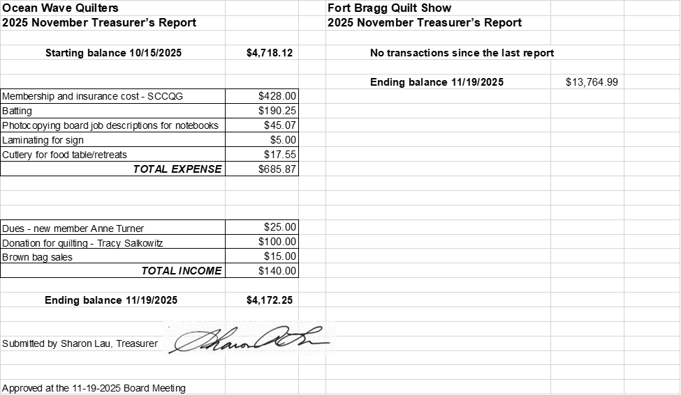

Sharon Lau, Treasurer

COMMUNICATIONS

- Please be aware the next FBQS meeting is not until next year – January 7, 2026

- The current calendar has an update: there will be a OWQ BOARD Meeting on December 17, 2026 – 10:30 am Sew n Sew. OWQ Board meetings take place on the 3rd Wednesday of every month.

Shari Lyons, Communications Committee Chair

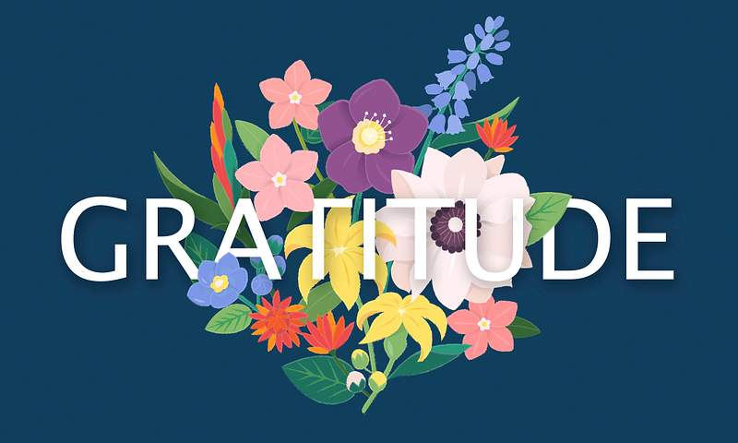

Linda Walzer just received a letter from the family of Stella Regalia, along with a donation for $1000! Linda will be presented this gift to the OWQ Guild at the Holiday Party on December 14^{th.}
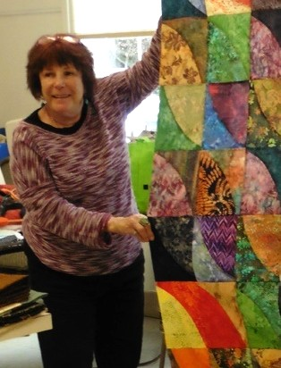
To: The Ocean Wave Quilters Guild
As most of you know, Stella Regalia passed away earlier this year in February.Stella was an avid and passionate quilter and the Ocean Wave Quilters Guild was an extremely important part of her life. The Guild provided Stella with years of quilting joy with special friends, a family, an outlet and escape, retreats and years of love and happiness. This holiday season Stella's family would like to celebrate by giving a monetary gift to the Guild in memory of our Mom and Nonni, Stella Regalia.
Thank you all for being there for Stella throughout the years.
Sincerely,
Jeanette, Rob, Diane, Rex, Sarah, Kevin, Rachael, and Mango

The HOLIDAYS are here!


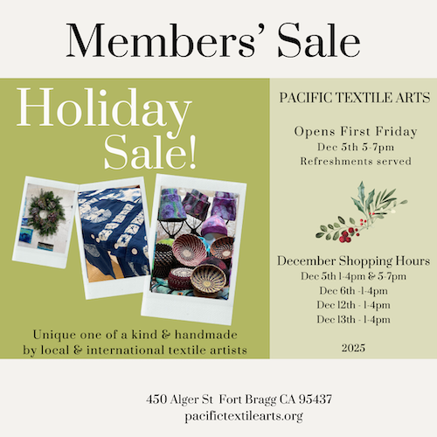

Dee Goodrich recently had a bit of good fortune and won the
Colusa Guild’s Opportunity Quilt!! Congratulations Dee! What a beautiful quilt!

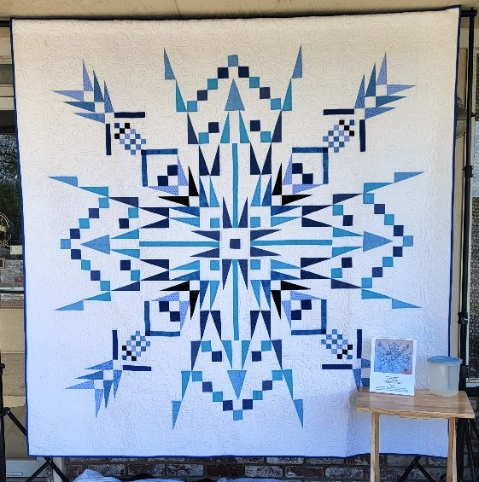

SERVICE COMMITTEE
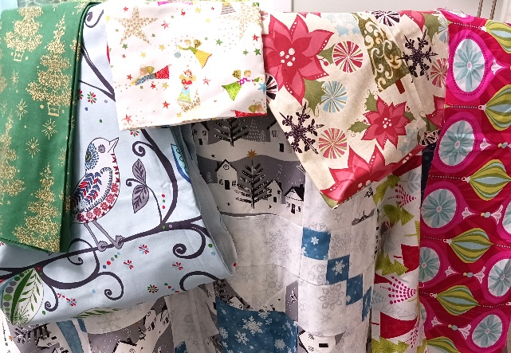
The donation numbers for the month of NOVEMBER 2025 from the Service Committee are as follows:
10 Community Quilts
6 Pillowcases
8 Warm Welcome Quilts
4 Pet Beds
4 Chemo Port Pillows

Dear Guild Members:
Judy Whitlock has requested Christmas/Winter themed baby quilts. Also, we continue to need any sized quilts that will fit a twin bed.
“So, pull out that HOLIDAY FABRIC and get BUSY!!!” Elizabeth F.

Thank you for all you do for our community, and Happy Holidays!

Kathy D., Service Committee Chair

Making Quilts for Our Community Projects – some Tips – Sharon L.

If you would like to make quilts to contribute to our community projects, here are some tips to remember:

YOU DO NOT NEED TO PURCHASE BATTING FOR YOUR QUILT! The guild provides batting. If you are going to quilt the quilt yourself, you can contact me, Sharon Lau, (sharon@oceanwavequilters.com) for batting – just let me know what size your quilt top is and I’ll get the batting to you.

Fabric Kits – Fabric kits are available in our storage area at Sew n Sew or at our monthly meetings. These kits have been put together by our Service Committee from fabric donations and often contain enough fabric to make a quilt top and a quilt back. Feel free to combine fabrics from different kits, or to use fabric from your own stash, if you like – whatever makes you feel creative! (Leftover fabric from the kit is yours to use as you wish.)

Warm Welcome Quilts – can be any size, but are typically 36″ x WOF or 45″ x 45″. Since these are for babies, they should not have buttons or anything else that can detach and be a choking hazard. Double-check for pins and stray threads or thread loops that could be a hazard. There are some pattern links on the website you may find helpful.

Texture or Touch Quilts – are generally lap-sized and made from fabric that has texture, such as corduroy, minky, velveteen, wool, chenille, seersucker, lace, etc. A peaceful state of mind can be gained by feeling the various textures. Consider adding a pocket or two to the quilt top for the patient to store a Kleenex or a personal item (put the quilt on your lap to decide where to put the pocket – make it reachable.) Recommended size: 45” X 60”. These also should not have buttons or anything else that can detach, but securely stitched on ribbons, pom-poms, etc. are fine. These do not have to have batting in them.

Quilts for Other Projects, such as the Infusion Center, Project Sanctuary, etc. – are typically at least 48” x 60-72”, but can be larger. We ask that, in addition to the quilt top, you also make the quilt back.

REMEMBER: if you do not want to do your own quilting, we have guild members (Martin, Nadine, and me) who will happily quilt it for you! Make sure your quilt back is at least 3” larger on all 4 sides than your quilt top. Also make sure that all 4 sides are STRAIGHT (no jagged edges, please!) and that the top is parallel to the bottom and the sides are parallel to each other. This is important for loading the quilt properly on the long-arm. (Quilts that have backs that do not meet these requirements will be returned to you to fix….)

There is a cardboard box in the storage area at Sew n Sew with my name, Sharon Lau, on it. You can drop your quilt off there, but please let me know via email or text (707-357-7447) that you have put a quilt in my box! I don’t check it regularly. Or you can bring your quilt to the monthly meeting. Make sure your name is securely pinned to the quilt, so I know who to return it to!

If you do not want to do your own binding, Sharon G. will bind it for you! Please make the 2½” fabric strip for her to use. You can call or text Sharon G. (707-961-0455) to let her know you have a quilt to be bound and arrange to get it to her or you can bring it to a monthly meeting.

We always label the quilts we make for our community projects. Labels are iron-on, but should also be securely stitched on to the quilt. There is a link to a PDF document on the website, or you can get labels from me or on the OWQ shelf at Sew n Sew. (If I quilt your quilt, I will always return it with a label safety-pinned on to it for you to use.)

If you go to the oceanwavequilters.com website and click on the Community Activities tab, you will find additional information about our community projects, including Dress-a-Girl, pillowcases, chemo port pillows, and pet beds.
Thank you for helping us help members of our community, and for helping us meet our obligations as a recognized non-profit organization!

EDUCATION & SPECIAL EVENTS

HOLIDAY PARTY

We are super excited for the upcoming
Holiday Party on December 14, 2025!

We have decided to start a new tradition this year – “Welcome Raffle” – we will be giving away 10 - $10 gift certificates from Sew n Sew. When you come into the party you will be given a raffle ticket for a chance to win. Join us for the fun!
- POTLUCK – Please bring your favorite savory or sweet dish or dessert to share!
- ORNAMENT EXCHANGE – Don’t forget to bring your homemade ornament—hang it on the holiday tree. One at a time, each person will be able to go to the tree and select which ornament they would like to take home (must bring an ornament to get one).
- QUARTERLY RAFFLE – Our quarterly raffle will also take place at the party. Get ready to purchase your tickets from Cindi Jo.
- BLOCK OF THE MONTH – Kathy D. will have instructors for the December BOM ready to handout. They will also be available at Sew n Sew and via the OWQ website.
- BROWN BAG CHALLENGE – We will be voting on the Brown Bag Challenge projects. Please drop your project off at Sew n Sew by 1 pm on December 13th!
- ROUND ROBIN – Remember to bring your RR project to exchange with the next participant on your list.
The GENERAL MEETING will take place from approximately 1:00-1:30 pm.
Please let us know if you have any questions regarding the holiday party.
*** NO free table and NO Show and Tell at this meeting***

BROWN BAG CHALLENGE
Please follow the rules that were included when you purchased your brown bag. The finished items will be displayed at the HOLIDAY PARTY/General Meeting on Sunday, Dec 14, 2025. Attendees will be able to vote for their favorite project without knowing who made which item, so please do not put your name in a visible location. Make sure you attach scraps of the fabrics that came from your brown bag to the outside of the project.
Please bring your Brown Bag Challenge projects to Sew n Sew and place in the large box on the lower left OWQ shelf by 1 pm on DEC 13th, so we have time to determine the appropriate category to display it in for the meeting.
BROWN BAG CATEGORIES: Quilts, Home goods/wares, Wearables, and Toys.

BLOCK OF THE MONTH
DECEMBER INSTRUCTOR: Kathy Demetri
***Instructions for NOVEMBER 2025 BLOCK OF THE MONTH can be found on the OWQ website, or get a copy at Sew n Sew in the BOM binder on the OWQ shelf. December’s BOM pattern will be available after the December 14th general meeting.

SPRING APPRECIATION LUNCHEON and One-Day Class
Yvonne Phenicie will be our guest for the April 26, 2026 Appreciation Luncheon. She will also be doing a one-day Ombre Bargello class on Monday, April 27, 2025.
Sign up and more information for the April 27th class will be available at our January 11 General Meeting.

ROUND ROBIN
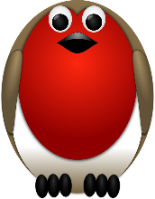
The first Round Robin exchange took place at the OCTOBER general meeting.

The next switch will take place at the December 14th general meeting. ♥️♥️ After that, each team member will pass on the project to the next team member on their list each month. Please provide only the project for the next month to the next participant, do not give multiple projects – for example if you received more than one project and are ahead, please keep until the appropriate month to exchange.

Elizabeth Foster, Education & Special Events Committee Chair
Committee members: Steffany Baroni, Kathy Demetri, and Lisa Carter

HOSPITALITY

- DECEMBER – QUARTERLY RAFFLE BASKET – Get your raffle tickets at the Holiday Party on December 14th.
- Sew Sunday is an open sew day from 10:30 to about 2:00 or 3:00 pm. Bring a snack or lunch for yourself, a project to work on, or stop in to sit and chat. Hope to see you there!
- Next Sew Sunday will be on December 28, 2025

Cindi Jo Wiley, Hospitality Committee Chair
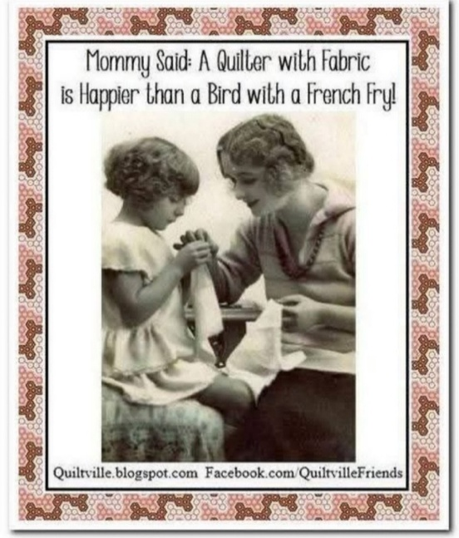
Contributed by Susan Collins

DECEMBER BIRTHDAYS


Bobbie Knapp December 14

Julie Rae Meuschke December 27

FORT BRAGG QUILT SHOW

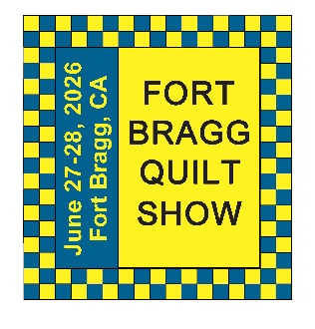
Next Quilt Show meeting will be
Wednesday, January 7, 2026 - 10:30 am at SEW N SEW

We still need volunteers for the Raffle Quilt and Communications. Paula and I are going to work together for the raffle baskets.
More to come after the beginning of the New Year!!!
Carole Poma, 2026 Fort Bragg Quilt Show Committee Chair

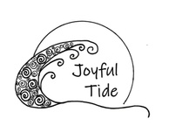
THANK YOU!
The Ocean Wave Quilters would like to express our thanks to Cindi Whitlock (Judy’s daughter) of Joyful Tide for her extreme generosity in donating custom created Thank you cards for the 2025 FBQS Sponsors and donors.

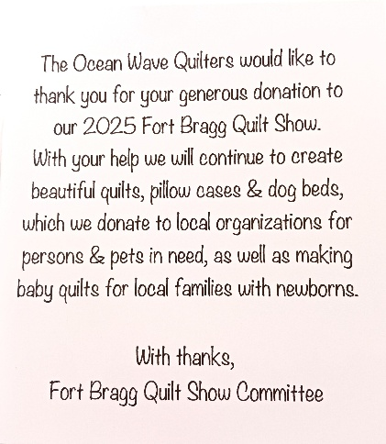
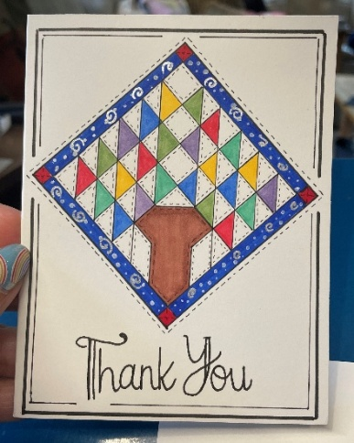

Cindi got her love of art from her dad, Chuck, & her love of quilts from her mom, Judy. She has always been an artist, believing it is “cheaper than therapy”. Her favorite style is ZenDoodles and she prefers to work in black ink. One of her favorite things to do is spread random acts of kindness. She draws every day and started her business “Joyful Tide” in 2024. Checkout Cindi’s website: Joyful Tide (Joyful-tide.com)

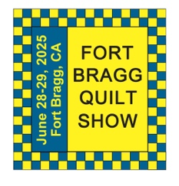
The 29th Annual
Fort Bragg Quilt Show
“Quilts for All Seasons”

A HUGE “Thank You”
to this year’s sponsors:

Diamond
Rossi Building Materials
Mendocino Railway

Platinum
Community First Credit Union

Gold
Sew-n-Sew Laurel Deli and Desserts
Mendo Litho REMax/First Equity Realty
D’Aurelio’s Noyo Fish Company
Norvell’s Noyo Pacific, Inc.

Silver
Pacific Pearl Upcycle Mercantile Mendocino Cookie Co.
Windsong Used Books & Records Chernoff’s Jewelers
Frankie’s Pizza & Ice Cream Noyo Fishing Center

Bronze
Beautiful Earth Splendiferous
Big Foot Ice Cream Essentially Hair
Tsunami’s Glass Shop Zapateria La Mexicana
Shirts and More Oh, Baby!
Egghead’s, Inc.

And THANKS to our Raffle contributors:
Purity, Imaginations, Reynolds, Cucina Verona Mercato, Sew-n-Sew, Fabled (Frame Mill), Pippi’s Socks, The Bookstore & Vinyl Cafe, Hot Pepper Jelly, Roundman’s
Smoke House, Lunar Tide, Safeway, Harvest Market, Hare Creek Nursery, Highway 20 Feed, Simply Succulents, Zho Cellars, Larkin Cottage, Harbor Lite Lodge, FBQS Vendors, and OWQ members

MARK YOUR CALENDARS FOR UPCOMING IMPORTANT DATES
DECEMBER | DAY | TIME | ACTIVITY | LOCATION
No FBQS Meeting in December | - | - | - | -
December 14th | Sun | 12:00 pm – 3: 30 pm | HOLIDAY PARTY/ General Meeting | Senior Center
December 17th | Wed | 10:30 am | Board Meeting | Sew n Sew
December 28th | Sun | 10:30 am – 3:00 pm | Sew Sunday | Senior Center
December 31st | Wed | 6:00 pm | NEWSLETTER items due | Send to Elizabeth F.
JANUARY 2026 | DAY | TIME | ACTIVITY | LOCATION
January 7th | Wed | 10:30 am | FBQS Meeting | Sew n Sew
January 11th | Sun | 1:30 – 3: 30 pm | General Meeting | Senior Center
January 21st | Wed | 10:30 am | Board Meeting | Sew n Sew
January 25th | Sun | 10:30 am | Sew Sunday | Senior Center
FEBRUARY | DAY | TIME | ACTIVITY | LOCATION
February 4th | Wed | 10:30 am | FBQS Meeting | Sew n Sew
February 8th | Sun | 1:30 – 3:30 pm | General Meeting | Senior Center
February 18th | Wed | 10:30 am | Board Meeting | Sew n Sew
February 22nd | Sun | 10:30 am – 3:00 pm | Sew Sunday | Senior Center

Monthly Activities:
Hand quilting: Every Tuesday/Senior Center – 1:00-3:00 pm
Sew Sunday: 4th Sunday of the Month – 10:30 am – 3:00 pm
***Hand Sewing: Every Wednesday/ZOOM – 1:00 – 4:00 pm – Join Zoom Meeting
https://us06web.zoom.us/j/81292075496?pwd=bldtVHFrRGhpTTVxUGEraEFFc2hvQT09
Meeting ID: 812 9207 5496 Passcode: HandSew

2025-2026 Board Members and Committee Chairs
President | Nadine Schultz | 707-684-9627 | Quilterqueenbee@yahoo.com
Vice-President | Carole Poma | 707-813-3001 | carolepoma@comcast.net
Secretary | Paula Perelstein | 707-962-9006 | Paula@sew-n-sew.com
Treasurer | Sharon Lau | 707-937-3049H  707-357-7447C | quiltkats@yahoo.com  sharon@oceanwavequilters.com
Communications | Shari Lyons | 707-684-0831 | lybra@mcn.org
Newsletter | Elizabeth Foster | 510-292-7833 | JJefoster@yahoo.com
Service | Kathy Demetri | 707-937-3667 | kathydemetri@gmail.com
Education & Special Events | Elizabeth Foster | 510-292-7833 | JJefoster@yahoo.com
Hospitality | Cindi Jo Wiley | 707-357-4774 | queenbee@mcn.org
FBQS Chair | Carole Poma | 707-813-3001 | carolepoma@comcast.net

NEWSLETTER – PLEASE NOTE! – Due to the Christmas Holiday the JANUARY 2026 OWQ Newsletter will be delayed by 1 week. Next newsletter articles/items are due December 31, 2025. The Newsletter will be sent out by January 4, 2026.

Thank you, Elizabeth Foster, OWQ Newsletter Editor

