OWQ November 2025 BOM

Disappearing Pinwheel

Selected by Steffany Baroni

NOTE: I wrote (and tested) these instructions,
so any errors are mine! Sharon Lau

Fabric requirements for each 12½" block: Two 10½" squares of contrasting fabric

I STRONGLY RECOMMEND THAT YOU SPRAY YOUR FABRIC
WITH BEST PRESS OR A COMPARABLE PRODUCT BEFORE CUTTING! There are bias edges involved in this block that can stretch!

With right sides together, lay on fabric square on top of the other. Stitch around all 4 sides using an accurate ¼" seam.

Cut on both diagonals to form 4 pieces.

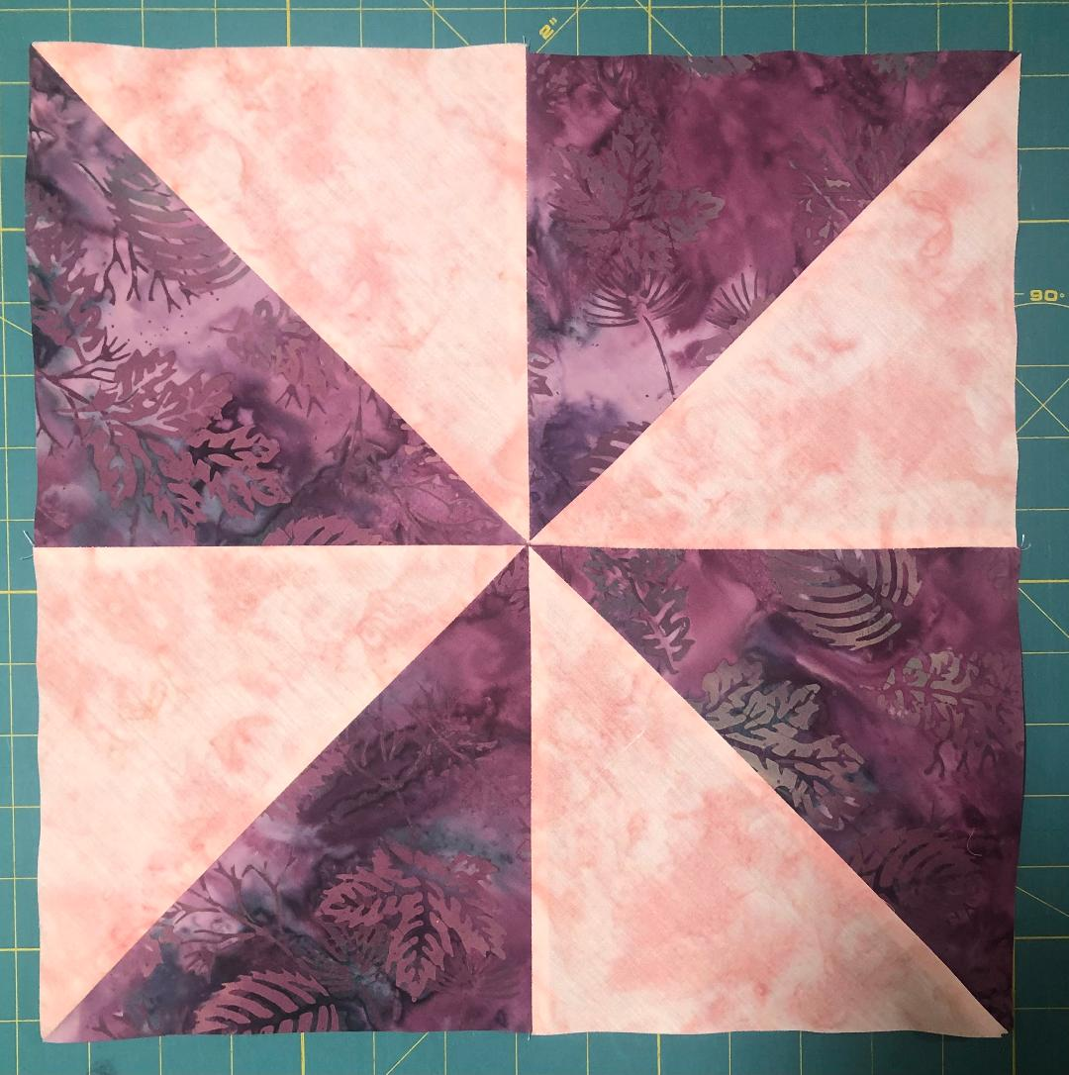
Press the squares open to form half-square triangles. (You may choose to press the seams to the darker fabric or - my preference - iron the seams open. I prefer to do the latter because there are a lot of intersecting seams in this block and it seems to lie flatter when the seams are pressed open.)

Each square should measure 7". If necessary, trim the squares, using the 45-degree mark on your ruler to line up with the seam.

Arrange the squares into a Pinwheel block and stitch together with an accurate ¼” seam.

Your Pinwheel block should measure 13½”. Trim if needed, MEASURING 6¾” FROM THE CENTER SEAM ON ALL 4 SIDES to make the cut. (When doing disappearing blocks, it is important to always measure from the center out to make sure your components are consistently sized.)

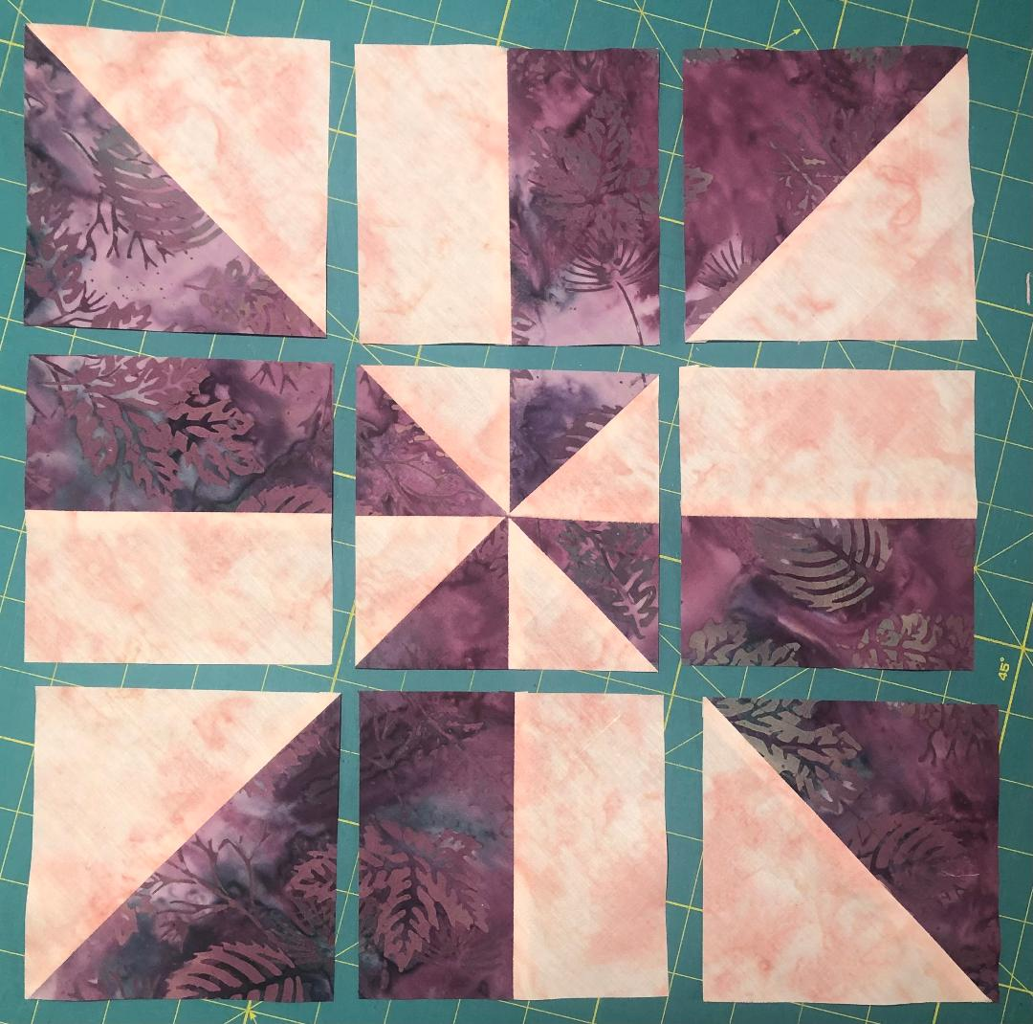

You will now cut the block into a 9-patch. Again, start by MEASURING FROM THE CENTER SEAM - 2¼” - to make the cut. Do this on all 4 sides. Your result will look like the picture to the left:

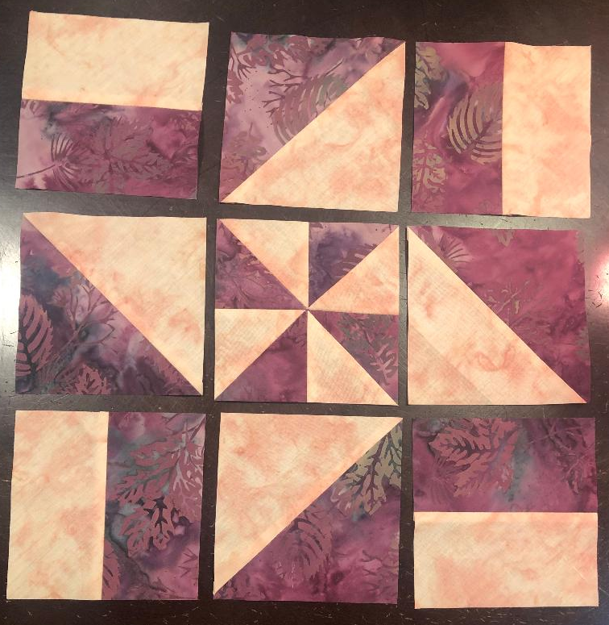
Arrange the pieces of the 9-patch as shown in the photo at the left. Double (triple!) check your arrangement – you should see a pinwheel inside a friendship star inside of a cross shape.

Stitch the pieces of the block together with an accurate ¼” seam.

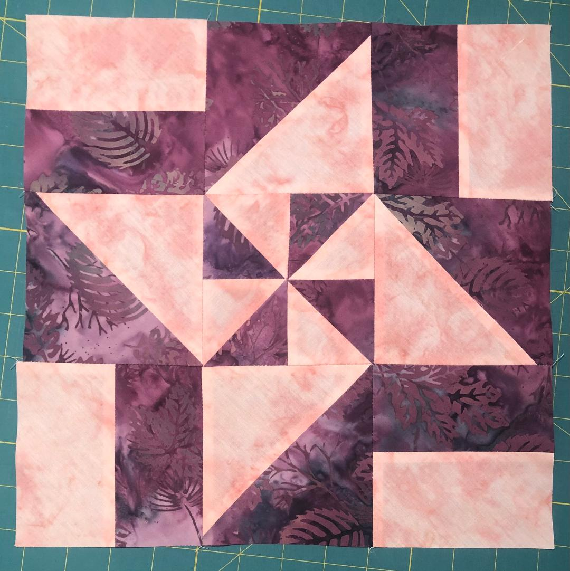

Your final block will measure 12½” and look like this:

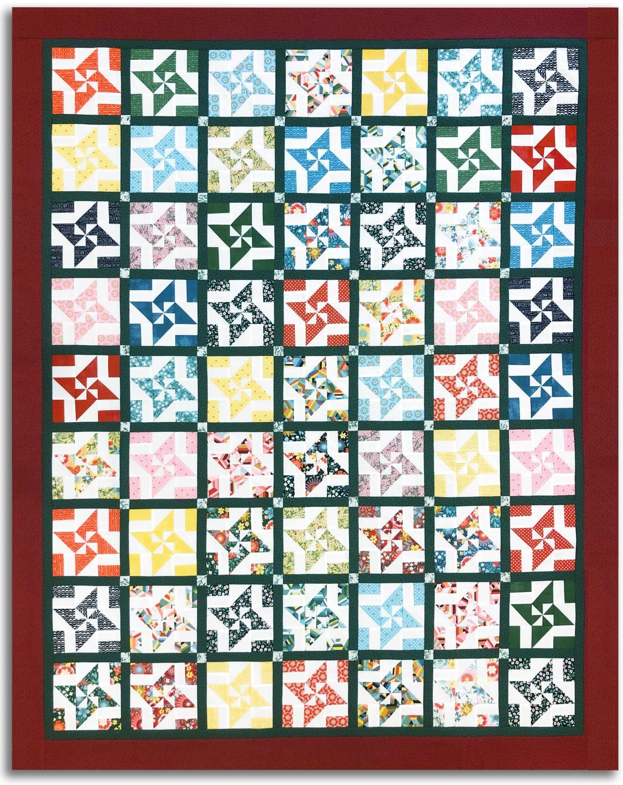
Example of a quilt made entirely of this block.
Adapted from a design by Donna Jordan for Jordan Fabrics

