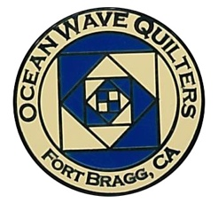
OCEAN WAVE QUILTERS
Fort Bragg, California – www.oceanwavequilters.com
NOVEMBER 2025 Newsletter

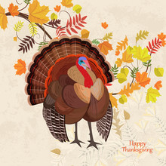
Happy Thanksgiving to Everyone!

I am thankful to be a quilter. I’m thankful for all of you who are part of our Ocean Wave Quilters Guild. I am thankful for the friendships that quilting has brought into my life. What are you thankful for?
May I share another quilting experience with you? It started a long time ago. I was born in Tanzania, a country in East Africa where my dad was a missionary doctor for 5 years. I don’t remember very much from there, but it was always a part of my childhood. My oldest brother went to school in nearby Kenya and on a school outing he drowned in the Indian Ocean. My dad’s sister was also in Africa, south of us in Botswana where she taught nursing. Later, my husband (before I met him) spent 9 months in Kenya teaching at a school. So, with this family history, one of my desires was to quilt a map of Africa. I had never seen a quilt pattern of Africa and so I knew I would have to create this myself. My goal was to have a large quilt for my bed, but I wanted to start with a smaller version to check out my methods. First, however, I began to collect fabric that contained African themes.
Thirteen years ago, I thought my stash was large enough, and so I began searching for a pattern of Africa. On the internet, I found a free “blackline masters” African map measuring 8 ½ X 11 inches. I took this page and enlarged it by 300 times. Then I printed it. The pages had little hash marks in the corners, so I could tape together this enlarged map from regular 8 ½” X 11” paper. Now I had an Africa which measured 30” X 33”. This was a nice size for a lap quilt. The lines dividing the countries were very pixilated, which made some lines hard to decipher, but I did my best. I cut the countries apart. Next, I brought out my stash of African fabrics which I had collected for about 12 years. These fabrics had African animals, people, or prints. Now the puzzle was to pick animals or people which would fit the size and shape of each country. This was much harder than it sounds. A puzzle indeed. I wanted a contrast in either fabric pattern or value between each country. The geometric prints, animal skin prints, or vegetation were easy to put in and ended up where it was difficult to find an animal or person. Finding the right fabric for the right country was very rewarding, but it could also be disappointing, as some fabrics I really liked either didn’t have good contrast, didn’t fit the shape of a country, or were too large or too small.
Once I found the perfect piece of fabric, I ironed “Wonder Under” (or something similar) to it. I cut the fabric about ¼ larger than the original paper country pattern. Later I learned to cut ¼ on some sides and not others so that there was only small overlap between the countries. When I had everything planned and laid out, I then began to iron the pieces in place on an ocean-looking blue fabric of my desired dimensions. I did this a section at a time and used a black zig-zag stitch to applique the countries down. When I began the first quilt, I didn’t know that there was another way to applique, but after I knew about blanket stitching, I still opted to use the black zig-zag because it created a nice black border between the countries.
I liked the bright colors on my first African quilt, put on a border of African animal prints, backed it with giraffe flannel, and gifted it to my dad for his birthday in 2013.
(More to come next month…) Nadine Schultz, OWQ President
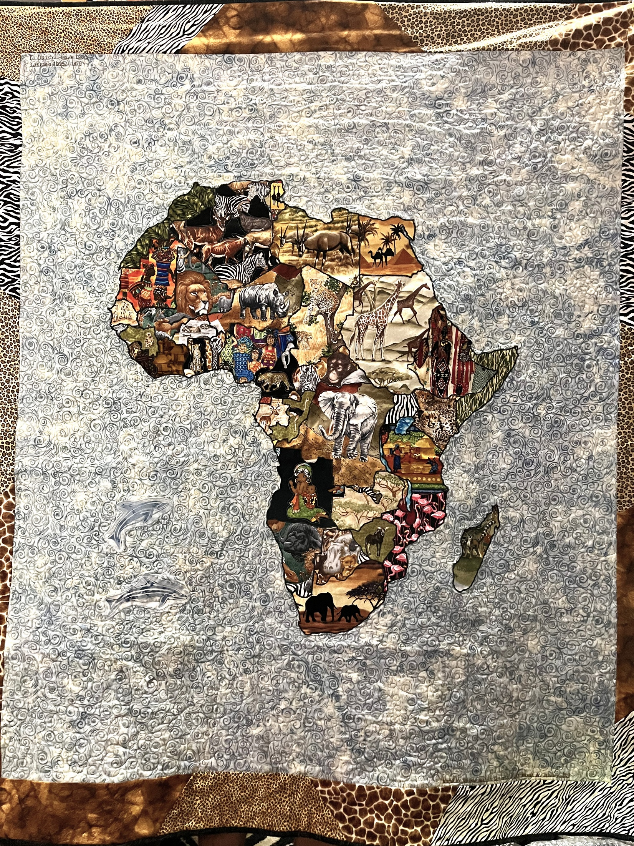

TREASURER’S REPORT
Ocean Wave Quilters
2025 October Treasurer’s Report

Starting balance 9/17/2025 | $5,097.82
Zoom annual renewal | $159.90
WordPress OWQ Domain renewal | $19.00
Cutting mats | $174.20
Food for BBQ | $56.60
TOTAL EXPENSE | $409.70
Dues - new member | $25.00
Brown bag sales | $5.00
TOTAL INCOME | $30.00
Ending balance 10/15/2025 | $4,718.12

Submitted by Sharon L., Treasurer - Approved at the 10/15/2025 Board Meeting

Sharon Lau, Treasurer
COMMUNICATIONS

- The Mystery Quilt - New instructions for each month can be found in the Mystery Quilt binder at Sew n Sew on the OWQ shelf. For information contact Chris Hartesveldt
- Contribute to the quarterly raffle baskets that will be raffled off at meetings in December, March, and June. You can leave your contributions in the raffle donation box on the OWQ shelf at Sew n Sew.
- Don’t forget Sew Sundays at the Senior Center! Every 4th Sunday of the month. Let’s keep it going! Meet, socialize & sew! Next Sew Sunday: October 26, 2025

Shari Lyons, Communications Committee Chair

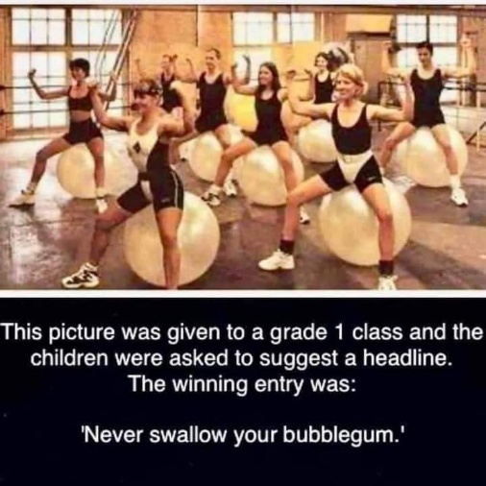
Contributed by Evelyn Harris

SERVICE COMMITTEE
The donation numbers for the month of OCTOBER 2025 from the Service Committee are as follows:
Pet beds 8
Community quilt 6
Warm welcome quilts 8
Port Pillows 6

Dear Guild Members,
The holidays are just around the corner. I know many of us are busy making gifts this time of year along with all our daily life chores... But, if you can fit in some items for donations, I will gladly donate them! We are in need of twin size quilts. Also, if you need batting or quilting done, please contact Sharon Lau at QuiltKats@yahoo.com, or Kathy at kathydemetri@gmail.com

As always, thank you for all you do for our community! Kathy
Kathy Demetri, Service Committee Chair

EDUCATION & SPECIAL EVENTS

BLOCK OF THE MONTH
NOVEMBER INSTRUCTOR: Steffany Baroni

***Instructions for OCTOBER 2025 BLOCK OF THE MONTH – Can be found on the OWQ website or get a copy at Sew n Sew in the BOM binder on the OWQ shelves. November’s BOM pattern will be available after the November 9th general meeting.

SPRING APPRECIATION LUNCHEON and One-Day Class
Yvonne Phenicie will be our guest for the April 26, 2026 Appreciation Luncheon. She will also be doing a one-day Ombre Bargello class on Monday, April 27, 2025. More information to come after Jan 1st.

HOLIDAY PARTY

We will have our annual Holiday Party on December 14, 2025. The ornament exchange last year was such a huge success that we have decided to do it again this year!
Everyone can make an ornament to hang on the HOLIDAY tree. One at a time each person will be able to go to the tree and select which ornament they like.
To exchange, you must bring an ornament you have made.
We also encourage you to bring lots of yummy goodies – potluck style savory or sweet to share!
The Brown Bag Challenge display and voting will take place at the holiday party, so get working on those wonderful projects!

ROUND ROBIN

The first Round Robin exchange took place at the OCTOBER general meeting.
If you did not do your first exchange or if you are not able to participate, please let Steffany know.
The next switch will take place at the November 9th general meeting ♥️♥️ After that, each team member will pass on the project to the next team member on their list each month. Please provide only the project for the next month to the next participant, do not give multiple projects – for example if you received more than one project and are ahead, please keep until the appropriate month to exchange.

Brown Bag Challenge
Bags for the “Brown Bag Challenge” will be available to purchase for $5.00 at the General Meetings. Please pay Sharon Lau. Please follow the rules that were included when you purchased your brown bag. The finished items will be displayed at the HOLIDAY PARTY/General Meeting on Sunday, Dec 14, 2025. Attendees will be able to vote for their favorite project without knowing who made which item, so please do not put your name in a visible location. Make sure you attach scraps of the fabrics that came from your brown bag to the outside of the project.
Please bring your Brown Bag Challenge projects to Sew n Sew and leave in the box (will be in place after Dec 1st) on the OWQ shelf between DEC 1ST and DEC 13th, so we have time to determine the appropriate category and display for the meeting.
BROWN BAG CATEGORIES: Quilts, Home wares, Wearables, and Toys.

Elizabeth Foster, Education & Special Events Committee Chair
Committee members: Steffany Baroni, Kathy Demetri, and Lisa Carter

HOSPITALITY

Thank you to Linda W., Connie, and Sharon G., for taking over last month when I could not be at the meeting.
This Sunday is open sew day (aka Sew Sunday) from 10:30 to about 2:00 or 3:00 pm. Bring a snack or lunch for yourself, a project to work on, or stop in to sit and chat. Hope to see you there!

Cindi Jo Wiley, Hospitality Committee Chair

NOVEMBER BIRTHDAYS

Nadine Schultz November 1

Kathy Demetri November 2

Marcia Weeks November 9

Lony Fiduccia November 20

Elizabeth Foster November 23

Elisabeth Weber November 25

FORT BRAGG QUILT SHOW
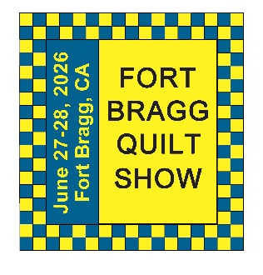
Next Quilt Show meeting will be
Wednesday, November 5, 2025-10:30 am at SEW N SEW

Not much happening at this time with the Quilt Show. We still have several open positions we would like to see filled. The paperwork has been turned into the School district for Dana Gray, and we are waiting for them to confirm our request and send us a contract.
Open Positions are: Raffle Quilt Coordinator and Basket Raffle Coordinator

Carole Poma, 2026 Fort Bragg Quilt Show Committee Chair
“2026 FBQS Raffle Quilt and Basket Raffle Coordinators needed! Great opportunity to express your creativity and help our Quilt Show make money to fund our guild’s activities.”
Together the quilt show Raffles bring in a few thousand $$$ per show! This is significant for our guild and allows us to continue to make beautiful donation quilts and items for the community and helps to support guild activities.
Please consider stepping up and taking on one of these very needed positions. Susan Collins is willing to assist with the the Raffle Quilt and Elizabeth and Bobbie will be there to help you every step of the way with the Basket Raffle. I am willing to keep the items stored at my house until after the show, if you are concerned about not having space. Thank you, Elizabeth Foster

2026 Fort Bragg Quilt Show

2025 September Treasurer’s Report
Starting balance 9/1/2025 | $13,795.84
Raffle Quilt ticket stock | $19.38
Stamps - sponsor thank you notes | $64.40
Check reorder | $37.07
TOTAL EXPENSE | $120.85
Raffle Quilt ticket sales | $90.00
TOTAL INCOME | $0.00
Ending balance 9/30/2025 | $13,764.99
Submitted by Sharon Lau, Treasurer
Approved at the 10-1-2025 FBQS Meeting
Combined checkbook
balances - 10/15/2025 | $18,483.11


This Joke Will Leave You in Stitches
Four men are in the hospital waiting room because their wives are having babies. A nurse approaches the first guy and says, “Congratulations! You're the father of twins.”
“That's odd,” answers the man. “I work for the Minnesota Twins!”
A nurse then yells to the second man, “Congratulations! You're the father of triplets!”
“That's weird,” answers the second man. “I work for the 3M company!”
A nurse goes up to the third man, saying, “Congratulations! You're the father of quadruplets." “That's strange,” he answers. “I work for the Four Seasons hotel!”
The last man begins groaning and banging his head against the wall. “What's wrong?” the others ask.
“I work for 7 Up!”
Contributed by Sharon Lau
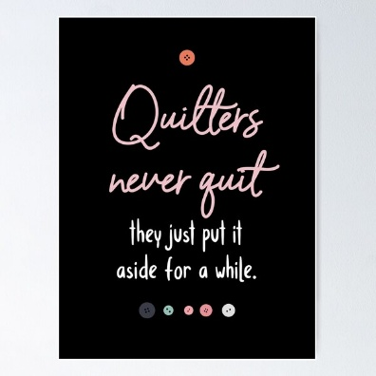
Contributed by Kate Rule-Gustafson

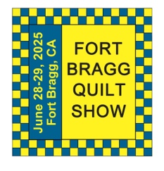
The 29th Annual
Fort Bragg Quilt Show
“Quilts for All Seasons”

A HUGE “Thank You”
to this year’s sponsors:

Diamond
Rossi Building Materials
Mendocino Railway

Platinum
Community First Credit Union

Gold
Sew-n-Sew Laurel Deli and Desserts
Mendo Litho REMax/First Equity Realty
D’Aurelio’s Noyo Fish Company
Norvell’s Noyo Pacific, Inc.

Silver
Pacific Pearl Upcycle Mercantile Mendocino Cookie Co.
Windsong Used Books & Records Chernoff’s Jewelers
Frankie’s Pizza & Ice Cream Noyo Fishing Center

Bronze
Beautiful Earth Splendiferous
Big Foot Ice Cream Essentially Hair
Tsunami’s Glass Shop Zapateria La Mexicana
Shirts and More Oh, Baby!
Egghead’s, Inc.

And THANKS to our Raffle contributors:
Purity, Imaginations, Reynolds, Cucina Verona Mercato, Sew-n-Sew, Fabled (Frame Mill), Pippi’s Socks, The Bookstore & Vinyl Cafe, Hot Pepper Jelly, Roundman’s
Smoke House, Lunar Tide, Safeway, Harvest Market, Hare Creek Nursery, Highway 20 Feed, Simply Succulents, Zho Cellars, Larkin Cottage, Harbor Lite Lodge, FBQS Vendors, and OWQ members

MARK YOUR CALENDARS FOR UPCOMING IMPORTANT DATES
OCTOBER | DAY | TIME | ACTIVITY | LOCATION
October 1st | Wed | 10:30 am | FBQS Meeting | Sew-n-Sew
October 8th -11th | Wed to Sat | 9:00 – 5:00 pm | OWQ Fall Retreat | Albion Field Station
October 12th | Sun | 1:30 -3:30 pm | General Meeting | Senior Center
October 15th | Wed | 10:30 am | Board Meeting | Sew-n-Sew
October 26th | Sun | 10:30 am | Sew Sunday | Senior Center
NOVEMBER | DAY | TIME | ACTIVITY | LOCATION
November 5th | Wed | 10:30 am | FBQS Meeting | Sew-n-Sew
November 9th | Sun | 1:30 – 3: 30 pm | General Meeting | Senior Center
November 19th | Wed | 10:30 am | Board Meeting | Sew-n-Sew
November 23rd | Sun | 10:30 am | Sew Sunday | Senior Center
 | DAY | TIME | ACTIVITY | LOCATION
December 3rd | Wed | 10:30 am | FBQS Meeting | Sew-n-Sew
December 14th | Sun | 12:00 pm – 3: 30 pm  (Doors open 11:00) | HOLIDAY PARTY/ General Meeting | Senior Center
NO BOARD MEETING | - | - | - | -
NO SEW SUNDAY | - | - | - | -

Monthly Activities:
Hand quilting: Every Tuesday/Senior Center – 1:00-3:00 pm
Sew Sunday: 4th Sunday of the Month – 10:30 am – 3:00 pm
***Hand Sewing: Every Wednesday/ZOOM – 1:00 – 4:00 pm – Join Zoom Meeting
https://us06web.zoom.us/j/81292075496?pwd=bldtVHFrRGhpTTVxUGEraEFFc2hvQT09
Meeting ID: 812 9207 5496 Passcode: HandSew

2025-2026 Board Members and Committee Chairs

President | Nadine Schultz | 707-684-9627 | Quilterqueenbee@yahoo.com
Vice-President | Carole Poma | 707-813-3001 | carolepoma@comcast.net
Secretary
Treasurer | Sharon Lau | 707-937-3049H  707-357-7447C | quiltkats@yahoo.com  sharon@oceanwavequilters.com
Communications | Shari Lyons | 707-684-0831 | lybra@mcn.org
Newsletter | Elizabeth Foster | 510-292-7833 | JJefoster@yahoo.com
Service | Kathy Demetri | 707-937-3667 | kathydemetri@gmail.com
Education & Special Events | Elizabeth Foster | 510-292-7833 | JJefoster@yahoo.com
Hospitality | Cindi Jo Wiley | 707-357-4774 | queenbee@mcn.org
FBQS Chair | Carole Poma | 707-813-3001 | carolepoma@comcast.net

NEWSLETTER – Next newsletter articles/items are due NOVEMBER 26, 2025
Please let me know if you have any suggestions, concerns, or corrections.
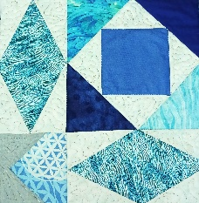
Thank you, Elizabeth Foster

