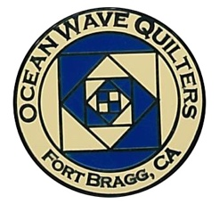
OCEAN WAVE QUILTERS
Fort Bragg, California – www.oceanwavequilters.com
JULY 2025 Newsletter

    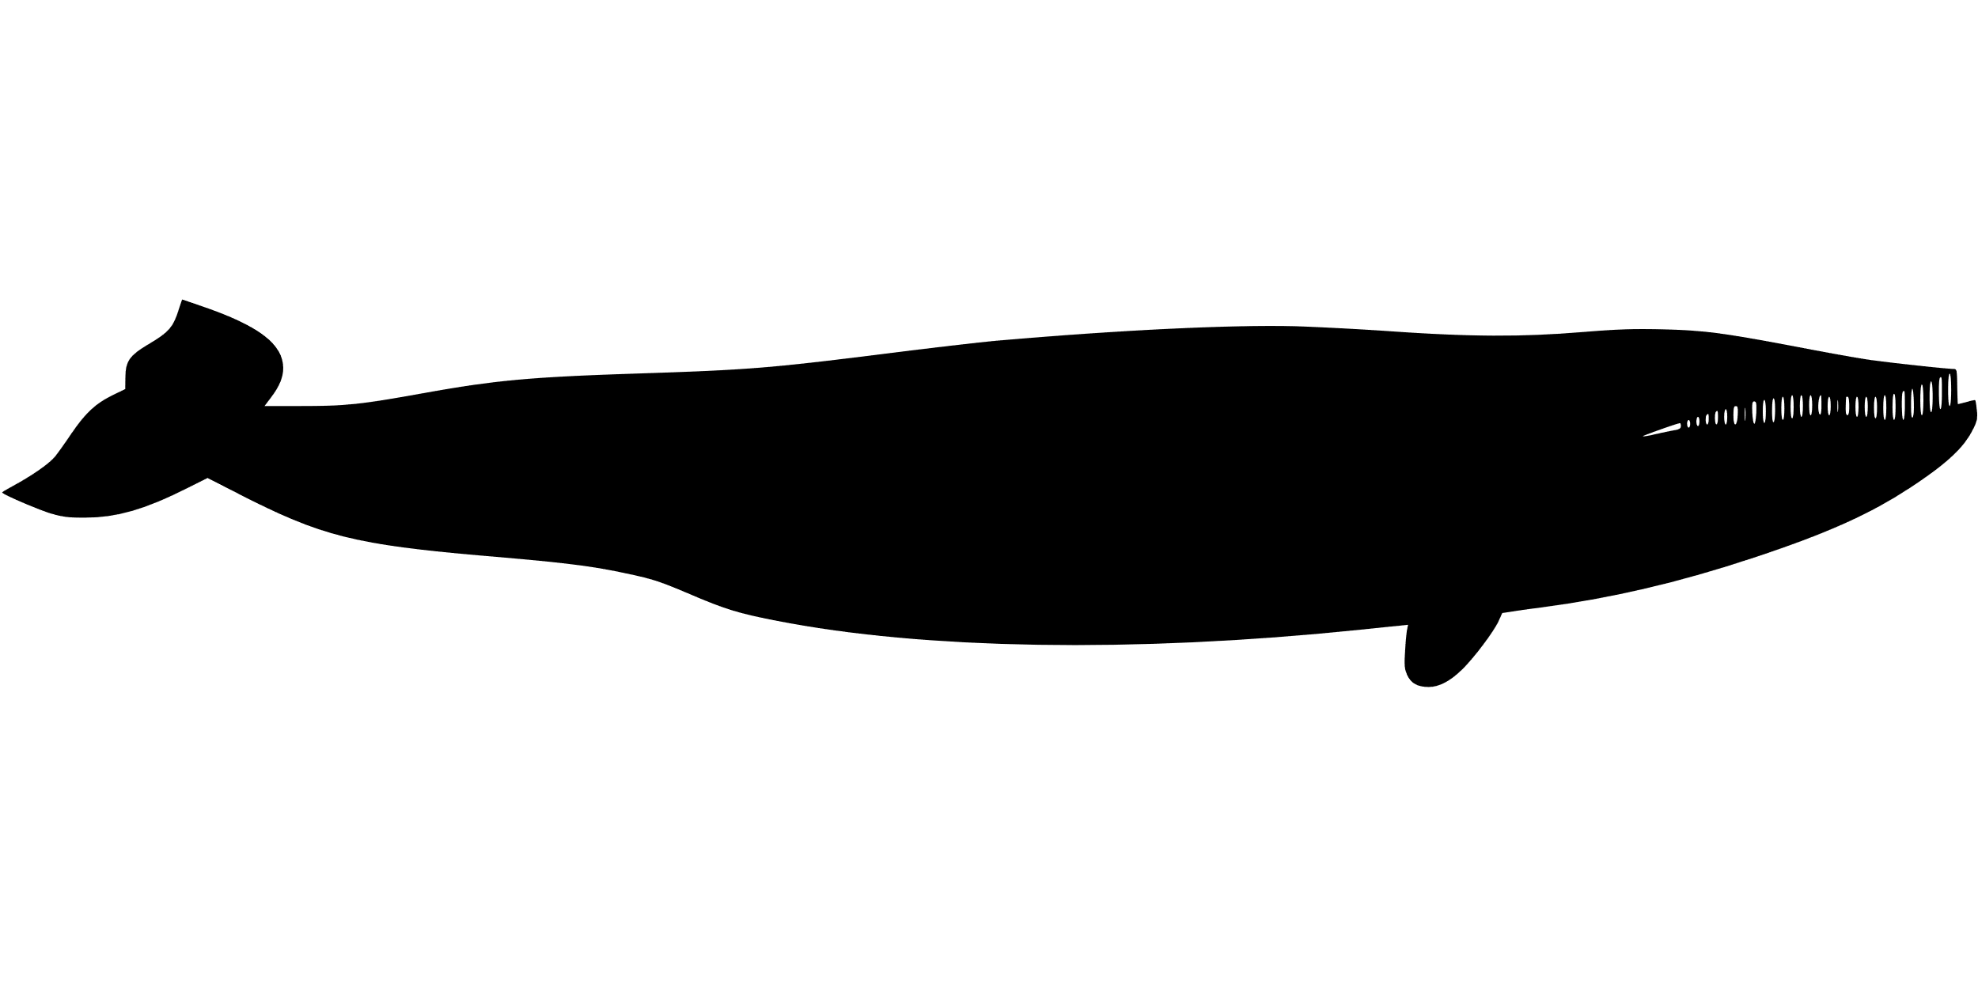     |   PRESIDENT’S MESSAGE  Greetings Ocean Wave Quilters!  Welcome to a new year. We have successfully completed another Fort Bragg Quilt Show. A huge thanks to last year’s team and all the volunteers who put in endless hours to make this a beautiful show. Thank you to each of you who not only made and entered quilts, but helped in making so many items to donate to our community. We make a difference in Fort Bragg.  As your newly elected president, I would like to introduce myself. I don’t really like introductions, but I really enjoyed reading the introduction about Ronnie Kemper at the Quilt Show and understanding her history. So, I thought it might be good to share a bit about my background.  My mother was a Home Economics major in college. She laughed that it took her a whole quarter to make one blouse. When I knew her, it took her a few hours to make one. She sewed most of my clothes and taught me to sew. She didn’t get seriously into quilting until I was in college. I think that became a natural progression for me as well. I made a quilt for Sheldon as my wedding gift to him. Since Sheldon taught elementary school, I made him fun-fabric shirts to wear. I made our sons shirts and shorts as well. But I really love to quilt more than I like to make clothes. When they were little, our boys loved to crawl into bed with us and this motivated us to purchase a king-sized bed. But with the larger bed, came a need for larger quilts. King-sized quilts are hard to quilt on a standard home machine. So, my mom and my husband got together and purchased a Grace Quilters’ wooden frame which had a carriage on it where I could put my Husqvarna machine and move it along the quilt which was mounted on the frame. This made it much easier to quilt any quilt. I used this for 16 years. In 2020, I was able to purchase a Longarm Bernina Q24 which is a dream. I love using this to quilt. I have about 16 inches of width to work on compared to the 6 inches with my standard machine. Whether using the programmable Edge to Edge patterns, rules, or free motion, I find it satisfying to be creating something beautiful. Not only do I enjoy working on my own quilts, but I find myself falling in love with the quilts which you bring for me to quilt. It is a privilege and trust which I take seriously.  One of my best experiences this last month (June), has been to watch the Dana Gray Elementary cafeteria be transformed into a beautiful display of quilts. I have helped here and there in the past years, but to be more deeply involved has been very rewarding. This is such a great team project that we do and I am proud to be part of this guild. I know so many have put in hours of planning, and, on behalf of OWQ, I thank you. I invite you, as a member, to think about how you can help. You may not think you have much to offer, but sometimes just having hands and feet to assist where needed is an important job.  Let’s continue this new year to make a difference in our community and to learn and share more about quilting.  Nadine Schultz
TREASURER’S REPORT
Ocean Wave Quilters
2025 June Treasurer’s Report
Starting balance 5/28/2025 | $6,986.79
EXPENSES
QGNQ Dues | $20.00
Printer labels for service quilts | $56.10
Batting for service quilts | $190.25
President’s Gift | $ 95.00
President’s petty cash – donuts for FBQS volunteers | $ 35.00
TOTAL EXPENSE | $396.35
INCOME
Donation, dues, raffle | $225.00
Dues, OWQ patch | $506.00
TOTAL INCOME | $731.00
ending balance 6/25/2025 | $7,321.44
Submitted by Sharon Lau, Treasurer
Approved at the 6-25-2025 Board Meeting

A Brief OWQ History Lesson – Why Are We a Non-Profit? – Sharon L.
At the most recent Board meeting, I gave a brief overview of the history of our becoming a non-profit corporation for the benefit of our newer members. It was suggested this might be helpful for other guild members, as well, so here is what I presented:
In 2015, the OWQ Board discussed at length the cost and benefits of becoming a non-profit organization, and decided this would be an appropriate action. Because of her significant experience in doing this for several of her clients, Paula P. extremely kindly offered to prepare and file the paperwork this would entail (saving our guild more than $1000, countless hours of researching, and hiring an attorney and accountant). We could not have done this without Paula.
Our specific reasons for pursuing this were:
- We should have been filing tax returns for the income we made on donations, the Quilt Show, etc.
- We were technically “illegally” receiving monetary “donations.” (We were often asked by those donating if we had non-profit status so they could file for tax benefits.)
- Theoretically, all members of the Ocean Wave Quilters board and membership were legally and financially exposed. (Example: a Warm Welcome quilt has a thread loop inadvertently left on it. Baby gets a toe caught in thread loop and the toe is damaged permanently before anyone notices. It was feasible that we could all be liable, and our homes, bank accounts, etc., could be at risk.) As a corporation, it becomes the corporation’s assets (which basically consists of our checking account) that are at risk, not our individual assets.

Being a non-profit does come with certain requirements. We need to document the community service that we do (this is why we tally and report how many quilts we give to various organizations). We must be careful that, when we spend money, we do so on activities that support our community service mission. We must budget and document our expenses (so, when we ask you to fill out paperwork to request reimbursement for something, there is a good reason!) But the benefits far outweigh the costs!
If you have any questions, please don’t hesitate to talk to one of your Board members; we are happy to make sure everyone understands what we are all about!
A Second Brief History Lesson – Did You Know We Have 2 Checking Accounts? – Sharon L.
Another presentation I made at the recent Board meeting was about our checking accounts. Again, this is something all guild members should know.

Ocean Wave Quilters (OWQ) has 2 checking accounts. The Financial Report you read every month in this newsletter (um, you DO read the report, right?) is the checking account that is the official OWQ account.

But we also maintain a checking account for the Fort Bragg Quilt Show. Why do we do this?

- The Fort Bragg Quilt Show (FBQS) is an activity of the OWQ that is doing business under a “fictitious business name” for purposes of identity within the community. (This year’s show was our 29th!)

- We keep the income and expense of that activity separate to help us track if it is an activity worth doing. This is both our largest money-making activity and our largest annual expense.

- Should we ever decide, in the future, to “partner” with an organization on the FBQS, we would have to have a separate account to make it possible to share expenses/income that are specific to the Quilt Show and not to other OWQ activities.

- Note that the two accounts are linked and money can be transferred from one account to the other when we need to do so (this is why you see an item in the proposed budget for Quilt Show). We keep a balance in the FBQS account so that, should we have any expenses (purchasing more metal frames, for example) they can be tracked as FBQS expenses and not general guild expenses.

If you have any questions, please do not hesitate to talk to one of your Board members; we are happy to make sure everyone understands what we are all about!

DUE NOW $$$

2026 MEMBERSHIP DUES
DUE NOW!
Dues increased to $35 if you didn’t pay by July 1st.
Please give membership dues to Sharon Lau or mail to OWQ

COMMUNICATIONS

PICK-UP FOR QUILT WALK QUILTS:
The Quilt Walk Team is gathering your quilts from the merchants that participated in the Quilt Walk. Please plan to pick up your quilt(s) from Sew-n-Sew on THURSDAY, JULY 10 BETWEEN 10:30a and 3p. Sharon G. & I will be there to hand them to you and check them off the list.

Please do not hesitate to contact me with questions and/or concerns.

Thank you again for generously providing your treasured quilts for the community to enjoy!

Shari Lyons, QW Chair
707-684-0831 cell

A BIG THANK YOU to Leslie Krongold, Ed.D.
For promoting the quilt walk on Facebook and NextDoor.
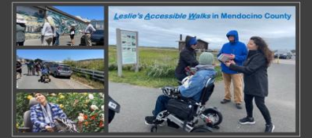
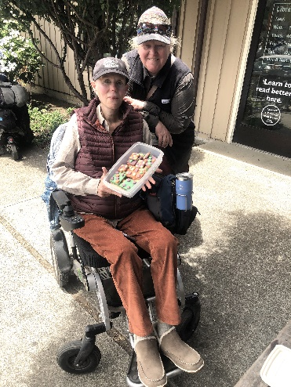https://lesliesaccessiblewalks.com/
Leslie Krongold, Ed.D. Home - Leslie's Accessible Walks
Leslie's Vision: Walks for All Abilities; join us on a journey to explore accessible walks.
Some things I do:
lesliekrongold.com Leslie's Accessible Walks

SERVICE COMMITTEE

Thank you, quilters, for the donation items. We were able to donate quite a bit this last month considering that we also put on a quilt show! Thank you all!

The Service Committee

24 Chemo Port Pillows
16 Dress-A-Girl dresses
3 Pet Beds
7 Community Quilts
8 Pillowcases
7 Warm Welcome Quilts

Kathy Demetri, Service Committee Chair

EDUCATION/SPECIAL EVENTS

Next Class coming up: Sun & Mon Aug 24 & 25th
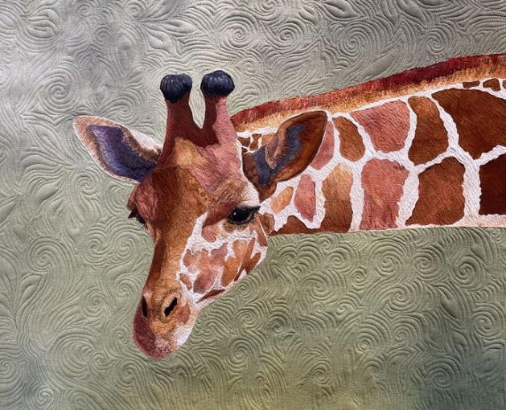
The Sandra Mollon class is a 2-day class in applique and media (color pencils and markers). Still awaiting the supply requirements from her. We will be doing her giraffe and will need to purchase the pattern. More information to come.

A sign-up for the class will be available at the July 13th General Meeting. Max 10-12 persons.
Check out her website: Sandra Mollon Quilts

OCEAN WAVE QUILTERS 2025 FALL RETREAT – The Fall retreat will take place from Wed, Oct 8-Sat Oct 11, 2025. We will again be located at the Albion Field Station in Albion. We are working on a possible project to complete during the retreat – Stay tuned there is more to come…

NEW BLOCK OF THE MONTH!!! – We will start a new block of the month project that will last the entire fiscal year July 2025 until June 2026 (May alter end date so we can do an exhibit for the 2026 FBQS). Each month we will have a OWQ member present a 12” block. It is up to you to decide what color scheme you would like to use in your quilt. You can make the block each month and when we have completed all 12 blocks, you chose how you want it to look in the overall quilt – will you add borders, sashing and embroidered touch? – it is totally up to YOU!!
JULY INSTRUCTOR: Evelyn Harris

Other events to look forward to: SUMMER BBQ, BROWN BAG PROJECT…

The first meeting of the EDUCATION/SPECIAL EVENTS COMMITTEE will take place on FRIDAY, JULY 18, 2025 at SEW N SEW from 3:30 – 4:30 pm. Anyone who is interested in being part of the committee is welcome to join us!!!

Looking forward to a great year!
Elizabeth Foster, Education/Special Events Committee Chair

HOSPITALITY

Cindi Jo Wiley will be taking over from Sharon Gieras as HOSPITALITY CHAIR

Grace will continue to send out Birthday cards, and Cindi Jo will be responsible for other occasion cards.

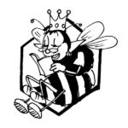

JULY BIRTHDAYS


^{WENDY HOPE} ^{JULY 3RD}
^{NANCY KRAGE} ^{JULY 5TH}
^{MARY FOSTER} ^{JULY 7TH}
^{TINA PERRY} ^{JULY 24TH}
^{JEANNE KINNEY} ^{JULY 25TH}
^{JUDY WHITLOCK} ^{JULY 26TH}

FORT BRAGG QUILT SHOW
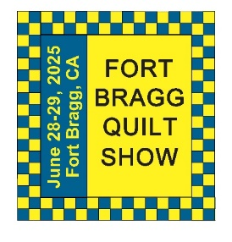

Next Quilt Show meeting will be Wednesday, August 6, 2025 at Sew n Sew
WRAP- UP MEETING – 2025 FBQS

Thank you to all the volunteers who really helped to make this a wonderful quilt show. We received lots of great comments!
Paula Perelstein, 2025 FBQS CHAIR

Good Morning, This is my first month in a year without a president’s message for the newsletter to write, so I thought I would just say Hello and good morning to you!
The quilt show worked out so well, everything so went well, and everyone pitched in. :)

Carole Poma, 2024-2025 OWQ PRESIDENT
FBQS Communications: thanks to everyone who helped with the show. It was a resounding success!

Susan Blackmer, 2025 FBQS COMMUNICATIONS CHAIR
Thanks to everyone who helped with the show. It was a resounding success!
--Please Note: included in this email as a second attachment is the list of winners. Congratulations!

From our Redding member:
Thank you for a wonderful show. Again! New friends, old friends, so fun. Your club stands out for your welcome, your friendly members, and of course your lovely sewing.

Pam McCurdy

QUILT SHOW WINNERS!!!
You will receive a separate attachment with all the winners of the 2025 FBQS. I will also be working on some photos from the show. In the meantime, I wanted to include these photos here, since I had the opportunity to show them off to the quilt show visitors as I was sitting across from them for the entire show.
SEW N SEW CHALLENGE QUILTS

Carole Poma, Tree of Life, 1st place Challenge
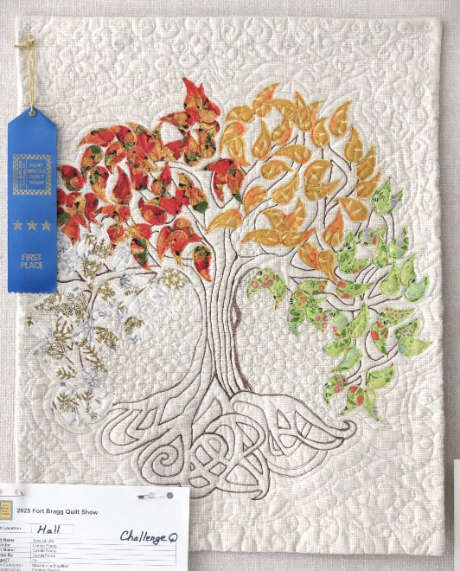

Sharon Lau, Five Breezy Pieces, 2nd place Challenge
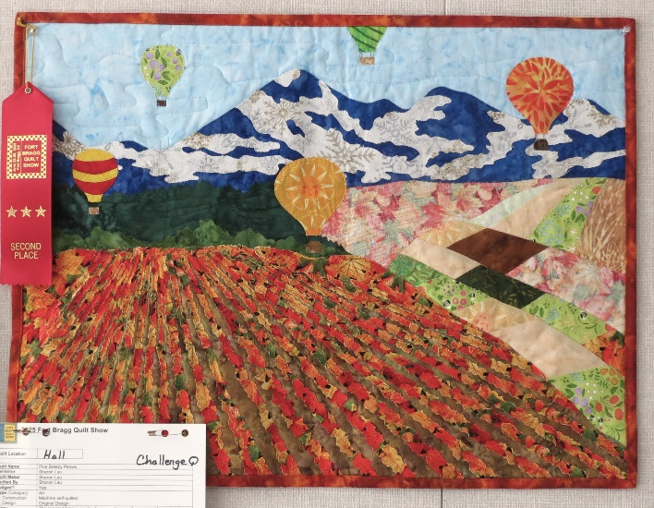

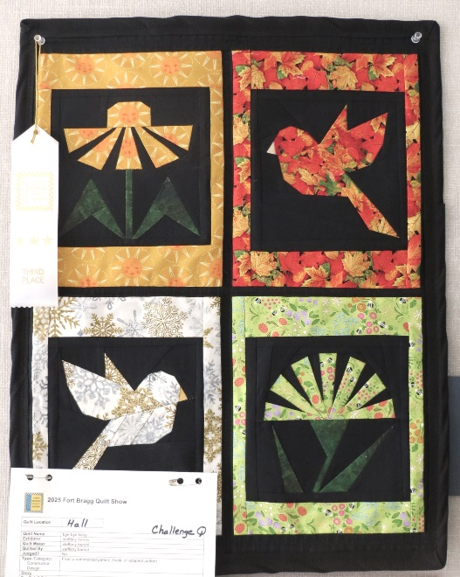
Steffany Baroni, Bye Bye Birdie, 3rd place Challenge

2025 FBQS – A Quilt for All Seasons – Raffle Quilt was won by:
DEE PAULSEN

2025 FBQS Community Quilt was won by:
HIGHWAY 20 FEED STORE
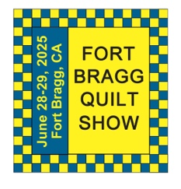

The 29th Annual Fort Bragg Quilt Show
“Quilts for All Seasons”

A HUGE “Thank You”
to this year’s sponsors:

Diamond
Rossi Building Materials
Mendocino Railway

Platinum
Community First Credit Union

Gold
Sew-n-Sew Laurel Deli and Desserts
Mendo Litho REMax/First Equity Realty
D’Aurelio’s Noyo Fish Company
Norvell’s Noyo Pacific, Inc.

Silver
Pacific Pearl Upcycle Mercantile Mendocino Cookie Co.
Windsong Used Books & Records Chernoff’s Jewelers
Frankie’s Pizza & Ice Cream Noyo Fishing Center

Bronze
Beautiful Earth Splendiferous
Big Foot Ice Cream Essentially Hair
Tsunami’s Glass Shop Zapateria La Mexicana
Shirts and More Oh, Baby!
Egghead’s, Inc.

And THANKS to our Raffle contributors:
Purity, Imaginations, Reynolds, Cucina Verona Mercato, Sew-n-Sew, Fabled (Frame Mill), Pippi’s Socks, The Bookstore & Vinyl Cafe, Hot Pepper Jelly, Roundman’s
Smoke House, Lunar Tide, Safeway, Harvest Market, Hare Creek Nursery, Highway 20 Feed, Simply Succulents, Zho Cellars, Larkin Cottage, Harbor Lite Lodge, FBQS Vendors, and OWQ members

MARK YOUR CALENDARS FOR UPCOMING IMPORTANT DATES

JULY | DAY | TIME | ACTIVITY | LOCATION
July 13th | Sun | 1:30 pm | General Meeting | Senior Center
July 18th | Fri | 3:30 pm | Ed/Spec events mtg | Sew n Sew
July 23 | Wed | 1:30 pm | Board Meeting | Sew n Sew
July 27th | Sun | 11:00 am | Sew Sunday | Senior Center
July 27th | Sun | AM | Newsletter send out | OWQ email
AUGUST | DAY | TIME | ACTIVITY | LOCATION
August 6th | Wed | 10:30 am | FBQS Meeting | Sew n Sew
August 10th | Sun | 1:30 pm | General Meeting | Senior Center
August 24 & 25 | Sun & Mon | 10:00 -4:00 pm | Sandra Mollin Class | Sew n Sew
August 27th | Wed | 1:30 pm | Board Meeting | Sew n Sew
August 31st | Sun | AM | Newsletter send out | OWQ email
SEPTEMBER | DAY | TIME | ACTIVITY | LOCATION
September 3rd | Wed | 10:30 am | FBQS Meeting | Sew n Sew
September 14th | Sun | 1:30 pm | General Meeting | Senior Center
September 24th | Wed | 1:30 pm | Board Meeting | Sew n Sew
September 28th | Sun | 11:00 am | Sew Sunday | Senior Center
BBQ date TBD

Monthly Activities:
Hand quilting: Every Tuesday/RCSC – 1:00-3:00 pm
Sew Sunday: 4th Sunday of the Month – 11:00 am – 4:00 pm
***Hand Sewing: Every Wednesday/ZOOM – 1:00 – 4:00 pm – Join Zoom Meeting
https://us06web.zoom.us/j/81292075496?pwd=bldtVHFrRGhpTTVxUGEraEFFc2hvQT09
Meeting ID: 812 9207 5496
Passcode: HandSew

NEW 2025-2026 BOARD


President Nadine Schultz
V. President Carole Poma
Treasurer Sharon Lau
Secretary Susan Blackmer
Communications Shari Lyons
Newsletter Elizabeth Foster
Service Committee Kathy Demetri
Special Events/
Education Committee Elizabeth Foster
Hospitality Cindi Jo Wiley
FBQS Chair TBD

2025-2026 Board Members and Committee Chairs

President | Nadine Schultz | 707-684-9627 | Quilterqueenbee@yahoo.com
Vice-President | Carole Poma | 707-813-3001 | carolepoma@comcast.net
Secretary | Susan Blackmer | 707-758-4195 | sswanson26@gmail.com
Treasurer | Sharon Lau | 707-937-3049  707-357-7447-c | quiltkats@yahoo.com  sharon@oceanwavequilters.com
Communications | Shari Lyons | 707-684-0831 | lybra@mcn.org
Newsletter | Elizabeth Foster | 510-292-7833 | JJefoster@yahoo.com
Service | Kathy Demetri | 707-937-3667 | kathydemetri@gmail.com
Education/Special Events | Elizabeth Foster | 510-292-7833 | JJefoster@yahoo.com
Hospitality | Cindi Jo Wiley | 707-357-4774 | queenbee@mcn.org
FBQS Chair | TBD

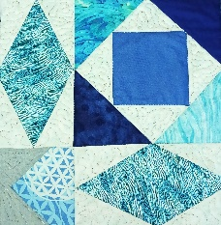
NEWSLETTER – Next newsletter articles/items are due JULY 23, 2025.
Please let me know if you have any suggestions, concerns, or corrections.

Thank you, Elizabeth Foster

510-292-7833
jjefoster@yahoo.com

