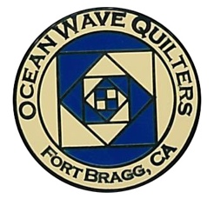
OCEANWAVE QUILTERS
Fort Bragg, California – www.oceanwavequilters.com

JANUARY 2025 Newsletter

HIGHTLIGHTS!  The Holiday Party was great fun!  Delicious food, an ornament exchange and presentation of the Brown Bag Projects – See the winners below –  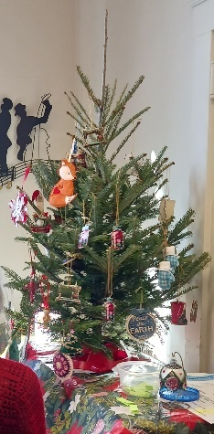  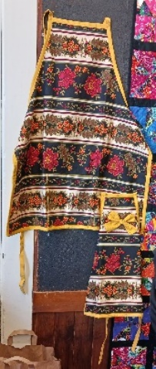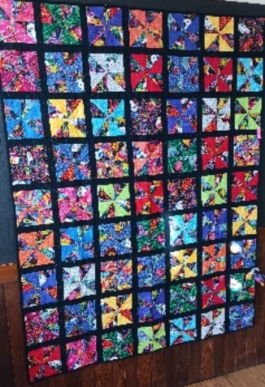  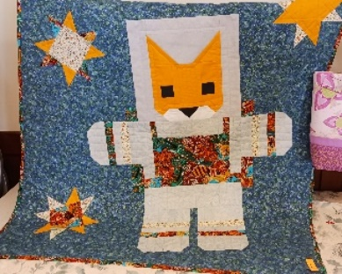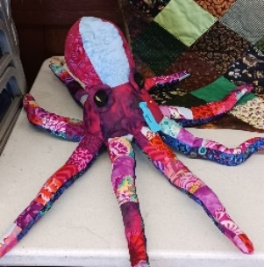 | PRESIDENT’S MESSAGE  This month will be a short message.  Here is wishing everyone a happy, joyous New Year! May you and your family find peace and joy in the New Year!  Take some time to care for yourself, enjoy life, and be kind to one another.  See you all at our January 2025 meeting.  Carole Poma  OWQ President  

COMMUNICATIONS AND EXTRAS

Hello fellow quilters,
We have received a request for quilts to cheer up our Fort Bragg library and all the hard-working librarians that work there. Dan, our local librarian, loves having quilts hanging in the library during the "dark and dreary" winter months. The quilts will probably be hung through February but Dan will let us know when he is ready to take them down.
The only guideline for the quilts is NO CHRISTMAS quilts, but holiday quilts are fine per Nancy K's discussion with Dan. A few SMALL children's quilts that the kids would enjoy would be great too! He would love to see colorful, cheery, warm, comfortable looking quilts.
If you are willing to look through your shelves and would like to "air out" some of your beautiful work and share your talents with others, please take your quilts to SEW & SEW. The quilts must have labels or identifying information so we know who they belong to. The guild has done this before, so it would be wonderful if there are quilts that have not been at the library in the past, BUT that is not a hard and fast rule!
Thank you for considering sharing your quilts! And keep on quilting!!!!!!

Happy Holidays, stay warm & dry!
Shari Lyons

From Pam McCurdy in Redding:
What a joy to come over from Redding to be with you all in person at the Christmas Guild meeting and the Zoom Hand-Sew group luncheon. Parrrtyyyy! Great time. Great friends. Great food. AND the Lit Boat Parade a bonus. You always make me feel so welcome. Group Hug ❤️😄

From Linda M: I ran across this website with a list of quilt shops and quilt shows in California: https://ronatheribbiter.com/ I thought it might be helpful.
(This has a very comprehensive list of quilt shows, retreats, shops, etc. The big one that was missing is PIQF 2025 – which is July 23-26, 2025 in Santa Clara. EF)

SPECIAL EVENTS – Steffany B.


Special Events here with a few things to put on your calendar for the new year;
This Photo by Unknown Author is licensed under CC BY-NC

In March we will be having our retreat in Albion again; dates are March 26th-29th. Also, we will be having another raffle basket at our meeting on the March 9th, so please bring your donations. There is a box on the Ocean Wave Quilters racks at Sew n Sew.
In April - two things: our Annual Luncheon will be on the April 27th starting at 12pm. Lunch will be provided by the guild as usual, and there will be a dessert table provided by all of us. I will not have a sign-up sheet for that, so, please, just bring something sweet to share with everyone! Also, at our normal meeting on April 13th, instead of our normal Show and Tell we will be presenting our finished Round Robins. I figure this will give everyone plenty of time to add more borders (if needed), quilt, and bind their projects before showing them off to everyone.
I hope everyone had a wonderful holiday season and a happy New Year.

Quick review:
March - 9th Raffle Basket
March - 26th-29th Spring Retreat
April - 13th Round Robin reveal
April - 27th Annual Luncheon

EDUCATION – Daisy W.

Sew Sunday: There is a Sew Sunday gathering on January 26 starting a 11:00 at the Senior Center. Carole P. & Sharon G. be there to provide instruction on how to create a quilt from Tee-Shirts. Come visit, quilt, and just enjoy the company.

Blockette of the month: remember to sign-up to present a blockette. We all like to learn new/different techniques. A great way to use stash, learn something new, and help create a community quilt!

Wow! I am so excited that we have a full class (12 students) for Pat Durbin’s Mosaic Trees on April 28! I am looking forward to learning more on appliqué techniques and ways to enhance my quilts. Pat will be sending me a supplies list shortly and will forward it as soon as it is received.

Mini Schoolhouse: we will have a mini schoolhouse at our February meeting. We still need a couple of teachers. Each teacher has 15 minutes to share a technique such as how to make an hour glass block or different ways to do a square in a square or flying geese!

Teach & Sew: This is a new demonstration program we are testing out. It starts at noon on March 9th (before our regular guild meeting). Dee G will be demonstrating mitered corners. This is a demonstration, so please Do Not bring your machine.

Daisy 🐾
SERVICE – Grace V.
DECEMBER SERVICE REPORT
Dress-A-Girl dresses | 20
Warm Welcome | 11
Pet Beds | 10
Pillowcases | 100

Items were given to the following organizations:
- Mendocino Children’s Fund
- Parents and Friends
- Project Sanctuary
- Sherwood Oaks Healthcare Center (skilled nursing facility)
- Hospitality House
- Child Protective Services
- Foster Children
Thanks,
Grace V.

HOSPITALITY – Sharon G.
- Quarterly Raffle Baskets – Steffany B. has a box at Sew n Sew for donation items – next raffle will be on March 9, 2025.
- SUNSHINE – Grace V. will be sending out birthday cards, and thank you cards will be handled by Sharon G.

QUILT GUILDS OF THE NORTH QUARTER – Dee G.

Upcoming 2025 meetings:
- January 25 Pacific Flyway Quilters – Colusa
- April 26 – Sun Country Quilters – Red Bluff
- Meet the Teacher July 26 – Sutter Buttes Quilt Guild – Sutter
- October 25 – Shasta Lily – Mt. Shasta

JANUARY BIRTHDAYS

HAPPY BIRTHDAY TO YOU!!!


Kim Rietveld Jan 1
Janet Nylund Jan 2
Shari Lyons Jan 4
Linda Moore Jan 4
Teresia Zadroga-Haase Jan 16
Tracy Salkowitz Jan 18
Phoebe Graubard Jan 28
Nancy Yearwood Jan 29

FORT BRAGG QUILT SHOW – Paula P.
The next quilt show meeting will be Wednesday, January 8, 2025 as the first is a holiday.
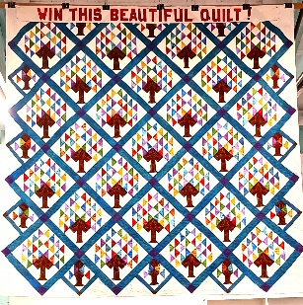
The quilt show has been approved again this year for Dana Grey School.
The raffle quilt, A Quilt for All Seasons, has been displayed at Harvest Market for ticket sales when it is not raining! It is a beautiful quilt so contact Susan Collins to buy tickets.
We are still looking for a judge.
Some great things are going on, so volunteer or join us for a meeting at Sew n Sew.
Paula Perelstein

I would like to start collecting donation items for the 2025 Quilt Show Basket Raffle – I will place a box on the OWQ back-room racks at Sew n Sew – labeled “QUILT SHOW RAFFLE”. Most appropriate items would be sewing related, but anything could be useful. If anyone wants to donate a gift certificate that would be very welcome as well. I will be reaching out to businesses closer to the event.
Thank you, Elizabeth F.

TREASURER’S REPORT – Sharon R.

Ocean Wave Quilters
December 2024 Treasurer’s Report
Opening Balance 11/28/24 $ 7,282.65
EXPENSES
Steffany B.- Brown Bag prizes | $ 66.00
Sew n Sew- Name Tag Gift Cert. | $ 60.00
Steffany B.- Holiday Party decor | $ 24.50

TOTAL EXPENSES $ 150.50
INCOME
Qtr. Raffle Basket ticket sales | $ 140.00

TOTAL INCOME $ 140.00
CLOSING BALANCE 12/27/24 $ 7,272.15

Submitted to the January 2025 Newsletter for all members to view.
No Board meeting held this month.
Sharon Rowan, Ocean Wave Quilters Treasurer

More COMMUNICATIONS (Shari L. Susan B.) AND EXTRAS
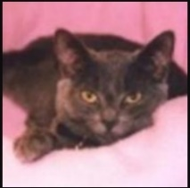
Making Quilts for Our Community Projects – some Tips – Sharon L.

If you would like to make quilts to contribute to our community projects, here are some tips to remember:
Fabric kits are available in our storage area at Sew n Sew or at our monthly meetings. These kits have been put together by our Service Committee from fabric donations and often contain enough fabric to make a quilt top and a quilt back. Feel free to combine fabrics from different kits, or to use fabric from your own stash, if you like – whatever makes you feel creative! (Leftover fabric from the kit is yours to use as you wish.)

Warm Welcome Quilts – can be any size, but are typically 36″ x width of fabric or 45″ x 45″. Since these are for babies, they should not have buttons or anything else that can detach and be a choking hazard. Double-check for pins and stray threads or thread loops that could be a hazard. There are some pattern links on the website you may find helpful.

Texture or Touch Quilts – are generally lap-sized and made from fabric that has texture, such as corduroy, Minky, velveteen, wool, chenille, seersucker, lace, etc. A peaceful state of mind can be gained by feeling the various textures. Consider adding a pocket or two to the quilt top for the patient to store a Kleenex or a personal item (put the quilt on your lap to decide where to put the pocket – make it reachable.) Recommended size: 45” X 60”. These also should not have buttons or anything else that can detach. But securely stitched on ribbons, pom-poms, etc. are fine. These do not have to have batting in them.

Quilts for Other Projects, such as the Infusion Center, Project Sanctuary, etc. – are typically at least 48” x 60-72”, but can be larger.

We ask that, in addition to the quilt top, you also make the quilt back.

YOU DO NOT NEED TO PURCHASE BATTING FOR YOUR QUILT! The guild provides batting. If you are going to quilt the quilt yourself, you can contact me (sharon@oceanwavequilters.com) for batting – just let me know what size your quilt top is and I will get the batting to you.

OR, if you do not want to do your own quilting, I will happily quilt it for you! Make sure your quilt back is at least 3” larger on all 4 sides than your quilt top. Also make sure that all 4 sides are STRAIGHT (no jagged edges, please!) and that the top is parallel to the bottom and the sides are parallel to each other. This is important for loading the quilt properly on the long-arm. (Quilts that have backs that do not meet these requirements will be returned to you to fix….)

There is a cardboard box in the storage area at Sew n Sew with my name on it. You can drop your quilt off there, but please let me know via email or text (707-357-7447) that you have put a quilt in my box! I do not check it regularly. Or you can bring your quilt to the monthly meeting. Make sure your name is securely pinned to the quilt, so I know who to return it to!

If you do not want to do your own binding, Sharon G. will bind it for you! Please be kind and make the 2½” fabric strip for her to use. You can call or text Sharon G. at 707-961-0455 to let her know you have a quilt to be bound and arrange to get it to her or you can bring it to a monthly meeting.

We always label the quilts we make for our community projects. Labels are iron-on, but should also be securely stitched on to the quilt. There is a link to a PDF document on the website, or you can get labels from me or Grace V. (If I quilt your quilt, I will always return it with a label safety-pinned on to it for you to use.)

If you go to the oceanwavequilters.com website and click on the Community Activities tab, you will find additional information about our community projects, including Dress-a-Girl, pillowcases, chemo port pillows, and pet beds.

Thank you for helping us help members of our community, and for helping us meet our obligations as a recognized non-profit organization!

MARK YOUR CALENDARS FOR UPCOMING IMPORTANT DATES
JANUARY 2025 | DAY | TIME | ACTIVITY | LOCATION
Jan 8th | Wed | 10:30 am | Quilt Show Meeting | Sew n Sew
Jan 12th | Sun | 1:30 pm | General Meeting | Senior Center
Jan 22nd | Wed | 1:30 pm | Board Meeting | Sew n Sew
Jan 26th | Sun | 11:00 am | Sew Sunday | Senior Center
FEBRUARY
Feb 5th | Wed | 10:30 am | Quilt Show Meeting | Sew n Sew
Feb 9th | Sun | 1:30 pm | General Meeting | Senior Center
Feb 23rd | Sun | 11:00 am | Sew Sunday | Senior Center
Feb 26th | Wed | 1:30 pm | Board Meeting | Sew n Sew
MARCH
Mar 5th | Wed | 10:30 am | Quilt Show Metting | Sew n Sew
Mar 9th | Sun | 12:00 pm | Teach & Sew (before general meeting) | Senior Center – Dee-Mitered Corners
Mar 9th | Sun | 1:30 pm | General Meeting | Senior Center
Mar 23rd | Sun | 11:00 am | Sew Sunday | Senior Center
Mar 26th | Wed | 1:30 pm | Board Meeting | Sew n Sew
Mar 26-29th | Wed-Sat | 9: 00 am | Spring Retreat | Albion Field Station

Monthly Activities:
Hand quilting: Every Tuesday/RCSC – 1:00 - 3:00 pm
Hand Sewing: Every Wednesday/ZOOM – 1:00 – 4:00pm
Sew Service Sunday: 4th Sunday of the Month – 11:00 am – 4:00 pm
2024-2025 Board Members and Committee Chairs

President | Carole Poma | 707-813-3001 | carolepoma@comcast.net
Vice-President | Paula Perelstein | 707-962-9006 | paula@sew-n-sew.com
Secretary | Susan Collins | 707-357-1766 | scollinsndgw@gmail.com
Treasurer | Sharon Rowan | 707-964-4511  707-357-4511- | sawrowan@gmail.com
Communications | Shari Lyons | 707-684-0831 | lybra@mcn.org
Communications –  Quilt Show | Susan Blackmer | 707-758-4195 | sswanson26@gmail.com
Newsletter | Elizabeth Foster | 510-292-7833 | jjefoster@yahoo.com
Service Chair | Grace Van Doren | 707-964-5282  707-972-3278- | qteddybear@outlook.com
Special Events | Steffany Baroni | 707-813-4066 | steffanybaroni2628@gmail.com
Education | Daisy Woodhams | 925-820-5844 | Dawo.retired@icloud.com
Quilt Guilds of the North Quarter Rep | Dee Goodrich | 707-962-0220 | deegoodrich@comcast.net
Hospitality | Sharon Gieras  Steffany Baroni | 707-961-0455  707-813-4066 | Steffanybaroni2628@gmail.com
Food Table | Carley Miller  Steffany Baroni | 707-357-0843  707-813-4066 | Cbrennfleck13@gmail.com  Steffanybaroni2628@gmail.com
Fort Bragg Quilt Show Co-Chairs | Susan Collins  Paula Perelstein | 707-357-1766  707-962-9006 | scollinsndgw@gmail.com  paula@sew-n-sew.com

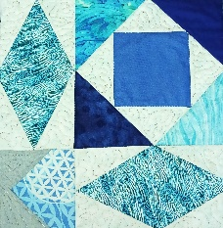
NEWSLETTER – Next newsletter articles/items are due JANUARY 22, 2025.
Please let me know if you have any suggestions, concerns, or corrections.
Thank you, Elizabeth Foster
510-292-7833
jjefoster@yahoo.com

