OCEAN WAVE QUILTERS
Of Fort Bragg, California – www.oceanwavequilters.com
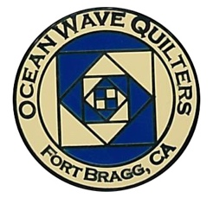
AUGUST 2024 Newsletter______________________________________
PRESIDENT’S MESSAGE
owq 2024-2025 BoaRD & Committee chairs
PRESIDENT:
Carole Poma
VICE PRESIDENT:
Paula Perelstein
TREASURER:
Sharon Rowan
SECRETARY:
Susan Collins
COMMUNICATIONS:
Shari Lyons
Susan Blackmer
HOSPITALITY:
Sharon Gieras
Steffany Baroni
SERVICE:
Grace Van Doren
EDUCATION:
Daisy Woodhams
SPECIAL EVENTS:
Steffany Baroni
NEWSLETTER:
Elizabeth Foster
QUILT SHOW CHAIR:
Susan Collins
Paula Perelstein
QUILT GUILDS OF THE NORTH QUARTER:
Dee Goodrich
FOOD TABLE CHAIR:
Carley Miller
Steffany Baroni

Hope everyone is keeping cool in the warm weather we have been experiencing. It sure has brought many visitors from inland.
The new board has been busy planning events for the coming year, and it sounds like a fun year ahead of us.
The first event is the BBQ on Aug 25th, at 27030 North Highway 1 in Inglenook, about 7 miles north of Fort Bragg City. The event should start about noon and we have lots of fun things planned. I hope to see everyone there. If you have not already signed up, please do so at the August 11th, general meeting.
If you have any ideas on classes, events or just a friendly "get together" please let the board know. We are open for any suggestions. New ideas are always welcome.

Regards,

Carole Poma
2024-2025 OWQ President
707-813-3001

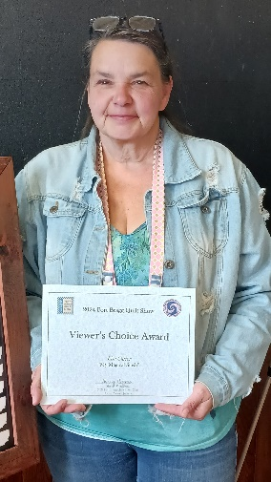
The 2024 Fort Bragg Quilt Show was a huge success!
SUMMER HIGHLIGHTS
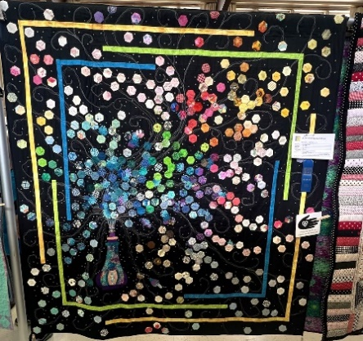
Congratulations to Lisa Carter for winning the Viewer’s Choice Award for
“My Magical Stash”!

Several attendees commented on how great a show it was!

- SPECIAL EVENTS – Steffany B.

Lots of great events coming up!
- Sunday, August 25th – Annual OWQ BBQ
Carole P’s house: 27030 N. Hwy 1, Inglenook
Time: 12:00 pm - Sign up at August general meeting
- Round Robin – Place your name in basket at August general meeting, and groups will be created at September general meeting
- OWQ Biannual Quilt Retreat – Weds, Oct 9th – Sat, Oct 12th
Albion Field Station – Opens @ 8:00 am Weds until @ 3:00 pm Sat
- Brown bags (updated fabrics) – Will be available at August general meeting and shared at Holiday Party in December
- EDUCATION -Daisy W.

Please let me know what you are interested in this year either as a workshop or a lecture. Also, if you have a teacher you. The current plan is to have a lecture during our appreciation lunch followed by a workshop the next day.
I am currently looking at the teachers who are part of the QGNQ “Meet the Teachers” as well as those associated with Northern California Quilt Council.
I am only looking at those who do in-person teaching, as many only do online teaching.
Daisy 🐾

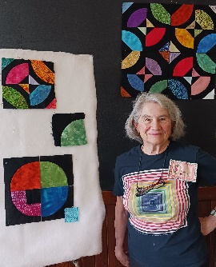
- Block of the Month – July
July General Meeting
Dee G. demos “Drunkard’s Path with a Twist” square. Instructions will be added to the website for those who missed the July meeting.


AUGUST Block of the Month: TBD

- SERVICE – Grace V.
JULY SERVICE REPORT
Community Quilts | 1
Warm Welcome | 5
Pet Beds | 6
Project Sanctuary | 8
Dress-A-Girl
Mendocino Coast Clinics
Pillow Cases
Port Pillows
Please note that we could really use some more baby quilts, but I have plenty of the bigger ones for now. Grace V.
- HOSPITALITY – Sharon G. & Steffany B.

Sharon G. is going to order tee shirts with the OWQ logo on them and she needs to know if you would be interested in purchasing them. Please let her know ASAP if you would like one. She can be reached by phone or via text at 707-961-0455. She does not have email.
Color choices (will be like the colors in the logo):
Black, Cream, Blue
Short sleeved (approx. $15.00) or long sleeved (approx. $20.00). Unisex sizing
She would like to have an estimate of the number to order no later than the next guild meeting, August 11. Sooner is better though!
- Quarterly Raffle Baskets – Steffany B. has a box at Sew-n-Sew for item donations. Can be items other than sewing as well.
- SUNSHINE – Grace V. will be sending out birthday cards and thank you cards will be handled by Sharon G.

OWQ is hosting the next QGNQ meeting on Saturday, October 26th – The meeting will take place at the Veteran’s Memorial Hall on the corner of E. Laurel and N. Harrison.
- COMMUNICATIONS – Shari L.

- TREASURER’S REPORT – JULY- Sharon R.
- QUILT GUILDS OF THE NORTH QUARTER – Dee G.
OCEAN WAVE QUILTERS
JULY 2024 TREASURER'S REPORT
6/26/2024 BEGINNING BALANCE |  |  |  | $ 7,819.55
EXPENSES
S. Baroni- Gift Cards for Raffle Baskets |  |  | $ 40.00
Oct. Retreat--Albion- Spec Event |  |  | $ 400.00
U.S. Postal - P.O. Box- Admin |  |  | $ 232.00
Amazon- Quilt Batting-Service |  |  | $ 399.13
IRS form filed |  |  | $ 54.99
TOTAL EXPENSE |  |  |  | $ 1,126.12
INCOME
Membership & patches |  |  | $ 306.00
Membership |  |  | $ 150.00
Membership & patch |  |  | $ 100.00
 | TOTAL INCOME |  |  | $ 556.00
7-22-24 CLOSING BALANCE |  |  |  | $ 7,249.43
SUBMITTED BY SHARON ROWAN, TREASURER, 7-24-24
APPROVED AT 7-24-24 BOARD MEETING
Sending this to the guild just in-case someone may be interested in participating.
Shari L. 707-684-0831
ACMC Quarterly Roundtable Meeting
Monday August 5, 12-1 pm by Zoom
The Arts Council of Mendocino County invites your participation in the ACMC Quarterly Roundtable meeting on Monday, August 5th, at noon. Registration is not necessary. Please use the link below to join. (please see email from Shari on details for link)
- FORT BRAGG QUILT SHOW – Susan C. & Paula P.

Much gratitude to Susan C. and Paula P. who will be co-chairing
the 2025 Fort Bragg Quilt Show! Looking forward to it already!
- AUGUST BIRTHDAYS

WISHING YOU A VERY HAPPY BIRTHDAY!!!
Catherine S. August 1st
Nancy L. August 16th
Sandy B. August 24th
Connie M. August 26th
Dianne S. August 28th
Carole P. August 29th

MARK YOUR CALENDARS FOR UPCOMING IMPORTANT DATES

AUGUST
DATE | TIME | EVENT
Wed – Aug 7 | 10:30 am | Quilt Show Committee Mtg
Sun – Aug 11 | 1:30 pm | General Meeting
Sun – Aug 25 | 12:00 pm | Annual BBQ
Wed – Aug 28 | 1:30 pm | Board Meeting

SEPTEMBER
Wed – Sep 4 | 10:30 am | Quilt Show Committee Mtg
Sun – Sep 13 | 1:30 pm | General Meeting
Sun – Sep 22 | 10:30 am | Sew Sunday – Make pins for QGNQ – Senior Center
Wed – Sep 25 | 1:30 pm | Board Meeting

OCTOBER
Wed – Oct 2 | 10:30 am | Quilt Show Committee Mtg
Wed – Sat Oct 9-12 | @8:00 am/Wed to @ 3 pm/Sat | OWQ Bi-annual Quilt Retreat
Sun – Oct 13 | 1:30 pm | General Meeting
Wed – Oct 23 | 1:30 pm | Board Meeting
Sat – Oct 26 | TBD | QGNQ Meeting

Monthly Activities:
Hand quilting: Every Tuesday/RCSC – 1:00-3:00 pm
Hand Sewing: Every Wednesday/ZOOM – 1:00 – 4:00pm
Sew Service Sunday: 4th Sunday of the Month – 10:00 am – 4:00 pm

- 2024-2025 Board Members and Committee Chairs
President | Carole Poma | 707-813-3001 | carolepoma@comcast.net
Vice-President | Paula Perelstein | 707-962-9006 | paula@sew-n-sew.com
Secretary | Susan Collins | 707-357-1766 | scollinsndgw@gmail.com
Treasurer | Sharon Rowan | 707-964-4511  707-357-4511-C | sawrowan@gmail.com
Communications | Shari Lyons | 707-684-0831 | lybra@mcn.org
Communications –  Quilt Show | Susan Blackmer | 707-758-4195 | Sswanson26@gmail.com
Newsletter | Elizabeth Foster | 510-292-7833 | jjefoster@yahoo.com
Service | Grace Van Doren | 707-964-5282  707-972-3278-C | qteddybear@outlook.com
Special Events | Steffany Baroni | 707-813-4066 | steffanybaroni2628@gmail.com
Education | Daisy Woodhams | 925-820-5844 | Dawo.retired@icloud.com
Quilt Guilds of the North Quarter | Dee Goodrich | 707-962-0220 | deegoodrich@comcast.net
Hospitality | Sharon Gieras  Steffany Baroni | 707-961-0455  707-813-4066 | Steffanybaroni2628@gmail.com
Food Table Chair | Carley Miller | 707-357-0843 | Cbrennfleck13@gmail.com
Fort Bragg Quilt Show Chair | Susan Collins  Paula Perelstein | 707-357-1766  707-962-9006 | scollinsndgw@gmail.com  paula@sew-n-sew.com

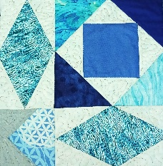
NEWSLETTER – Next newsletter articles/items are due August 28th.
Please let me know if you have any suggestions, concerns, or corrections.
Thank you, Elizabeth Foster
510-292-7833
jjefoster@yahoo.com

