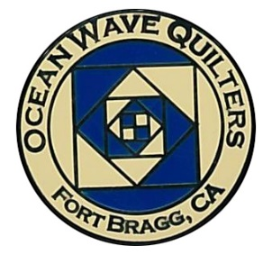
Ocean Wave Quilters
February 2024 Newsletter



President’s Message

First, I would like to thank everyone that stepped forward last meeting and either bought or took tickets to sell for the 2024 Opportunity Quilt raffle. This is so important and we are still behind in sales compared to our previous years. You can get more tickets at Sew n Sew. All members, please help so that Ocean Wave Quilters can qualify for a permit next year.
I would also like to remind members to bring snacks for the food table. Finger foods are best. The amount of participation has tapered off in the last couple of months. This was such a fun idea to bring back to our meetings. Thank you to Shirlee P, Sharon B, and Jeanne K for setting up and taking down the table.
Looking forward to seeing everyone at the February 11th meeting.
Paula P
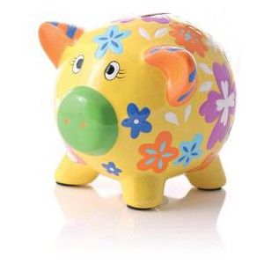

OCEAN WAVE QUILTERS
JANUARY 2024 TREASURER’S REPORT

12-26-23 BEGINNING BALANCE $ 8144.94

EXPENSES
QNQ Dues |  | $ 15.00
Yearly rent of Sew-N-Sew |  | $ 1000.00
Albion Field Station – March Retreat |  | $ 300.00
SCCQG Insurance, March retreat | $ 10.00
Paula P- Balance on Printer | $ 130.65
Joann’s Batting for service quilts | $ 269.68

TOTAL EXPENSES $ 1725.33

INCOME
Charlene Y – Linda Schmidt class | $ 45.00

TOTAL INCOME $ 45.00

CLOSING BALANCE 1-30-24 $ 6464.61

Submitted by Sharon R, Treasurer




Your Vote Will Make a Difference

The Fort Bragg Quilt Show Committee would like to purchase additional metal quilt frames for the 2024 show. Since this is a non-budgeted item that costs more than $50, per the OWQ By-Laws a vote by the membership will be necessary. This expenditure will be discussed at the General Meeting on February 12th. If a motion is made, the vote will take place at the General Meeting on March 10th.

The additional frames will permanently replace a row of hard to assemble and dangerous wooden frames. The additional frames will give the quilt show more flexibility in displaying quilts.

The total cost is $1,253.93 and will use money from the FBQS funds.

Quilt Guilds of the North Quarter (QGNQ)

The 2024 QGNQ meetings are:

- April 27: Ladies of the Lake in Lower Lake
- July 27: Mountain Quilt Quilters in MacArthur
- October 26: Ocean Wave Quilters in Fort Bragg (Yep! That’s us!)
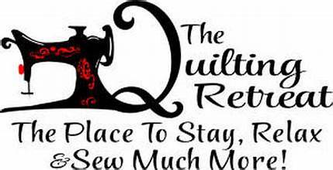

Special Events – Steffany B

Happy February everyone! Second month of the new year is starting and I already haven’t stuck to my quilting resolution to use my scraps and stash. New fabric has definitely been bought and new projects have been started. Ha ha, maybe next year.
The next special event is the March Retreat, which will be held in Albion this year at the Albion Field Station, April 21st-24th. This is a change of days from Thursday to Sunday as well as a change in venue. Cabins or RV spaces are available to rent if anyone is interested in staying on site. Please contact Nadine S for more information
The Appreciation Luncheon is April 28th and it will be catered by Los Gallitos. I am asking the membership to bring desserts. There will be fresh strawberry agua fresca and water bottles. Don’t forget the luncheon is also when we will be presenting our UFO projects! So excited to see what everyone has done!
Hope everyone has a February filled with love ❤️

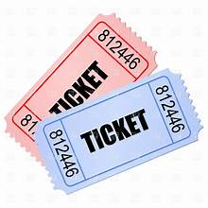
Hospitality ~ Daisy 🐾

Don’t forget to donate for the raffle baskets.
There is a designated box at Sew n Sew. Next raffle is in March 2024.

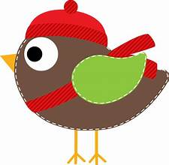Service – Grace V.

January Service Report
Dress-a-Girl Dresses
Warm Welcome Quilts | 4
Chaplain Quilts
Project Sanctuary | 6
Texture Quilts
Infusion Center
Pillowcases
Pet Beds | 5
Port Pillows
Community Quilts | 5

The Infusion Center does not need any additional quilts at this time. They have a stockpile of 6 tubs filled with quilts. So, I am going to take 6 quilts a month to different community organizations. In January I took 6 quilts to Project Sanctuary. Other suggested places are the Mendocino Coast Children’s Fund, Hospitality House, the Food Bank, and the Sherriff and Police Departments. If you have other ideas, please contact me. ~ Grace V
Communications ~ Susan B

The FBQS Quilt Walk quilt registration is available on our website under "Forms and Documents". Just fill out the form--no need to print anything--BUT make sure your name and the title of your quilt (if you submit more than one) is pinned to your quilt(s) when you drop them off at Sew n Sew. We will print the info card for you and attach it to the quilt when we deliver it to the participating business.

ALSO on the website is a new section called "Upcoming Quilt Shows". I'll be posting shows as the info comes in. If you know of any shows in California (or near our borders), please send me details or their flyer so that I can add them.

Education – Carole P

Linda Schmidt will present her Fantasy Falls Workshop on Monday, February 12, 2024. The class is 6 hours and will run from 10:00 am to 4:00 pm at Sew n Sew Fabrics. The cost for the class is $45.00 (to OWQ) with a supplies fee of $20 per student to be paid directly to the teacher at the time of class. As always, your place in class is not confirmed until you pay for your space in class. Your check should be made out to "Ocean Wave Quilters" but given to Carole Poma directly. Materials list for class will be given out when you sign up and pay. Please take a few minutes to look her up on line and view her beautiful work. There is still room in the class.

At the April Luncheon, Jeri Kennedy will share a trunk show. Her specialty is needle turn applique. You will not want to miss this!

Further Questions? Give me a call.
Block of the Month

Want to teach a Block of the Month? There are two spots left to fill. Can we put your name on one of them? Contact Carole P.

August 2023 | Lony F | February 2024 | Ginny C
September 2023 | Evelyn H | March 2024 | Daisy W
October 2023 | Paula P | April 2024 | Luncheon
November 2023 | School House | May 2024 | Martin W
December 2023 | Holiday Party | June 2024
January 2024 | Lisa C | July 2024
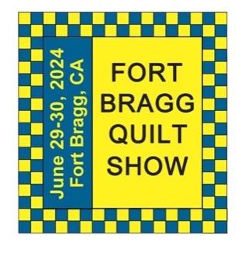
Quilt Show ~ Sherry W
"Around the Block"

The 2024 OWQ Quilt Show is heading our way, yahoo!!

Join us at the FBQS Committee Meeting on Wednesday, February 7th at 10 am at Sew n Sew. And, check the calendars at the bottom of this newsletter. There have been a few changes to accommodate the judging process for this year.

Opportunity Quilt Tickets are on sale NOW! Tickets are $5 each or 3 for $10. Contact Sharon G to purchase.


Quilt Walk ~ Sherry W

Reminder about lending your quilts for the Quilt Walk, it’s that time of year again. We currently have 15 quilts turned in! Below you will find all the information, thank you.

Business Quilts: The preferred quilt sizes for businesses are 18x24 or 12x12. We will need about 96 quilts. Ideas for quilts are:
- Previous Quilt Show Challenge quilts
- Brown Bag Challenge quilts
- Quilts in progress-make an extra block for the Quilt Walk-turn it into a wall hanging
- Make any single block of your favorite pattern.
- Make a quilt that reflects a business, or reflects the show theme of “Around the Block”
If you would like to submit a quilt for a specific business, please contact Sherry W at arjnkd@gmail.com.

Library Quilts: The Library can display 5 larger quilts (approx. 60”x60”) and numerous misc. sized quilts. They’ll find a place to display as many quilts as we can provide them!

Hospital Quilts: The Hospital can display 9 large quilts, with sleeve. The sleeve should be sewn on, but safety pins no farther apart than 2” on both sides of the sleeve will be accepted.

Entry forms are available on our website.
You may drop your quilts off anytime at Sew n Sew. They will be stored on the racks in the back room of the store.

All quilts are due at Sew ‘n Sew by Friday, May 10th, 2024 and will be delivered to the businesses by May 15. The quilts will be returned in early July.

Questions? Contact Kathy McC at kathmac8@gmail.com or 707-367-3423 or Sherry W at arjnkd@gmail.com or 916-216-6041


February 6 Susan H February 22 Nancy K
February 8 Yola S February 24 Evelyn H
February 8 Sandi S February 27 Kalynn O
February 18 Dee G

Happy Birthday!


Some Interesting Facts……

- The average quilter is 63 years old.
- “Dedicated quilters” (those who spend more than $500 per year on quilting) buy, on average, 99 yards of fabric a year, almost an entire football field’s worth.
- Dedicated quilters usually spend an average of $3,363 on quilting supplies per year.
- Beginning quilters spend an average of 6.9 hours a week on their craft. Advanced quilters spend around 17.6 hours.
MARK YOUR CALENDAR
February 2024

Fri | 2 | Newsletter Distribution Deadline
Wed | 7 | Quilt Show Committee Meeting
Thu | 8 | Education/Special Events
Sun | 11 | General Meeting
Mon | 12 | Linda Schmidt’s workshop “Fantasy Falls”
Sun | 25 | Sew Service Sunday
Tue | 27 | Board Meeting and Newsletter Articles Due

Hand Sewing Group via Zoom
every Thursday 1-4 pm
Hand Quilting Group every Tuesday 1-4 pm at Senior Center

March 2024

Fri | 1 | Newsletter Distribution Deadline
Wed | 6 | Quilt Show Committee Meeting
Thu | 7 | Education/Special Events
Sun | 10 | General Meeting
Thurs -Sun | 21 -24 | Retreat in Albion
Tue | 26 | Board Meeting and Newsletter Articles Due
Fri | 29 | Newsletter Distribution Deadline

Hand Sewing Group via Zoom
every Thursday 1-4 pm
Hand Quilting Group every Tuesday 1-4 pm at Senior Center

May 2024
Wed | 1 | Quilt Show Committee Meeting
Fri | 3 | Newsletter Distribution Deadline
Fri | 10 | Last day to turn in Quilt Walk Quilts at Sew n Sew
Sun | 12 | General Meeting
Sun | 26 | Sew Service Sunday
Tues | 28 | Board Meeting and Newsletter Articles Due
Fri | 31 | Newsletter Distribution Deadline
Hand Sewing Group via Zoom
every Thursday 1-4 pm
Hand Quilting Group every Tuesday 1-4 pm at Senior Center

April 2024

Wed | 3 | Quilt Show Committee Meeting
Thu | 4 | Education/Special Events
Sun | 14 | General Meeting
Sun | 28 | Appreciation Luncheon + UFO Reveal + Jeri Kennedy Trunk Show
Tue | 30 | Board Meeting and Newsletter Articles Due–Who wants to apply for officer/committee chair positions?
Hand Sewing Group via Zoom
every Thursday 1-4 pm
Hand Quilting Group every Tuesday 1-4 pm at Senior Center

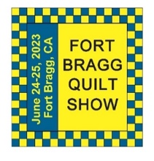
The 27th Annual Fort Bragg Quilt Show

A HUGE “Thank You”
to this year’s sponsors:

Diamond
Community First Credit Union
Rossi Building Materials
Platinum
Mendocino Railway
D’Aurelio’s
Gold
The Larkin Cottage | Todd Farmhouse Antiques
Laurel Deli and Desserts | Bitterroot Family Therapy
Mendo Litho | Mendocino Yarn Shop
First Equity/Remax | Sew ‘n Sew Fabrics
Roundman’s Smokehouse | Out of This World
Savings Bank of Mendocino County
Carol Millsap – State Farm Insurance
Silver
Cheap Cigarettes | Frankie’s Pizza & Ice Cream
Coast Hardware | Norvell’s
Mendocino Cookie Co | Sacred Woods
Tsunami Glass | Windsong Books & Records
Bronze
Chernoff’s Jewelers | Imaginations
The Outdoor Store | North Coast Artists
Simply Succulent | Beautiful Earth
Shirts and More | Oh, Baby!
Noyo Fish Company | Harbor Lite Lodge
Melrose X Lost Coast | Egghead’s

Ocean Wave Quilters Board 2023/2024
President | Paula P. | 702-962-9006 | paula@sew-n-sew.com
Vice-President | Dee G. | 707-962-0220 | deegoodrich@comcast.net
Secretary | Susan C. | 707-357-1766 | scollinsndgw@gmail.com
Treasurer | Sharon R. | C-707-357-4511  H-707-964-4511 | sawrowan@gmail.com
Communications | Susan B. | 707-758-4195 | sswanson26@gmail.com
Volunteer Coordinator
Documentarian
Newsletter | Linda M. | C-530-263-3764  H-707-937-1891 | lmoore0052@me.com
Committee Chairs

Service | Grace V. | 707-964-5282 | qteddybear@outlook.com
Hospitality | Daisy W. | 925-820-5844 | Dawo.retired@icloud.com
Special Events | Steffany B. | 707-813-4066 | steffanybaroni2628@gmail.com
Education | Carole P. | 707-813-3001 | carolepoma@comcast.net
Quilt Show | Sherry W. | 916-216-6041 | arjnkd@gmail.com

