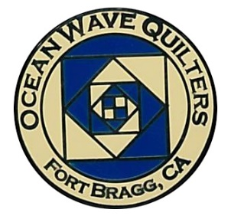
Ocean Wave Quilters
January 2024 Newsletter



President’s Message

Greetings to everyone!

I hope that your holidays were wonderful and that you got some time to sew. I am looking forward to the new year and all the new projects we will be presenting at Sew n Sew. I went to a three-day class in Sacramento and learned so much that I will be teaching.

The Ocean Wave Quilters’ Holiday Party was a nice event with time to share and visit. The Brown Bag projects were so creative. Thank you to everyone who participated.

Looking forward to seeing you all at our next meeting on Sunday, January 14, 2024!

Paula P, President
Ocean Wave Quilters
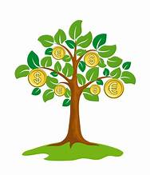

OCEAN WAVE QUILTERS
DECEMBER 2023 TREASURER’S REPORT

11-28-23 BEGINNING BALANCE $ 8018.94

EXPENSES
Use of classroom for Vortex Class | $ 100.00
Money for Brown Bag Prizes | $ 135.00
Department of Justice | $ 30.00

TOTAL EXPENSES $ 265.00

Donation- Tracy for 50.00  Sharon L Quilting | $ 50.00
Donation- Charleen A 40.00  Infusion RN | $ 40.00
Linda Schmidt class. $45 each  Martin M  Daisy W  Sharon L | $ 135.00
Raffle at Dec Mt. | $ 141.00
New Member Dues Carley B-M | $ 25.00

TOTAL INCOME $ 391.00

CLOSING BALANCE 12-26-23 $ 8144.94

Submitted by Sharon Rowan, Treasurer

Sent copy to each Board member for approval 12/16/23
Quilt Guilds of the North Quarter (QGNQ)

The 2024 QGNQ meetings are:

- January 27: Ridge Quilters in Paradise: Meet the teacher. Carole P is planning to attend. Contact her if you would like to go as well.
- April 27: Ladies of the Lake in Lower Lake
- July 27: Mountain Quilt Quilters in MacArthur
- October 26: Ocean Wave Quilters in Fort Bragg (Yep! That’s us!)



Special Events – Steffany B

Hello everyone, thank you so much for joining in our Holiday Party! it was so fun seeing everyone’s brown bags. I enjoyed chatting with everyone and getting to taste all the wonderful cookies! I wish a cookie exchange was part of every meeting. The next event we have on the books will be the March Retreat and then the Luncheon in April. If anyone has opinions on what we should serve this year, I am more than happy to hear them. Feel free to shoot me an email. I hope everyone had a wonderful holiday season with family and friends.
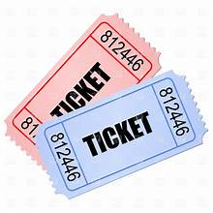
Hospitality ~ Daisy 🐾

Don’t forget to donate for the raffle baskets.
There is a designated box at Sew n Sew. Next raffle is in March 2024.

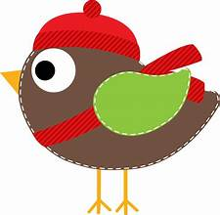Service – Grace V.

December Service Report
Dress-a-Girl Dresses
Warm Welcome Quilts | 11
Chaplain Quilts
Other Community Quilts
Texture Quilts
Infusion Center | 5
Pillowcases | 12
Pet Beds | 4
Port Pillows
Community Quilts | 3

We will continue to need more of everything to donate in the New Year. Let’s keep sewing so we can keep spreading love and warmth in 2024. HAPPY NEW YEAR!

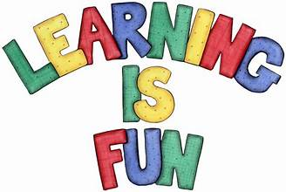

Education – Carole P

Linda Schmidt will present her Fantasy Falls Workshop on Monday, February 12, 2024. The class is 6 hours and will run from 10:00 am to 4:00 pm at Sew n Sew Fabrics. The cost for the class is $45.00 (to OWQ) with a supplies fee of $20 per student to be paid directly to the teacher at the time of class. As always, your place in class is not confirmed until you pay for your space in class. Your check should be made out to "Ocean Wave Quilters" but given to Carole Poma directly. Materials list for class will be given out when you sign up and pay. Please take a few minutes to look her up on line and view her beautiful work.

Further Questions? Give me a call.

Block of the Month

Want to teach a Block of the Month? There are three spots left to fill. Can we put your name on one of them? Contact Carole P.

August 2023 | Lony F | February 2024 | Ginny C
September 2023 | Evelyn H | March 2024
October 2023 | Paula P | April 2024 | Luncheon
November 2023 | School House | May 2024 | Martin W
December 2023 | Holiday Party | June 2024
January 2024 | Lisa C | July 2024
Tip of the Month ! ~ Bobbie K

No tip of the month since we had the Holiday Party
at our last Guild meeting.

Did you know….
- Even though the sewing machine was invented in 1790, hand-quilting was still more popular for the next 100 years.
- Susan B. Anthony’s first women’s suffrage speech was given at a church quilting bee in Cleveland, Ohio.
- The expected life span of cotton fabric is about 100 years. If you’re making an heirloom quilt, this makes cotton the way to go!
- During the expansion into the Western United States, quilts were used as window coverings, doors, and walls for temporary housing as well as currency for pioneers.
- National Quilting Day is March 16, 2024.

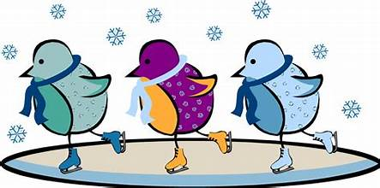
Quilt Walk ~ Sherry W

Bring your quilts to Sew n Sew. It is not too early to drop them off. Make sure to complete the FBQS Quilt Walk Form on our website. www.oceanwavequilters.com The form is under the Fort Bragg Quilt Show.

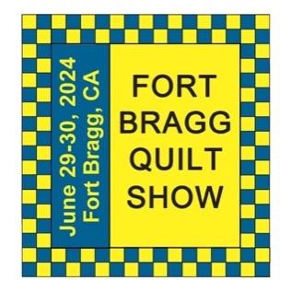

Quilt Show ~ Sherry W
"Around the Block"

The 2024 OWQ Quilt Show is heading our way, yahoo!!

All the background work being done by the Quilt Show Committee, all the beautiful quilts being created for entry in the show, don't forget about the Quilt Walk around town.
With all with the great members we have, we can't help but have another fantastic show.

Opportunity Quilt Tickets are on sale NOW! Tickets are $5 each or 3 for $10. Contact Sharon G to purchase.


New Year’s Resolutions

- Sew two hours every day. ~ Linda M
- I don't seem to have a problem committing to "sew time" but I do want to increase my physical activity time so my New Year's resolution is 30 minutes of activity ( indoors or out!) for every 2 hours of sewing. ~ Shari L
- I am going to work out on the elliptical bike for 12 minutes, 5 days a week. No, really, I am!!!! I have used this resolution every year. ~ Pam M
- This year I want to finish a project before I start a new one. I think it’s the same as last year's 😅 ~ Sherry W
- Empty those scrap drawers, then the fat quarter drawers! Someday I’ll tackle the yardage…. ~ Sharon L
- My quilting resolution is use more of my stash.
My everyday resolution is to make all my own butter and bread products. ~ Steffany B
- Add labels to my quilts. ~ Dee



January 1 Kim R January 18 Tracey S
January 2 Janet N January 26 Phoebe G
January 4 Linda M January 29 Nancy Y
January 4 Shari L
Happy Birthday!
MARK YOUR CALENDAR
February 2024

Fri | 2 | Newsletter Distribution Deadline
Wed | 7 | Quilt Show Committee Meeting
Thu | 8 | Education/Special Events
Sun | 11 | General Meeting
Mon | 12 | Linda Schmidt’s workshop “Fantasy Falls”
Sun | 25 | Sew Service Sunday
Tue | 27 | Board Meeting and Newsletter Articles Due

Hand Sewing Group via Zoom
every Thursday 1-4 pm
Hand Quilting Group every Tuesday 1-4 pm at Senior Center

January 2024

Wed | 3 | Quilt Show Committee Meeting
Thu | 4 | Education/Special Events
Sun | 14 | General Meeting
Sun | 28 | Sew Service Sunday
Tue | 30 | Board Meeting and Newsletter Articles Due

Hand Sewing Group via Zoom
every Thursday 1-4 pm
Hand Quilting Group every Tuesday 1-4 pm at Senior Center
r

March 2024

Fri | 1 | Newsletter Distribution Deadline
Wed | 6 | Quilt Show Committee Meeting
Thu | 7 | Education/Special Events
Sun | 10 | General Meeting
Wed-Sat | 20-24 | Retreat
Tue | 26 | Board Meeting and Newsletter Articles Due
Fri | 29 | Newsletter Distribution Deadline

Hand Sewing Group via Zoom
every Thursday 1-4 pm
Hand Quilting Group every Tuesday 1-4 pm at Senior Center

Hand Sewing Group via Zoom
every Thursday 1-4 pm
Hand Quilting Group every Tuesday 1-4 pm at Senior Center

April 2024

Wed | 3 | Quilt Show Committee Meeting
Thu | 4 | Education/Special Events
Sun | 14 | General Meeting
Sun | 28 | Appreciation Luncheon + UFO Reveal + Jeri Kennedy Trunk Show
Tue | 30 | Board Meeting and Newsletter Articles Due–Who wants to apply for officer/committee chair positions?
Hand Sewing Group via Zoom
every Thursday 1-4 pm
Hand Quilting Group every Tuesday 1-4 pm at Senior Center

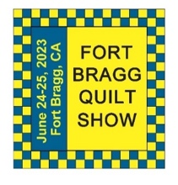
The 27th Annual Fort Bragg Quilt Show

A HUGE “Thank You”
to this year’s sponsors:

Diamond
Community First Credit Union
Rossi Building Materials
Platinum
Mendocino Railway
D’Aurelio’s
Gold
The Larkin Cottage | Todd Farmhouse Antiques
Laurel Deli and Desserts | Bitterroot Family Therapy
Mendo Litho | Mendocino Yarn Shop
First Equity/Remax | Sew ‘n Sew Fabrics
Roundman’s Smokehouse | Out of This World
Savings Bank of Mendocino County
Carol Millsap – State Farm Insurance
Silver
Cheap Cigarettes | Frankie’s Pizza & Ice Cream
Coast Hardware | Norvell’s
Mendocino Cookie Co | Sacred Woods
Tsunami Glass | Windsong Books & Records
Bronze
Chernoff’s Jewelers | Imaginations
The Outdoor Store | North Coast Artists
Simply Succulent | Beautiful Earth
Shirts and More | Oh, Baby!
Noyo Fish Company | Harbor Lite Lodge
Melrose X Lost Coast | Egghead’s

Ocean Wave Quilters Board 2023/2024
President | Paula P. | 702-962-9006 | paula@sew-n-sew.com
Vice-President | Dee G. | 707-962-0220 | deegoodrich@comcast.net
Secretary | Susan C. | 707-357-1766 | scollinsndgw@gmail.com
Treasurer | Sharon R. | C-707-357-4511  H-707-964-4511 | sawrowan@gmail.com
Communications | Susan B. | 707-758-4195 | sswanson26@gmail.com
Volunteer Coordinator
Documentarian
Newsletter | Linda M. | C-530-263-3764  H-707-937-1891 | lmoore0052@me.com
Committee Chairs

Service | Grace V. | 707-964-5282 | qteddybear@outlook.com
Hospitality | Daisy W. | 925-820-5844 | Dawo.retired@icloud.com
Special Events | Steffany B. | 707-813-4066 | steffanybaroni2628@gmail.com
Education | Carole P. | 707-813-3001 | carolepoma@comcast.net
Quilt Show | Sherry W. | 916-216-6041 | arjnkd@gmail.com

