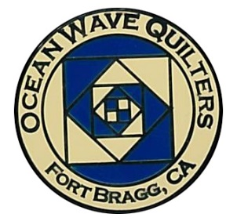
Ocean Wave Quilters
December 2023 Newsletter

President’s Message

Greetings to everyone!

How can it be the end of the year already? Our next meeting on December 10th will also be our Holiday Party and Cookie Exchange. If you want to be part of the exchange bring at least a dozen cookies.

Also bring finger food and sweets for the food table. We will have a time to share food and visit. This is a nice time to get to know our new members.

There will also be voting on the Brown Bag items made and prizes given to the winners.

There will be a short meeting before we adjourn for the get together.

Looking forward to seeing you all.

Paula P, President
Ocean Wave Quilters


OCEAN WAVE QUILTERS
NOVEMBER 2023 TREASURER’S REPORT

OCEAN WAVE QUILTERS
NOVEMBER 2023 TREASURER’S REPORT

10-30-2023 BEGINNING BALANCE $ 8351.15

EXPENSES

Hospitality – Dec Raffle Basket | $ 21.74
Education – Lunch Vortex Teacher | $ 14.97
Administration – Travel QGNQ | $ 347.50
TOTAL EXPENSES $ 384.21

INCOME
Silent Auction for Donated Wall Hanging | $ 52.00
TOTAL INCOME $ 52.00

11-28-2023. CLOSING BALANCE $ 8018.94

Submitted by Sharon Rowan, Treasurer

Approved at 11-28-2023 Board Meeting
Quilt Guilds of the North Quarter (QGNQ)

What exactly is the QGNQ? How long has OWQ belonged? What do they do? I reached out to Daisy W and Sharon L to get a few answers.

Ocean Wave Quilters has belonged to the QGNQ since 2015.
We belong because it is a group of rural-based guilds, so much like us. We used to belong to NCQC ( Northern California Quilt Council) but those are mainly huge urban guilds that we really couldn’t relate to (and much costlier to join!) QGNQ only costs us $15 per year.

Our rep attends meetings for a couple of reasons:

Networking - always good to know folks in other guilds in case we have questions about how they do things: run their quilt shows, get a good price on bulk batting, have fundraisers, store their supplies, etc. Some lasting friendships have been made.

Opportunity quilt ideas - many guilds bring their quilts to the meetings to sell tickets. (We haven’t been as successful, because they complain about our $5 ticket price…theirs are $1, but we have agreed we are the smart ones to set our price at $5.) Linda M is doing the math to see just how many chances we have to win a quilt under both pricing scenarios.

Speaker and class ideas - often there is a speaker at the meetings. And other guilds gladly share the classes and speakers they like/don’t like and why.
The meetings are a LONG drive… but Daisy, Becky, and Dee have all attended from their other residences along Highway 5 or 101, which makes it a little quicker. Sharon L has been to a couple from here and Martin W attended one last year. Want to go? Contact Paula P who will put you in touch with the people attending.

The 2024 QGNQ meetings are:

- January 27: Ridge Quilters in Paradise: Meet the teacher
- April 27: Ladies of the Lake in Lower Lake
- July 27: Mountain Quilt Quilters in MacArthur
- October 26: Ocean Wave Quilters in Fort Bragg (Yep! That is us!)



At the last general meeting Dee G presented a non-budgeted item over $50 to the membership. It was discussed and is being published in this newsletter as outlined in our by-laws.

Ocean Wave Quilters will pay $1000 per year to Sew n Sew as rent for the space we use for meetings and storage in the building. This would be in addition to fees paid for holding classes there. Since this is an unbudgeted amount exceeding $50 allowed in the by-laws, the motion will be placed in the December Newsletter and brought back to the general meeting for a vote.

A secret ballot will be taken at the December General Meeting.
Any questions? Contact Sharon R


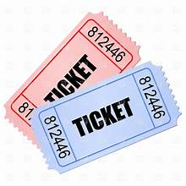
Hospitality ~ Daisy 🐾

The Holiday Basket is really special this time. So, be prepared to buy tickets at the General Meeting on December 10th:
1 for $1; 6 for $5; 15 for $10; 34 for $20.

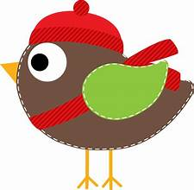Service – Grace V.

November Service Report
Dress-a-Girl Dresses
Warm Welcome Quilts
Chaplain Quilts
Other Community Quilts
Texture Quilts
Infusion Center | 5
Pillowcases | 48
Pet Beds | 10
Port Pillows
Community Quilts

Everyone is so grateful for our gifts. Thank you all for doing such a wonderful job. Special thanks to Nancy L who has upped our pillow case supply to never before levels!




Education – Carole P
The school house went very well. Paula presented applique, Daisy presented quilt as you go, Tracy presented crumb quilting and Evelyn presented how to piece a thin line of fabric in your quilting. All presentations were well received and it was requested that we have the School House again in spring.
Daisy will be presenting her "Quilt as you Go" and "Ruler Quilting" class in March or April 2024 for anyone who is interested in learning these two quilting skills. More information will be forthcoming.
We will have another teacher on Monday, February 12, 2024. Linda Schmidt will present her Fantasy Falls Workshop. The class is 6 hours and will run from 10:00am to 4:00pm at Sew n Sew Fabric Store. The cost for the class is $45.00 (to OWQ) with a supplies fee of $20 per student to be paid directly to the teacher at the time of class. As always, your place in class is not confirmed until you pay for your space in class. Your check should be made out to "Ocean Wave Quilters" but given to Carole Poma directly. Materials list for class will be given out when you sign up and pay. Please take a few minutes to look her up on line and view her beautiful work.

Further Questions? Feel free to ask me at our December meeting or give me a call.

Block of the Month

Want to teach a Block of the Month? There are three spots left to fill. Can we put your name on one of them? Contact Carole P.

August 2023 | Lony F | February 2024 | Ginny C
September 2023 | Evelyn H | March 2024
October 2023 | Paula P | April 2024 | Luncheon
November 2023 | School House | May 2024 | Martin W
December 2023 | Holiday Party | June 2024
January 2024 | Lisa C | July 2024

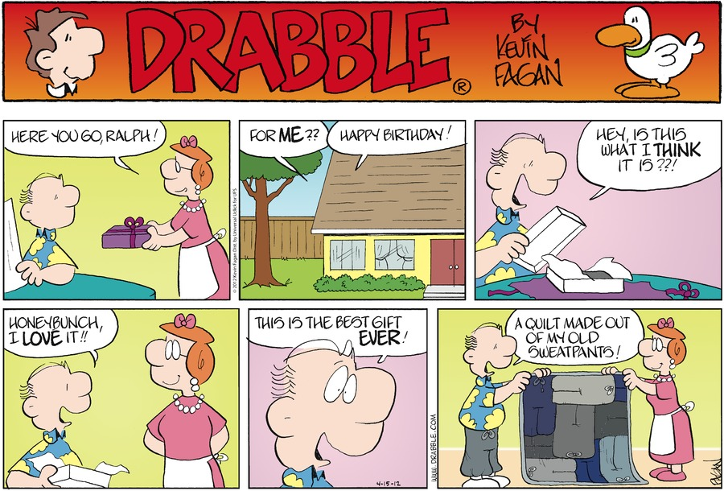



Tip of the Month ! ~ Bobbie K

- On Line Site: “thequiltersgarden.com” & “thesprucecrafts.com” both have needle crafts, quilting, quilting basics, and more. The reason I was looking on line was the age- old questions of “to prewash or not to prewash” and “how to do it”. The first one was one of the better sites for answering these questions and had particularly great “tips for prewashing quilt fabrics” .

- Quilting: Precut quilt kits may sound like cheating, but they get you right to the fun part, sewing, quickly. No measuring, cutting, or prewashing fabrics. The prices aren't that bad either. Some kits include threads, others not. For a quick project/gift they are well worth considering. One particularly good site is “missouriquiltco.com”.

- Tool: Feathers are a great tool for cleaning your machine. Other devices such as canned air can be harmful even. When the can is almost empty the pressure is lower and spraying can lodge things in crannies instead of blowing it out. Compliments of Connie.

Quilt Walk ~ Sherry W

The 2024 Quilt Walk Submission Form is available on our website under Forms and Documents. Please submit a form for each quilt you share. You may drop off your quilts anytime at Sew n Sew. I know this seems early but we need about 100 quilts. Here is a link to the OWQ webpage. www.oceanwavequilters.com
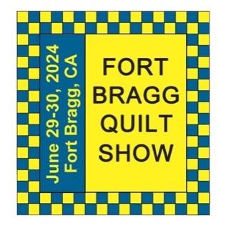

Quilt Show ~ Sherry W

2024 is almost here, and for Ocean Wave Quilters that means donation quilts to make, personal quilts to make and quilts for our Quilt Show. This is where we get to create exceptional quilts to share our talents with others. Little quilts, big quilts, upcycled quilts, art quilts, the list goes on and on. This will be the 28th Quilt Show, we know it's going to be awesome!

Did you know….During the 1800s there was a custom for a girl to make a baker’s dozen of quilt tops before she was engaged. 12 were utility quilts and one was a masterpiece for her bridal bed. After her engagement she would complete the tops into quilts.

The world’s largest quilt is the AIDS Memorial Quilt. It weighs 54 tons and spans 1.2 million square feet. In 1987 it contained 1,920 panels commemorating people who died of AIDS. Now there are 48,000 panels. Most blocks are rectangles measuring 6 feet by 3 feet or roughly the size of a grave.
2024 Large Opportunity Quilt

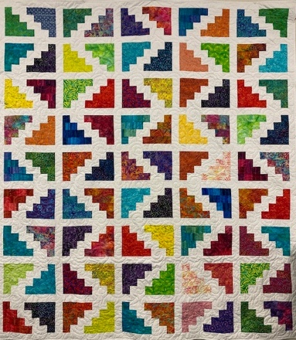

“Around the Countryside”
83” x 92”
Pattern “Countryside Trail” by Ariga Mahmoudlou for Robert Kaufman
Project led by Sharon G and pieced by Ocean Wave Quilters
Quilted by Nadine S

Tickets are $5 each or 3 for $10. Contact Sharon G.
Sharon will have tickets for sale at the General Meeting.
She also needs ideas on where to sell tickets in the community.



December 14 Bobbie Knapp

Bobbi, enjoy your Birthday in Hawaii!
MARK YOUR CALENDAR
January 2024

Wed | 3 | Quilt Show Committee Meeting
Thu | 4 | Education/Special Events
Sun | 14 | General Meeting
Sun | 28 | Sew Service Sunday
Tue | 30 | Board Meeting and Newsletter Articles Due

Hand Sewing Group via Zoom
every Thursday 1-4 pm
Hand Quilting Group every Tuesday 1-4 pm at Senior Center

December 2023

Fri | 1 | Newsletter Distribution Deadline
Wed | 6 | Quilt Show Committee Meeting
Thurs | 7 | Education/Special Events
Sun | 10 | General Meeting – Holiday Party +Brown Bag Reveal
Tue | 26 | Board Meeting and Newsletter Articles Due
Fri | 29 | Newsletter Distribution Deadline

Hand Sewing Group via Zoom
every Thursday 1-4 pm
Hand Quilting Group every Tuesday 1-4 pm at Senior Center

February 2024

Fri | 2 | Newsletter Distribution Deadline
Wed | 7 | Quilt Show Committee Meeting
Thu | 8 | Education/Special Events
Sun | 11 | General Meeting
Mon | 12 | Linda Schmidt’s workshop “Fantasy Falls”
Sun | 25 | Sew Service Sunday
Tue | 27 | Board Meeting and Newsletter Articles Due

Hand Sewing Group via Zoom
every Thursday 1-4 pm
Hand Quilting Group every Tuesday 1-4 pm at Senior Center

March 2024

Fri | 1 | Newsletter Distribution Deadline
Wed | 6 | Quilt Show Committee Meeting
Thu | 7 | Education/Special Events
Sun | 10 | General Meeting
Wed-Sat | 20-24 | Retreat
Tue | 26 | Board Meeting and Newsletter Articles Due
Fri | 29 | Newsletter Distribution Deadline

Hand Sewing Group via Zoom
every Thursday 1-4 pm
Hand Quilting Group every Tuesday 1-4 pm at Senior Center

Hand Sewing Group via Zoom
every Thursday 1-4 pm
Hand Quilting Group every Tuesday 1-4 pm at Senior Center

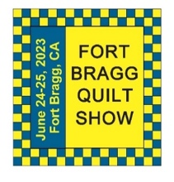
The 27th Annual Fort Bragg Quilt Show

A HUGE “Thank You”
to this year’s sponsors:

Diamond
Community First Credit Union
Rossi Building Materials
Platinum
Mendocino Railway
D’Aurelio’s
Gold
The Larkin Cottage | Todd Farmhouse Antiques
Laurel Deli and Desserts | Bitterroot Family Therapy
Mendo Litho | Mendocino Yarn Shop
First Equity/Remax | Sew ‘n Sew Fabrics
Roundman’s Smokehouse | Out of This World
Savings Bank of Mendocino County
Carol Millsap – State Farm Insurance
Silver
Cheap Cigarettes | Frankie’s Pizza & Ice Cream
Coast Hardware | Norvell’s
Mendocino Cookie Co | Sacred Woods
Tsunami Glass | Windsong Books & Records
Bronze
Chernoff’s Jewelers | Imaginations
The Outdoor Store | North Coast Artists
Simply Succulent | Beautiful Earth
Shirts and More | Oh, Baby!
Noyo Fish Company | Harbor Lite Lodge
Melrose X Lost Coast | Egghead’s

Ocean Wave Quilters Board 2023/2024
President | Paula P. | 702-962-9006 | paula@sew-n-sew.com
Vice-President | Dee G. | 707-962-0220 | deegoodrich@comcast.net
Secretary | Susan C. | 707-357-1766 | scollinsndgw@gmail.com
Treasurer | Sharon R. | C-707-357-4511  H-707-964-4511 | sawrowan@gmail.com
Communications | Susan B. | 707-758-4195 | sswanson26@gmail.com
Volunteer Coordinator
Documentarian
Newsletter | Linda M. | C-530-263-3764  H-707-937-1891 | lmoore0052@me.com
Committee Chairs

Service | Grace V. | 707-964-5282 | qteddybear@outlook.com
Hospitality | Daisy W. | 925-820-5844 | Dawo.retired@icloud.com
Special Events | Steffany B. | 707-813-4066 | steffanybaroni2628@gmail.com
Education | Carole P. | 707-813-3001 | carolepoma@comcast.net
Quilt Show | Sherry W. | 916-216-6041 | arjnkd@gmail.com

