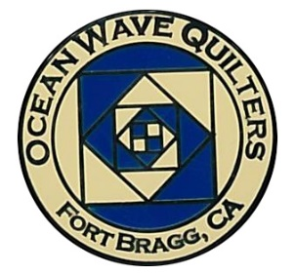
Ocean Wave Quilters
August 2023 Newsletter

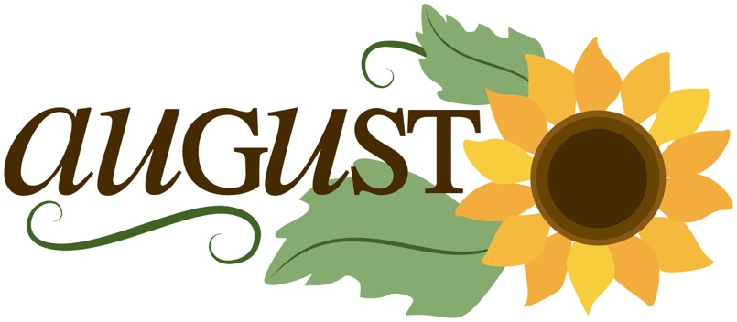
President’s Message

Hello Guild members,

As summer comes to a close the Guild is planning many events and classes.

At the next meeting there will be a motion to purchase a printer for Ocean Wave quilters. This will be great for all of the printing that needs to be done. It is hard to determine how much ink and paper to ask the guild to reimburse for jobs being done.

Next meeting we will also talk about the UFO exchange and brown bag projects so everyone can get involved.

Looking forward to seeing you at the next meeting and enjoying snacks at break.

Paula P, President
Ocean Wave Quilters
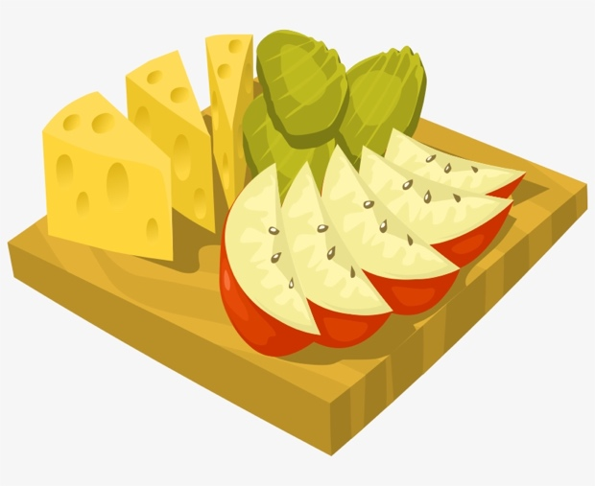

Snack Table

Shirlee P, Jeanne K, and Sharon B have come together to revive the snack table at the General Meetings. Here are some suggested guidelines if you would like to participate.

- Finger foods are best.
- Homemade and/or store-bought snacks are welcome.
- Contributions to the snack table are voluntary.
- Leftovers, if any, shall be taken home by the donor.
- Bottled water will be supplied by the guild for those who are thirsty.
- All trash will be taken home and recycled as appropriate.
- Guidelines are not rules, there will always be exceptions.
Our Guild is made-up of wonderful people; fun, food and friendship bring us togetherness.



Ocean Wave Quilters
2022-2023 Year-End Treasurer's Report
Submitted by Sharon L
EXPENSES
Hospitality | $336.07
Education | $1,492.39
Special Events | $2,038.90
Service | $777.71
Communications | $726.12
Administration | $2,410.64
Unbudgeted | $1,876.43
TOTAL EXPENSE | $9,658.26
INCOME
Hospitality | $613.00
Education | $300.00
Special Events | $190.00
Administration | $3,924.85
TOTAL INCOME | $5,027.85
Checking balance 6-30-2023 | $10,510.99


OWQ annual membership dues of $25 are delinquent on August 1, 2023. Pay the $25 NOW to avoid additional charges. You may mail your check to:
Ocean Wave Quilters
P.O. Box 2687
Fort Bragg, CA 95437

Service – Grace V.

July Service Report
Dress-a-Girl Dresses
Warm Welcome Quilts | 7
Chaplain Quilts
Other Community Quilts
Texture Quilts | 1
Infusion Center | 5
Pillowcases
Pet Beds | 5

Anyone that gives a quilt to someone in the name of the Quilt Guild can text or email me and I will put it in the next newsletter. ~ Grace V

A Milestone – Judy W

OWQ has just passed a milestone: 20 years of providing baby quilts to all families in Fort Brag (and the coast) having a baby through the Warm Welcome program. Thanks and kudos to Shirlee P who started this joyful program in 2003. OWQ members have contributed to the tradition by making many lovely quilts. Our families love the quilts they receive from us at this momentous time in their life.

A Bit of Sad News….

Tina P’s husband, Russ, passed away. Many of you knew Russ as he was the radiologist at the hospital for many years. Cards would be appreciated. You can find her new address in Windsor on the OWQ’s address list. Tina participates in the hand sewing group on Thursday afternoons from 1 pm to 4 pm. Pop on the Zoom link and say hello!

Education – Carole P

Our first class for the new fiscal year will be Scrap Vortex, taught by Sandra Bruce. The class will be on Monday October 23, 2023 9:30am to 3:30 pm. If you are interested in her work you can look her up on line at: https://www.sandrabruce.com
The class will cost $35.00 and sign-ups will start at the August Meeting. Class size is limited so please sign up early to assure yourself a seat. Here is a little information on her class.

SCRAP VORTEX WORKSHOP by SANDRA BRUCE

We all have bins/boxes/drawers of scraps that we'd love to put into use! This technique, called Scrap Vortex, is a way to use them up (or at least, try!). I will send 3 examples of Scrap Vortex quilts to your guild next month, all using scraps I couldn't bear to get rid of. In the workshop, you will bring your scraps to use and share to make yours varied and top-notch. I will demo different techniques to use, such as curved piecing, wonky log cabin blocks, and how to fussy-cut to make a great looking block, among others. The beauty of this technique is you can make it any size, any color combo, and there's unlimited freedom in your piecing!

Block of the Month

Here are the current sign-ups for Block of the Month. If no one signs up for a particular month there will not be a BOM that month at the General Meeting. Contact
Carole P if you would like to volunteer.

August 2023 | Lony F | February 2024
September 2023 | Evelyn H | March 2024
October 2023 | Paula P | April 2024
November 2023 |  | May 2024
December 2023 | Lisa C | June 2024
January 2024

Special Events – Steffany B

The BBQ will be held September 24th from 12-3pm at Carole P’s house. The sign-up sheet for side dishes will be up at the August and September meetings. Please sign-up with the number of guests that will be attending. I will be buying the main dish and drinks according to the sign-up sheet. I would hate for there to not be enough food.

The brown bags will go on sale starting the August meeting and will be ongoing until the revel. Each bag will be $5 a bag and the revel will be at the holiday party, December 10th. There will be no theme this year. I like the idea that there are no rules for the brown bag.

The UFO bags will be handed out (empty) at the August meeting and I ask that they please be brought back at the September meeting filled and sealed. If everyone brings their bag back at the September meeting we can get them handed out the same day. The reveal for the UFO's will be held at the luncheon on April 28th.
The Fall retreat will be held at the grange in Inglenook October 18th-21st. Daisy W will be doing a demo/class on the folded star.

The spring retreat will be held at the grange in Inglenook as well, March 20th-23rd. We may have another member of the guild do a demo on one of their specialties or this one may not have a speaker. That is still to be determined. If anyone would like to do a demo/class on March 20th the first day of the retreat, please contact me.

Quilt Show 2024 – Sherry W

It's a new year and another quilt show for our guild.
One of the very first items for the Quilt Show Committee, is to select a theme for the 2025 show. Let's all put on our "quilting" hats and think of a theme that would be perfect for our 2025 quilt show. Please send your ideas to me or contact me by Tuesday, August 1.

Want to have more fun? After the theme is selected, in September the Quilt Show Committee will be asking you for patterns or ideas for the 2025 Opportunity Quilt, so be on the lookout for patterns that you think may WOW us all!

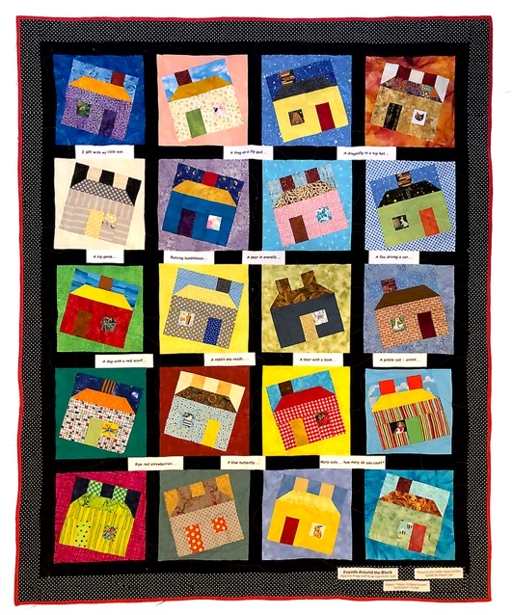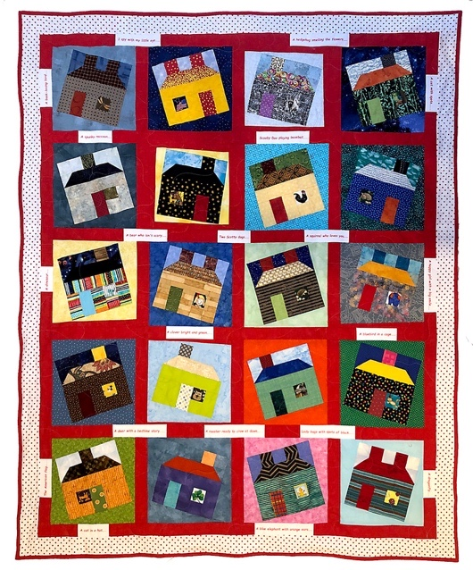

“Friends Around the Block”
53” x 65”
Pattern “Happy Scrappy Houses” by Bonnie K. Hunter
Project led by Sharon L and Daisy W
Quilted by Sharon L


August 1 Catherine S August 16 Nancy L
August 24 Sandy B
August 26 Connie M
August 28 Diane S
August 29 Carole P

Enjoy your Special Day!

MARK YOUR CALENDAR
August

Wed | 2 | Quilt Show Committee Meeting
Thu | 3 | Education/Special Events
Sun | 13 | General Meeting
Sun | 27 | Sew Service Sunday
Tue | 29 | Board Meeting and Newsletter Articles Due

Hand Sewing Group via Zoom every Thursday 1-4 pm
Hand Quilting Group every Tuesday
1-4 pm at Senior Center

September
Fri | 1 | Newsletter Distribution Deadline
Wed | 6 | Quilt Show Committee Meeting
Thu | 7 | Education/Special Events
Sun | 10 | General Meeting
Sun | 24 | BBQ 12-3 pm Carole P’s
Tue | 26 | Board Meeting and Newsletter Articles Due
Fri | 29 | Newsletter Distribution Deadline

Hand Sewing Group via Zoom every Thursday 1-4 pm
Hand Quilting Group every Tuesday
1-4 pm at Senior Center

October

Wed | 4 | Quilt Show Committee Meeting
Thu | 5 | Education/Special Events
Sun | 8 | General Meeting
Wed-Sat | 18-21 | Retreat at Inglenook Grange
Mon | 23 | “Scrappy Vortex” class at Sew n Sew
Tue | 31 | Board Meeting and Newsletter Articles Due

Hand Sewing Group via Zoom every Thursday 1-4 pm
Hand Quilting Group every Tuesday 1-4 pm at Senior Center

November

Wed | 1 | Quilt Show Committee Meeting
Thu | 2 | Education/Special Events
Fri | 3 | Newsletter Distribution Deadline
Sun | 12 | General Meeting
Sun | 26 | Sew Service Sunday
Tue | 28 | Board Meeting and Newsletter Articles Due

Hand Sewing Group via Zoom
every Thursday 1-4 pm
Hand Quilting Group every Tuesday 1-4 pm at Senior Center

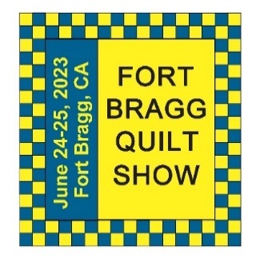
The 27th Annual Fort Bragg Quilt Show

A HUGE “Thank You”
to this year’s sponsors:

Diamond
Community First Credit Union
Rossi Building Materials
Platinum
Mendocino Railway
D’Aurelio’s
Gold
The Larkin Cottage | Todd Farmhouse Antiques
Laurel Deli and Desserts | Bitterroot Family Therapy
Mendo Litho | Mendocino Yarn Shop
First Equity/Remax | Sew ‘n Sew Fabrics
Roundman’s Smokehouse | Out of This World
Savings Bank of Mendocino County
Carol Millsap – State Farm Insurance
Silver
Cheap Cigarettes | Frankie’s Pizza & Ice Cream
Coast Hardware | Norvell’s
Mendocino Cookie Co | Sacred Woods
Tsunami Glass | Windsong Books & Records
Bronze
Chernoff’s Jewelers | Imaginations
The Outdoor Store | North Coast Artists
Simply Succulent | Beautiful Earth
Shirts and More | Oh, Baby!
Noyo Fish Company | Harbor Lite Lodge
Melrose X Lost Coast

Ocean Wave Quilters Board 2023/2024
President | Paula P. | 702-962-9006 | paula@sew-n-sew.com
Vice-President | Dee G. | 707-962-0220 | deegoodrich@comcast.net
Secretary | Susan C. | 707-357-1766 | scollinsndgw@gmail.com
Treasurer | Sharon R. | C-707-357-4511  H-707-964-4511 | sawrowan@gmail.com
Communications | Susan B. | 707-758-4195 | sswanson26@gmail.com
Volunteer Coordinator
Documentarian
Newsletter | Linda M. | C-530-263-3764  H-707-937-1891 | lmoore0052@me.com
Committee Chairs

Service | Grace V. | 707-964-5282 | qteddybear@outlook.com
Hospitality | Daisy W. | 925-820-5844 | Dawo.retired@icloud.com
Special Events | Steffany B. | 707-813-4066 | steffanybaroni2628@gmail.com
Education | Carole P. | 707-813-3001 | carolepoma@comcast.net
Quilt Show | Sherry W. | 916-216-6041 | arjnkd@gmail.com

