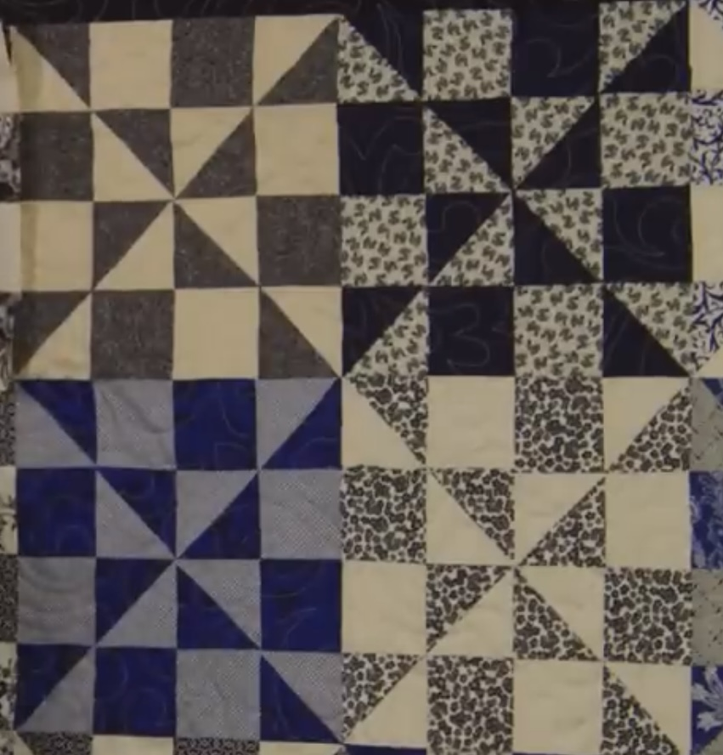
This was a Missouri Star tutorial. I changed up the size of the starting block as I’m not too fond of HST on the bias

Materials: (starch before cutting as it makes a better cut and less raveling)
Background:
* white or what reads as white (e.g., white on white)
* 2 squares cut at 7 7/8” or (my fave 8”)

Print Fabric:
* your choice with a children’s theme. These blocks will finish at 3 1/2” (after cutting) .
So, I would stay with smaller prints.
* 2 squares cut at 7 7/8” or (my fave 8”)

- Make 2 HST using 1 background and 1 print. Draw a line corner to corner and sew 1/4” from the line on each side of the line. Remember, right sides together.
- Cut apart along the line. You now have 2 HST. Press seam open (preferably) which minimizes the bulk.
- Repeat for the second pair of squares. You will have 4 HST that are approximately 7 1/4” square.
- Square up each HST to 7”.
- For each HST, measure over 3 1/2” from the edge and cut vertically. Do not move the pieces. Rotate your ruler and cut 3 1/2” from the bottom edge. You now have 4 squares which consists of 2 smaller HST, 1 background square and 1 print square. Repeat for the remaining large HSTs.

- Sew a HST with a background square. Start and end at a 1/4” Press per arrow.

- Sew a Print square with a HST. Start and end at a 1/4” Press per arrow.
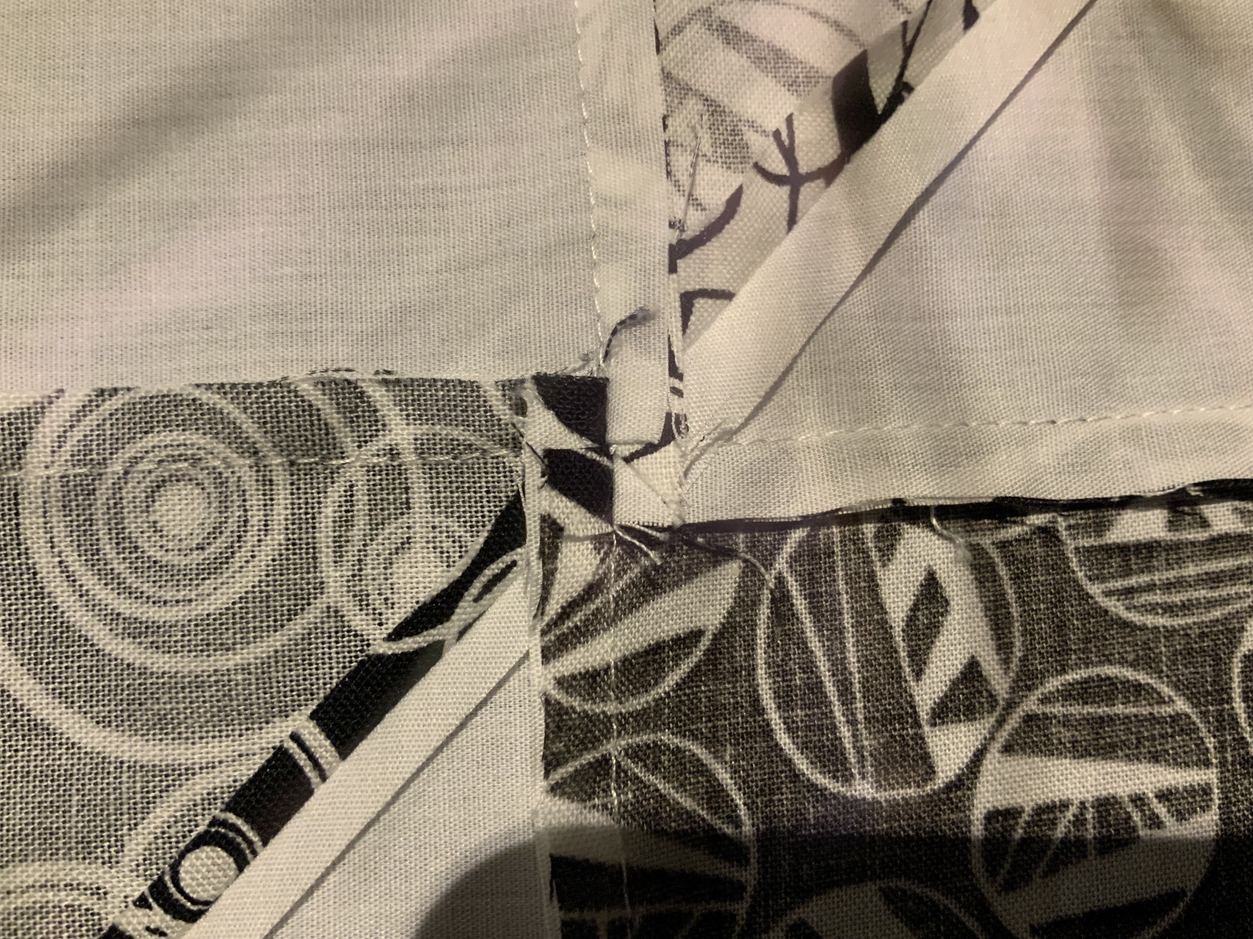

- Sew together. Press per arrow. Make 4 blocks.
Note: you will spin the seam to minimize bulk.
All seams should be clockwise.

7. Starting with block 1, take block 2 and rotate. Sew the 2 blocks together. Repeat with the other two blocks. Spin the seams. 12 1/2” square.

Block 2 Block 3

Block 1 Block 4

