Block of the Month – Patriotic Pinwheels – March 2022

You will need: 8 half-square triangles in Red and White 4$\frac{1}{2}$ x 4$\frac{1}{2}$ inches
8 half-square triangles in Blue and White 4$\frac{1}{2}$ x 4$\frac{1}{2}$ inches
1 Red square 4$\frac{1}{2}$ x 4$\frac{1}{2}$ inches
1 Blue square 4$\frac{1}{2}$ x 4$\frac{1}{2}$ inches
All the reds, blues, and whites can be one color or you can use various reds, blues and whites. I used all the same blue fabric, but I used 4 different white fabrics and 5 different red fabrics. They all read solid. Also, try to keep the white very close to “white”, not too cream or a slight shade of another color.
Arrange the half square triangles to make the 2 pinwheels as shown.
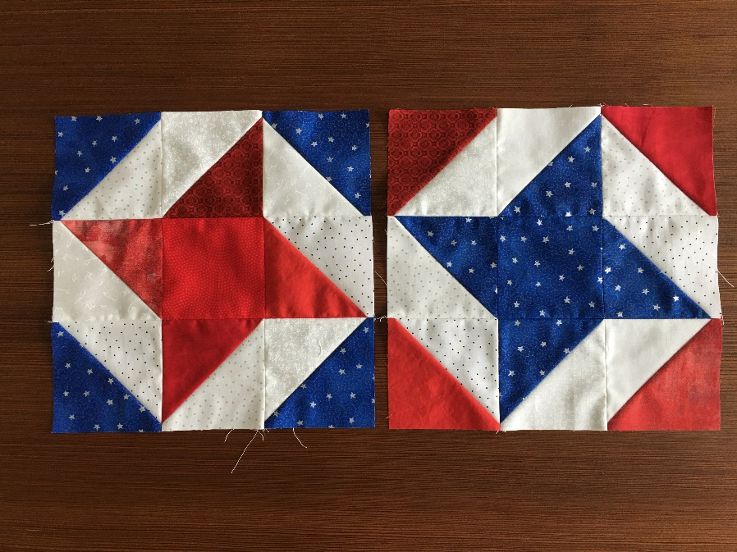

Your blocks will measure 12$\frac{1}{2}$ inches square, but don’t trim them if they are just a little too big.
Block of the Month – Patriotic Pinwheels – March 2022
How to make Half Square Triangles – 3 different ways
To make Two at a time. Cut 5” squares, one colored and one white. Draw a diagonal across from opposite corners. Sew $\frac{1}{4}$ inch on both sides of that drawn diagonal. Press to set the seams. Cut on the diagonal. Press to the colored side. TRIM down to 4$\frac{1}{2}$ inches square. (The black line is the cut line and the red lines are the stitch lines.)
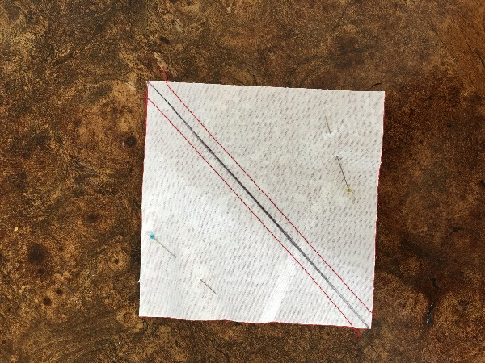
To make 4 at a time. They will all be the same fabrics. Cut 2 squares
7$\frac{1}{4}$ inches by 7$\frac{1}{4}$ inches of each (white and your color). These will be cut on the bias so spray with Best Press. Sew $\frac{1}{4}$ inch all around the edge of the square (right sides together) as shown by the red stich line.
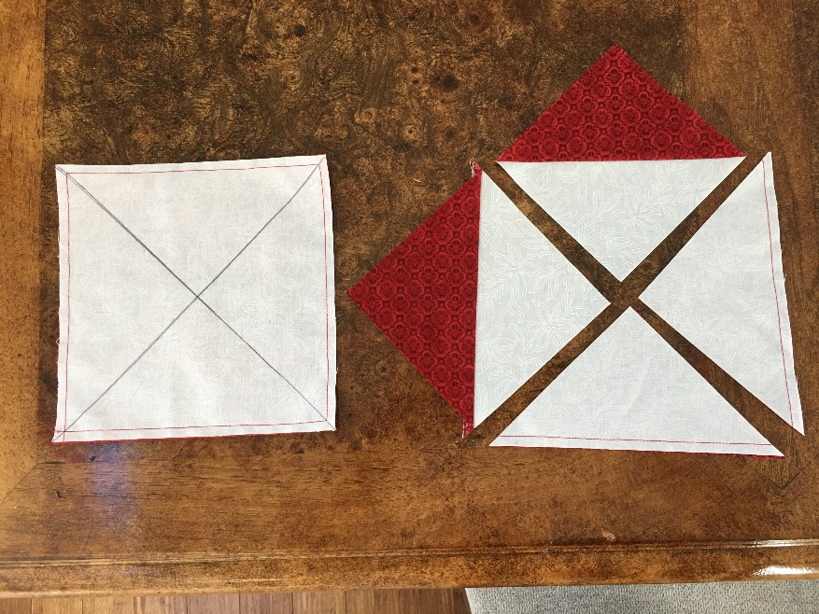
4 at a Time, continued.
Set the seams by pressing before you cut on the diagonals. It is helpful to use a rotating cutting mat so that you don’t have to move the fabric to cut the second diagonal. (I can really only safely cut from the one direction, so I really like my rotating cutting mat for this.) Press to the dark side. Be careful not the stretch the squares. Trim the squares to 4$\frac{1}{2}$ inches square.
To make 8 at one time.
Again, these will all be out of the same fabric. Use 10 inch squares. Draw 2 diagonals kitty corner across the squares (shown in black). Sew $\frac{1}{4}$ inch on both sides of each diagonal. The stich lines are in blue. Set the seams before you cut. Use the rotating cutting mat to cut, 1st horizontally, don’t move the fabric, then cut the vertical and finally the diagonals. The rotating cutting mat is very useful here.
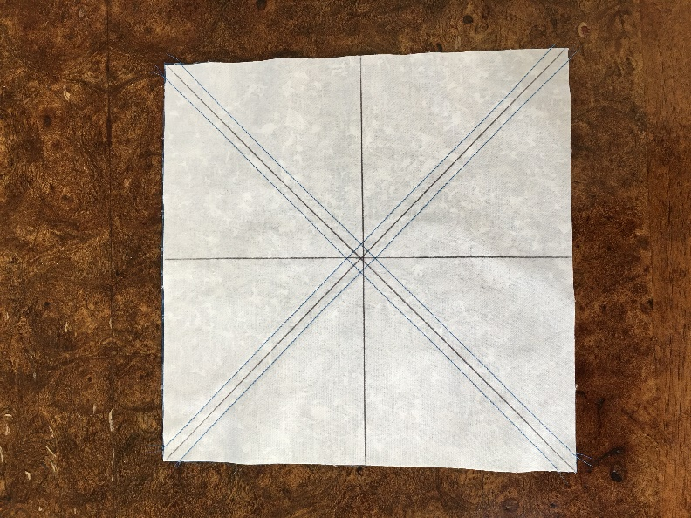
Press to the dark side and Trim to 4$\frac{1}{2}$ inches squares.
There are a number of good demonstrations of how to make HSTs on youtube. If you have access they may be worth your time.
Just Get It Done Quilts – How to make a Half Square Triangle – 10 Ways to Make an HST
3 Ways to Make 1/2 Square Triangles w/ Carmen Geddes

