March 2021 Block of the Month
Spring Flowers / Blossom Time
By Bonnie Hunter
Addicted to Scraps – “Quiltmaker”

CUTTING
Light blue or sky blue
Cut: two squares 3” x 3”
two squares 2$\frac{1}{2}$” x 2$\frac{1}{2}$”
two squares 2$\frac{1}{8}$” x 2$\frac{1}{8}$”
two squares 1$\frac{1}{2}$” x 1$\frac{1}{2}"$
Green for the leaves and stem
Cut: one square 3” x 3”
one square 2$\frac{1}{\begin{aligned}2 \\ \end{aligned}}$“ x 2$\frac{1}{2}$”
Pastel Color for the flower
Cut: one square 3” x 3”
one square 2$\frac{1}{\begin{aligned}2 \\ \end{aligned}}$“ x 2$\frac{1}{2}$”
Accent complementary/ coordinating color
Cut: 2 squares of different colors
Each 1$\frac{1}{2}"$x 1$\frac{1}{2}$”

STEM SQUARE
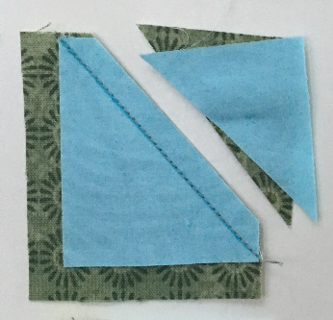
Draw a diagonal on the wrong side of both of the light blue 2$\frac{1}{8}$” squares. Place a light
blue 2$\frac{1}{8}$” square and the green 2$\frac{1}{2}"$ square
right sides together and sew on the diagonal.
Trim to $\frac{1}{4}$”. Press to the light blue.
Repeat on the opposite corner.

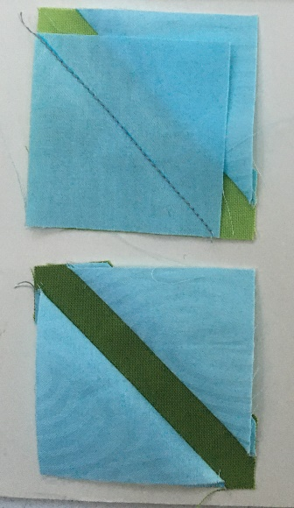
LEAVES and the FLOWER
HST

Draw a diagonal on the wrong side of both of the blue 3” squares. Put a blue square and a 3” green square right sides together. Sew ¼ “ on both the right and left sides of the diagonal. Cut on the diagonal. Press away from the blue side. Square up to 2 ½ “ square.
Repeat with the blue and flower 3” squares.

4 Patch

Sew a 4 patch using the 2 light blue 1 ½ “ squares and the two 1 ½” colored squares.

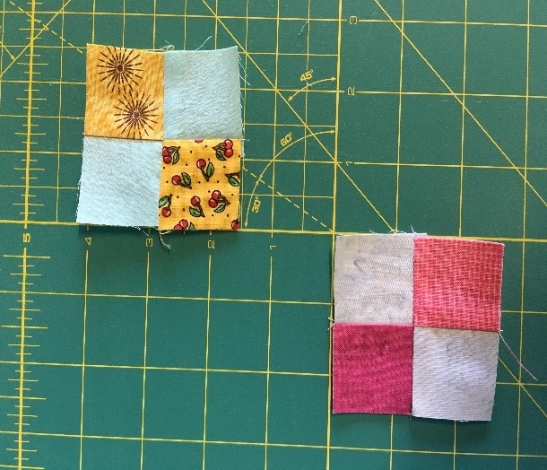

9 Patch
Finally, sew together all 9 squares to make the tulip block. It should measure 6 ½ “ x 6 ½ “. Don't trim it. Let the winner of the blocks do that.



