Disappearing Grecian Block

FABRIC:
From a white fabric cut Two 4 ½” squares and Four rectangles 3 ½” x 2”

From the light gray cut: Two 4 ½” squares

From the red/orange cut: One 3 ½” square and Four rectangles 3 ½” x 2”

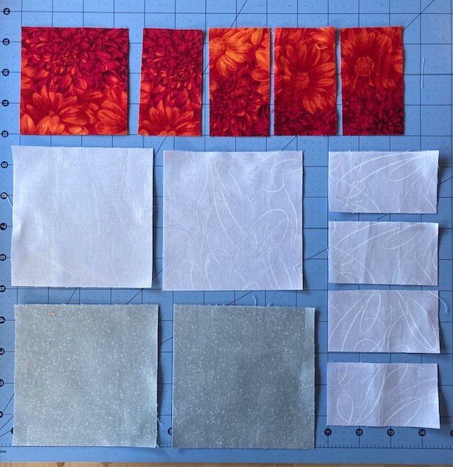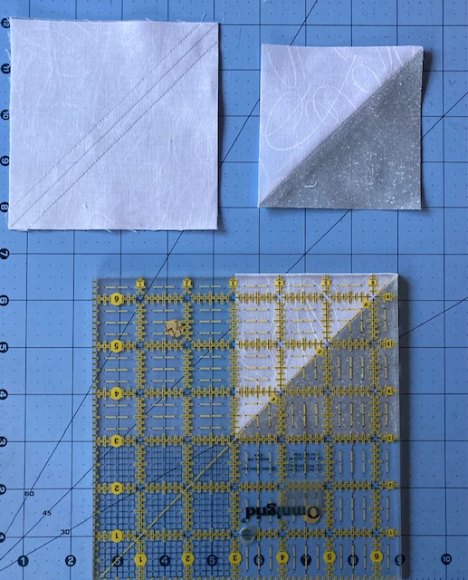
Figure 1 Figure 2

Referring to Figure 2, take a light gray square and the white square, right sides together, mark a diagonal line and sew ¼” seam down each side, cut on diagonal line and you have 2 half-square triangles. Trim to 3 ½”. Do the same with other white and gray square.

Note: Press all seams open

Complete the Grecian block. Start by piecing the white and red rectangles, continue per the layout below, Figure 3

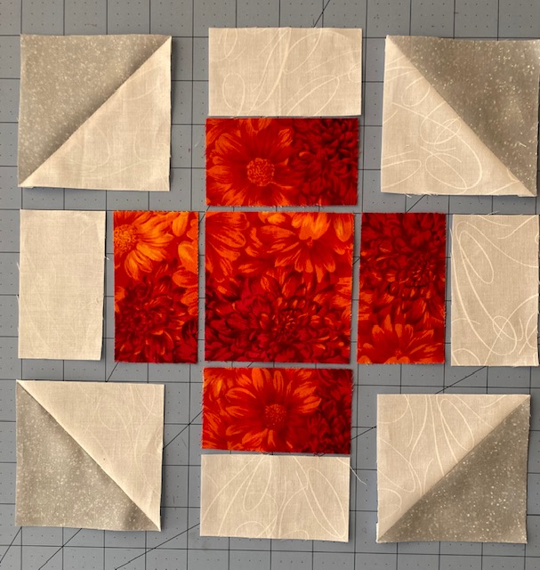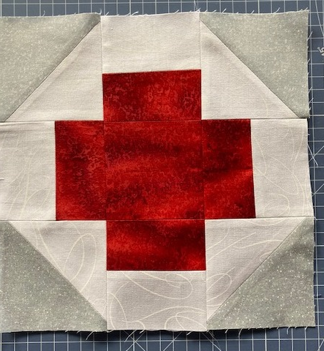
Figure 3 Your block should measure 9 ½” by 9 ½” (unfinished)

Cut your Grecian block exactly in half horizontally and vertically.

A B
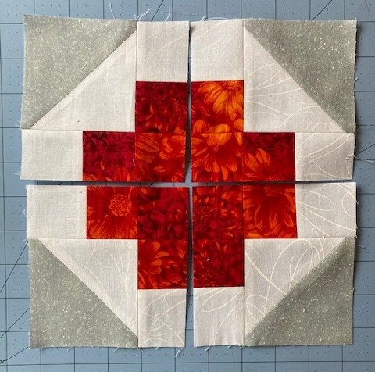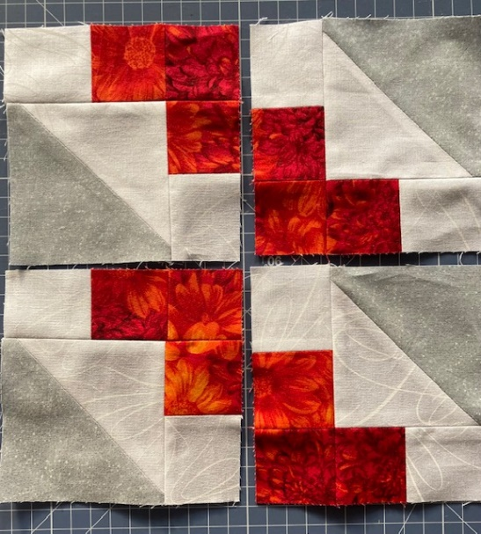
C D
Rotate A once to the left.

Rotate D once to the left.

Your completed block – Measures 9” unfinished

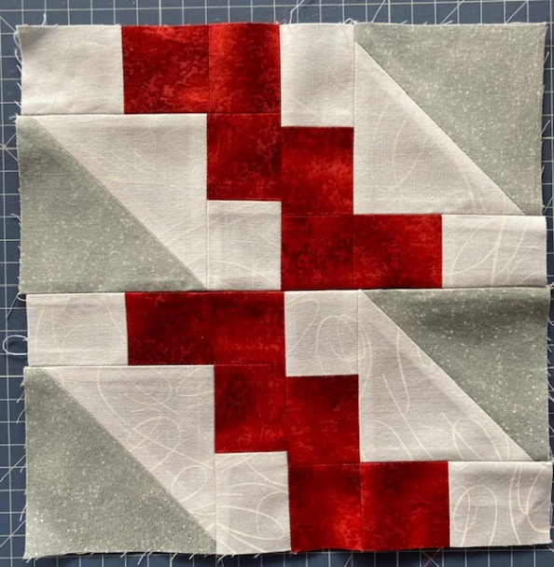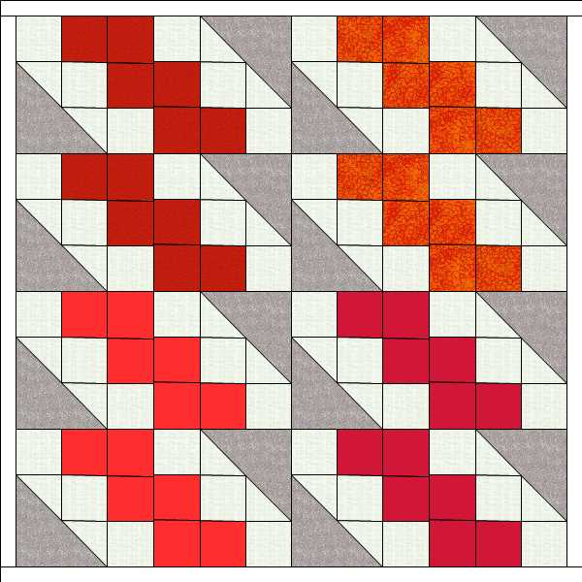

Sample of partial quilt.

