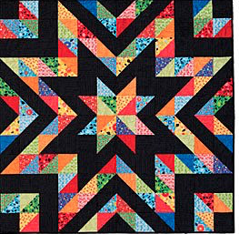

NOTE: This year we are asking you to make half-square triangles (HST) rather than a whole block, because we want to get a good dispersion of color throughout the quilt.

The Fabric
You will need at least 2 (and as many as 7) different colors of 5 1/2” squares of fabrics with dots. Make it colorful!

PLEASE PRE-WASH YOUR FABRIC! You can do this just by putting the pieces in the sink with warm water and a little detergent, swish them around, then let them dry and press.

While the HST method below minimizes bias edges, it’s always a good idea to spray starch your pieces before you start.

- The background fabric is provided for you
- Anything that has dots or even spots that look like dots will work! Batiks or cottons or both are fine.
- Use small or medium dots; avoid large dots because the trimmed square is 4 1/2”.
- Dot spacing can be random or even, swirled or crazy. We want a nice mix of dot design and colors and want the eye to travel around the quilt.

The Packets
This quilt is basically all HST with a few solid background squares.
There are 12 packets at Sew n Sew, each packet containing these instructions along with 3 background squares cut to 5 1/2”. There is a check out sheet for each packet — enter your name on the check out sheet along with the date. Note: keep the packet as you will return the HST in the packet.

The Process
- You will be making:
  - 4 HST using only patterned dot fabric
  - 6 HST using a patterned dot fabric and a 5 1/2” background square from the packet

- Make HST using the "make 2" method. This prevents the outside edges from being on the bias. For this method:
  - Start with 2— 5 1/2“ squares to allow for trim room.
  - Place 2 pieces right sides together and draw a line diagonally corner to corner.
  - On each side of the line sew 1/4” from the line
  - Cut on the line. Press seams open.
  - Trim to 4 1/2".

Final Step
- Place the 10 trimmed HST back into the packet
- Return the packet to Sew n Sew
- Note the return date on the check out sheet
- Packets will be gathered by Daisy

Coming together
Depending upon COVID, volunteers to stitch the blocks will either meet via a Zoom or at Sew n Sew (COVID rules will be followed). All the squares returned will be laid out on a design wall adding the solid background squares and then stitched together to make the final quilt.

