Ocean Wave Quilt Blockette for September 2020

4 ½ “ Center squares: PLEASE NOTE THE INSTRUCTIONS SAY MAKE 4, YOU ONLY NEED ONE

Nine Patch—Cut (4) O’S 1 ½” x 2” in a Bright Color, U’s (4) 2” squares in Orange, & (1) Y 1 ½” square in Orange
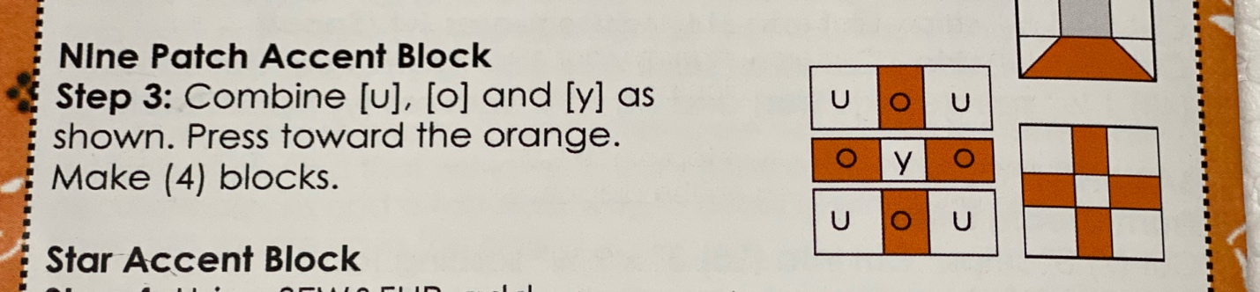

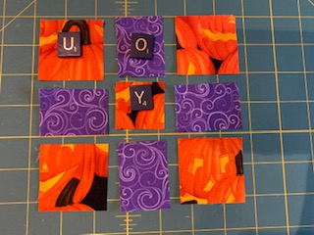

Spool- (1) Z 2” square in Contrast Color, (2) N’s 1 ¾” X 4 ½” Contrast Color, (2) T’s 2” X 1 ¾” in Orange, (4) V’s 1 ¾” squares on Orange
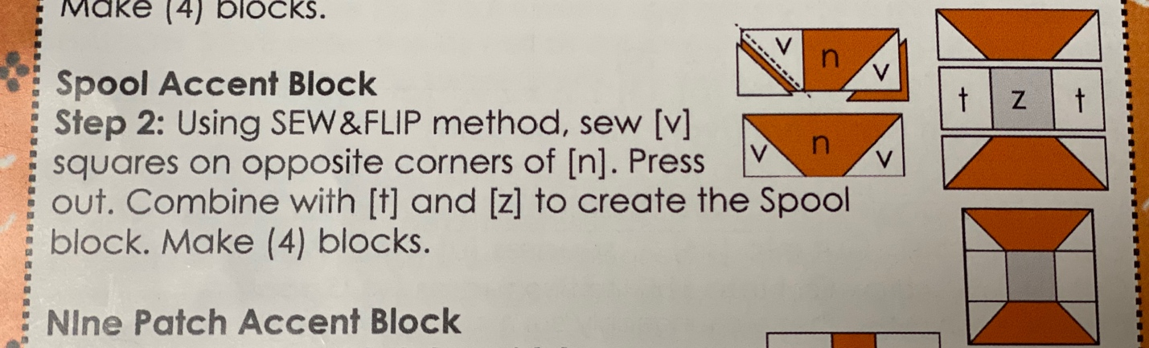

Churn Dash- (2) W’s 1 ½” X 1 ¼” Bright Color, (2) S’s 2 ½” Squares cut on the diagonal Bright Color, (2) K’s 2 ½” Squares cut on diagonal in Orange, (4) L’s 1 ½” X 1 ¼” in Orange, & (1) M 1 ½” Square in Orange

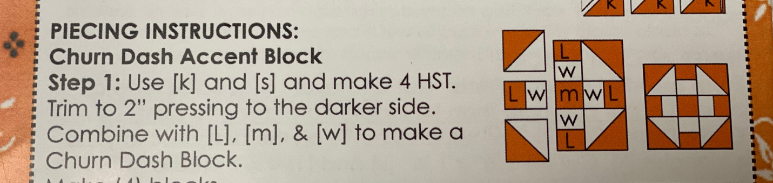

Star Block- (12) X’s 1 ½” Squares Bright Color, (1) P 2 ½” Square in Orange, (4) Q’s 1 ½” X 2 ½” Squares in Orange, & (4) R’s 1 ½” Squares in Orange

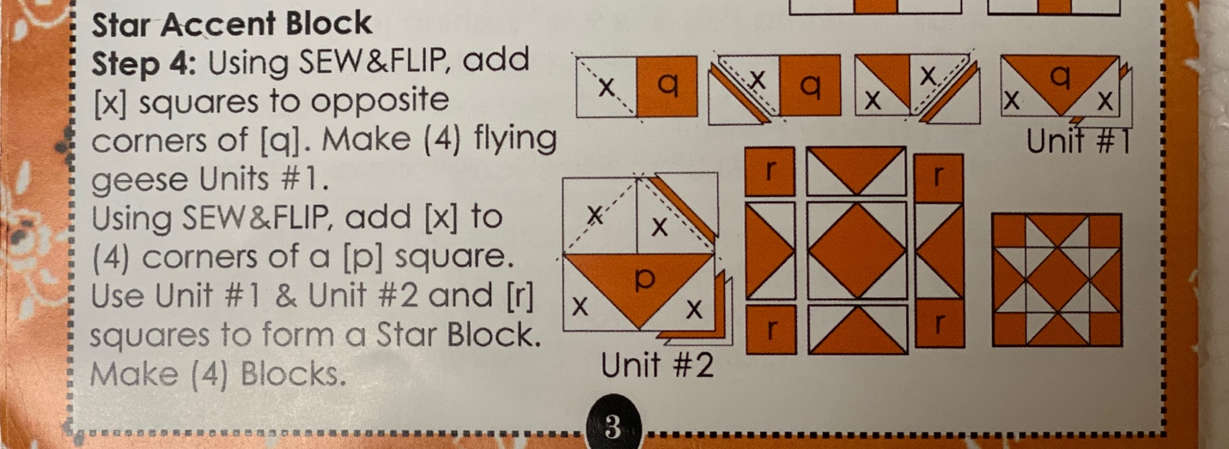

Disregard where it says make 4 blocks, you only need one

Pumpkin- Orange (Pumpkin) Color: (2) A’s 3”X 4 ½,(2) B’s 2” X 5”, (1) C 2” X 9 ½”.
Solid Black Background: (2) D’s 2 ½” X 4 ½”, (2) E’s 2 ¼” Squares, (2) F’s 2” Squares, 1 G 1 ¼ “ Square.
Green Stem Color: (1) H 1 ½” X 2 ½ “, (1) I 1 ½” Square, (1) J 1 ½” Square

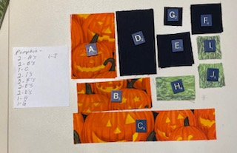

Pumpkin Assembly:

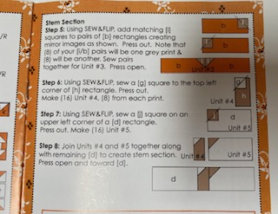
****Sew and Flip F Squares Last



