

We’re having an Ice Cream Social
Thank You, Thank You, Thank You
To: All Quilt Show Volunteers and Families
If you helped with the show, entered a quilt,
worked on the opportunity quilts – come join us!

When: Sunday, August 4, 2019
Where: Redwood Coast Senior Center
Time: 1 p.m. to 4 p.m.
PLEASE RSVP TO SHERRY WAGGONER
(arjnkd@gmail.com) BY JULY 24TH
SO WE KNOW HOW MANY PEOPLE ARE COMING

Sundaes Ice Cream Cones 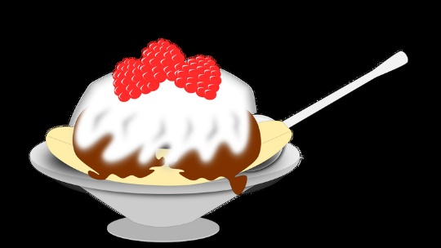 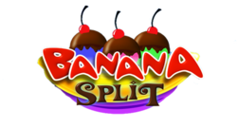 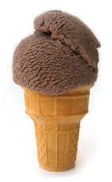

Ice Cream Bingo

Yummy Ice Cream

Raffle Prizes Drawings

